Experiences from the BItFROST Project: Developing a 3D repository at the Museum of Cultural History

Pantos George Alexis1*, Bonelli Letizia1, Indgjerd Hallvard1, Uleberg Espen1

1 Museum of Cultural History, University of Oslo

*Corresponding author

Correspondence: g.a.pantos@khm.uio.no

Abstract

The Museum of Cultural History has been maintaining records and publishing its catalogues since the early 19th century. In recent years, the institution has been working to improve data standardisation through the adoption of common vocabularies and adapting and upgrading the data systems to incorporate developments in technology. This work includes providing access to 3D datasets acquired at the museum seen as a part of essential research and artefact stewardship. The growing recognition of the value and potential of 3D data at the museum has provided a strong incentive, but also brought new challenges of data volume, complexity, and diversity of audience. This has been identified as only one part of broader sector-wide challenges of training and re-skilling in the face of a rapidly changing technological landscape. While this paper does not presume to hold answers to the current challenges it will share recent experiences in the hope that it may contribute to ongoing discussions of the challenges of data storage and dissemination and help others facing similar predicaments.

***Keywords:*** Digital archaeology, 3D models, long-term preservation, accessibility

Introduction

With a collection of more than 3 million finds and objects, the Museum of Cultural History (MCH) at the University of Oslo is the largest of the five Norwegian university museums with cultural historical collections (Figure 1). The museum is responsible for archaeological excavations in the south and east of the country as well as bearing primary responsibility for the storage and care of cultural material that predates the reformation in the region (1537) (Ministry of Climate and Environment 1979). Alongside the archaeological finds, the museum holds both ethnographic and numismatic collections after the merging of their respective institutes in 1999 (MCH 2012). The museum’s collection comprises a diverse array of fine craftsmanship and art including a unique assemblage of medieval wooden church architecture, painted sculpture and some of the world’s most iconic Viking Age ships and artefacts. Additionally, the collections contain ethnographic and archaeological objects from all continents and over a quarter of a million coins from all historical periods (MCH *The collections* 2021).

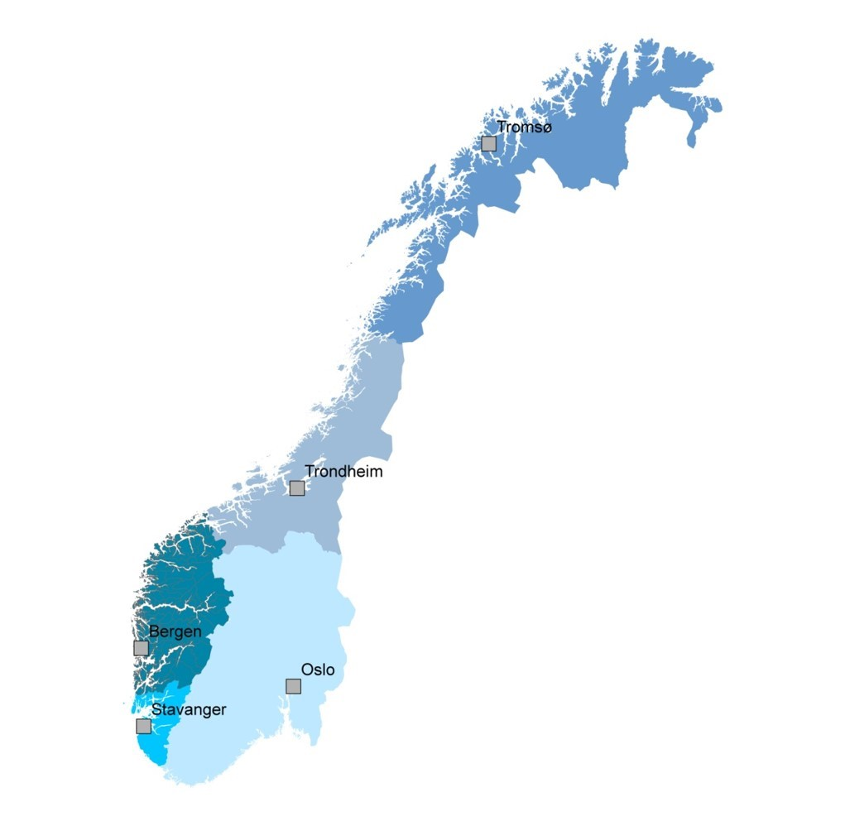

**Figure 1 –** The five archaeological museum districts in Norway.

Because of the size and complexity of the collection in comparison to those of the other university museums in Norway, the MCH has played a significant role in the development of documentation practices and approaches to data storage within the Norwegian heritage and archaeology scene. Through a series of successful collaborations with the other university museums since the 1990s the museum has been working to promote the adoption of standardised vocabulary, terminology, and interoperable data systems and to make archaeological documentation more accessible.  A part of this was the development of a system for the management of research and collection data (MUSIT – the Norwegian museum database initiative), as well as opening the collection management records (descriptions, measurements, locations, photographs) of the archaeological, ethnographic, and numismatic collections stored at the museum. These records are accessible online through searchable catalogues (unimus.no/portal) and more directly through an open API. In recent years, these catalogues have been modified to be internationally interoperable thanks to the mapping of the vocabularies to the Getty’s Art and Architecture Thesaurus (AAT) as part of the recent ARIADNE+ project (Uleberg et al. 2023).

The first experiences with 3D at the museum started in the early 2000s with the laser scanning survey of one of the ships preserved and exhibited at the Viking Ship Museum. The primary objective of this research was to obtain faithful documentation of the artefact in its current state of conservation and to use the data for a possible virtual reconstruction. Starting from this pioneering experience and considering the advantages of 3D, the museum extended the program of digitisation of artefacts, opting to employ Structured Light Scanning (SLS) as the primary documentation technology, alongside laser scanning. This approach was suited to satisfy the research questions at the time, with additional documentation supplied by the descriptive catalogues and conventional photography. Within the wider scope of the museums day-to-day work as a whole, however, this type of digitisation could be considered a relatively limited activity and the volume of datasets produced did not require special management.

Since the mid-2010s, the number of recorded artefacts by means of SLS increased. Photogrammetry was also adopted as a method, especially on excavations due to its versatility and the relatively low equipment costs. Terrestrial and drone-based photogrammetry were utilised to digitise single archaeological contexts, entire archaeological excavations and historical buildings outside the museum, and 3D documentation including architectural elements of UNESCO world heritage sites. At present, photogrammetry and SLS are employed daily in the documentation routines of the museum while other technologies like Micro-CT Scanning are beginning to be used on a more regular basis (Kimball et al. 2024). Data from 3D recording at the museum is used for a range of purposes, including condition monitoring of artefacts, mount making, conceptual exhibition planning, and research support, as well as documentation of archaeological sites and excavations. In the field of dissemination and outreach, 3D data has proven to be a valuable tool to mediate with a wider public and provide access to otherwise inaccessible resources.  In these last ten years the amount and range of data acquired has greatly increased. At the same time there has been a diversification in stakeholders of the data and the end-user needs and expectations. In addition to this, since technologies have become more accessible 3D recording is no longer performed by a few specialist technicians, but by a far wider demographic with a much broader range of expertise and varying familiarity with the requisite problems.

It is with the backdrop of this complex reality that the BItFROST project was initiated in 2021. BItFROST – Bridging Research Across Heritage Studies – is intended as an infrastructure project shared across several departments within the University of Oslo, a close collaboration with DARKLab at the University of Lund and the Visual Computing Lab at ISTI-CNR, Pisa (MCH 2021).

The BItFROST Project

The current BItFROST repository is best described as one element of the museum’s presentation systems, or in OAIS terminology a Dissemination Information Package (DIP) (CCSDS 2012). This is only one small part of a much larger interconnected ecosystem of data capture and storage that intersects with a 2D image database and descriptive catalogues. The current media database began its development over two decades ago and came out of the museum's collections management system and digital catalogues (Uleberg et al. 2023). At the time the need for a dedicated media base was driven by the increase in digital 2D imagery at the point of transition to digital photography and projects that aimed to digitise the museums analogue records – pressures that could be considered analogous to the adoption of 3D capture technologies today. Despite ongoing development this existing system was never intended to handle the size nor complexity typical of many current digitisation techniques. At the same time the spread of technology into all areas of modern life has seen cultural attitudes to data storage, and the expectations of functionality of digital archives change significantly.  These different, and at times competing factors combine into a situation that can be challenging for the effective integration of a novel system.

The current BItFROST repository is best described as one element of the museum’s presentation systems, or in OAIS terminology a Dissemination Information Package (DIP) (CCSDS 2012). This is only one small part of a much larger interconnected ecosystem of data capture and storage that intersects with a 2D image database and descriptive catalogues. The current media database began its development over two decades ago and came out of the museum's collections management system and digital catalogues (Uleberg et al. forthcoming). At the time the need for a dedicated media base was driven by the increase in digital 2D imagery at the point of transition to digital photography and projects that aimed to digitise the museums analogue records – pressures that could be considered analogous to the adoption of 3D capture technologies today. Despite ongoing development this existing system was never intended to handle the size nor complexity typical of many current digitisation techniques. At the same time the spread of technology into all areas of modern life has seen cultural attitudes to data storage, and the expectations of functionality of digital archives change significantly.  These different, and at times competing factors combine into a situation that can be challenging for the effective integration of a novel system.

Project aims and targets audience

The main objective of the project was to promote the reuse of 3D data held at the museum and explore the potential the format might offer. It was also developed to maintain sovereignty over 3D data through self-hosting, as opposed to use of other centralised data repositories maintained by third parties where geographical location of the data may not be fully disclosed. The project focused on a specific target audience - students and researchers including communities in other institutions supporting the University’s commitment to open data and efforts toward better compliance with the FAIR principals (Wilkinson et al. 2016). This open approach to data publishing and access has helped to identify and highlight differences between potential users of the museums 3D data not originally considered as the target audience at the beginning of the study, such as other members of the collections management department, exhibition designers and members of the public.

Description of the system

Central to the initiative was the deployment of a web platform that contextualises 3D data with core metadata relating to the original object and the creation of the dataset itself (Figure 2). The intention being to provide an opportunity to go beyond a mere visual representation of the artefact and create a more meaningful and reusable resource. The current web front end is based on 3DHOP (Potenziani et al. 2015), the same technology employed by the ARIADNE+ web portal (Ponchio et al. 2016) and shares many resources with the University of Lund's own Dynamic Collections interface and repository system (Ekengren et al. 2021). This open-source framework allows for streaming of high-resolution 3D data over the internet without the challenges of decimation and optimisation of 3D assets common in other online presentation technologies. It also provides tools for annotating, measuring, and creating custom collections of objects without requiring user-login or tracking.

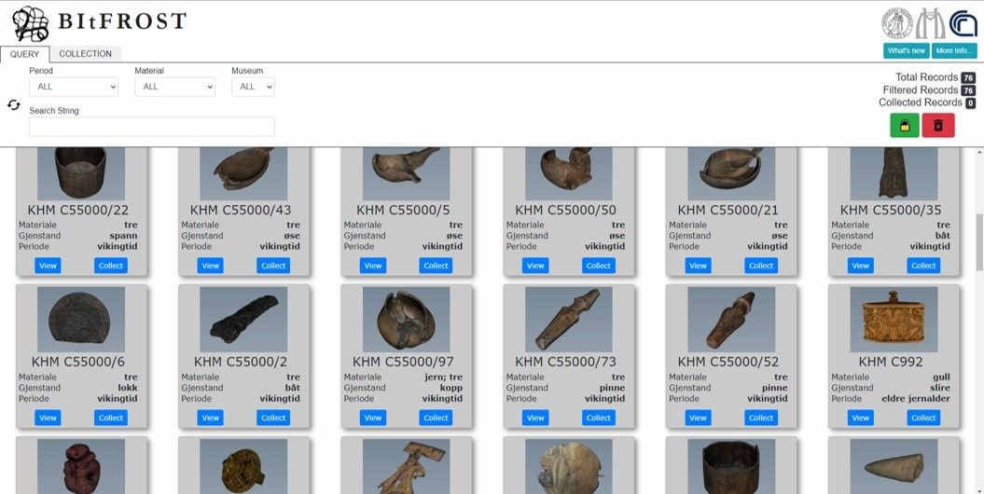

**Figure 2 –** Screenshot of the BItFROST platform.

Discussion and appraisal - BItFROST in the wider context

The platform is being used in teaching within the university. However, the chief success of the project is better characterised by the challenges and feedback that were raised during the implementation of the system. Informal feedback highlighted the variety in user expectations for 3D data and the challenges in meeting diverse needs. This feedback led to direct and meaningful changes to the interface design and inclusion of new tools and features including bounding box estimation and multi-part model handling. It also emphasised some of the more intractable challenges in rendering and realistic presentation of complex materials faced by current web technologies especially where direct comparison between original artefacts and the digital surrogate were possible. The implementation of a self-hosted 3D repository was also instrumental in identifying workflow and data handling challenges around the preparation of data and the storage of source material that might have otherwise received less attention.

Wider context

The need to store and share 3D data is not a new problem in the heritage sector. Institutions such as Data Archiving and Networked Services (DANS) in the Netherlands, the Archaeological Data Service (ADS) in the UK or the Digital Archaeological Record (tDAR) in the USA have invested heavily in developing long-term approaches to storage and retrieval of complex heritage data, including 3D. Guides to best practice are free and easily accessible and many recent projects such as Europeana and Ariadne have encouraged the heritage community toward common approaches to improve the interoperability and search-ability of our data. When it comes to the practical implementation of data management, there are also many commercial solutions available on the market, though few of those currently on offer were built with 3D data sharing at their core. At the same time online 3D repositories, such as the now well established Sketchfab, are often employed as 3D library and distribution tools by heritage institutions but are not suitable for long-term storage and distribution as evidenced by numerous similar 3D sharing platforms that are no longer operable. There is a growing community of open-source asset management solutions. In-house solutions are not unconventional, such as University of Minnesota's Elevator App (University of Minnesota n.d.) that employs the same 3DHOP engine used in BItFROST project, and the trio of software frameworks developed by the Digitisation Program Office at the Smithsonian institute (DPO n.d.); PackRat data management platform, The Cook processing pipeline, and the Voyager web-platform.

Work culture as data stewardship

Despite international projects such as 3DCOFORM (Arnold 2013) and 3D-ICONS (3D-ICONS 2014), consensus on 3D data storage strategies and metadata has yet to be realised (European Commission 2022, p. 5). The current situation of a heterogeneous implementation of 3D data storage in heritage institutions is well summarised in the recent guide *3D Data, Creation to Curation* (Moore *et al.* 2022). The authors stress that the specific needs of each institution can be hard to satisfy with one single solution and point out that the reasons for poor adherence to standardisation and existing guidelines can be complex. Resources and funding differences between institutions undoubtedly has a large impact, as does long term stability of funding within institutions and the ability to maintain personnel and skills both during and following individual projects. Yet the importance of the human component of our digital infrastructure cannot be understated. The effective implementation of technology can depend on sometimes invisible investment in personnel. Not only does it take time for a person to develop a competence and familiarity with a particular data system, so too does the development of social and inter-personal networks that ensure knowledge and skills are effectively and equitably distributed within the wider workforce.

Add into this the quick pace of change in technology versus the flexibility and responsiveness of complex institutions and the implementation of any new system is quickly fraught with challenges. The need for shared objectives and for updating and maintaining appropriate work culture as well as the technology is evidenced in the growing resources, training and support available for improving archiving research data, such as the University of Oslo Library's own data archiving initiative (UiO 2023).  Such training and support are invaluable for all positions within an institution, but the time required for these concepts to become properly embedded within a work force can be substantial.  The development of different work cultures within institutions, work groups and sub-disciplines over time is an inevitable part of human collaboration and the MCH has many years of experience reconciling and accommodating such differences within the museums data systems (Uleberg *et al.* 2023). Such challenges are not unique to the heritage sector and even where there are clear and simple guides, controlled implementation and adherence to standards there is still room for variation, misinterpretation and miscommunication.

**Data Subjectivity**

During the current project, it was found that seemingly small details became much bigger challenges as the user base was broadened. Conversations within our own group and with end users highlighted the disparities in technical knowledge that consequently impacted how the system was perceived. While no formal user survey was undertaken, it became apparent that the expectations of what 3D data represented and could or should offer was often misunderstood and was often correlated with an individual’s prior experience with 3D capture and their intention for interacting with the 3D data. The discrepancy between model and expectation was more noticeable for groups outside the designated core user group of students and academics. The dissonance between virtual and real object expressed by some users was by no means prescribable to specific user groups, neither was it static, with personal prior knowledge with specific artefacts or features contributing to the experience. Processing errors such as holes in meshes, shadows in textures, noise or loss of detail that can be unavoidable in some documentation situations are familiar to 3D capture specialists but can be disproportionately distracting for less experienced users.

Such misunderstandings can be exacerbated by the apparent ease of use and accessibility of 3D technology available in consumer devices like mobile phones. This can be compounded by terminology such as digital twin that encourage the perception that 3D data are a faithful representation of reality, rather than the imperfect approximations we know them to be. The potential pitfalls of 3D representations of heritage were explored in the London and Seville charters (The London Charter 2009, Bendicho and Grande 2011) which sought to encourage responsible work practices and thorough documentation to ensure end users can effectively appraise the quality of the data and understand some of the process or bias that produced it. However, such types of detailed documentation are poorly suited to how most users expect to interact with data today. Even short descriptions can prove cumbersome and more immediate forms of communicating meaningful criteria such as the coverage, known errors and recommendations for suitable reuse were identified as a valuable feature. While it is tempting to suggest that less supporting documentation will be acceptable as familiarity with 3D data increases, experience with 2D image catalogues suggests otherwise.  Ratings, labelling, and categorisation tools are an integral part of most modern DAMS, especially where they are used by diverse audiences is expected to take place.

Interactions with non-target user groups including conservation staff and exhibition designers, forced the project to re-evaluate how models were presented and which supporting information was prioritised. It also led to the development of criteria to help rank the models in qualitatively. The intention here was not to classify models as 'good' or 'bad', but to build on the concept of these data as ‘extended objects’ (Jeffrey et al. 2021) with a rich variety of both potential and limitations depending on the users aims and to encourage dialogue between practitioners in the intersecting departments (Figure 3 and 4).

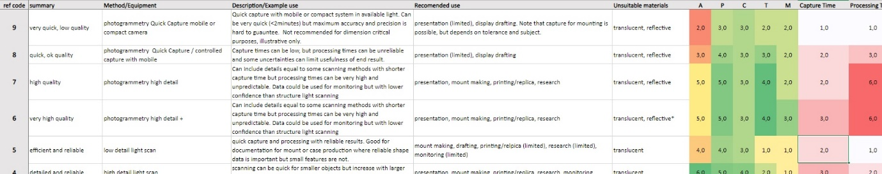

**Figure 3 –** Excerpt ofjob specification chart developed as response to how models were perceived by different user groups. This document remains complicated for non-specialists but aims to simplify communication and simplify planning within the digitization group. It also provides the basis for more user-facing implementation (see figure 4).

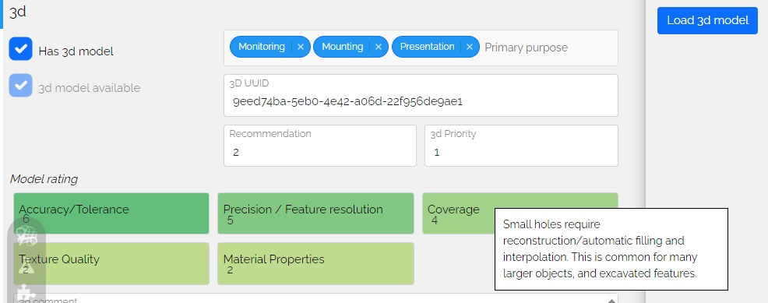

**Figure 4 -** Statistics such as polygon count, and file size do not provide a reliable proxy for data quality or complexity across capture technologies and are difficult to interpret for non-specialists. Here is an example of the self-referred quick reference indicating "quality" implemented in an internal database for exhibition planning. Categories include model coverage, detail capture and texture quality.

As Huggett (2022) and others have emphasised, our choices when developing storage systems can have long lasting implications, not only in terms of future technological challenges, but also in the way they shape and structure our knowledge and research practices. As such, taking a long-term view is essential. The aforementioned guide by Moore *et al*. (2022) stresses the value of project gap analysis – the identification of features or elements that were either not included or not achieved during the lifespan of a particular project in order to facilitate and guide future developments. To achieve this, it was necessary to contextualise the BItFROST platform within the wider museum data structures and to make explicit many of the implicit processes and interactions that had developed over time as different sectors of the organisation adopted and implemented 3D capture for different purposes (Figure 5). This recent project drew on the OAIS standard (CCSDS 2012) to structure this information and reveal the hidden complexity of many of the processes, which has in turn helped better delineate aspects such as metadata requirements, ingest procedures and the importance of disambiguating the responsibilities of different stages of data handling within the organisation. Perhaps most importantly this work and the use of existing terminology provided a common ground and vocabulary that clarified differences in understanding and approach that had arisen between different actors over time.

The process of creating this shared reference made it easier to identify areas for improvement upstream of the repository and better appraise existing solutions. Important features arising out of this work included the implementation of Universally Unique Identifiers (UUIDs), identification of automatable processes and proposed changes to metadata and paradata capture strategies.  While promising tools for meta- and para-data capture such as the CHI lab notebook (CHI 2023) do exist, the data entry workflows are plagued by inconsistent standardisation and incompatibilities and churn between competing software companies. For the time being the MCH has adopted a relatively unrestricted approach to paradata documentation based on markdown. On the one hand this attempt to avoid some of the file-format issues of other document types while remaining accessible. On the other it provides enough flexibility to adapt to very different working scenarios with the primary aim of facilitating rather than interrupting the working process. Reducing the complexity of workflows, and especially lowering barriers to documentation through greater reliance on data extraction and clearer separation between archive and processing files remain important areas for future development. This is especially important as 3D data becomes even more available and new forms of technology are introduced at a time when earlier promises of infinite storage made by technology giants are being rolled back.

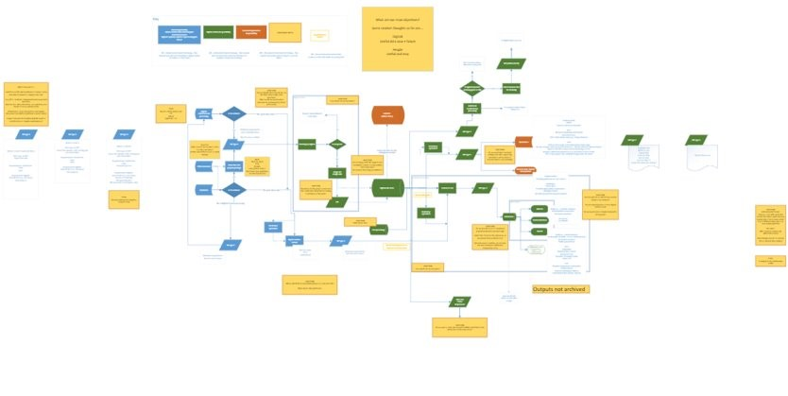

**Figure 5 –** Overview of the work in progress schematic of the 3D data pipeline at the museum. Development of the diagram helped to identify unseen process and stakeholders in the complex data handling activities. In this version blue, green, and orange identify responsibilities of different stakeholders. Yellow squares are notes with standing questions. The illustration serves as reminder of the true complexity of such systems.

Conclusions

The hype of the technology sector remains a powerful force that should not be underestimated. Despite of simpler workflows, increased efficiency and other benefits often fail to become a reality. The idea that one single good technological solution might one day resolve all our problems remains an attractive, yet pernicious fallacy. It is unlikely that a single system will suit all needs, and compromises will have to be made. The value of embracing and building on the lessons of others cannot be understated, but even the best guides require time and experience to be fully realised. Often it is only through experiencing the challenges and pitfalls first hand that we gain a deeper understanding of the problems we are attempting to resolve and can properly delineate our final goals. Perhaps above all else this project has shown the value of taking a long-term view of our data systems, not as a product that can be finished, but as continuously developing structures that need to be grown and guided thoughtfully in new directions. Essential to this approach is investing time in deeper understanding of community needs, the changing potentials of our data, but also of our own work culture. Perhaps it is the cultivation of collaboration and goodwill built on communication, shared knowledge and better understanding of technology that can best moderate the destabilising forces of techno-hype and techno-scepticism that buffet much of our daily lives and perhaps remains the most difficult challenge in the age of seemingly unending technological revolution.

Abbreviations

CCSDS = Consultative Committee for Space Data Systems

CHI = Cultural Heritage Imaging

DAMS = Digital Asset Management System

DIP = Dissemination Information Package

DPO = Digitization Program Office

MCH = Museum of Cultural History

OAIS = Open Archival Information System

SLS = Structured Light Scanning

UUID = Universally Unique Identifier

Conflict of interest disclosure

The authors declare that they comply with the PCI rule of having no financial conflicts of interest in relation to the content of the article. George Alexis Pantos has been chair of the session ‘For a Bright Future: Challenges and Solutions for the Long-Term Preservation of 3D and Other Complex Data in Digital Cultural Heritage’.

References

3D-ICONS 2014 Guidelines and Case studies https://pro.europeana.eu/files/Europeana_Professional/Projects/Project_list/3D-ICONS/Deliverables/3D-ICONS%20Guidelines%20and%20Case%20Studies.pdf

Arnold D. 2013 Tools and Expertise for 3D Collection Formation: Final Report https://www.brighton.ac.uk/_pdf/research/lhps-groups/3d_co_form_final_report_v1_0_public_1.pdf

Bendicho V.M. and Grande A. 2011, ‘The principles of the Seville Charter’, In Proceedings of the XXIII CIPA Symposium, Prague, Czech Republic, CIPA Heritage Documentation.

Cultural Heritage Imaging 2023 Digital Lab Notebook <https://culturalheritageimaging.org/Technologies/Digital_Lab_Notebook/index.html> [last accessed 30.08.2023]

Consultative Committee for Space Data Systems 2012, Reference model for an open archival information system (OAIS). Recommended Practice, Issue 2, CCSDS 650.0-M-2, ISO 14721:2012, Washington, DC: Consultative Committee for Space Data System. <https://public.ccsds.org/pubs/650x0m2.pdf>

Digitization Program Office n.d. Smithsonian Open Source Pipeline https://github.com/Smithsonian/dpo-packrat [last visited 25 Aug 2023]

European Commission, Directorate-General for Communications Networks, Content and Technology 2022 Study on quality in 3D digitisation of tangible cultural heritage: mapping parameters, formats, standards, benchmarks, methodologies, and guidelines: executive summary, Publications Office of the European Union. <https://data.europa.eu/doi/10.2759/581678>

Ekengren, F., Callieri, M., Dininno, D., Berggren, Å., Macheridis, S. and Dell’Unto, N. 2021 'Dynamic Collections: A 3D Web Infrastructure for Artifact Engagement', Open Archaeology 7(1), 337–352. <https://doi.org/10.1515/opar-2020-0139>

Huggett J. 2022 ‘Data Legacies, Epistemic Anxieties, and Digital Imaginaries in Archaeology’, Digital, 2(2), 267-295. <https://doi.org/10.3390/digital2020016>

Kimball J.J.L., With R. and Rødsrud C.L. 2024 ‘A new and 'riveting' method: micro-CT scanning for the documentation, conservation, and reconstruction of the Gjellestad ship’, Journal of Cultural Heritage.

Ministry of Climate and Environment 1979 Act concerning the cultural heritage <https://lovdata.no/dokument/NLE/lov/1978-06-09-50> [Last accessed 29 Mar 2023]

Moore J., Rountrey A. and Scates Kettler H. (eds) 2022 3D Data Creation to Curation: Community Standards for 3D Data Preservation, Chicago: Association of College and Research Libraries.

Ponchio F., Potenziani M., Dellepiane M., Callieri M. and Scopigno R. 2016 ‘ARIADNE Visual Media Service: Easy Web Publishing of Advanced Visual Media’, in S. Campana, R. Scopigno, G. Carpentiero and in M. Cirillo (eds) CAA 2015: Keep the revolution going. Proceedings of the 43rd Annual Conference on Computer Applications and Quantitative Methods in Archaeology, Volume 1, Oxford: Archeopress. 433-442. ISBN 978-1-78491-337-3.

Potenziani, M., Callieri, M., Dellepiane M. and Corsini, M. 2015 '3DHOP: 3D Heritage Online Presenter', Computer & Graphics 52. <https://doi.org/10.1016/j.cag.2015.07.001>

Jeffrey S., Love S. and  Poyade M. 2021 ‘The Digital Laocoön: Replication, Narrative and Authenticity’ Museum and Society 19 (2), 166-183. <https://doi.org/10.29311/mas.v19i2.3583>

The London Charter 2009 <https://londoncharter.org/> [last accessed 29.08.2023]

Uleberg E., Matsumoto M., Pantos G.A. and Bonelli L. 2023 ‘Toward standardised vocabularies for Norwegian archaeology’, Internet Archaeology.

Wilkinson M.D., Dumontier M., Aalbersberg I.J., Appleton G., Axton M., Baak A., Blomberg N. et al. 2016 ‘The FAIR Guiding Principles for scientific data management and stewardship’, Scientific Data (3), 1-9. <https://doi.org/10.1038/sdata.2016.18>

University of Minnesota n.d. Elevator. Multi-instance digital asset repository  <https://www.elevatorapp.net/> [last accessed 28.08.2023]

University of Oslo, Museum of Cultural History 2012 Kulturhistorisk museum: Historikk <https://www.khm.uio.no/om/tall-og-fakta/historie/> [Last accessed 10 Aug 2023]

University of Oslo, Museum of Cultural History 2021 BItFROST <https://www.khm.uio.no/english/research/projects/bitfrost/index.html> [Last accessed 17.08.2023]

University of Oslo, Museum of Cultural History 2021 The collections <https://www.khm.uio.no/english/collections/index.html> [last accessed 24.08.2023]

University of Oslo, University of Oslo Library 2023 Research data management courses <https://www.ub.uio.no/english/subjects/medicine/courses/research-data/> [last accessed 27.08.2023]