Technological analysis of lithic assemblages from surface collections. First evidence of a Palaeolithic frequentation of the Po plain in Piedmont: the case of Trino (north-western Italy).

Daffara Sara*^{1,2}, Giraudi Carlo³, Berruti Gabriele L.F. ^{1,2}, Caracausi Sandro ^{1,2}, Garanzini Francesca ⁴

¹ Dipartimento di studi umanistici, Università degli studi di Ferrara – Ferrara (FE), Italy
² Associazione culturale 3P – Progetto Preistoria Piemonte – San Mauro Torinese (TO), Italy
³ TRIDINUM Associazione per l’Archeologia, la Storia e le Belle Arti – Trino (VC), Italy
⁴ Soprintendenza Archeologia, Belle Arti e Paesaggio per le provincie di Biella, Novara, Verbano-Cusio-Ossola e Vercelli – Novara (NO), Italy

*Corresponding author
Correspondence: dffsra@unife.it

Abstract
The Trino hill is an isolated relief located in north-western Italy, close to Trino municipality. The hill was subject of multidisciplinary studies during the 70s, when, because of quarry activities and agricultural arrangements, five concentrations of lithic artefacts were recognized and referred to a Palaeolithic frequentation of the area. During the 80s and the 90s, surface collections continued, but the lithic finds have never been subject of specific studies. Even if most of the lithic assemblages count a few lithic implements, four collection areas (3, 13 E, 13 W and 14) have significative lithic assemblages, representing the most important evidence of a Palaeolithic frequentation of the Po plain in north-western Italy.
The present work, in the limits imposed by a surface and not systematic collection, propose a technological study of the lithic artefacts from the Trino hill, with the aim to define the main features of the technological behaviour of the human groups that inhabited the area. The results obtained allow to clearly identify a Middle Palaeolithic frequentation of the Trino hill, characterized by the exploitation of vein quartz and other local raw materials; allochthonous varieties of chert were used in the next frequentation phases to produce blades and bladelets. Even if part of the laminar production can be referred to Neolithic, most of that remains of indeterminate chronology and could be the result of both an Upper Palaeolithic and Neolithic human presence.

Keywords: Palaeolithic, north-western Italy, lithic technology, surface collections, vein quartz
Introduction
The characteristics and dynamics of the Palaeolithic frequentation of Piedmont (north-western Italy) and of the western part of the southern margin of the Alps are barely known. As of today, the only reliable data come from the Ciota Ciara cave (Borgosesia – VC) concerning Middle Palaeolithic (Angelucci et al., 2019; Berto et al., 2016; Buccheri et al., 2016; Daffara, 2018; Daffara et al., 2014; Daffara et al., 2021; Daffara et al. 2023) and from Castelletto Ticino – Via del Maneggio (NO) for Upper Palaeolithic (Berruti et al., 2017). The main aim of the proposed research is to contribute to the increasing of the knowledge about Middle Palaeolithic lithic technology from the the western alpine region. Looking at the alpine and sub-alpine area (Fig. 1), data about Middle Palaeolithic are not homogenized.

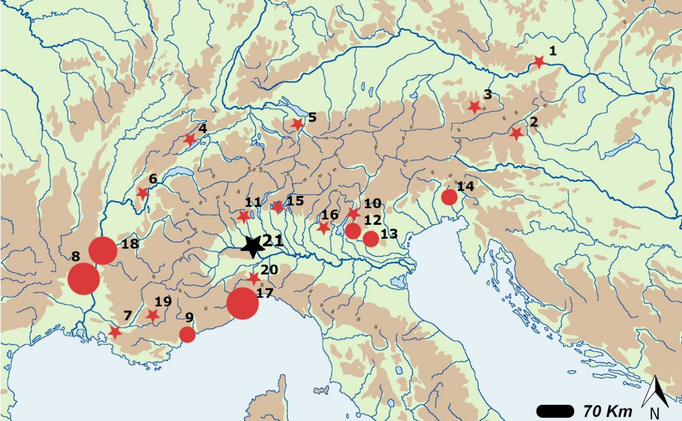
Figure 1 - Map showing the main Middle Palaeolithic sites of the alpine and sub-alpine region. The black star (21) indicates the location of the Trino area. Austria: (1) Gudenus cave (2) Repoulust cave; (3) Salzofen. Switzerland: (4) Cotencheler cave; (5) Wildkirchli cave. France: (6) Grotte Chenelaz; (7) La Combette; (8) Grotte Mandrin, Grotte de Néron, Abri Moula, Grotte du Figuier, Orgnac 3, Barasses II, Abri de Pêcheurs, St. Marcel; (9) Grotte du Lazaret (18) Abri du Maras, Payre, Baume des Peyrards, Bau de l’Aubesier; (19) Grotte de la Baume Bonne. Italy: (10) Monte Baldo; (11) Ciota Ciara cave; (12) Fumane cave; Tagliente rock-shelter; Mezzena rock-shelter; (13) San Bernardino cave, Stria Cave, Brojon rock-shelter, Nadale cave; (14) Rio Secco cave; Pradis caves; (15) Generosa cave; (16) Monte Netto; (17) Grotta del Principe, Madonna dell’Arma, Grotta di Santa Lucia superiore, Arma della Manie, Grotta del Colombo, Grotta delle Fate, Barma Grande; (20) Arma Veirana
North of the alpine chain, in Austria and Switzerland, fewer archaeological sites are known (Fig. 1, numbers from 1 to 5 refers to most important and studied ones) (Bächler, 1940; Ehrenberg, 1958; Bernard-Guelle, 2004; Bednarik, 2008; Brandl et al., 2011; Cartonnet & Combier, 2018; Deák et al., 2019). A very different situation can be observed in France, in particular in the Rhône valley and the Mediterranean area bordering Italy. Dozens of Middle Palaeolithic sites (caves and rock-shelters) are known in these areas (in Fig. 1 we illustrate just the most important ones, numbers 6, 7, 8, 9, 18 and 19) and the multidisciplinary studies carried out in the last decades demonstrate in detail the modalities of site occupation, intra-site space organization, hunter-gatherer mobility, relationships among different sites and, in general, dynamics and changes of human frequentation of the area during Middle Palaeolithic (e.g. Carmignani et al., 2017; Daffara et al., 2019; Daujeard et al., 2012, 2016; Fernandes et al., 2008; Hardy & Moncel, 2011; Mathias, 2016; Moncel, 2005; Moncel et al., 2008a; 2008b, 2013; Moncel & Daujeard, 2012; Slimak, 2008; Slimak et al., 2004; Wilson et al., 2018). The southern margin of the alpine region in northern Italy, shows a similar scenario, with several Middle Palaeolithic sites in the eastern and in the Mediterranean area and just a few sites in the north-western regions (Fig. 1). In the eastern Alps, caves and rock-shelters attest an intense occupation of the area during Middle Palaeolithic with an abundance of good-quality lithic resources outcropping at the lower margin of the alpine chain. Multidisciplinary studies show quite clear and detailed knowledge about the modalities of occupation, mobility, strategies of exploitation of natural resources and technological behaviour for each of the main archaeological contexts (Fig. 1) (e.g. Arnaud et al., 2017; Berruti et al., 2020; Dalmeri et al., 2008; Delpiano et al., 2018; Giunti & Longo 2010; Jequier et al., 2015; Peresani et al., 2011, 2014, 2019; Peresani, 2011; Picin et al., 2013). The same can be said for the Mediterranean area of the Italian sub-alpine region, where several caves are known and have been systematically investigated during the XXth century and in the last decades (Fig. 1, numbers 17 and 20) (e.g. Cauche 2002, 2012; Eixea 2018; Holt et al., 2019; Marciani et al., 2020).
On the other hand, the Middle Palaeolithic of the south-western margin of the Alps is poorly investigated. Besides some non-systematic surface collections known since the XIXth century, systematic investigations rarely took place in this area. As of today this are has just four Middle Palaeolithic archaeological sites (Fig. 1, n° 11, 15, 16, 21) (Angelucci et al., 2019; Daffara et al., 2021; Delpiano et al., 2019; Fedele, 1985).
Ciota Ciara cave (Fig. 1, n° 11) in the Piedmont of Monte Fenera karst has been under systematic excavation since 2009. These investigation resulted in chronological placement of the site occupation to the second half of Middle Pleistocene. The dating has also provides a detailed understanding of the modalities of site occupations, as well as the techno-economic behaviour of the human groups frequenting the site (Daffara, 2018; Daffara et al. 2021). Castelletto Ticino – Via del Maneggio represents the only Upper Palaeolithic lithic assemblage from systematic archaeological excavations that has recently undergone a new technological study ascribing the lithic industry to the Late Epigravettian (Berruti et al., 2017). Other evidence consist in patchy surface finds or archaeological excavations and surveys, mainly conducted with non-systematic methodologies (D’Errico & Gambari, 1983; Fedele 1976, 1990; Forno & Mottura, 1993; Giacobini, 1976; Giraudi & Venturino Gambari, 1983; Guerreschi & Giacobini, 1998; Mottura, 1994).
The slow pace of the Palaeolithic studies in Piedmont is probably due to the perspective that the area was inhospitable during Pleistocene (Fedele, 1985), but in the last ten years, the new archaeological investigations at the Ciota Ciara cave peeked the interest in Palaeolithic studies with new research projects and the re-examination of old data (Berruti et al., 2016; Rubat Borel et al., 2013, 2016)
The present work concerns the technological study of the lithic assemblages found during survey activities carried out between the’70s and the ‘90s in the Trino area, in particular at Rilievo Isolato di Trino (RIT), a small hill located in the north western part of the Trino territory (Fig. 2) with a sequence of Pleistocene fluvial terraces (GSQP, 1976). Today, these lithic assemblages represent the only considerable evidence of a Palaeolithic occupation of the Po plain in Piedmont. Even in the absence of clear stratigraphic data, and therefore of a precise chronological framework, the proposed analysis aims to outline the technological characteristics of Trino lithic assemblages. The location of the collection areas is known (Fig. 2), however, the original environment has been strongly affected by agricultural arrangements that destroyed most of the areas were lithic artefacts were collected. Considering the scarcity of data for this portion of the southern alpine arc, it is important to deal with the study of these lithic assemblages, currently representing the only evidence of a Palaeolithic foccupation of this sector of the Po plain.
Based on a technological approach, the objective of this paper is to present a report of each lithic assemblage, update the knowledge about this area and discuss the importance of the considered lithic industries in the regional context. In fact, despite the importance of the Trino lithic assemblages in the field of Palaeolithic studies in north-western Italy, they have never been published in detail and no review have ever been reported since the original studies completed in the ‘70s and concerning just a small part of the lithic industries of the Trino collection (Fedele, 1974; GSQP, 1976).

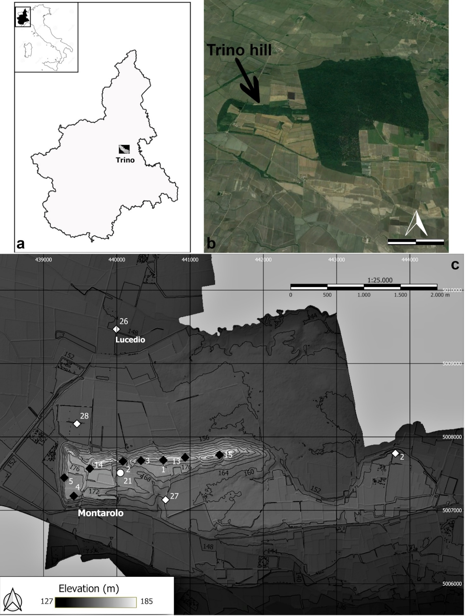
Figure 2 - Geographic location of Piedmont and Trino (a); aerial view of the Trino hill (modified from Google Earth) showing evidnece of agricultural activity effecting the area in the last decades, the woods on the right of the natural reserve of Bosco della Partecipanza (the scale bar is 1 Km) (b); location of the areas where archaeological materials were collected (c): black squares = lithic assemblages; white squares = protohistoric, roman or Medieval archaeological materials (not considered in the present study); white dot = collection area of the bifacial tool recently found. The map has been created with QGIS software, using DTM 5 meters and it is based on “Geo Portale Piemonte” data set (http://www.geoportale.piemonte.it/geocatalogorp). The Geographic Coordinate Reference Systems are EPSG: 4326 – WGS 84. The numbering of the collection areas follows that of the maps present at Museum “G. Irico”. Concerning the lithic assemblages, the location is not known for some of the collection areas reported in the text.
History of research and geologic setting
Research in the Trino area started in the ‘70s when quarries and agricultural activity took place at the Trino hill. Terracing works over an area of about 200 m² in the north-eastern part of the hill affected different archaeological layers (Fedele, 1974). Geological surveys in 1974 recovered the first assemblage of lithic artefacts at the top of the hill; subsequent surveys collected approximately 300 artefacts from an area of about 90x20 m² (TR 1). The first technological study demonstrated the homogeneity of the general state of preservation and the technological features of the assemblage. The technological featurers included intensive exploitation of local vein quartz, followed by chert of probable non-local provenience, and the presence of frequent cores and of Levallois technology. Based on technological criteria, different phases of human occupation were recognized and attributed to Middle and Upper Palaeolithic, while for some of the TR 1 lithic artefacts a Lower Palaeolithic attribution was also proposed (Fedele, 1974). In the subsequent two years, systematic survey campaigns took place in the area and led to the identification of four other lithic assemblages (TR 2 – 10 lithic artefacts; TR 3 – 30 lithic artefacts; TR 4 – 10 lithic artefacts; TR 5 – 2 lithic artefacts), in addition to the finding of further lithic artefacts from TR 1 (GSQP, 1976). The technological study completed in 1976 outlined the main technological features of each lithic assemblage; despite the presence of Levallois technology, according to the preferential use of local raw materials (vein quartz) and of cores mainly manufactured on pebbles and scarcely exploited, the lithic assemblages were mainly attributed to Lower Palaeolithic (GSQP, 1976).
In 2016, during the cataloguing of the archaeological materials at Museo Civico G. Irico, a huge lithic assemblage was found in the museum storage room. The assemblage is the result of further survey activities that took place in the last decades and that has never been considered for a technological study. Indeed, other concentrations of archaeological materials have been identified at the Trino hill and some of them consist of Palaeolithic lithic artefacts. What is known about these surface collections is that they were conducted in different localities following the agricultural activities that involved the hill in the last decades (personal communication by members of TRIDINUM). During recent field leveling for a rice field, a 4-5 m thick stratigraphic succession was exposed in an area not previously excavated. In the lower part of the sediments, a bifacial tool manufactured on metamorphic rock was found at the base of the exposed stratigraphy (Fig. 3)(Daffara & Giraudi, 2020).
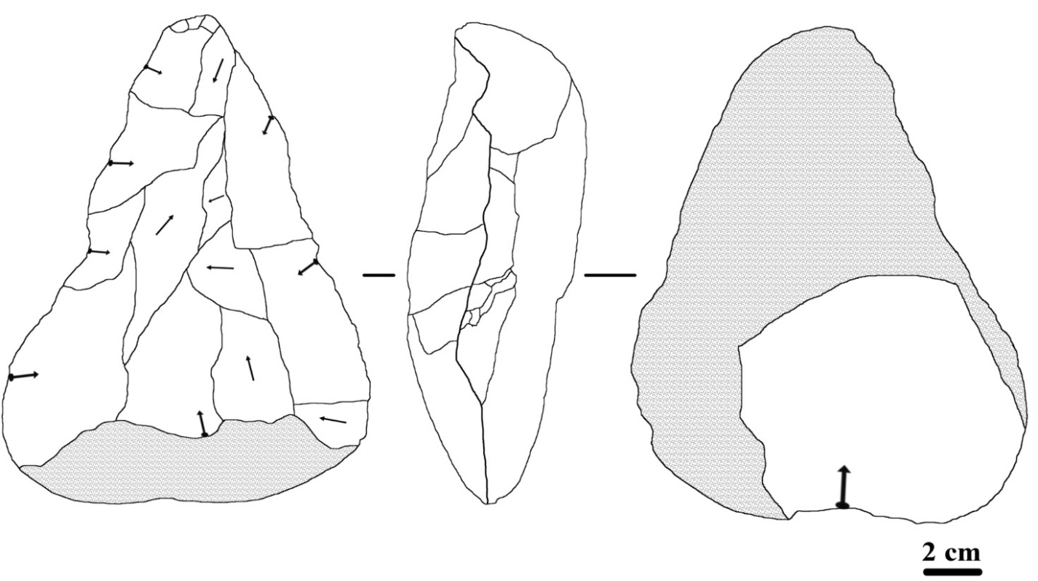
Figure 3 - Bifacial tool on a metamorphic rock pebble recently found at the Trino hill One side show just one invasive removal aimed to the thinning of the base. On the other side big, invasive removals are visible in the mesial and distal portion, while the proximal part is a natural surface. (Daffara & Giraudi, 2020)

Geological background
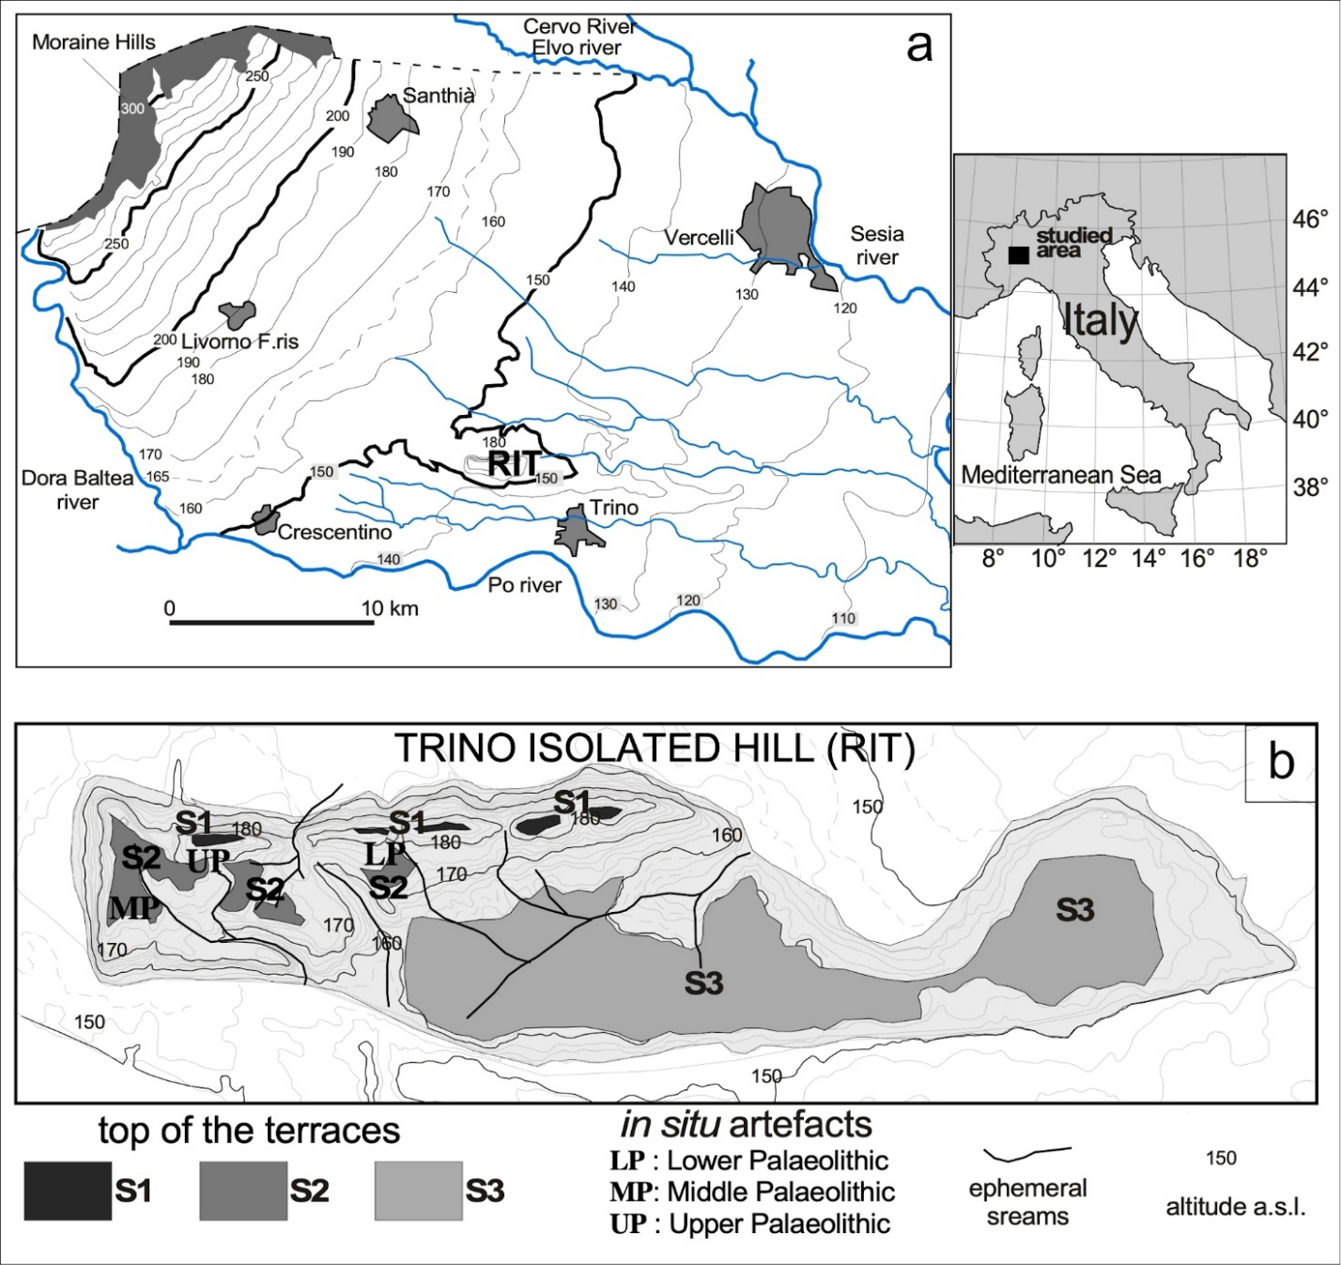
Figure 4 - (a) Topographic map of the Vercelli plain (NW Italy) with the location of the Trino hill (RIT); (b) the that form the RIT and their shape.

The Trino isolated hill (RIT) is a peculiar morphological feature present in the low Vercelli plain, reaching an altitude of about 190 m a.s.l., surrounded by fluvioglacial and fluvial terraces that reach maximum altitudes of 150-155 m a.s.l. (Fig. 4). During the research carried out in the 70s (GSQP, 1976), in which one of the authors (CG) took part, many artifacts were found on the top of the hill. Most of the artifacts were collected in plowed soil and quarry materials, while a few artifacts were in situ, among the pedogenic aeolian sediments that form the top of the terraces.
Trino isolated hill is formed by a core of tertiary marine sediments, similar to those outcropping in the nearby Monferrato hills, covered by fluvioglacial and aeolian deposits (Giraudi, 2014; GSQP, 1976; Servizio Geoogico d’Italia, 1969).
The fluvioglacial deposits of the RIT form three terraces (S1, S2, S3): of these terraces (Fig. 4B), S1 is preserved in a thin and discontinuous ridge oriented W-E, S2 forms a large area in the western RIT but it disappears towards the east, while S3 is much larger and limited to the eastern portion of the hill. While the western portion of the S1 and S2 areas of the RIT was subject to deforestation, levelling for agricultural use and quarrying, the easternmost portion does not show traces of recent anthropogenic impact as it has been occupied, since the Middle Ages, by the wood known as Bosco della Partecipanza di Trino (Fig. 2).
The now abandoned quarrying operations and rice field levvelng formed scarps exposing RIT stratigraphy. Furthermore, as part of ENEL's studies on the Po1 nuclear site (ENEL, 1984), cores with continuous sampling were drilled and a trench about 200 m long and about 7 m deep was dug on the higher surface of the RIT.
Sandy gravel and sand characterize the buried surfaces S1, S2, and S3 terraces, and exhibit different degrees of pedogenesis. Three levels of clearly distinguishable aeolian loess overlie the terrace surfaces with the oldest being a yellowish-red soil, the intermediate a brown soil, and the youngest a yellowish-brown. Based on the correlation between fluvioglacial sediments and moraines (Carraro et al., 1991; Gianotti et al., 2008), formed by the Dora Baltea glacier, and their degree of pedogenesis (Giraudi (2014) determined that the deposits overlying surfaces of the terraces S1, S2 and S3 of the RIT date back to the final phases of the Lower Pleistocene and to a part of the Middle Pleistocene (MIS 22 - 12, between 870.000 and 424.000 years ago). Similarly, according to the morphological and stratigraphic correlations between fluvioglacial and morainic deposits, developed by Giraudi (2014), also supported by the dating of volcanic minerals, the two oldest loess are chronologically attributable to the late Middle Pleistocene, while the youngest and more discontinuous was sedimented in the Upper Pleistocene.
The exposed sediments also show the stratigraphical succession lying below the scarps between the three terracesenabling the illulstration of a geological section through the terraces that form the isolated hill (Fig. 5).
The stratigraphy of the sediments that form the scarp between S1, S2 and S3 is formed, from top to bottom, by (Fig. 5):
- thin and discontinuous layers of the same loess present on the terraces top;
- mainly silty and sandy colluvium interbedded with gravelly-sandy ones; the colluvium is interfingered with the fluvioglacial deposits that form the terraces S2 and S3.

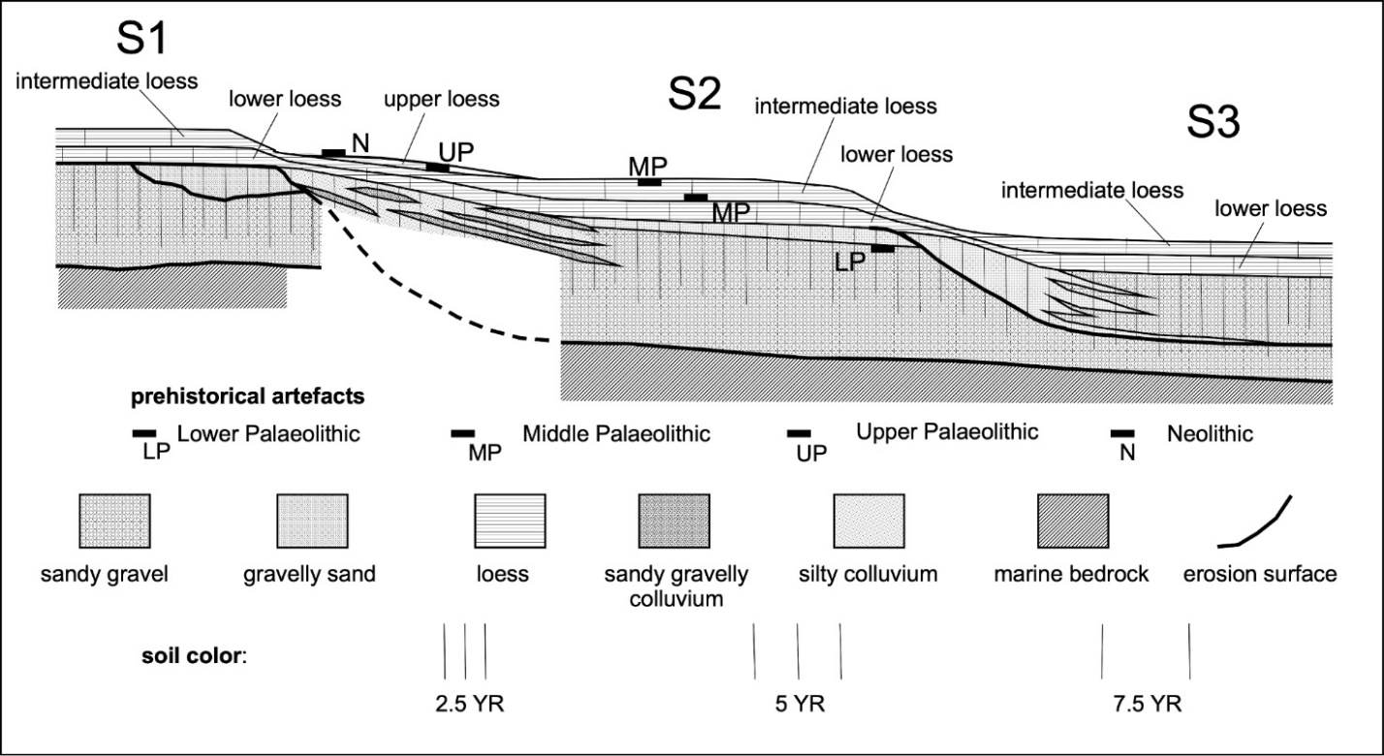
Figure 5 - Schematic section of the terraces of the Trino hill with stratigraphic position of the bifacial tool (LP) and of the Middle and Upper Palaeolithic artefact found during the investigations completed in the ‘70s

Materials and Methods
Materials
The proposed technological analysis concerns the lithic assemblages currently stored at Museo Civico G. Irico (Trino – VC) for a total of 1964 artefacts collected in the last decades at Trino hill and in other localities of the Trino municipality (Table 1). The different collection areas are named with a progressive number preceded by the acronym “RIT”. All the other localities listed in Table 1 are placed in the immediate surroundings, but the precise location of the areas where lithics were collected is unknown. Sites from RIT 1 to RIT 4 correspond to the collection areas documented in the ‘70s. Part of the lithic assemblages from RIT 1 and RIT 4, originally counting about 300 and 10 artefacts respectively, is no more present at the Museum and it has not been possible to deal with a complete technological study of this assemblages. The 83 lithic artefacts here considered for RIT 1 are a small part of the original lithic assemblage, while for RIT 4 just one lithic artefact is still kept in the Museum. On the other hand, the lithic assemblages from RIT 2 and 3 that, after the collections completed in the ‘70s, were composed by 10 and 30 findings respectively, have had an increase thanks to the surface collections carried out in recent years and currently count 19 and 137 lithics respectively (Tab. 1).

Table 1 - General composition of the considered lithic assemblages grouped by collection area. RIT (= Rilievo Isolato di Trino). RIT X includes the lithic artefacts from the Trino hill but without any precise information about the location of the collection area. Name sites not preceded by “RIT” refers to localities in the surroundings of the Trino hill: B.P.T. = Bosco della Partecipanza; C.A. = Cascina Ariosa.
 | Cores | Flakes/  Blades | Core  management | Retouch  flakes | Retouched  tools | Debris | Polished  axes | Tot.
RIT 1 | 8 | 52 | 5 | 3 | 6 | 9 | - | 83
% | 9.6% | 62.7% | 6.0% | 3.6% | 7.2% | 10.8% | -% | 4%
RIT 2 | - | 16 | 1 | - | 1 | 1 | - | 19
% | -% | 84.2% | 5.3% | -% | 5.3% | 5.3% | -% | 1.0%
RIT 3 | 11 | 110 | 5 | 2 | 3 | 6 | - | 137
% | 8.0% | 80.3% | 3.6% | 1.5% | 2.2% | 4.4% | -% | 7.0%
RIT 4 | 1 | - | - | - | - | - | - | 1
% | 100% | -% | -% | -% | -% | -% | -% | 0.1%
RIT 7 | - | 5 | - | - | - | 1 | - | 6
% | -% | 83.3% | -% | -% | -% | 16.7% | -% | 0.3%
RIT 8 | - | 12 | - | - | - | - | - | 12
% | -% | 100% | -% | -% | -% | -% | -% | 0.6%
RIT 10 | 1 | - | - | - | - | - | - | 1
% | 100% | -% | -% | -% | -% | -% | -% | 0.1%
RIT 13 E | 12 | 75 | 18 | 2 | 7 | 8 | - | 122
% | 9.8% | 61.5% | 14.8% | 1.6% | 5.7% | 6.6% | -% | 6.2%
RIT 13 W | 13 | 100 | 4 | 1 | 2 | 1 | - | 121
% | 10.7% | 82.6% | 3.3% | 0.8% | 1.7% | 0.8% | -% | 6.2%
RIT 14 | 63 | 960 | 150 | 19 | 41 | 87 | - | 1320
% | 4.8% | 72.7% | 11.4% | 1.4% | 3.1% | 6.6% | -% | 67.2%
RIT 15 | 2 | 10 | - | - | - | 1 | - | 13
% | 15.4% | 76.9% | -% | -% | -% | 7.7% | -% | 0.7%
RIT 16 | - | 4 | 2 | - | - | 1 | - | 7
% | -% | 57.1% | 28.6% | -% | -% | 14.3% | -% | 0.4%
RIT X | 3 | 28 | 1 | - | 6 | - | - | 38
% | 7.9% | 73.7% | 2.6% | -% | 15.8% | -% | -% | 1.9%
CASOTTO  DIANA | 2 | 25 | - | 1 | - | - | - | 28
% | 7.1% | 89.3% | -% | 3.6% | -% | -% | -% | 1.4%
CANTONE | - | - | - | - | - | - | 1 | 1
% | -% | -% | -% | -% | -% | -% | 100% | 0.1%
B.P.T. | 6 | 10 | 9 | - | 1 | 7 | 1 | 34
% | 17.6% | 29.4% | 26.5% | -% | 2.9% | 20.6% | 2.9% | 1.7%
C.A. | 2 | 13 | 1 | - | - | - | - | 16
% | 12.5% | 81.3% | 7.7% | -% | -% | -% | -% | 0.8%
RONSECCO | - | - | - | - | 2 | - | 1 | 3
% | -% | -% | -% | -% | 66.7% | -% | 33.3% | 0.2%
TRICERRO | - | - | 1 | 1 | - | - | - | 2
% | -% | -% | 50.0% | 50.0% | -% | -% | -% | 0.1%
Total | 124 | 1420 | 197 | 29 | 69 | 122 | 3 | 1964
% | 6.3% | 72.3% | 10% | 1.5% | 3.5% | 6.2% | 0.2% | 100.0%

Methods
The different lithic assemblages are studied following the chaîne opératoire approach, that includes all the technical procedures necessary to satisfy specific needs and implemented by the knappers according to their own skills (Geneste, 1991; Leroi-Gourhan, 1964; Pelegrin et al., 1988; Tixier, 1978). Cores are analysed considering the number of flaking surfaces, the presence or not of a hierarchical configuration of the surfaces and the direction of the detachments. The description of S.S.D.A. (Système par surface de débitage alterné) and opportunistic cores is based on Forestier (1993) and on Carpentieri and Arzarello (2022). The Levallois and discoid methods are identified and described according to the criteria defined by Boëda (1993, 1994) and considering further works regarding their variability and definitions (Chazan, 1997; de Lombera-Hermida & Rodríguez-Rellán, 2016; Dibble & Bar-Yosef, 1995; Moncel et al., 2020; Peresani, 2003). The analysis of laminar cores and products refers to Tixier et al. (1984) and Pelegrin (2000). For flakes, different technological features have been considered: presence and position of natural surfaces (cortex, neocortex), characteristics of the butts, sizes, direction of the negatives on the dorsal face, presence of knapping accidents, presence and characteristics of retouch. The identification of the knapping technique is based upon the criteria listed by Inizan et al. (1995). For vein quartz artefacts we refer to specific works about the identification of the knapping scars and rate and modalities of fragmentation (Mourre, 1996; Colonge & Mourre, 2006; de Lombera-Hermida, 2009; Di Modica & Bonjean, 2009; Tallavaara et al., 2010; Driscoll, 2011; Manninen, 2016). Retouched tools are distinguished following Bordes' (1961) typological list. The term debris is here referred to lithics with traces of knapping scars but whose role in the chaîne opératoire cannot be determined, regardless their size.
Dealing with lithic assemblages issued from non-systematic surface collections, at the very first step of analysis we faced the problem of the coherence of the lithic assemblages: from each of the numbered collection locations come lithic artefacts belonging to different chronologies and it was necessary to define some criteria useful to try to refer each lithic artefact to the appropriate one. The knapping methods and techniques are useful elements to propose a reliable subdivision within each lithic assemblage. Even if opportunistic, S.S.D.A. and discoid reduction strategies are documented from Lower Palaeolithic to Bronze age contexts (Carbonell et al., 1999; Peresani, 2003; Picin &Vaquero, 2016; Stout et al., 2010; Vaquero & Carbonell, 2003), considering other criteria, like the raw material employed, it was possible to propose a reliable subdivision of the considered lithic assemblages.
Typological characteristics were used concerning retouched tools as a chronological indicator. Following these criteria, we propose to refer to the Middle Palaeolithic Levallois, discoid and opportunistic/S.S.D.A. cores and flakes obtained through direct hard hammer percussion and issued from the exploitation of local raw materials (e.g., vein quartz). As shown in the Results section, chert is mainly exploited through laminar method: we can then assume that the presence of this raw material in the assemblage is linked to the most recent frequentations of the area. Chert artefacts issued from Levallois reduction strategies are also placed in the Middle Palaeolithic assemblage, while the attribution to this chronology for discoid and opportunistic chert implements is uncertain even if based on the identification of similarities in technological between these artefacts and those absolutely belonging to Middle Palaeolithic. Laminar cores and products have been referred to Neolithic when realized through the pressure technique or on a typological basis (e.g., sickle elements). Laminar cores and products cannot be referred to a specific chronology and they have been assigned to a frequentation of the area going from Upper Palaeolithic to Neolithic. Also with regard to laminar production by direct percussion, the technological characteristics of the cores and products found at Trino allow us to rule out their attribution to the Middle Palaeolithic (Révillion, 1995; Blaser et al., 2012; Fontana et al., 2013; Peresani et al., 2013). Upper Palaeolithic is clearly recognizable just on a typological basis (i.e., retouched tools); therefore, its importance could have been underestimated.
For the aim of this work, we decided to present a complete technological study for the assemblages with at least one hundred lithic artefacts, while smallest assemblages as well as sporadic findings are described in the text in order to give a complete picture of the Trino area, but the interpretation of the general technological features is based on the most abundant lithic assemblages.

Results
The Trino hill lithic assemblages, general overview
According to Fedele (Fedele, 1974; GSQP, 1976), the first lithic assemblages of Rilievo Isolato di Trino were collected in situ and slightly affected by the terracing activities that brought out the archaeological levels (they correspond to the assemblages RIT 1, RIT 2, RIT 3 and RIT 4). No precise data are available concerning the lithic assemblages collected in subsequent years, but it is likely to suppose that the collections took place during further agricultural arrangements (personal communication by members of TRIDINUM). It can be assumed that the circumstances of these last surface collections are like those occurred in the ‘70s, with archaeological layers affected by terracing or quarry activities. This hypothesis is supported by the post depositional surface modifications present on the surfaces of the lthic artefacts (Table 2): pseudo-retouch and other alterations of mechanical origin are rare (10 findings – 0.5%), thus suggesting that the agricultural arrangements and the quarry activities do not caused any intense re-working of the archaeological materials. Most of the surface alterations are due to water circulation and are represented by roundings and white patina. On the other hand, 51.1% of the lithic implements do not show strong post depositional surface modification (Table 2 - NA).
Thermal alteration is present on chert implements, mainly issued from laminar knapping methods, thus belonging to the Upper Palaeolithic or to the Neolithic frequentation of the area.
Concerning raw materials, vein quartz of local origin is clearly predominant in all the lithic assemblages, followed by non-local raw materials, like radiolarite and different kind of chert, representing 7.8% and 15.4% of the total, respectively. Other allochthonous sedimentary and volcanic rocks have been exploited to produce flakes, blades and polished axes: the presence of jasper (0.4%), limestone (0.3%) and other rocks like porphyry, quartzite and metamorphic rocks (0.6%) is attested. Due to post depositional alterations, a small portion of the lithic artefacts (0.5%) is undetermined concerning the raw material (Table 3).
Looking at the general composition of the lithic assemblages from Trino (Table1), it seems that for the main collection areas (RIT 3, RIT 13 E, RIT 13 W and RIT 14), the reduction sequences can be considered as complete. The presence of several cores, debris and of flakes belonging to core shaping and/or management, let us suppose that knapping activities took place in the area. Given this, the number of debris and of the minute fraction of the lithic assemblages is probably underrepresented: dealing with surface collection, the composition of the lithic assemblage is strongly affected by the visibility conditions and by other factors that are not easy to quantify (e.g. Schiffer et al., 1978; Banning et al., 2017).
Table 2 - Post depositional surface modifications present on the lithic assemblages from Trino, grouped by collection areas. WP = white patina; R = roundings; P = pseudo-retouch; TA = thermal alteration; NA = no alterations

 | WP | WP+R | WP+P | WP+TA | R | R+P | P | TA | TA+R | NA | Tot.
RIT 1 | 7 | - | - | - | 17 | - | 1 | 2 | - | 56 | 83
% | 8.4% | -% | -% | -% | 20.5% | -% | 1.2% | 2.4% | -% | 67.5%
RIT 2 | 1 | - | - | - | 7 | - | - | - | - | 11 | 19
% | 5.3% | -% | -% | -% | 36.8% | -% | -% | -% | -% | 57.9%
RIT 3 | 4 | 2 | 1 | - | 42 | - | - | 1 | 1 | 86 | 137
% | 2.9% | 1.5% | 0.7% | -% | 30.7% | -% | -% | 0.7% | 0.7% | 62.8%
RIT 4 | - | - | - | - | 1 | - | - | - | - | - | 1
% | -% | -% | -% | -% | 100% | -% | -% | -% | -% | -%
RIT 7 | - | - | - | - | 2 | - | - | - | - | 4 | 6
% | -% | -% | -% | -% | 33.3% | -% | -% | -% | -% | 66.7%
RIT 8 | 1 | - | - | - | 4 | - | - | - | - | 7 | 12
% | 8.3% | -% | -% | -% | 33.3% | -% | -% | -% | -% | 58.3%
RIT 10 | - | - | - | - | - | - | - | - | - | 1 | 1
% | -% | -% | -% | -% | -% | -% | -% | -% | -% | 100%
RIT 13 E | 8 | - | - | - | 57 | - | 2 | 1 | - | 54 | 122
% | 6.6% | -% | -% | -% | 46.7% | -% | 1.6% | 0.8% | -% | 44.3%
RIT 13 W | 1 | - | - | - | 36 | - | - | - | - | 84 | 121
% | 0.8% | -% | -% | -% | 29.8% | -% | -% | -% | -% | 69.4%
RIT 14 | 52 | 9 | 3 | 1 | 613 | 6 | 6 | 12 | - | 618 | 1320
% | 3.9% | 0.7% | 0.2% | 0.1% | 46.4% | 0.5% | 0.5% | 0.9% | -% | 46.8%
RIT 15 | - | - | - | - | 7 | - | - | - | - | 6 | 13
% | -% | -% | -% | -% | 53.8% | -% | -% | -% | -% | 46.2%
RIT 16 | - | - | - | - | 1 | - | - | 1 | - | 5 | 7
% | -% | -% | -% | -% | 14.3% | -% | -% | 14.3% | -% | 71.4%
RIT X | 3 | - | - | - | 13 | 1 | - | - | - | 21 | 38
% | 7.9% | -% | -% | -% | 34.2% | 2.6% | -% | -% | -% | 55.3%
CASOTTO  DIANA | - | - | - | - | 18 | - | - | - | - | 10 | 28
% | -% | -% | -% | -% | 64.3% | -% | -% | -% | -% | 35.7%
CANTONE | - | - | - | - | - | - | - | - | - | 1 | 1
% | -% | -% | -% | -% | -% | -% | -% | -% | -% | 100%
B.P.T. | 3 | 1 | - | - | 4 | - | - | - | - | 26 | 34
% | 8.8% | 2.9% | -% | -% | 11.8% | -% | -% | -% | -% | 76.5%
C.A. | - | - | - | - | 5 | - | - | - | - | 11 | 16
% | -% | -% | -% | -% | 31.3% | -% | -% | -% | -% | 68.8%
RONSECCO | - | - | - | - | 1 | - | 1 | - | - | 1 | 3
% | -% | -% | -% | -% | 33.3% | -% | 33.3% | -% | -% | 33.3%
TRICERRO | - | - | - | - | - | - | - | - | - | 2 | 2
% | -% | -% | -% | -% | -% | -% | -% | -% | -% | 100%
Total | 80 | 12 | 4 | 1 | 828 | 7 | 10 | 17 | 1 | 1004 | 1964
% | 4.1% | 0.6% | 0.2% | 0.1% | 42.2% | 0.4% | 0.5% | 0.9% | 0.1% | 51.1% | 100%

Table 3 - Lithic raw materials present at Rilievo Isolato di Trino, grouped by collection areas. Others = different rocks sporadically attested in the lithic assemblages, i.e., porphyry, quartzite, metamorphic rocks.

Site | Vein quartz | Radiolarite | Chert | Limestone | Jasper | Others | Indet. | Tot.
RIT 1 | 53 | 10 | 19 | - | - | - | 1 | 83
% | 63.9% | 12% | 22.9% | -% | -% | -% | 1.2%
RIT 2 | 15 | - | 2 | 2 | - | - | - | 19
% | 78.9% | -% | 10.5% | 10.5% | -% | -% | -%
RIT 3 | 117 | 9 | 8 | 1 | - | 2 | - | 137
% | 85.4% | 6.6% | 5.8% | 0.7% | -% | 1.5% | -%
RIT 4 | 1 | - | - | - | - | - | - | 1
% | 100% | -% | -% | -% | -% | -% | -%
RIT 7 | 2 | 2 | 1 | - | - | - | 1 | 6
% | 33.3% | 33.3% | 16.7% | -% | -% | -% | 16.7%
RIT 8 | 10 | - | 1 | 1 | - | - | - | 12
% | 83.3% | -% | 8.3% | 8.3% | -% | -% | -%
RIT 10 | 1 | - | - | - | - | - | - | 1
% | 100% | -% | -% | -% | -% | -% | -%
RIT 13 E | 75 | 16 | 29 | 2 | - | - | - | 122
% | 61.5% | 13.1% | 23.8% | 1.6% | -% | -% | -%
RIT 13 W | 117 | - | 3 | - | - | 1 | - | 121
% | 96.7% | -% | 2.5% | -% | -% | 0.8% | -%
RIT 14 | 993 | 107 | 202 | - | 6 | 6 | 6 | 1320
% | 75.2% | 8.1% | 15.3% | -% | 0.5% | 0.5% | 0.5%
RIT 15 | 13 | - | - | - | - | - | - | 13
% | 100% | -% | -% | -% | -% | -% | -%
RIT 16 | - | 2 | 3 | - | 1 | - | 1 | 7
% | -% | 28.6% | 42.9% | -% | 14.3% | -% | 14.3%
RIT X | 31 | 1 | 6 | - | - | - | - | 38
% | 81.6% | 2.6% | 15.8% | -% | -% | -% | -%
CASOTTO DIANA | 28 | - | - | - | - | - | - | 28
% | 100% | -% | -% | -% | -% | -% | -%
CANTONE | - | - | - | - | - | 1 | - | 1
% | -% | -% | -% | -% | -% | -% | -%
B.P.T. | 3 | 5 | 25 | - | - | 1 | - | 34
% | 8.6% | 14.3% | 71.4% | -% | -% | 2.9% | -%
C.A. | 16 | - | - | - | - | - | - | 16
% | 100% | -% | -% | -% | -% | -% | -%
RONSECCO | - | - | 2 | - | - | 1 | - | 3
% | -% | -% | 66.7% | -% | -% | 33.3% | -%
TRICERRO | - | 1 | 1 | - | - | - | - | 2
% | -% | 50.0% | 50.0% | -% | -% | -% | -%
Total | 1475 | 153 | 302 | 6 | 7 | 12 | 9 | 1964
% | 75.6% | 7.8% | 15.4% | 0.3% | 0.4% | 0.6% | 0.5% | 100%

RIT 1
Collection area RIT 1 corresponds to the location where, in the 70’s, first evidence of a Palaeolithic frequentation of the Trino hill were found. According to the works of F. Fedele (Fedele, 1974; GSQP, 1976), the lithic assemblage was composed by approximately 300 lithic implements. At present, 83 lithic artefacts from RIT 1 are kept in Museo Civico G. Irico (Table 1). The 83 lithic artefacts here considered are made on vein quartz (53), radiolarite (10) and chert (19). An opportunistic core is indetermined for what concerns the raw material because of post depositional alterations (Table 3). On a technological basis, we can tell the difference between a Middle Palaeolithic and an Upper Palaeolithic/Neolithic frequentation of the area. Debris (9), retouch flakes (3), flakes issued from management and shaping of laminar cores (3) and fragmented flakes not referable to any knapping method (6), in the absence of stratigraphic data, have not been referred to any chronology.
The Middle Palaeolithic assemblage is the largest, with 53 lithic artefacts (Table 4) mainly realized on vein quartz (48). Opportunistic, Levallois (lineal and recurrent centripetal) and discoid reduction strategies are attested by cores and flakes, while just three opportunistic flakes are retouched (1 vein quartz side scraper, 1 chert notch and 1 radiolarite notch) (Fig. 6). Opportunistic flakes have unipolar, bipolar, orthogonal, or crossed negatives on the dorsal face, thus attesting the frequent exploitation of different core surfaces during the production. Looking at the cores (2), one of them shows the exploitation of three adjacent striking platforms to produce medium-sized and non-standardized flakes. Vein quartz rounded pebbles are used as Levallois cores both for the lineal and the recurrent centripetal modalities. In one case, the striking platform is natural, while for the two lineal Levallois cores, the detachment of the predetermined flake is preceded by the shaping of the core convexities (Fig. 6). The discoid core is unifacial with a natural striking platform and centripetal removals aimed to the detachment of non-standardized flakes. For all these knapping methods the technique employed is freehand hard hammer percussion.

Table 4 - RIT 1 Middle Palaeolithic assemblage
Knapping method | Flakes | Cores | Retouched tools | Tot.
Opportunistic | 25 | 2 | 3 | 30 – 56.6%
Levallois | 11 | 3 | - | 14 – 26.4%
Discoid | 2 | 1 | - | 3 – 5.7%
Indet | 6 | - | - | 6 – 11.3%
Tot. | 44 | 6 | 3 | 53
% | 83.0% | 11.3% | 5.7% | 100%

A chert laminar core, four blades and two retouched tools on blade (1 scraper and 1 end-scraper) attest the use of direct percussion by soft hammer and can be referred to the Upper Palaeolithic/Neolithic period (Fig.6). The core has two opposite striking platforms, it is exhausted, and it is aimed to the detachment of bladelets. A sickle element obtained through indirect percussion is the only lithic artefact surely belonging to the Neolithic period

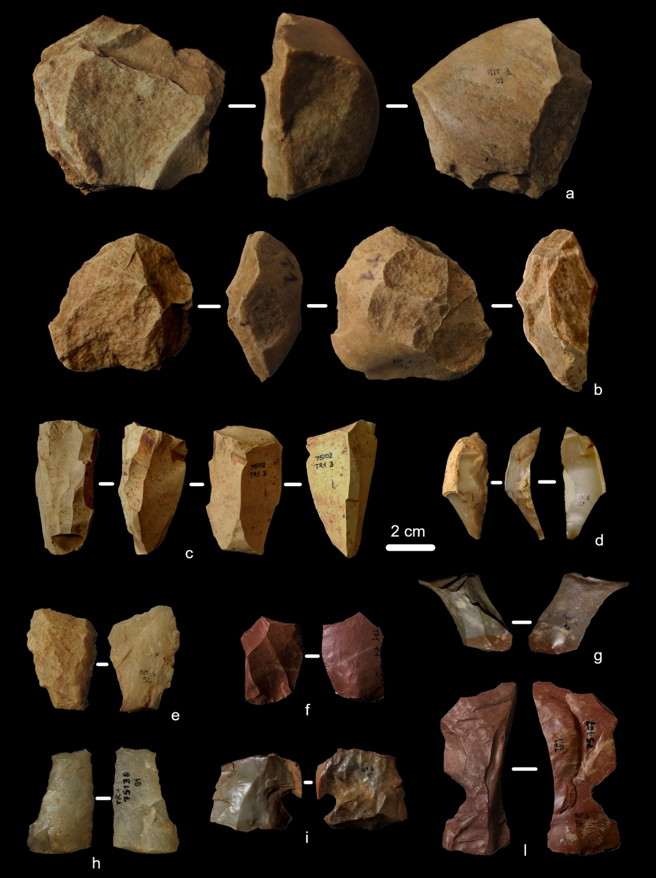
Figure 6 - Lithic artefacts from RIT 1: lineal Levallois cores (a, b); chert laminar core (c); Neolithic sickle element (d); Levallois flake (e); radiolarite recurrent centripetal Levallois flake (f); discoid flake (g); vein quartz sidescraper on opportunistic flake (h); chert and radiolarite notches (i, l)

RIT 2
The lithic assemblage collected in the area RIT 2 between 1974 and 1976 was composed by ten lithic implements which belonging to a Lower Palaeolithic frequentation was proposed at that time (GSQP, 1976). RIT 2 currently has 19 lithic artefacts with technological characteristic suggesting their belonging to different chronologies, but mainly to Middle Palaeolithic (13 flakes) (Fig. 7). The predominant raw material is vein quartz (15 artefacts) but also limestone (2 artefacts) and chert (2 artefacts) are attested (Table 3). No cores are present in this small assemblage (Table 1). One of the cherts implements, issued from a laminar is the only artefact from RIT 2 that could be referred to Upper Palaeolithic or to the Neolithic period. Vein quartz and limestone flakes are obtained through direct hard hammer percussion according to opportunistic, Levallois and discoid knapping strategies. The Levallois method is attested in the recurrent centripetal and in the lineal modalities; opportunistic flakes show unipolar negatives on the dorsal face (7 flakes) and natural or flat butts, thus suggesting the use of not prepared striking platforms and the exploitation of a natural convexity until its exhaustion. One vein quartz flake belongs to the shaping or management of a centripetal core. Six fragmented flakes are indetermined for what concerns the knapping method. A vein quartz convergent scraper issued from an opportunistic reduction strategy is attested (Fig. 7).

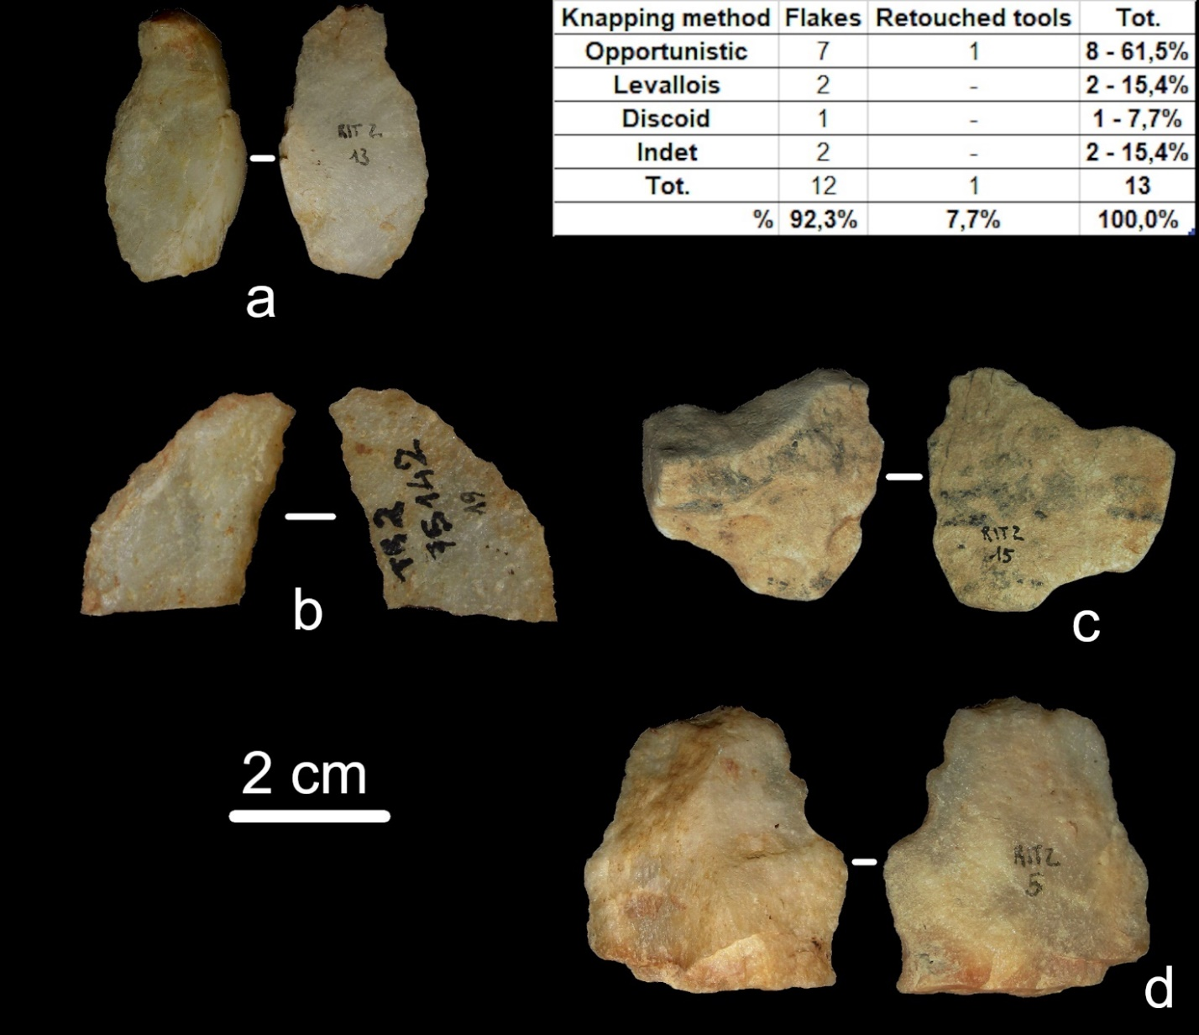
Figure 7 - Lithic artefacts from RIT 2: opportunistic flakes with unipolar knapping scars on the dorsal face (a, d); limestone preferential Levallois flake strongly affected by roundings (c); convergent scraper (b). On the top right: Middle Palaeolithic flakes from RIT 2 grouped by knapping method

RIT 3
Following the surface collection carried out in the last thirty years, the lithic assemblage of RIT 3 has expanded, reaching 137 finds (Table 1) realized on different rocks: vein quartz, radiolarite, chert and limestone (Table 3). The main group of lithic implements (125) belongs to Middle Palaeolithic (Table 5), while the presence of two products issued from laminar reduction sequences suggest a frequentation of this area in most recent times (i.e., Upper Palaeolithic or Neolithic).

Table 5 - RIT 3 Middle Palaeolithic assemblage
Knapping method | Flakes | Cores | Core shaping/management | Retouched tools | Tot.
Opportunistic | 53 | 3 | - | 1 | 57 – 45.6%
Levallois | 24 | 4 | - | 1 | 29 – 23.2%
Discoid | 12 | 3 | - | - | 15 - 12,0%
Indet | 20 | - | 4 | - | 20 - 16%
Tot. | 109 | 10 | 4 | 2 | 125
% | 87.2% | 8.0% | 3.2% | 1.6% | 100%

Being the subdivision of the lithic artefact based upon technological criteria, some of the lithic implements form RIT 3 (i.e., debris and retouch flakes) have not been assigned to any phase of human frequentation of the Trino hill (10).
The Middle Palaeolithic assemblage includes opportunistic, Levallois and discoid flakes and cores (Fig. 8). The Levallois method is attested in the lineal and in the recurrent centripetal modalities by cores and flakes. For both the modalities, cores are realized on vein quartz pebbles with natural convexities already suitable for this kind of exploitation. Concerning the striking platforms, they correspond to the natural surface of the pebble or are prepared through a reduced number of detachments in a centripetal direction (Fig. 8). In the same way, the lateral and distal convexities on the flaking surface are prepared through a low number of centripetal or chordal removals. All the Levallois cores are discarded before their complete exhaustion. Levallois reduction sequences are applied also on radiolarite, limestone and chert. The presence of a chert flake with faceted butt, let us suppose that on this raw material Levallois reduction strategies involve careful preparation of the striking platforms.
Discoid cores are realized on vein quartz pebbles exploited according to a unifacial or a bifacial reduction strategy. The three discoid cores are exhausted, and their exploitation was aimed to the production of short and large flakes not standardized concerning their dimensions (Fig. 9). A radiolarite flake testifies the use of discoid reduction strategy on this rock. Opportunistic cores are just three, two on vein quartz pebbles and one on a chert polygonal block of small dimensions. All the cores were abandoned before their exhaustion and show the exploitation of two adjacent or opposite surfaces according to a unipolar direction (Fig. 8).

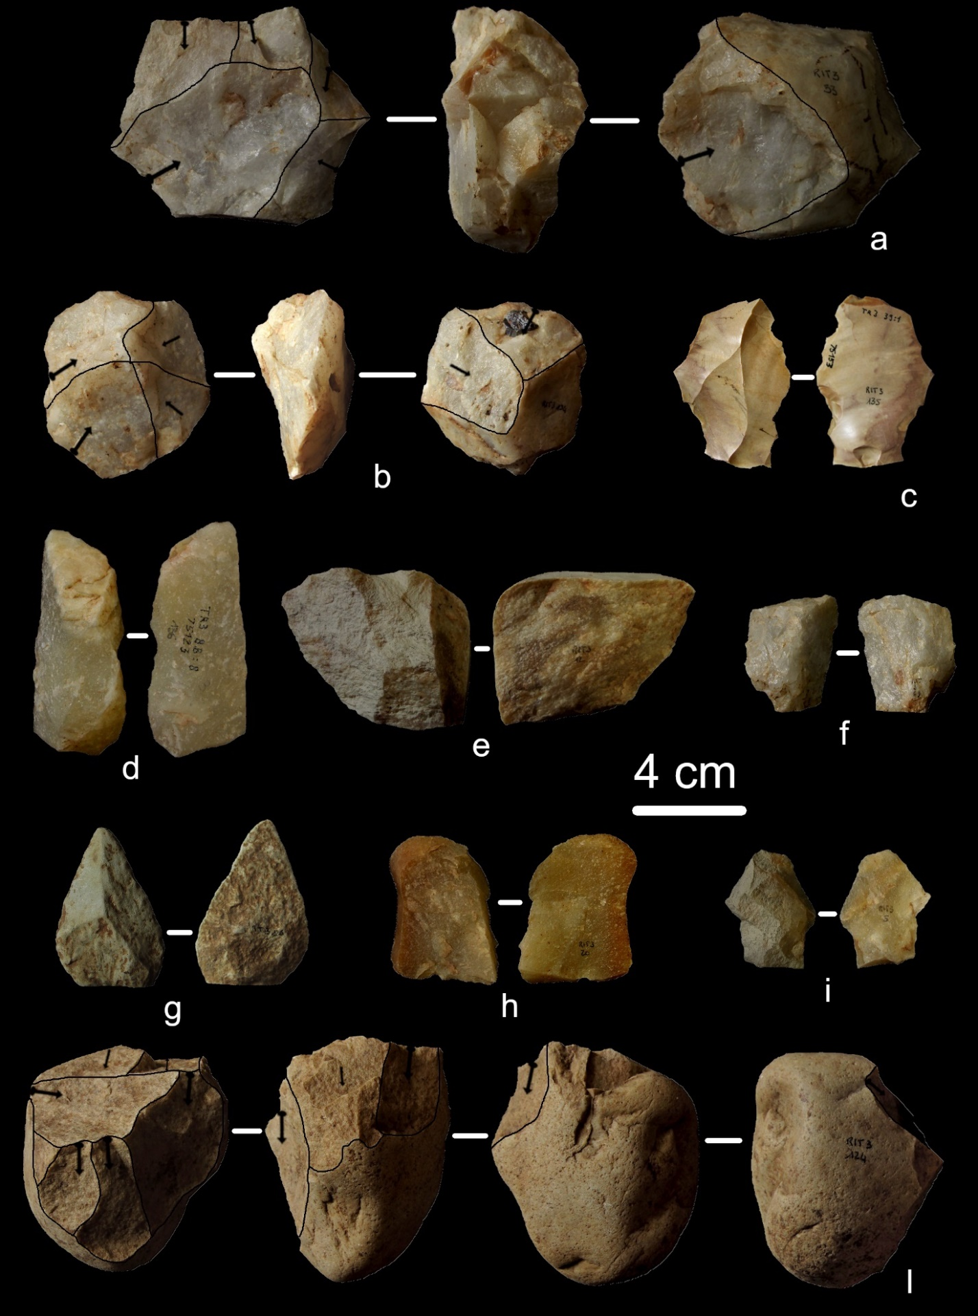

Figure 8 - Lithic artefacts from RIT 3: Levallois preferential core (a); discoid core (b); Levallois preferential flake on chert (c) and on limestone (g); sidescraper on opportunistic flake (d); discoid flake (e); opportunistic flakes (f, h); recurrent centripetal Levallois flake (i); opportunistic core on a vein quartz pebble (l)

Flakes from RIT 3 are mostly complete (57.4%) or present fractures affecting less than 30% of the flake (incomplete flakes – 19.1%) (Fig. 9). Cortical and neocortical surfaces are rarely visible on the dorsal faces of the flakes and usually are located on their lateral portion (lateral cortex = 10.4%; lateral and distal cortex = 6.1%; lateral and proximal cortex = 2.6%). The predominance of flat and natural butts confirms the data obtained from the observation of the cores: the production of opportunistic, discoid and Levallois flakes starts from the natural surfaces of the cores or after a short preparation of the striking platforms (Fig. 9). Unipolar, orthogonal and bipolar removals on the dorsal faces are exclusively associated to opportunistic reduction sequences as well as convergent negatives are associated to the preferential Levallois method. On the other hand, centripetal negatives belong to discoid or recurrent centripetal reduction strategies.
The dimensional analysis (Fig. 9) show that the discoid method is aimed to the production of short and large products while Levallois flakes, both preferential and recurrent centripetal, seem to be more elongated. Concerning opportunistic reduction strategies, they are not standardized in shapes and dimensions and, according to the characteristics of the cores, their morphology appears as strongly influenced by those of the pebbles chosen as cores.

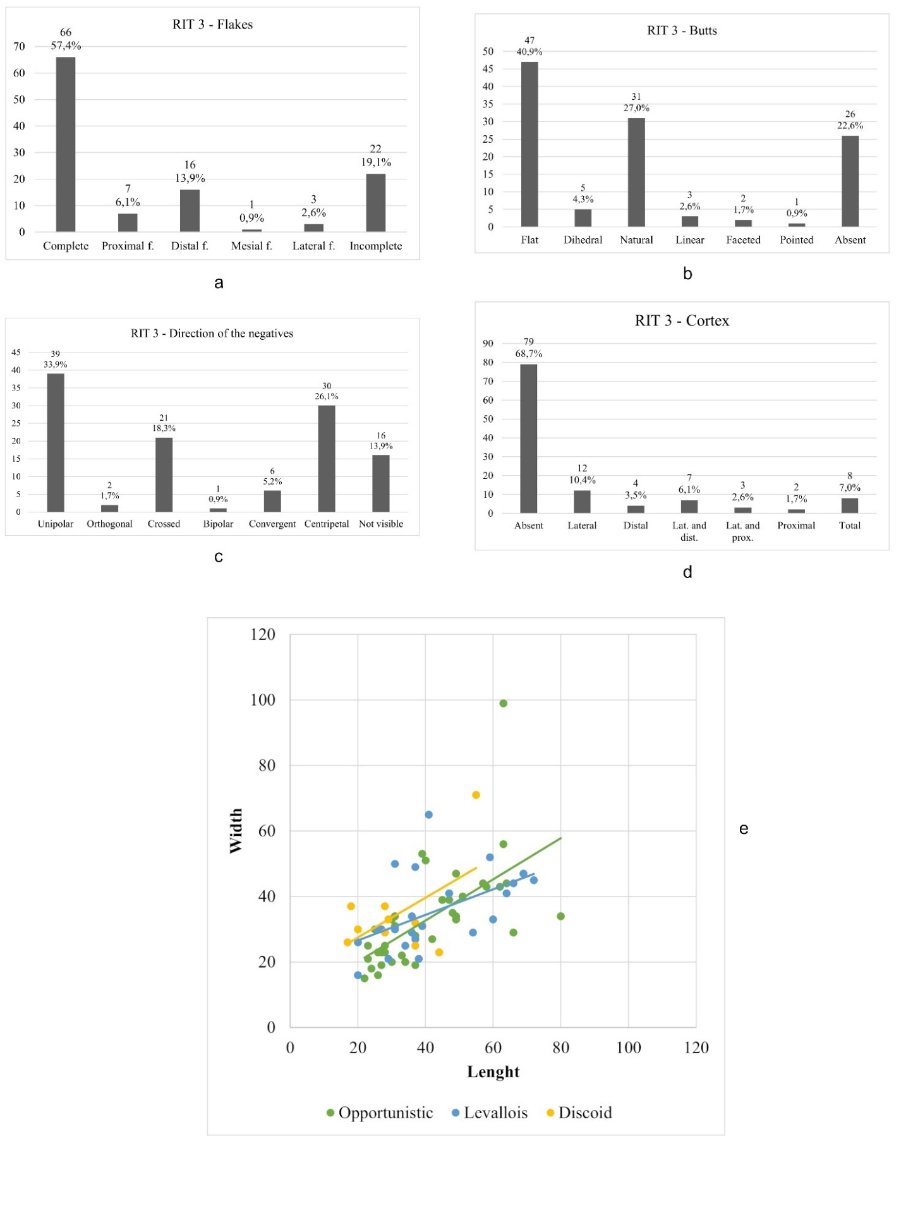
Figure 9 - Charts showing the main technological characteristics of the RIT 3 Middle Palaeolithic lithic assemblage. Flakes (a); butts typology (b); direction of the negatives on the dorsal faces (c); presence and position of cortical and neocortical surfaces on the dorsal faces (d); dimensional analysis of complete and incomplete flakes grouped by knapping method (e)

RIT 4
According to the work published in 1976 (GSQP, 1976), RIT 4 lithic assemblage counts 10 artefacts. At today, just one of them is present at Museo Civico G. Irico. It is a vein quartz core exploited till exhaustion of the convexities through direct percussion by hard hammer (Fig. 10). The striking platform is natural (neocortical surface), and four detachments are visible on the knapping surface: one belonging to a rough phase of core shaping, three to a production phase. The general core geometry and the standardization of the three detachments on the knapping surface, let us suppose that this core belongs to a laminar debitage which attribution is uncertain.

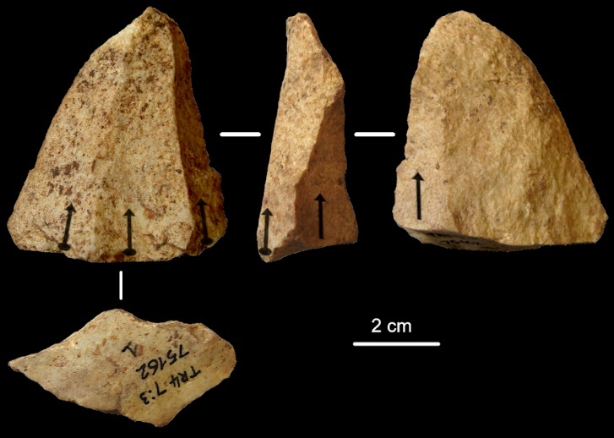
Figure 10 - Vein quartz laminar core with natural striking platform from RIT 4

RIT 7
Four flakes, one blade and one debris form the lithic assemblage from RIT 7. The raw materials here attested are vein quartz, radiolarite, chert and an indetermined rock (Table 3). Flakes are issued from Levallois (1), discoid (1) and opportunistic (2) reduction strategies through direct percussion by hard hammer and are realistically referable to Middle Palaeolithic (Fig. 11). Levallois is attested in the preferential modality; opportunistic flakes have unipolar knapping scars on the dorsal faces and natural or flat butts.
The blade is fragmented, and it is not possible to determine the knapping technique: in the absence of clear diagnostic elements, it is not possible to make hypothesis about its chronology (Fig. 11).

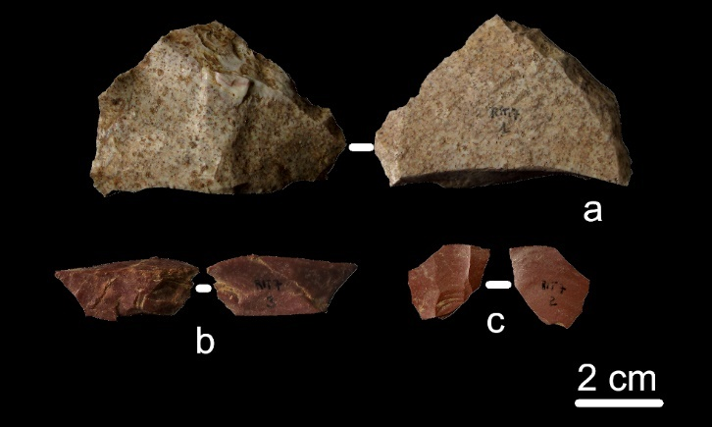
Figure 11 - Lithic artefacts from RIT 7: distal fragment of a Levallois preferential flake (a); radiolarite discoid flake (b); fragmented radiolarite blade (c)

RIT 8
The lithic assemblage from RIT 8 is composed by 12 flakes (Table 1) realized on vein quartz (10), limestone (1) and chert (1) (Table 3). Limestone and chert flakes have strong post depositional alterations, roundings and white patina respectively (Table 2), that prevent their technological understanding. On the other hand, the vein quartz assemblage is less affected by post depositional alterations and its technological features suggest an attribution to Middle Palaeolithic. Preferential Levallois, discoid and opportunistic reduction strategies are attested (Fig. 12). The presence of orthogonal and crossed negatives on the dorsal faces of opportunistic flakes indicates that these reduction strategies develop through the exploitation of different core surfaces, probably according to an S.S.D.A. knapping sequence. Negatives on the dorsal face are not visible for three vein quartz flakes which remain indeterminate for what concern the knapping method.

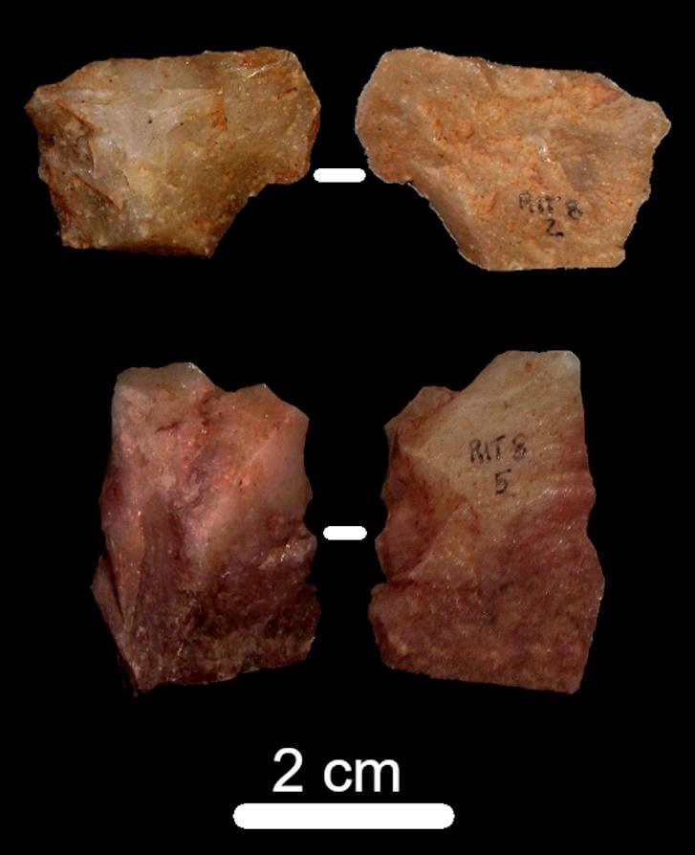

Figure 12 - Vein quartz flakes from RIT 8: discoid flake (top) and opportunistic flake with crossed negatives on the dorsal face (bottom)

RIT 10
From the collection area RIT 10 just a vein quartz core is attested (Fig. 13). It is a large core on pebble where a natural (i.e., neocortical) surface has been used as striking platform. The technique employed is direct percussion by hard hammer and the products obtained are medium-sized flakes not standardized regarding shape and dimensions. The core was discarded before its exhaustion. A chronological attribution of this core, in the absence of clear stratigraphic data, is quite difficult.
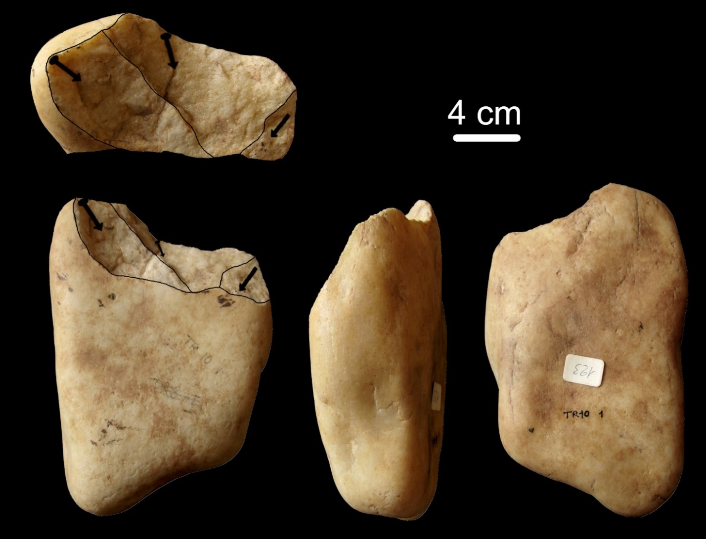
Figure 13 - Vein quartz opportunistic core from RIT 10

RIT 13 East
The lithic assemblage from RIT 13 East counts 122 lithic artefacts (Table 1) mainly realized on vein quartz (75) but also on radiolarite (16), limestone (2) and chert (29) (Table 3). Opportunistic, Levallois, discoid and laminar knapping methods are attested by cores, flakes and blades, mainly obtained through direct percussion with hard or soft hammer and through indirect percussion. Due to post depositional alterations or to the fragmentation of the lithic implements, the technique cannot be identified for 29 artefacts. The Middle Palaeolithic assemblage is composed by 83 lithic implements (Table 6), of which 71 are made on vein quartz, 2 on limestone, 8 on radiolarite and 2 on chert. Opportunistic, Levallois and discoid knapping sequences are attested by cores and flakes and three retouched tools are present (2 sidescrapers and 1 notch).

Table 6 - RIT 13 East Middle Palaeolithic assemblage
Knapping method | Flakes | Cores | Core shaping/management | Retouched tools | Tot.
Opportunistic | 48 | 6 | - | 1 | 55 – 66.3%
Levallois | 6 | 1 | 2 | 2 | 11 – 13.3%
Discoid | 4 | 2 | - | - | 6 – 7.2%
Indet | 9 | - | 2 | - | 11 – 13.3%
Tot. | 67 | 9 | 4 | 3 | 83
% | 80.7% | 10.8% | 4.8% | 3.6% | 100%

The Levallois method is attested in the lineal and in the recurrent centripetal modalities. The only Levallois core identified belongs to the recurrent centripetal modality and it is realized on a vein quartz pebble (Fig. 14). The striking platform is still in part natural because it is prepared through big centripetal removals only in correspondence of the impact points. Discoid cores show the development of the exploitation according to a bifacial modality to produce short, quadrangular flakes mainly through centripetal detachments (Fig. 14). The opportunistic cores (2 on limestone and 4 on vein quartz pebbles) show the preferential unipolar or multidirectional exploitation of one core surface until the exhaustion of the natural convexity (Fig. 14). Once the convexity is exhausted, the core is discarded. Just one core has three adjacent striking platforms with a debitage that develops according to an S.S.D.A. scheme.
Debitage products are mostly complete (70.3%) and fractures, when present, usually affect less than 30% of the flake (incomplete flakes: 16.2%) (Fig. 15). Just 55.4% of the flakes do not have cortex or neocortex on the dorsal face: it means that, regardless the knapping method, the production starts directly from the natural core surfaces. According to what is observed on the opportunistic cores, the significative proportion of lateral cortex and neocortex (lateral = 21.6%; lateral and distal = 5.4%), the predominance of unipolar negatives on the dorsal faces (45.9%) and the frequency of natural and flat butts (41.9% and 40.5% respectively) suggests that the knapping sequences started from the natural surfaces of the cores and they preferably followed a unipolar direction.
Orthogonal negatives (2.7%) are linked to a multidirectional opportunistic core exploitation, while crossed negatives (25.7%) were identified both on opportunistic products and on flakes belonging to the shaping of Levallois cores (Fig. 15).
The dimensional analysis (Fig. 15) shows that no clear differences are visible concerning the dimensions of the products issued from the different Middle Palaeolithic knapping sequences.
The use of vein quartz is attested for the most recent phases of site frequentation (Upper Palaeolithic/Neolithic) by three laminar cores exploited through direct hard hammer percussion. Even for the laminar method, the production of blades starts from natural striking platforms and vein quartz pebbles with suitable morphologies are chosen as cores. Core shaping is quite rough and obtained through a reduced number of detachments, while for the management of the core convexities sometimes a second striking platform, opposite to the first one, is exploited (Fig. 14).
Laminar production on chert and radiolarite is attested by one core and 13 products (Fig. 14). Of them, just two belong to the phase of plein debitage, while 11 are maintenance flakes. According to the characteristics of the butts and of the ventral faces, the main technique employed for the laminar production is direct percussion with soft hammer. In the absence of further diagnostic data their chronology remains uncertain, and they could be referred to phases of frequentation going from Upper Palaeolithic to Neolithic. Two laminar products are retouched (1 notch and one point). A sickle element and two incomplete blades obtained through indirect percussion belong to the Neolithic period (Fig. 14).

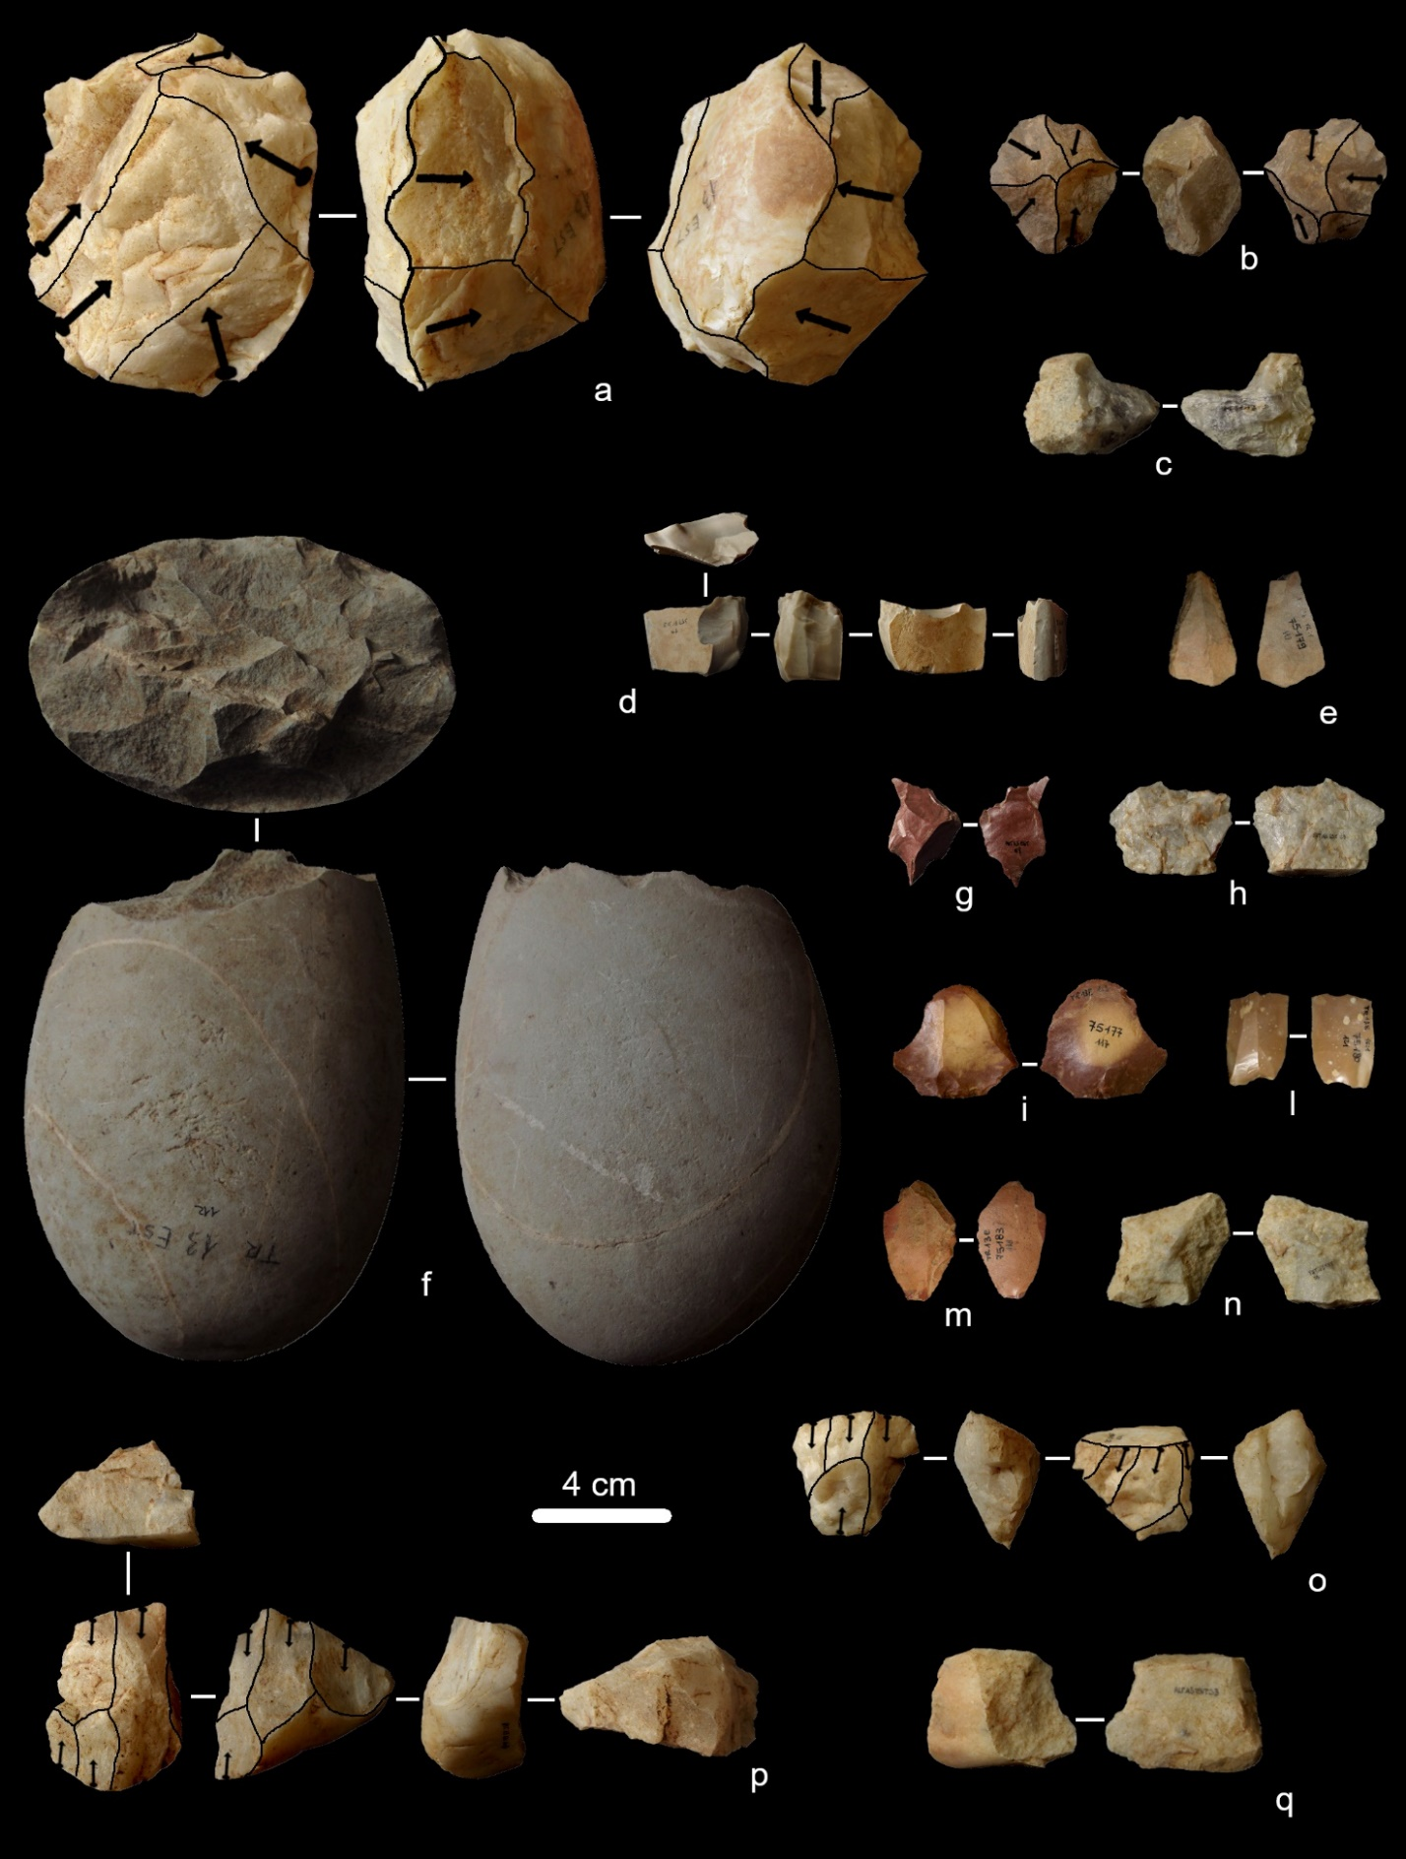

Figure 14 - Vein quartz and chert artefacts from RIT 13 East. Recurrent centripetal Levallois core (a); vein quartz discoid core (b); notch on an opportunistic vein quartz flake (c); chert laminar core (d); radiolarite blade with abrupt, short retouch on both edges (e); opportunistic core on a big limestone pebble, removals mainly follow a centripetal direction (f); radiolarite and vein quartz discoid flakes (g, n); recurrent centripetal Levallois flake (h); radiolarite sidescrapers on recurrent centripetal Levallois flakes (i, m); sickle element (l); vein quartz opportunistic core (o); vein quartz laminar core (p); opportunistic flake with lateral neocortical surface (q)

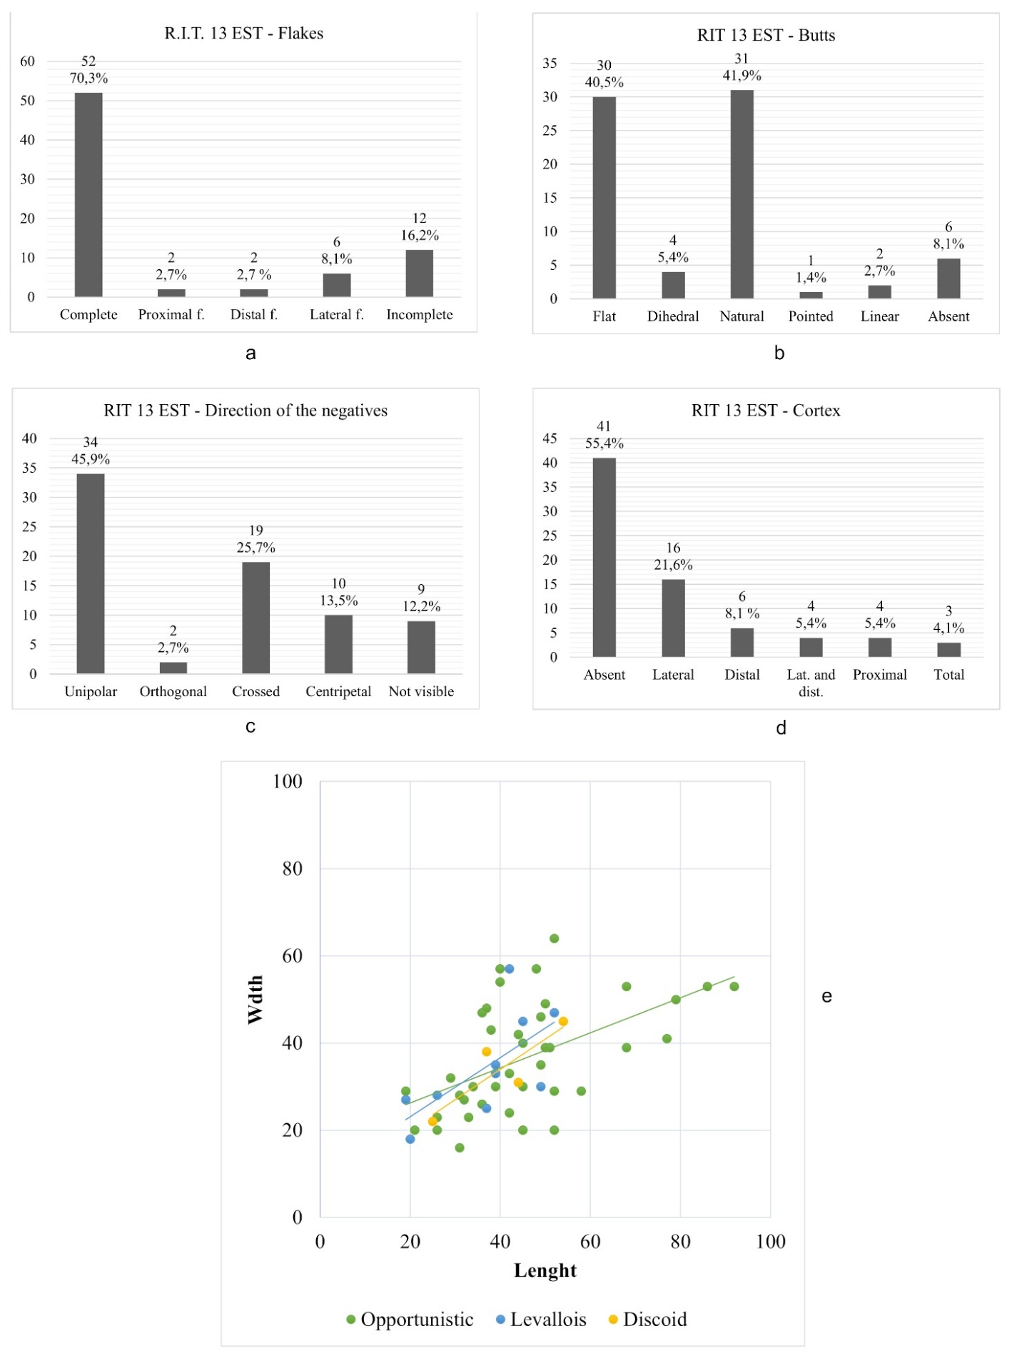
Figure 15 - Charts showing the main technological characteristics of the RIT 13 E Middle Palaeolithic lithic assemblage. Flakes (a); butts typology (b); direction of the negatives on the dorsal faces (c); presence and position of cortical and neocortical surfaces on the dorsal faces (d); dimensional analysis of complete and incomplete flakes grouped by knapping method (e)

RIT 13 West
RIT 13 West counts 121 lithic implements (Table 1) of which 117 are made on vein quartz, 3 on chert and 1 on an indeterminate rock (Table 3). Opportunistic, Levallois, discoid and laminar reduction strategies are attested by a considerable number of cores (13) and knapping products (107) while just two retouched tools (denticulates) have been identified (Table 1). The main knapping technique attested is direct percussion by hard hammer.
The three chert products are issued from a direct percussion by soft hammer and are a blade, a core-management flake, and a retouch flake. Together with a vein quartz blade, these lithic artefacts could be referred the Upper Palaeolithic or to the Neolithic period. Due to fractures or post-depositional alterations, the technique remains indeterminate for four vein quartz flakes. According to their technological features, 115 flakes and cores can be placed in the Middle Palaeolithic assemblage of the Trino hill (Table 7).

Table 7 - RIT 13 West Middle Palaeolithic assemblage
Knapping method | Flakes | Cores | Core shaping/management | Retouched tools | Tot.
Opportunistic | 67 | 5 | - | 2 | 74 – 64.3%
Levallois | 14 | 4 | - | - | 18 – 15.7%
Discoid | 5 | 4 | - | - | 9 – 7.8%
Indet | 13 | - | 1 | - | 14 – 12.2%
Tot. | 99 | 13 | 1 | 2 | 115
% | 86.1% | 11.3% | 0.9% | 1.7% | 100%

The Levallois method is attested in the recurrent centripetal and in the lineal modalities and it is represented by 4 cores (2 lineal and 2 recurrent centripetal) and 14 flakes (8 lineal and 6 recurrent centripetal). The cores area realized on vein quartz pebbles and for all the modalities the production of predetermined flakes starts after a short phase of core shaping, realized through 4 or 5 detachments. In a case, the striking platform is natural (i.e., neocortical surface) (Fig. 16). Discoid cores show a bifacial (3) and a unifacial (1) exploitation (Fig. 16). Three of them are exploited until complete exhaustion and for all the modalities the discoid exploitation starts directly from the natural surfaces of the vein quartz pebbles. The wanted products are short and large flakes of small dimensions for discoid reduction strategies, and elongated flakes for the Levallois debitage (Fig. 17). The opportunistic method is aimed to the production of flakes of various shapes and dimensions, which general morphology depend on the characteristics of the cores (Fig. 17), that are pebbles or polygonal block of medium dimension. Three of the cores have one striking platform exploited according to a unipolar direction, one core has two orthogonal striking platforms and one show a bipolar exploitation with two opposite striking platforms. Two opportunistic flakes show a modification of the edges and can be classified as denticulates (Fig. 16).
57.8% of the debitage products is complete, while 23.5 % presents fractures affecting less than 30% of the lithic artefact (incomplete flakes) (Fig. 17). Most of the flakes do not have cortex or neocortex on the dorsal face (69.6%); when present, natural surfaces are mainly on the lateral portion of the dorsal face (lateral = 17.6%; lateral and distal = 1%) (Fig. 17).

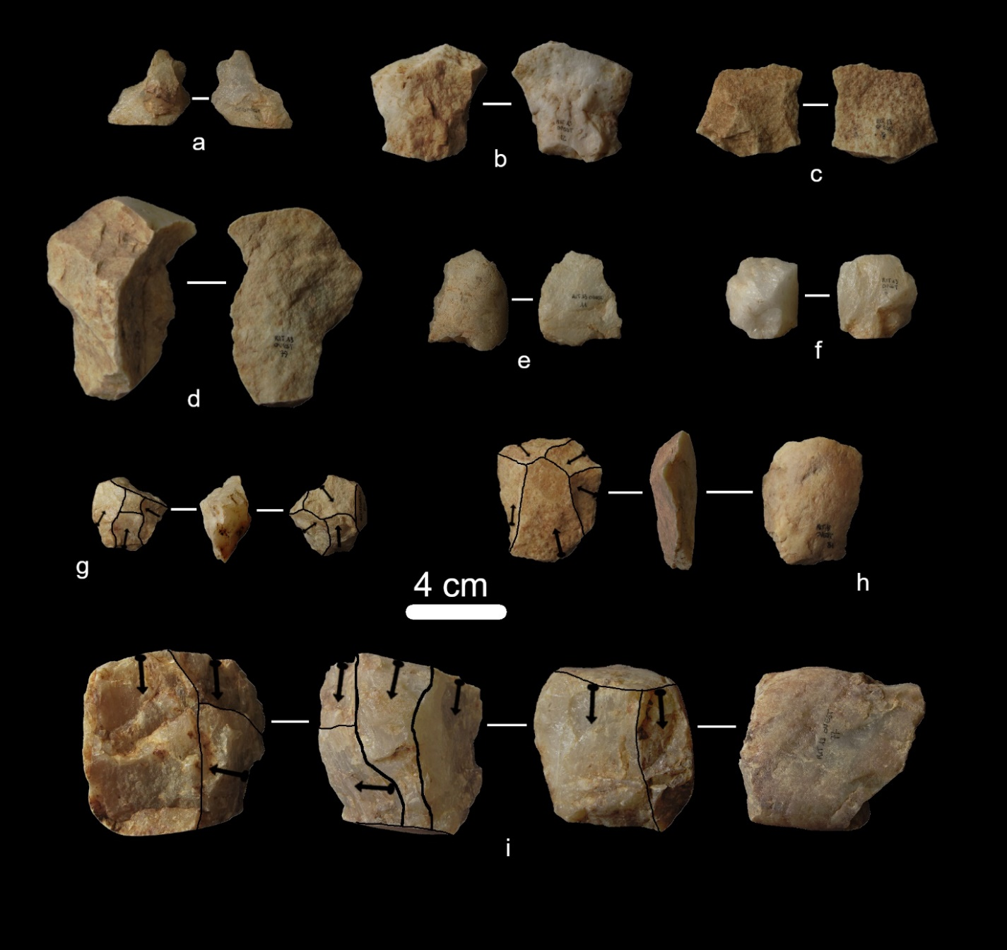

Figure 16 - Lithic artefacts from RIT 13 W. Denticulates on opportunistic flakes (a, e); Levallois preferential flake (b); Levallois recurrent centripetal flake (c); opportunistic flake (d); discoid flake (f); bifacial discoid core (g); preferential Levallois core (h); opportunistic core (i)

Concerning opportunistic reduction sequences, this characteristic, together with the predominance of flat (44.1%) and natural (27.5%) butts and of unipolar negatives on the dorsal faces (47.1%) confirms that generally the exploitation starts from core surfaces naturally suitable for knapping activities or after the detachment of a big flake to open a striking platform. The exploitation usually develops according to a unipolar direction even if the presence of a flake with orthogonal negatives and of two flakes with bipolar negatives confirms that, as already observed on cores, also this kind of reduction strategies were employed. Crossed negatives are also present on opportunistic flakes (16.7%) and testify the implementation of multidirectional knapping sequences (Fig. 17). Centripetal (16.7%) and convergent (2.9%) negatives are exclusively linked to Levallois and discoid products. The dimensional analysis shows no clear differences among the products issued from the different Middle Palaeolithic knapping sequences (Fig. 17). As already highlight for the RIT 13 East lithic assemblage, it is likely to hypothesize that the dimensions of the products mostly depend on those of the pebbles or polygonal blocks selected to be core. A chronological placing is not possible for a vein quartz debris and for a vein quartz flake.

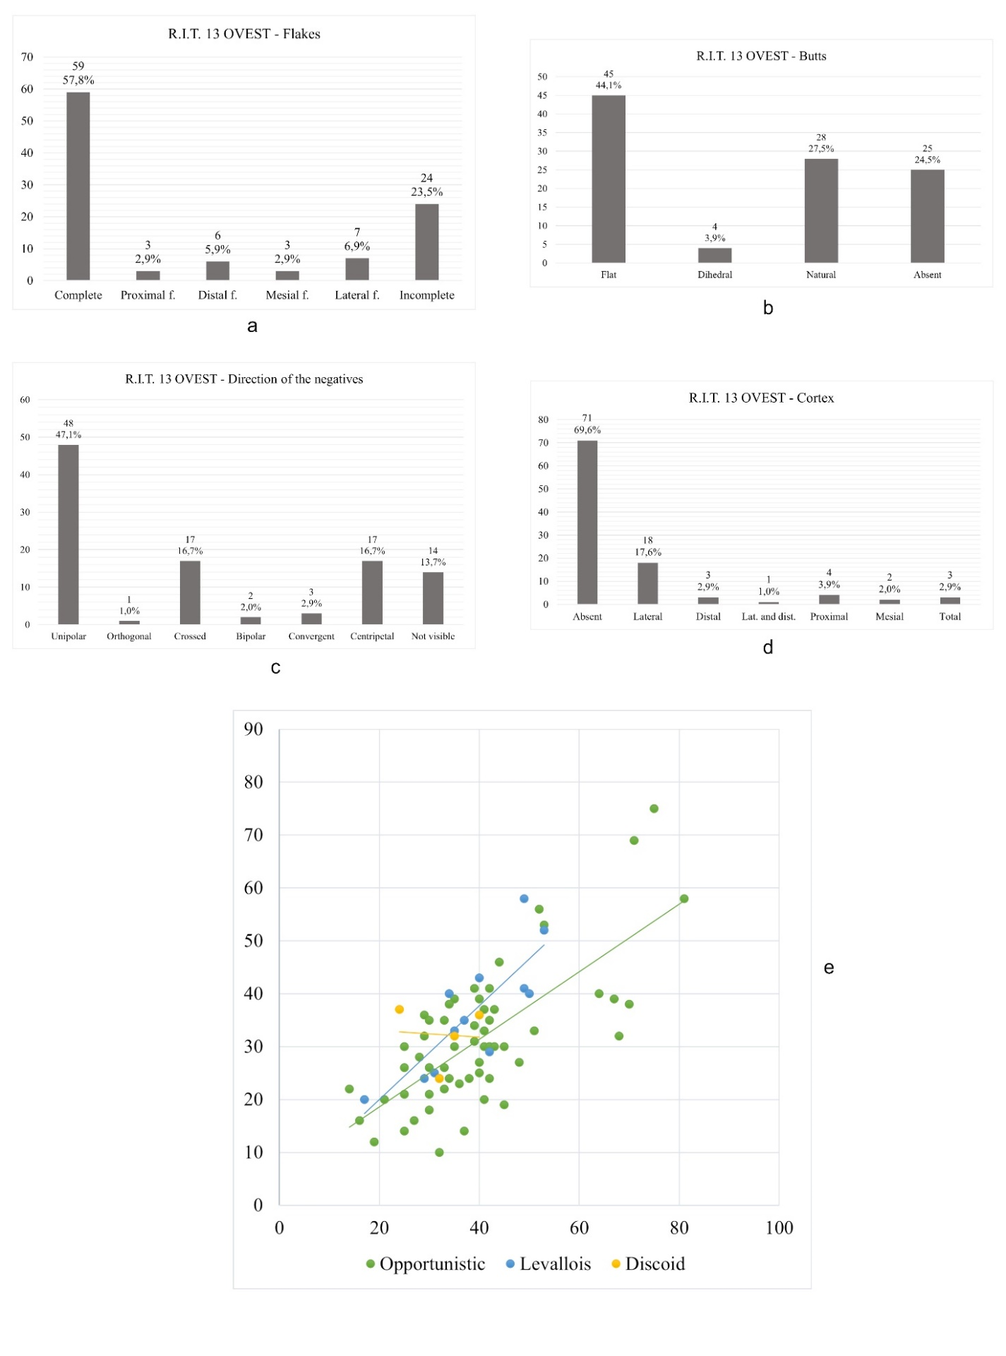
Figure 17 - Charts showing the main technological characteristics of the RIT 13 W Middle Palaeolithic lithic assemblage. Flakes (a); butts typology (b); direction of the negatives on the dorsal faces (c); presence and position of cortical and neocortical surfaces on the dorsal faces (d); dimensional analysis of complete and incomplete flakes grouped by knapping method (e)

RIT 14
Collection area 14 is in the northern part of the Trino hill (Fig. 2 C). From this area come the most important lithic assemblage, composed by a total of 1320 lithic implements. The technological analysis allows to clearly distinguish a Middle Palaeolithic assemblage including 962 artefacts (Table 8). The main raw material is vein quartz (925 artefacts) but also radiolarite (16 artefacts), chert (14 artefacts) and other rocks (11 artefacts) are attested (Table 3). 155 lithic implements are issued from laminar knapping sequences: 30 of them likely belong to the Neolithic frequentation of the area, and are cores, blades and retouched tools (3 sickle elements and a notch) obtained through pressure or indirect percussion. Even if an Upper Palaeolithic collocation can be proposed, on a typological basis, for 15 retouched tools, all the other laminar elements do not present technological characteristics that allow to clearly refer them to a certain period. This group is formed by 58 core management flakes obtained through direct percussion by hard or soft hammer, 42 unretouched blades obtained through direct percussion by soft hammer or with indeterminate knapping technique and 10 laminar cores exploited through direct percussion. Neolithic, Upper Palaeolithic and laminar implements with uncertain chronology are realized mainly on chert and radiolarite (144 artefacts), to a lesser extent on vein quartz and other rocks (11 artefacts). Chronology remains uncertain for debris, retouch flakes and for flakes affected by post-depositional alterations that prevent their technological reading.

Table 8 - RIT 14 Middle Palaeolithic assemblage
Knapping method | Flakes | Cores | Core shaping/management | Retouched tools | Tot.
Opportunistic | 492 | 16 | 2 | 13 | 523 – 54.4%
Levallois | 149 | 14 | 12 | 3 | 178 – 18.5%
Discoid | 59 | 12 | - | 1 | 72 – 7.5%
Indet | 140 | 3 | 43 | 3 | 189 – 19.6%
Tot. | 840 | 45 | 57 | 20 | 962
% | 87.3% | 4.7% | 5.9% | 2.1% | 100%

In the Middle Palaeolithic assemblage, opportunistic, Levallois and discoid knapping sequences are well attested by cores and flakes. Retouched tools are quite rare and are represented by sidescrapers (7), convergent scrapers (2), a double scraper, a transversal scraper, a Mousterian point, notches (3) and denticulates (5). Recurrent centripetal and preferential Levallois reduction sequences are documented by 13 cores, mainly realized on vein quartz pebbles and with a neocortical striking platform (Fig. 18). The shaping of the convexities on the knapping surface consists in a reduced number of removals in a centripetal or chordal direction. Two preferential Levallois cores are on chert and present a prepared striking platform. Despite the raw material, cores are discarded before their exhaustion, thus avoiding the re-shaping of the core surfaces. One vein quartz core belongs to a recurrent unipolar Levallois knapping sequence and the production of predetermined flakes is preceded by a careful preparation of the core surfaces.
The discoid method is applied on vein quartz, radiolarite and chert pebbles to produce short, quadrangular flakes (Fig. 18). Both the bifacial and the unifacial modalities are present: in the unifacial modality the striking platform mostly correspond to a neocortical surface. The discoid flakes show a predominance of flat (35) and natural (8) butts, thus confirming that the cores were usually not prepared before the beginning of the discoid production. The removals visible on the cores indicates that most of the discoid production is completed through centripetal removals, with no regards for the management of the core convexities. Discoid cores are indeed discarded after short production phases.
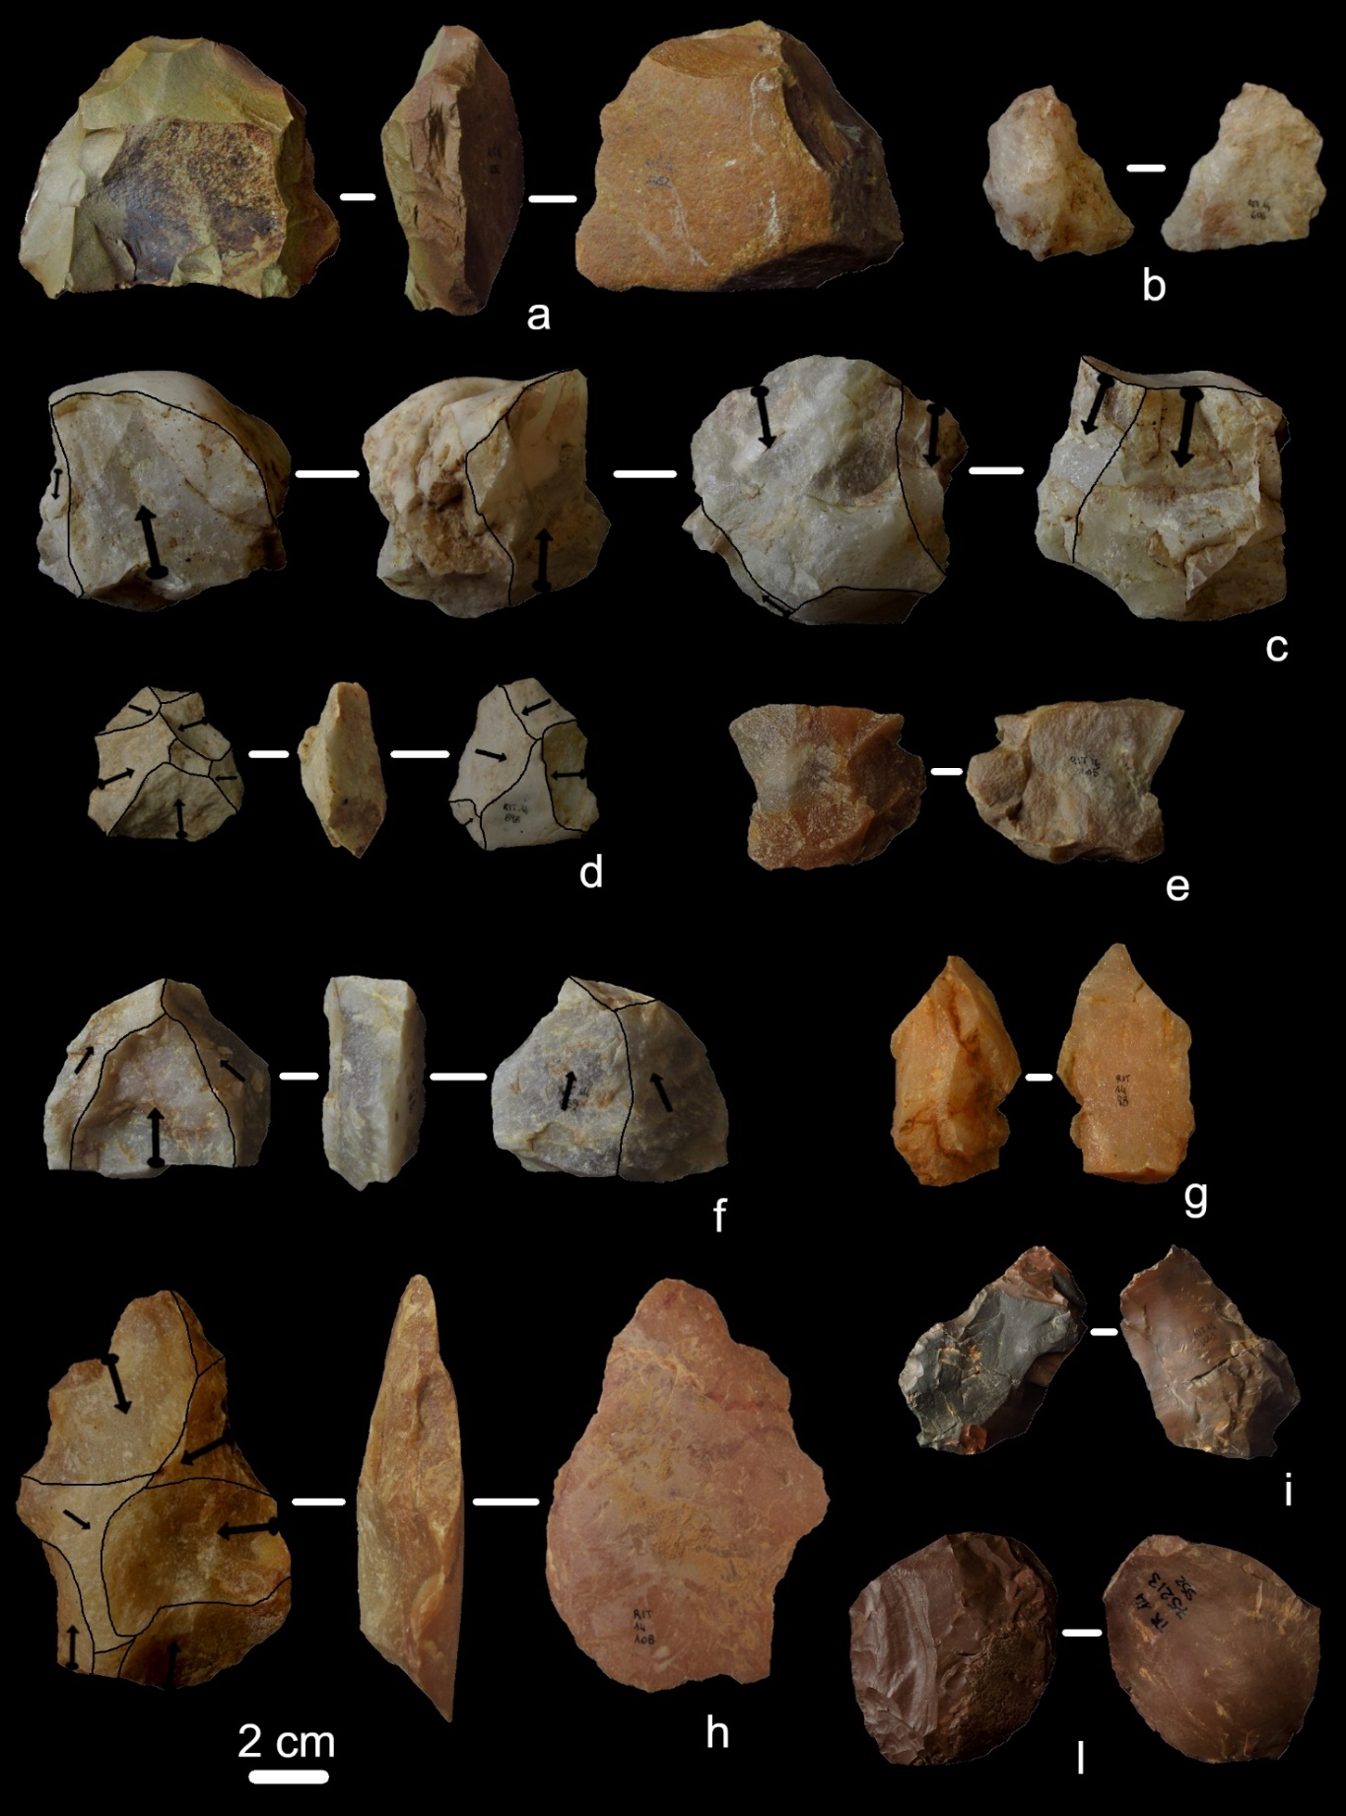
Figure 18 - Middle Palaeolithic lithic artefacts from the RIT 14 area. Preferential Levallois core on chert (a); discoid flake (b); opportunistic core on a vein quartz pebble (c); bifacial discoid core (d); preferential Levallois flake (e); preferential Levallois core on vein quartz (f); opportunistic flake with unipolar removals on the dorsal face and lateral neocortical surface (g); recurrent centripetal Levallois core (h); jasper (i) and radiolarite (l) sidescrapers on opportunistic flakes, the jasper flake was glued by the discoverers to fix a post-depositional fracture

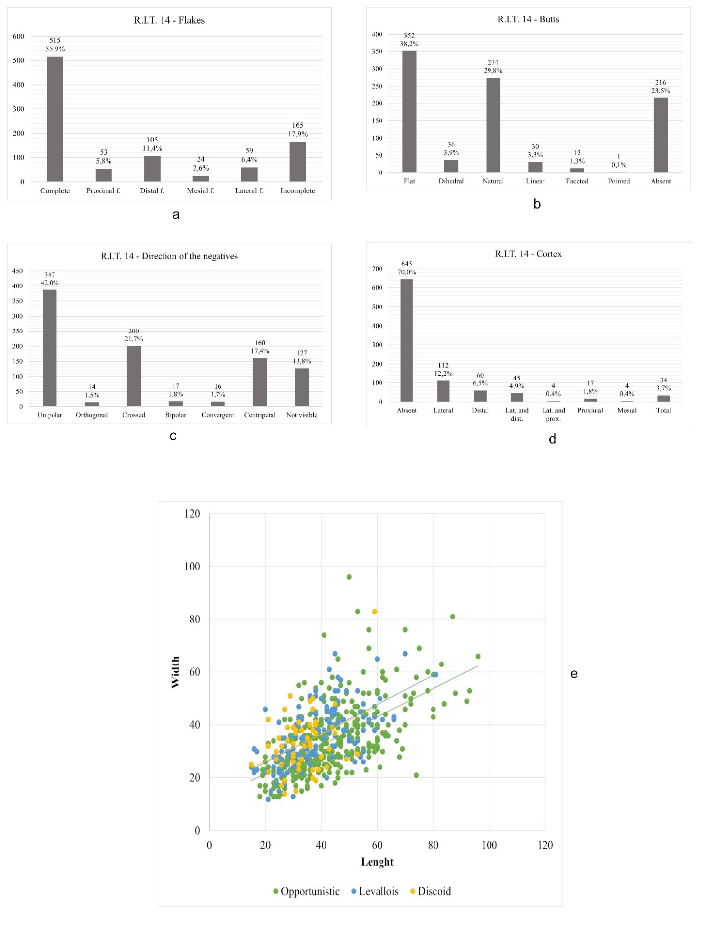
Figure 19 - Charts showing the main technological characteristics of the RIT 14 Middle Palaeolithic lithic assemblage. Flakes (a); butts typology (b); direction of the negatives on the dorsal faces (c); presence and position of cortical and neocortical surfaces on the dorsal faces (d); dimensional analysis of complete and incomplete flakes grouped by knapping method (e)

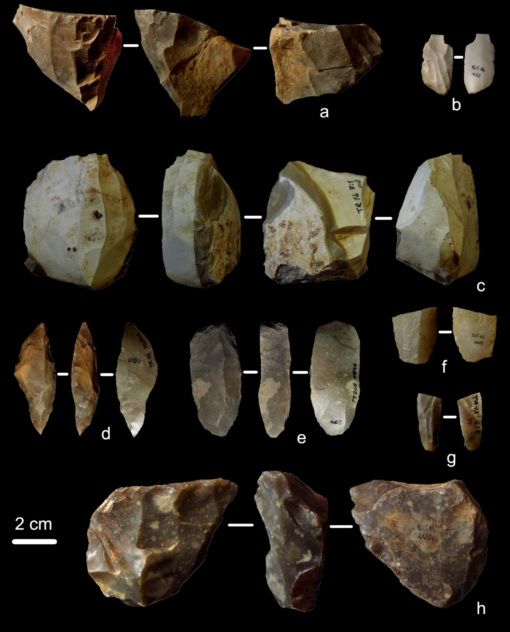
Figure 20 - Laminar debitage from RIT 14. Laminar cores on chert (a, c, h); core management flake obtained through direct percussion by soft hammer (b); point on chert laminar blank (d); end scraper (e); vein quartz blade obtained through pressure technique (f); chert bladelet obtained through indirect percussion (g)

Opportunistic reduction sequences are represented by 16 cores and 507 flakes. Cores are all realized on vein quartz pebbles or polygonal blocks. The exploitation often consists in the knapping of one surface in correspondence of a suitable convexity and according to a unipolar direction. One core shows a bipolar exploitation (Fig. 18) while 6 cores are exploited according to an S.S.D.A. scheme. As well as for Levallois and discoid knapping sequences, for this method, cores are discarded after short production phases. The flakes obtained have mainly unipolar negatives on the dorsal face and their dimensional characteristics are determined by the morphology and dimensions of the cores (Fig. 18). Two flakes represent the opening of a striking platform by removing a spherical cap from vein quartz pebbles. They present a neocortical dorsal face and are probably linked to the beginning of an opportunistic exploitation.
Regardless the knapping method, flakes are mostly complete (55.9%), while a significative proportion (17.9%) has fractures affecting less than 30% of the artefact (Fig. 19). Lateral fragments are often linked to siret accidents occurred during knapping activities. Cortical or neocortical surfaces are present on about a third of the considered flakes, and mostly on the lateral part (Fig. 19). The predominance of unipolar negatives on the dorsal faces of the flakes (exclusively associated to opportunistic flakes) and of flat and natural butts confirms what has been observed on the cores: regardless the knapping method, the exploitation starts from surfaces already present on the cores; opportunistic reduction strategies are aimed to a unipolar exploitation of one of the core convexities.
Neolithic laminar cores are realized on chert and radiolarite slabs (Fig. 20): they are exploited through pressure to produce bladelets. Four cores have one striking platform exploited for different phases of bladelets production. Laminar cores exploited through direct percussion by hard and soft hammer are realized on the same raw materials, but their chronology remains indeterminate. They usually have one striking platform, but in four cases a second and opposite striking platform is opened, probably to control the core convexity. The products obtained are blade and bladelets and the blanks chosen as cores are small pebbles or slabs (Fig. 20).
Concerning the Middle Palaeolithic assemblage, the reduction sequences are complete, with all the phases of lithic production represented in the archaeological record; concerning the laminar method, cores and core-shaping/management flakes are well represented in the assemblage, while blades and retouched tools are scarce. This data let us suppose that the knapping activities took place in the area for all the phases of human frequentation, but during Middle Palaeolithic the lithic artefacts were produced, used and discarded in the site, while during the following periods part of the lithic production was probably transported out of the area of the Trino hill.

RIT 15
The lithic assemblage from RIT 15 is composed by thirteen vein quartz lithic implements (Tables 1 and 3) that from the technological point of view can be referred to Middle Palaeolithic. The scars on flakes and cores indicates that the only technique employed is freehand hard hammer percussion. Recurrent centripetal Levallois is documented by one core and one flake. The core does not show phases of core configuration and it is exhausted (Fig 21). The wanted products are oval, medium-sized flakes. The presence of preferential Levallois knapping strategies is confirmed by one flake. Seven flakes belong to opportunistic reduction sequences: butts are flat or natural while the knapping scars on the dorsal faces are always unipolar (Fig. 21). It is likely to suppose that the opportunistic exploitation starts directly from the natural surfaces of the core and develops until the exhaustion of the convexity. After a short production phase cores were probably abandoned. Two lithic implements are indetermined concerning the knapping method.
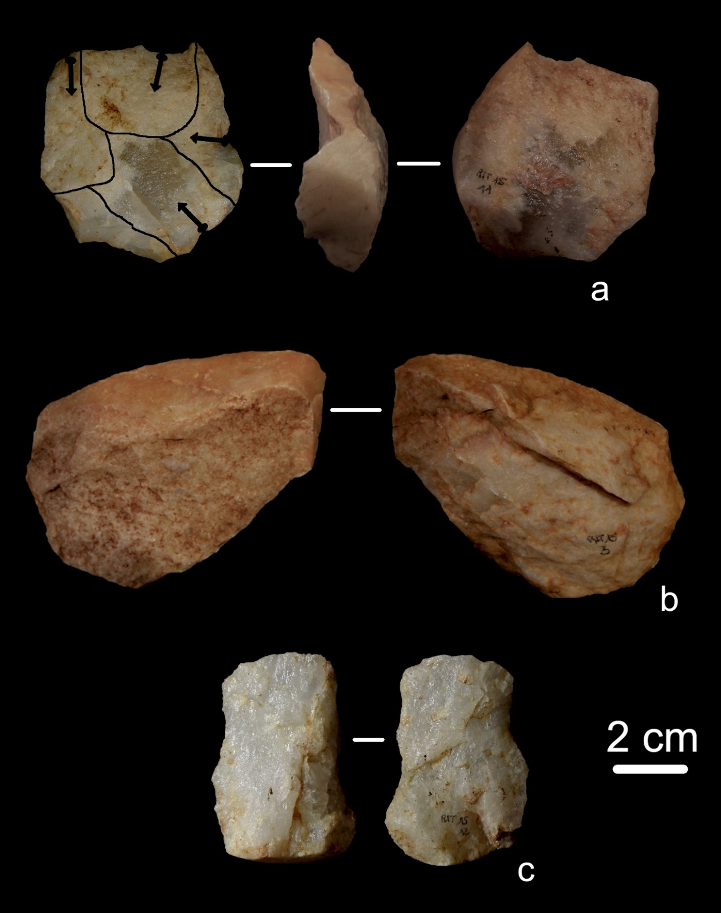
Figure 21 - Vein quartz lithic artefacts from RIT 15. Recurrent centripetal Levallois core (a); Opportunistic flakes (b, c)

RIT 16
A small lithic assemblage comes from collection area RIT 16, and it is composed by seven lithic artefacts (Tables. 1 and 3) issued from the exploitation of radiolarite, jasper and chert according to opportunistic, Levallois and laminar reduction strategies (Fig. 22); one radiolarite flake, affected by thermal alteration, is indetermined concerning the knapping method (Fig. 22), while one of the artefacts is a debris strongly affected by roundings. The Levallois method is present in the preferential modality with one chert flake with faceted butt and it is referred to Middle Palaeolithic. The laminar component of this small assemblage shows characteristics consistent with an exploitation of chert and radiolarite through direct percussion by soft hammer. Only one blade belongs to a production phase, while the other two laminar elements belong to phases of core management. In the absence of significative data and of retouched tools, it is difficult to propose a chronology for the laminar products, that could belong both to the Upper Palaeolithic and to the Neolithic frequentation.

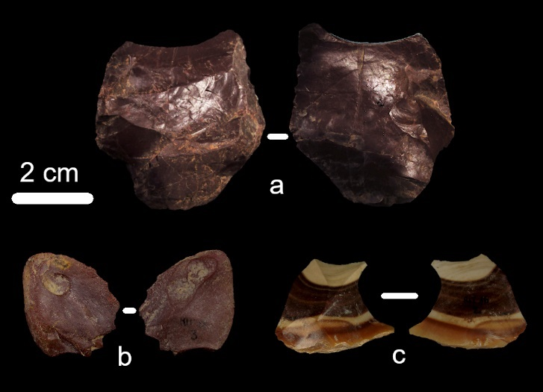
Figure 22 - Lithics from RIT 16. Opportunistic flake made of jasper (a); indeterminate radiolarite flake affected by thermal alterations (b); chert Levallois preferential flake (c)

RIT X
In this group are placed all the lithic artefacts collected at Trino hill but without indication of the collection area. It includes 38 lithic implements mainly realized on vein quartz but also on chert and radiolarite (Tables 1 and 3). From a technological perspective, 27 artefacts could belong to Middle Palaeolithic. Of them, 23 are vein quartz flakes, 2 are vein quartz cores (1 discoid and 1 preferential Levallois) and 2 are chert retouched tools. Debitage products are issued from recurrent centripetal Levallois (5), preferential Levallois (4), discoid (4) and opportunistic (10) knapping methods (Fig. 23). Four flakes are indeterminate concerning the knapping method. The only technique employed is direct percussion by hard hammer. The two cores attest the choice of vein quartz pebbles with suitable convexities for the development of discoid and Levallois reduction sequences (Fig. 23). In both cases the production of the wanted products starts after a short phase of core shaping. Retouched tools are represented by two convergent scrapers and a denticulate (Fig. 23). The scrapers are realized on Levallois products, while the denticulate on an opportunistic flake.
Two chert retouched blades and a laminar core belong to the Neolithic period (Fig. 23). They are realized through the pressure technique and the blades are typologically classifiable as a sickle element and a point respectively.
A fragmented retouched blade, showing an invasive retouch localized on both the edges, is realized through direct percussion by soft hammer.
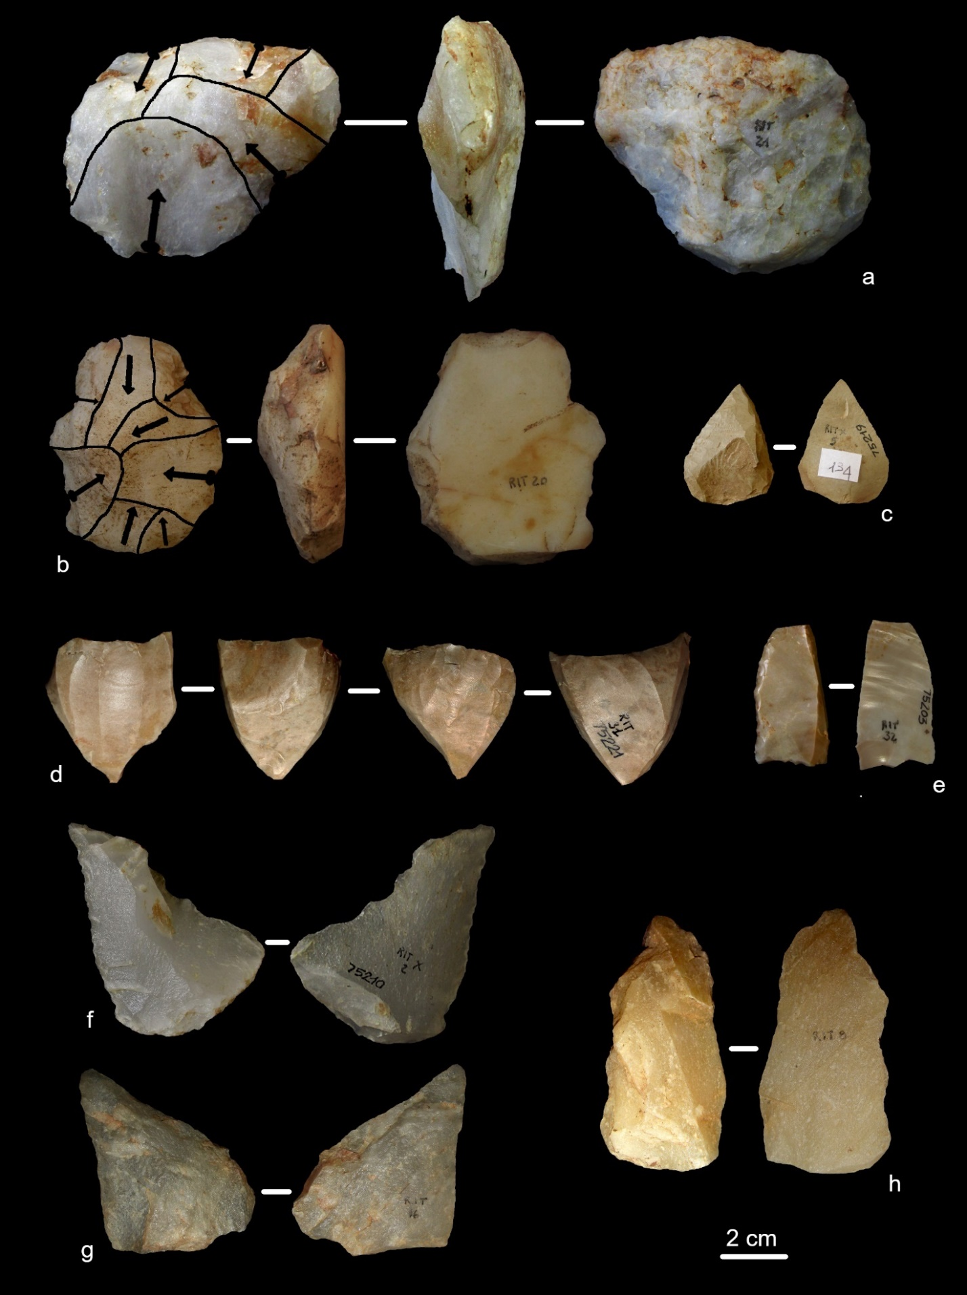
Figure 23 - Vein quartz and flint lithic artefacts from Trino hill. Levallois preferential core (a); unifacial discoid core with neocortical striking platform (b); convergent scraper on a Levallois point (c); laminar core (d); sickle element (e); convergent scraper on a Levallois flake (f); discoid flake (g); opportunistic flake with a denticulate retouch on the left margin (h)

Other surface collections in the Trino area
In addition to the collection areas located on the Trino hill, sporadic findings come from the immediate surroundings. A small vein quartz assemblage is from Casotto Diana, south of the Trino hill (Table 1): 25 flakes and two cores are issued from opportunistic, Levallois and discoid reduction strategies which characteristics are like those observed in the Middle Palaeolithic assemblages described so far. To the east of the Trino hill, beyond the Natural Reserve “Bosco della Partecipanza di Trino” (Fig. 2), in the surroundings of Cascina Ariosa, 16 vein quartz lithic artefacts were collected: 6 flakes and 1 core can be referred to Middle Palaeolithic; 2 blades belong to most recent frequentations of the area, while 7 lithic implements are affected by strong post-depositional alterations that prevent their technological interpretation.
The lithic artefacts from “Bosco della Partecipanza” and from the adjacent localities of Ronsecco, Tricerro and Cantone (Table 1) are almost exclusively chert blades and bladelets which chronology cannot be determined. On the other hand, the three polished axes from Cantone, Bosco della Partecipanza and Ronsecco certainly date back to the Neolithic period but in the absence of additional information, the laminar assemblages form these localities cannot be clearly associated to this phase of frequentation of the area.

Stratigraphic position of the lithic assemblages
Even if the artifacts found in situ within the sediments are numerically few and, exception made for the bifacial tool (Fig. 3), come just from the collections carried out in the ‘70s (RIT 1, RIT 2, RIT 3 and RIT 4), we can propose a realistic stratigraphic position of the different groups of lithic artefacts identified on a technological basis.
While the artefacts seem to lie only on the S2 surface (see Fig. 4), they were also found on S1 (Fig. 5). On the S2 surface, due to the presence of quarries and other artificial exposures, the stratigraphic sections containing lithic artefacts were observed.
The bifacial tool recently found at the base of the stratigraphic section exposed by agricultural activities (Fig. 3) is the only lithic artefact that on technological and stratigraphic basis can be placed within a Lower Palaeolithic occupation of the Trino hill. The biface was found below the surface of the S2 terrace, not far from the base of the terrace scarp that separates it from S1, in a sandy gravel of fluvioglacial origin, colour red 2.5 YR from the Munsell Soil Colour Chart (MSCC) (Fig. 5). From the top of this level the stratigraphy observed is the following:
- sand and gravelly sand of alluvial origin, with a colour between red 2.5 and yellowish red 5YR MSCC;
- lower silty loess, colour yellowish red 5 YR MSCC;
- compact clay that forms the infilling of a narrow erosion surface that cuts the oldest loess;
- intermediate silty loess, colour brown 7.5 YR MSCC, like that which, in other exposures, contains, near the bottom and the top, Middle Palaeolithic artefacts;
- upper silty loess, colour yellowish brown 10 YR MSCC, like that which, in other exposures, contains Upper Palaeolithic artefacts;
- silt that fills a small incision that cuts the upper loess.
According with the known stratigraphic data (ENEL, 1984; Giraudi ,2014; GSQP, 1976; Servizio Geoogico d’Italia, 1969), the age of the sandy gravel containing the bifacial tool can be between 870.000 years ago (MIS 22 – beginning of the sedimentation of the gravels) and 478.000/424.000 years ago (MIS 12) that is the age of the sandy gravels that form the terrace S3.
Middle Palaeolithic artefacts (RIT 4 – the artefacts are not yet present at the museum but were analysed by GSQP, 1976) were found in situ in a quarry located in the western area of the S2 surface (Fig. 4). The stratigraphic sequence (Fig. 5) was composed (from the bottom to the top) of:
- medium and fine sandy gravel, strongly weathered, colour red 2.5 YR MSCC, 1-2 m thick, like that containing the bifacial tool;
- lower silty loess, yellowish-red 5 YR MSCC, about 3 m thick;
- intermediate silty loess, brown colour 7.5 YR MSCC, with a maximum thickness of about 1 m.
Middle Palaeolithic lithic artefacts were found both in the lower and in the upper part of the intermediate loess. According to the stratigraphic position, the lower loess is earlier than MIS 6 and is possibly attributable to MIS 8 (300.000-243.000 BP), while the age of the intermediate loess is between MIS 6 and MIS 4.
Upper Palaeolithic tools (RIT 1, 2 and 3) were found in a small outcrop located on the S2 surface (Fig. 4), near the base of the scarp on the S1 terrace (Fig. 5). The stratigraphic sequence, from the bottom to the top is the following:
- weathered silty loess, brown 7.5 YR MSCC that can be correlated to the intermediate loess described above;
- upper loess, i.e. a discontinuous layer lying on the intermediate loess with a maximum thickness of about 30 cm, slightly pedogenic, yellowish-brown 10 YR MSCC.
Lithic artefacts attributed on a techno-typological basis to the Upper Palaeolithic were found in the upper loess (Fig. 5) that can be dated to the Upper Pleistocene, probably MIS 3-2.
Neolithic artefacts have never been found in a clear stratigraphic position.
Discussion
Summary of the results
The study of the lithic assemblages from Trino represent a further step in the understanding of the peopling of north-western Italy, as evidences about population and technological characteristics of Palaeolithic in this area and in particular in Piedmont are scarce and mostly represented by sporadic findings and not-systematic investigations (i.e. Guerreschi and Giacobini 1998). At today, the lithic artefacts from the Trino hill are the only significative evidence of a Palaeolithic frequentation of the Po plain in the region and, even in the limits of a study based on non-systematic surface collections, they allow to make some considerations about the identification of different phases of human frequentation and the technological behaviour of the hunter-gatherer groups that frequeted the area.
On a technological basis, the lithic assemblages of the Trino hill, can be divided in five groups: a huge set of lithic artefacts belonging to Middle Palaeolithic; a reduced number of Neolithic cores, blades and retouched tools; a few retouched tools that can be referred to Upper Palaeolithic; a considerable set of laminar cores and products that could belong both to Upper Palaeolithic and Neolithic frequentations; a biafacial tool.
The bifacial tool (Fig. 3), according to its stratigraphic position, can be attributed to Lower Palaeolithic and it represents the only Lower Palaeolithic artefact known in the region. The hypothesis of a Lower Palaeolithic human presence at the Trino hill was already proposed by F. Fedele according to the characteristics of the lithic artefacts from RIT 1, 2, 3 and 4 (Fedele, 1974; GSQP, 1976) but the revision of the lithic assemblages here completed makes more advisable to place those lithics in the Middle Palaeolithic assemblage, given the well attested Levallois technology.
The most important set of lithic artefacts analysed show characteristics of a Middle Palaeolithic technology. Most of the artefacts were found without a clear stratigraphic position but the general technological features and the consistency between their post depositional alterations and those observed on the lithics found in the intermediate loess, makes realistic to suppose that they belong to the same stratigraphic horizon. The chronology of the Middle Palaeolithic frequentation of the Trino hill could then belong to a time span between MIS 6 and MIS 4.

Technological observations
The technological characteristics observed on the different Middle Palaeolithic assemblages and, in particular, on that from RIT 14 (962 artefacts) allow to make several considerations about the general technological behaviour. The collection of the raw material mainly took place at the Trino hill and in the immediate surroundings. Vein quartz is the most exploited rock (Table 3) and can be easily found on the Trino hill in secondary position in the form of rounded pebbles or small polygonal blocks. The same must be said for limestone, porphyry, and quartzite, sporadically attested in the lithic assemblages. Other rocks like radiolarite and chert are of allochthonous provenience, and the ongoing identification of their supply areas will clarify the mobility of these human groups. The radiolarites exploited at the Trino hill are consistent with those identified at the Ciota Ciara cave (Borgosesia, VC) (Daffara et al., 2019) that come from the nearby Lombardy. Even though, precise data on the provenience of the rocks exploited at the Trino hill will come from the ongoing analysis. It is not even possible to propose here a provenience for the different kinds of chert exploited, since studies aimed to the identification of possible lithic raw materials supply areas have not yet been completed on the regional territory.
Reduction sequences are complete for vein quartz and radiolarite that were introduced in the site as natural blanks and then exploited through opportunistic, discoid and Levallois reduction strategies. Exception made for three cores, in the Middle Palaeolithic assemblage, chert is a secondary raw material, present just in the form of retouched tools and flakes. These observations, make us suppose a sub-local origin for radiolarite and an allochthonous provenience for chert, that was probably collected in a range of some kilometres from the Trino hill (Geneste, 1988; Kuhn, 1992; Féblot-Augustins, 1999; Bourguignon et al., 2004; Jaubert & Delagnes, 2007; Meignen et al., 2009; Turq et al., 2013; Wilson et al., 2018). In the considered Middle Palaeolithic assemblages, opportunistic reduction strategies are very well documented by cores and flakes: they are applied on pebbles and polygonal blocks of various sizes and morphologies that are often discarded before exhaustion. The cores show a preferential unipolar exploitation that starts from a natural surface: a limited number of products is produced, and the core is abandoned. Sometimes, multidirectional reduction strategies are applied but the knapping sequences continue to be short: each of the surfaces is usually exploited to produce one or two flakes. These data are reflected in the characteristics observed on the flakes issued from opportunistic debitage like the preponderance of unipolar negatives and of natural or flat butts (Figs. 9, 15, 17 and 19)
Levallois and discoid methods are also well attested by complete reduction sequences. Cores are small and medium-sized rounded pebbles with natural convexities suitable for these kinds of exploitation. Concerning Levallois technology, some differences need to be highlight depending on the raw material employed. Vein quartz cores show just one phase of exploitation, after which the core is discarded. In the recurrent centripetal modality, the production of Levallois flakes starts directly from the natural surfaces of the core with a striking platform that is often natural. In the preferential modality the striking platform is prepared in correspondence of the impact point with large, centripetal removals. Levallois preferential and recurrent centripetal cores on chert show a more careful preparation of the convexities and, even if sporadically, faceted butts are attested. Moreover, on the knapping surfaces are visible different phases of core configuration, thus attesting longer Levallois reduction strategies on chert than on vein quartz. As already pointed out by studies on vein quartz (Mourre, 1996; de Lombera-Hermida, 2009; Tallavaara et al., 2010), these differences are linked to technological adaptations to the raw materials properties: for vein quartz, the most the exploitation proceeds, the most the results of the knapping activities are unpredictable, due to the formation of inner fracture planes; moreover, the use of neocortical surfaces as striking platforms reduces the occurrence of knapping accidents and fractures.
The same technological adaptations are visible for discoid reduction strategies, mainly developed on vein quartz small pebbles. The unifacial modality uses a neocortical surface as striking platform and also in the bifacial modality natural surfaces are visible. The discoid production follows a centripetal direction, with no regards for the management of the core convexities: the reduction sequences are intentionally short, and cores are discarded before their complete exhaustion.
The Middle Palaeolithic technological behaviour at the Trino hill can be defined as expedient (Binford, 1979; Bamforth, 1986; Kuhn, 1992; Andrefsky Jr., 1994; Vaquero et al., 2015; Vaquero & Romagnoli, 2018), with the predominant exploitation of local lithic resources and the choice of natural blanks with suitable morphologies in order to start the production of the wanted products without long phases of core configuration.
Laminar reduction strategies are attested on radiolarite, chert and, to a lesser extent, on vein quartz. The use of vein quartz during Neolithic is attested in the region in the site of Montalto Dora (Padovan et al., 2019), while no evidence are known for Upper Palaeolithic. Techno-typological criteria allow to place 18 retouched tools in the Upper Palaeolithic; the same criteria, together with the identification of the pressure technique, let us identify 53 lithic implements as undoubtedly attributable to Neolithic, even if it is not possible to understand to which phase of the Neolithic period these lithics belong to.
Cores, blades and flakes without diagnostic characteristics or issued from phases of core configuration or management cannot be referred to a specific chronology. Exception made for the Epigravettian site of Castelletto Ticino (Berruti et al., 2017), no other Upper Palaeolithic contexts are known in the region, thus making very difficult the identification of this horizon, in the absence of clear stratigraphic data, at the Trino hill. The only clear similarity with Castelletto Ticino is the production of laminar implements through direct percussion by organic hammer, documented by an end-scraper, two scrapers, two retouched blades and a notch typologically attributable to Upper Palaeolithic. 141 further blades from Trino are obtained through the same technique, but in the absence of other diagnostic features they cannot be placed in the Upper Palaeolithic assemblage.
Beside the chronologic issues, it is interesting to note that of 257 laminar implements, 28 are cores and 110 are flakes and blades belonging to core configuration and management. The production phases and the retouched tools seems to be underrepresented in the considered assemblage. It marks a clear difference with respect to what has been observed for Middle Palaeolithic. During the most recent phases of frequentation of the Trino hill, chert was introduced in the site as natural blanks or as cores partially configurated, cores were knapped in the site, but the final products were transported outside the area of the Trino hill. We can then hypothesize that during Middle Palaeolithic the Trino hill was a residential place, probably linked to seasonal and repeated frequentation, with subsistence activities probably realized in the area, while in most recent periods the occupations become more sporadic, probably in the form of hunting camp, and linked to the production of tools.

Trino in the Northern Italian context
It is not easy to propose a precise contextualisation of the lithic assemblages of Trino mainly because of the absence of a precise chronological framework. Even thought, on a technological basis we can make some interesting considerations, especially considering the Middle Palaeolithic assemblage.
At a local scale, the Middle Palaeolithic reduction strategies documented at the Trino hill find a close comparison with those described at the Ciota Ciara cave (Arzarello et al., 2012; Daffara, 2018; Daffara et al., 2014; Daffara et al. 2021). It is, at today, the only Middle Palaeolithic site object of systematic and multidisciplinary excavations in the southern margin of the central and western Alps. The Trino hill shares with the Ciota Ciara cave some technological features: i.e., the predominant use of vein quartz, radiolarites and chert to produce lithic tools according to opportunistic, Levallois, discoid and Kombewa s.l. methods; use of technological adaptation strategies to exploit vein quartz pebbles. The use of vein quartz is broadly documented in Piedmont by lithic assemblages issued both form old excavations and form sporadic findings in different localities (Conti, 1931; Fedele, 1966; Rubat Borel et al., 2013, 2016). Further technological comparison on a regional scale can be found in the Middle Palaeolithic lithic assemblage from Vaude canavesane (Rubat Borel et al., 2013). Issued from un-authorized excavations and surface collections, also these assemblage shows the predominant exploitation of vein quartz through opportunistic, Levallois and discoid reduction strategies and its attribution to Middle Palaeolithic is based on technological criteria. Beside the sporadic nature of the data available concerning Piedmont, the ongoing studies suggest a quite homogeneous technological behavior during the Middle Palaeolithic frequentations of the region. They seem to be based on the exploitation of vein quartz as main lithic resource, from time to time accompanied by other local lithic resources with technological adaptation to the quality and mechanical properties of the raw materials employed.
In the context of the Alpine and sub-Alpine region, Piedmont represents a particular case-study in the field of lithic technology. A first aspect concerns the lack of reliable data about Middle Palaeolithic frequentations along the southern margin of the central and western Alps (i.e., Piedmont and Lombardy), while in the nearby Liguria and in the eastern side of the Southern Alps archaeological sites are numerous and well documented (Cauche, 2007; Delpiano et al., 2018; Holt et al., 2019; Peresani et al., 2014; Picin et al., 2013) (Fig. 1).
It is difficult to identify the causes of this absence, but one of them is certainly the lack, in the last decades, of specific studies aimed at investigating these issues. Another factor is the lithic raw materials availability at a regional scale. Chert is very abundant in the eastern part of the Alpine arc and many formations provide excellent quality lithic resources that were systematically exploited by the Middle Paleolithic human groups. In Piedmont, the most diffused rock is vein quartz, while Monte Fenera (north-eastern Piedmont) is the only area where chert can be easily accessible.
The data available for the western part of the alpine arc are in our opinion still too scarce to propose a detailed contextualization at a large scale but the ongoing research will certainly provide a more precise placement of Piedmont even in the context of the European Palaeolithic.
Conclusion
Middle Palaeolithic studies completed in the recent past (Ciota Ciara cave, Vaude Canavesane, Baragge Biellesi) (Berruti et al., 2016; Rubat Borel et al., 2013, 2016) and the data from Trino, give a quite homogeneous picture of the Piedmontese area. We observe the presence of human occupations based on the exploitation of local resources, among which vein quartz is the most diffused, and with similar technological behaviours. On the other hand, there is still a long way to go to clarify modalities and characteristics of the Upper Paleolithic in the. Even in the absence of precise stratigraphic data and therefore of a clear chronological framework, the technological analysis of the lithic assemblages collected at the Trino hill allows us to define some technological trends useful to hypothesize the modalities of occupation of the site, essentially definable as an area object of repeated human occupations linked to the production of lithic tools and to the development of subsistence activities.
The study completed for the Trino hill helps to outline the picture of the Palaeolithic peopling of the southern margin of the western Alps that in the last years is becoming far more articulated and intense than it was known.

Acknowledgements
New research about the lithic assemblages from Trino have been possible thanks to Soprintendenza Archeologia, Belle Arti e Paesaggio per le provincie di Biella, Novara, Verbano-Cusio-Ossola e Vercelli, to the Trino municipality and to the help and support of the members of Tridinum. Associazione per l’Archeologia, la Storia e le Belle Arti. We would like to thank Elena Molzino and Pier Luca Monge, members of TRIDINUM, for their significant help in the development of the present research. The research work here presented is dedicated to the loving memory of Elena Molzino.
Conflict of interest disclosure
The authors declare that they comply with the PCI rule of having no financial conflicts of interest in relation to the content of the article. The authors declare the following non-financial conflict of interest: Sara Daffara and Gabriele L.F. Berruti are recommenders of PCI Archaeology
Funding
No funding was received.
References
Andrefsky Jr., W., 1994. Raw-Material availability and the organization of technology. American Antiquity 59, 21–34.
Angelucci, D.E., Zambaldi, M., Tessari, U., Vaccaro, C., Arnaud, J., Berruti, G.L.F., Daffara, S., Arzarello, M., 2019. New insights on the Monte Fenera Palaeolithic, Italy: Geoarchaeology of the Ciota Ciara cave. Geoarchaeology 34, 413–429. doi:http://doi.org/10.1002/gea.21708
Arnaud, J., Benazzi, S., Romandini, M., Livraghi, A., Panetta, D., Salvadori, P.A., Volpe, L., Peresani, M., 2017. A Neanderthal deciduous human molar with incipient carious infection from the Middle Palaeolithic De Nadale cave, Italy. American Journal of Physical Anthropology 162, 370–376. doi: https://doi.org/10.1002/ajpa.23111
Arzarello, M., Daffara, S., Berruti, G.L.F., Berruto, G., Bertè, D., Berto, C., Gambari, F.M., Peretto, C., Berté, D., Berto, C., Gambari, F.M., Peretto, C., 2012. The Mousterian settlement in the Ciota Ciara cave: the oldest evidence of Homo neanderthalensis in Piedmont (Northern Italy). Journal of Biological Research LXXXV, 71–75. doi:https://doi.org/10.4081/jbr.2012.4068
Bächler, E., 1940. Das alpine Paläolithikum des Schweiz im Wildkirchli Drachenloch und Wildenmannlisloch. Birkhäuser, Basel.
Bamforth, D.B., 1986. Technological efficiency and tool curation. American Antiquity 51, 38–50. doi: https://doi.org/10.2307/280392
Banning, E.B., Hawkins, A.L., Stewart, S.T., Hitchings, P., Edwards, S., 2017. Quality Assurance in Archaeological Survey. Journal of Archaeological Method and Theory 24, 466–488. doi: https://doi.org/10.1007/s10816-016-9274-2
Bednarik, R.G., 2008. Pedogenetic dating of loess strata. Journal of Archaeological Science 35, 3124–3129. doi: https://doi.org/10.1016/j.jas.2008.06.017
Bernard-Guelle, S., 2004. Un site moustérien dans le Jura suisse: la grotte de Cotencher (Rochefort, Neuchâtel) revisitée. Bulletin de la société préhistorique française 101, 741–769.
Berruti, G.L.F., Arnaud, J., Arzarello, M., Belo, J., Berruto, G., Caracausi, S., Daffara, S., Ferreira, C., Reis, C.H., Rosina, P., Rubat Borel, F., 2016. Geo-archaeological survey in the Baragge Biellesi area. New data on the Middle Paaleolithic in Piedmont. In: Negrino, F., Fontana, F., Moroni, A., Riel Salvatore, J. (Eds.), Il Paleolitico e Il Mesolitico in Italia: Nuove Ricerche e Prospettive Di Studio The Palaeolithic and Mesolithic in Italy: New Research and Perspectives. Istituto Italiano di Preistoria e Protostoria (IIPP), Genova, pp. 93–94.
Berruti, G.L.F., Garcia Rojas, M., Motella de Carlo, S., Rubat Borel, F., Viola, S., 2017. Il sito epigravettiano di via del Maneggio, Castelletto sopra Ticino (NO). Annali dell’Università degli Studi di Ferrara. Museologia Scientifica e Naturalistica 13, 18–19. doi:https://doi.org/10.15160/1824-2707/1497
Berruti, G.L.F., Bianchi, E., Daffara, S., Gomes, M., Ceresa Genet, A.J., Fontana, F., Arzarello, M., Peretto, C., 2020. The use of blades and pointed tools during Middle Palaeolithic, the example of Riparo Tagliente (VR). Quaternary International 554, 45–59. doi: https://doi.org/10.1016/j.quaint.2020.07.016
Berto, C., Bertè, D., Luzi, E., Lopez Garcia, J.M., Pereswiet-Soltan, A., Arzarello, M., 2016. Small and large mammals from Ciota Ciara cave (Borgosesia, Vercelli, Italy): an Isotope stage 5 assemblage. Comptes Rendus - Palevol 15, 669–680. doi:https://doi.org/10.1016/j.crpv.2015.05.014
Binford, L.R., 1979. Organization and formation processes: looking at curated technologies. Journal of Anthropological Research 35, 251–273.
Blaser, F., Bourguignon, L., Sellami, F., Rios, J., Vieillevigne, E., Guibert, P., 2012. Un site à composante laminaire dans le Paléolithique Moyen du sud-ouest de la France: le site de Cantalouette 4 (Creysse, France). Bulletin de la Societé Préhistorique Française 109, 5–33.
Boëda, E., 1993. Le débitage discoïde et le débitage Levallois récurrent centripète. Bulletin de la Société préhistorique française 90, 392–404. doi:https://doi.org/10.3406/bspf.1993.9669
Boëda, E., 1994. Le concept Levallois: variabilité des méthodes. Archéo éditions, Paris.
Bordes, F., 1961. Typologie du Paléololithique ancien et moyen. Mémoires de l’institut Préhisorique de l’Université de Boreaux 1.
Bourguignon, L., Faivre, J.-P., Turq, A., 2004. Ramification des chaînes opératoires: une spécificité du Moustérien? Paléo 16, 37–48.
Brandl, M., Hauzenberger, C., Postl, W., Modl, D., Kurta, C., Trnka, G., 2011. Repolust cave (Austria) revisited: Provenance studies of the chert finds. Quartär 58, 51–65.
Buccheri, F., Bertè, D.F., Berruti, G.L.F., Cáceres, I., Volpe, L., Arzarello, M., 2016. Taphonomic Analysis on Fossil Remains From the Ciota Ciara Cave (Piedmont, Italy) and New Evidence of Cave Bear and Wolf Exploitation With Simple Quartz Flakes By Neanderthal. Rivista Italiana di Paleontologia e Stratigrafia 122, 41–54. doi:https://doi.org/10.13130/2039-4942/7674
Carbonell, E., García-Antón, M.D., Mallol, C., Mosquera, M., Ollé, A., Rodríguez, X.P., Sahnouni, M., Sala, R., Vergès, J.M., M Dolores, G.-A., Mallol, C., Mosquera, M., Ollé, A., Rodriguez, X.P., Sahnouni, M., Sala, R., Vergès, J.M., Garcia-Anton, M.D., Mallol, C., Mosquera, M., Olle, A., Rodriguez, X.P., Sahnouni, M., Sala, R., Verges, J.M., Márquez, B., Mosquera, M., Ollé, A., Rodríguez, X.P., Sala, R., Vergès, J.M., 1999. The TD6 level lithic industry from Gran Dolina, Atapuerca (Burgos, Spain): production and use. Journal of Human Evolution 37, 653–693. doi: https://doi.org/10.1006/jhev.1999.0336
Carpentieri, M., Arzarello, M., 2022. For our world without sound. The opportunistic debitage in the Italian context: a methodological evaluation of the lithic assemblages of Pirro Nord, Cà Belvedere di Montepoggiolo, Ciota Ciara cave and Riparo Tagliente. Journal of Palaeolithic Archaeology 5. doi:https://doi.org/10.1007/s41982-022-00117-9
Carraro, F., Lanza, R., Perotto, A., Zanella, E., 1991. L’evoluzione morfologica del Biellese occidentale durante il Pleistocene inferiore e medio, in relazione all’inizio della costruzione dell’Anfiteatro Morenico di Ivrea. Bollettino del Museo Regionale di Scienze Naturali Torino 9, 99–117.
Cartonnet, M., Combier, J., 2018. Une halte de chasse moustérienne en grotte dans le Jura méridional (Ain). L’Anthropologie 122, 610–625. doi: https://doi.org/10.1016/j.anthro.2018.10.002
Cauche, D., 2002. Les cultures moustériennes en Ligurie italienne: études des industries lithiques des grottes de la Madonna dell’Arma, d’Arma delle Manie et de Santa Lucia Superiore. Université de la Méditerranée-Aix-Marseille II.
Cauche, D., 2007. Les cultures moustériennes en Ligurie italienne: analyse du matériel lithique de trois sites en grotte. L’Anthropologie 111, 254–289. doi: https://doi.org/10.1016/j.anthro.2007.05.002
Cauche, D., 2012. Productions lithiques et comportements techno-économiques de groupes humains acheuléens et moustériens en région liguro-provençale. Comptes Rendus Palevol 11, 519–527.doi: https://doi.org/10.1016/j.crpv.2011.12.008
Chazan, M., 1997. Redefining Levallois. Journal of human evolution 33, 719–735. doi:https://doi.org/10.1006/jhev.1997.0167
Colonge, D., Mourre, V., 2006. Quartzite et quartzites: aspects pétrographiques, économiques et technologiques des matériaux majoritaires du Paléolithique ancien et moyen du sud-ouest de la France. In: Grimaldi, S., Cura, S. (Eds.), Technological Analysis on Quartzite Exploitation. Proceedings of the XV UISPP World Congress (Lisbon, 4-9 September 2006). BAR International Series, 1998. Archaeopress, Oxford.
Conti, C., 1931. Valsesia Archeologica. Note per una sua storia dalle origini alla caduta dell’Impero Romano. Bollettino della Società Storica Sudalpina 123, 1–61.
D’Errico, F., Gambari, F.M., 1983. Nuovi contributi alla conoscenza del Paleolitico piemontese. QuadPiem 2, 1–20.
Daffara, S., 2018. Non-flint raw materials in the European Middle Palaeolithic: variability of Levallois and discoid knapping methods and study of the supply areas. Universitat Rovira i Virgili.
Daffara, S., Giraudi, C., 2020. Un bifacciale del Paleolitico inferiore sul Rilievo isolato di Trino (VC): tipologia, inquadramento stratigrafico e morfologia del sito. Quaderni di Archeologia del Piemonte 4, 336–340.
Daffara, S., Arzarello, M., Berruti, G.L.F., Berruto, G., Bertè, D., Berto, C., Casini, A.I., 2014. The Mousterian lithic assemblage of the Ciota Ciara cave (Piedmont, Northern Italy): exploitation and conditioning of raw materials. Journal of Lithic Studies 1, 63–78. doi:https://doi.org/10.2218/jls.v1i2.1102
Daffara, S., Borel, A., Moncel, M.-H.M.-H., 2019a. Conditioning of the raw materials on discoid exploitation strategies during the Early Middle Palaeolithic: the example of Payre level D (South-East France). Archaeological and Anthropological Sciences 11, 4681–4695. doi: https://doi.org/10.1007/s12520-019-00823-6
Daffara, S., Berruti, G.L.F., Berruto, G., Eftekhari, N., Vaccaro, C., Arzarello, M., 2019b. Raw materials procurement strategies at the Ciota Ciara cave: New insight on land mobility in north-western Italy during Middle Palaeolithic. Journal of Archaeological Science: Reports 26. doi:https://doi.org/10.1016/j.jasrep.2019.101882
Daffara, S., Berruti, G.L.F., Arzarello, M., 2021. Expedient behaviour and predetermination at the Ciota Ciara cave (north-western Italy) during Middle Palaeolithic. Quaternary International 557, 71–92. doi:https://doi.org/10.1016/j.quaint.2021.01.001
Daffara, S., Berruti, G.L.F., Caracausi, S., Garcia-Rojas, M., Arzarello, M., 2023. Techno-economy of lithic raw materials in Piedmont (north-western Italy). A First lifelike scenario. Jornal of lithic studies 10, 41 p. doi: https://doi.org/10.2218/jls.7322
Dalmeri, G., Duches, R., Rosà, V., 2008. Nuovi ritrovamenti del Paleolitico medio sul Monte Baldo settentrionale. Preistoria Alpina 43, 5–11.
Daujeard, C., Fernandes, P., Guadelli, J.-L., Moncel, M.-H., Santagata, C., Raynal, J.-P., 2012. Neanderthal subsistence strategies in Southeastern France between the plains of the Rhone Valley and the mid-mountains of the Massif Central (MIS 7 to MIS 3). Quaternary International 252, 32–47. doi: https://doi.org/10.1016/j.quaint.2011.01.047
Daujeard, C., Abrams, G., Germonpré, M., Pape, J. M. Wampach, A. Le, Modica, K. Di, Moncel, M.H., 2016. Neanderthal and animal karstic occupations from southern Belgium and south-eastern France: Regional or common features? Quaternary International 411. doi: https://doi.org/10.1016/j.quaint.2016.02.009
Deák, J., Preusser, F., Cattin, M.I., Castel, J.C., Chauvière, F.X., 2019. New data from the Middle Palaeolithic Cotencher cave (Swiss Jura): site formation, environment, and chronology. E&G Quaternary Science Journal 67, 41–72. doi: https://doi.org/10.5194/egqsj-67-41-2019
Delpiano, D., Heasley, K., Peresani, M., 2018. Assessing neanderthal land use and lithic raw material management in discoid technology. Journal of Anthropological Sciences 96, 89–110. doi:http://doi.org/10.4436/jass.96006
Delpiano, D., Peresani, M., Bertola, S., Cremaschi, M., Zerboni, A., 2019. Lashed by the wind: short-term Middle Palaeolithic occupations within the loess-palaeosoil sequence at Monte Netto (Northern Italy). Quaternary International 502, 137–147. doi: https://doi.org/10.1016/j.quaint.2019.01.026
Dibble, H.L., Bar-Yosef, O., 1995. The definition and interpretation of Levallois technology. Prehistory Press, Madison.
Driscoll, K., 2011. Vein quartz in lithic traditions: An analysis based on experimental archaeology. Journal of Archaeological Science 38, 734–745. doi:https://doi.org/10.1016/j.jas.2010.10.027
Ehrenberg, K., 1958. Vom dermaligen Forschungsstand in der Heohle am Salzofen. Quartär 10, 237–251.
Eixea, A., 2018. Middle palaeolithic lithic assemblages in western Mediterranean Europe from MIS 5 to 3. Journal of Archaeological Science: Reports 21, 643–666. doi:http://doi.org/10.1016/j.jasrep.2018.08.039
ENEL, 1984. Rapporto per la localizzazione di una Centrale Elettronucleare nella Regione Piemonte. Area Po 1. ENEL - Direzione delle Costruzioni., Roma.
Féblot-Augustins, J., 1999. Raw material transport pat- terns and settlement systems in the European Lower and Middle Palaeolithic: Continuity, change and variability. In: Roebroeks, W., Gamble, C. (Eds.), The Middle Palaeolithic Occupation of Europe. University of Leiden, Leiden, pp. 193–214.
Fedele, F., 1966. La stazione paleolitica del Monfenera in Valsesia. Rivista di Studi Liguri 1,2, 5–105.
Fedele, F., 1974. Scoperte paletnologiche a Trino Vercellese. Studi Trentini di Scienze Naturali 51, 113–228.
Fedele, F., 1976. Découverte du paléolithique supérieur en Piémont: les recherches du Monfenera. In: Congrès Préhistorique de France. Parigi, pp. 251–276.
Fedele, F., 1985. Il paleolitico in Piemonte le alpi occidentali. Bollettino del Gruppo Archeologico «Ad Quintum» di Collegno (Torino) 7, 23–44.
Fedele, F., 1990. Boira Fusca e Rupe di Salto, 1977-1980. Ad Quintum 8, 1–77.
Fernandes, P., Raynal, J.P., Moncel, M.-H., 2008. Middle Palaeolithic raw material gathering territories and human mobility in the southern Massif Central, France: first results from a petro-archaeological study on flint. Journal of Archaeological Science 35, 2357–2370. doi: http://doi.org/10.1016/j.jas.2008.02.012
Fontana, F., Moncel, M.-H.H., Nenzioni, G., Onorevoli, G., Peretto, C., Combier, J., 2013. Widespread diffusion of technical innovations around 300,000 years ago in Europe as a reflection of anthropological and social transformations? New comparative data from the western Mediterranean sites of Orgnac (France) and Cave dall’Olio (Italy). Journal of Anthropological Archaeology 32, 478–498. doi: http://doi.org/10.1016/j.jaa.2013.08.003
Forestier, H., 1993. Le Clactonien: mise en application d ’une nouvelle méthode de débitage s’inscrivant dans la variabilité des systèmes de production lithique du Paléolithique ancien. Paléo 5, 53–82. doi:http://doi.org/10.3406/pal.1993.1104
Forno, M.G., Mottura, A., 1993. L’evoluzione pleistocenica medio-superiore di un settore astigiano (Piemonte): dati geologici e archeologici. Il Quaternario VI, 249–264.
Geneste, J.-M., 1988. Les industries de la grotte Vaufrey: Technologie du débitage, économie et circulation de la matière première. In: Rigaud, J.-P. (Ed.), La Grotte Vaufrey- Paléoenvironnement, Chronologie, Activités Humaines. Mémoires de la SPF, Paris, pp. 441–517.
Geneste, J.-M., 1991. Systèmes techniques de production lithique: variations techno-économiques dans le processus de réalisation des outillages paléolithiques. Techniques et culture 17–18, 1–36. doi: http://doi.org/10.4000/tc.5013
Giacobini, G., 1976. Note di preistoria piemontese: il Paleolitico. Studi Piemontesi V.
Gianotti, F., Forno, M.G., Ivy-Ochs, S., Kubik, P.W., 2008. New chronological and stratigraphical data on Morainic Amphiteatre of Ivrea (Piedmont, NW Italy). Quaternary International 190, 123–135. doi: https://doi.org/10.1016/j.quaint.2008.03.001
Giraudi, C., 2014. Quaternary studies as a tool to validate seismic hazard potential of tectonic structures: the case of the Monferrato thrust front (Vercelli Plain, NW Italy). Alpine and Mediterranean Quaternary 27, 5–28.
Giraudi, C., Venturino Gambari, M., 1983. Conzano, loc. Cascina Mongianone. rinvenimento di reperti litici isolati. QuadPiem 2, 143–144.
Giunti, P., Longo, L., 2010. The Production System of the Mousterian Lithic Industry of Layer III from the Mezzena rockshelter (Verona, northern Italy). Human Evolution 25, 83–96.
GSQP, 1976. Studio Interdisciplinare del “Rilievo Isolato” di Trino (Bassa Pianura Vercellese, Piemonte). Quaderni del Gruppo di Studio del Quaternario Padano 3, 161–253.
Guerreschi, A., Giacobini, G., 1998. Il Paleolitico e il Mesolitico nel Piemonte. In: Mercando, L., Venturino Gambari, M., Micheletto, E. (Eds.), Archeologia in Piemonte: La Preistoria. Vol. 1. Allemandi, Torino, pp. 87–100.
Hardy, B.L., Moncel, M.-H., 2011. Neanderthal use of fish, mammals, birds, starchy plants and wood 125-250,000 years ago. PLoS ONE 6, 0–9. doi: http://doi.org/10.1371/journal.pone.0023768
Holt, B., Negrino, F., Riel-Salvatore, J., Formicola, V., Arellano, A., Arobba, D., Boschian, G., Churchill, S.E., Cristiani, E., Canzio, E. Di, Vicino, G., 2019. The Middle-Upper Paleolithic transition in Northwest Italy: new evidence from Riparo Bombrini (Balzi Rossi, Liguria, Italy). Quaternary International 508, 142–152. doi:http://doi.org/10.1016/j.quaint.2018.11.032
Inizan, M., Reduron-Ballinger, M., Roche, H., Tixier, J., 1995. Technologie de la pierre taillée. CREP, Nanterre.
Jaubert, J., Delagnes, A., 2007. De l ’espace parcouru à l’espace habité au Paléolithique moyen. In: Vandermeersch, B., Maureille, B. (Eds.), Les Néandertaliens. Biologie et Cultures. CTHHS, pp. 263–281.
Jequier, C., Peresani, M., Romandini, M., Delpiano, D., Renaud, J.B., Lembo, G., Livraghi, A., Lopez Garcia, J.M., Obradovic, M., Nicosia, C., 2015. The De Nadale Cave, a single layered Quina Mousterian site in the North of Italy. Quartär 62, 7–21.
Kuhn, S.L., 1992. On planning and curated technologies in the Middle Paleolithic. Journal of Anthropological Research 48, 185–214.
Leroi-Gourhan, A., 1964. Le geste et la parole. Albin Michel, Paris.
Lombera-Hermida, A. de, 2009. The Scar Identification of Lithic Quartz Industries. In: Sternke, F., Eigeland, L., Costa, L.J. (Eds.), Non-Flint Raw Material Use in Prehistory . Old Prejudices and New Directions. BAR International Series. Archaeopress, Oxford, pp. 5–11.
Lombera-Hermida, A. de, Rodríguez-Rellán, C., 2016. Quartzes matter. Understanding the technological and behavioural complexity in quartz lithic assemblages. Quaternary International 424, 2–11. doi:http://doi.org/10.1016/j.quaint.2016.11.039
Manninen, M.A., 2016. The effect of raw material properties on flake and flake-tool dimensions: A comparison between quartz and chert. Quaternary International 424, 24–31. doi: http://doi.org/10.1016/j.quaint.2015.12.096
Marciani, G., Ronchitelli, A., Arrighi, S., Badino, F., Bortolini, E., Boscato, P., Boschin, F., Crezzini, J., Delpiano, D., Falcucci, A., Figus, C., Lugli, F., Oxilia, G., Romandini, M., Riel-Salvatore, J., Negrino, F., Peresani, M., Spinapolice, E.E., Moroni, A., Benazzi, S., 2020. Lithic techno-complexes in Italy from 50 to 39 thousand years BP: An overview of lithic technological changes across the Middle-Upper Palaeolithic boundary. Quaternary International 551, 123–149. doi: https://doi.org/10.1016/j.quaint.2019.11.005
Mathias, C., 2016. After the Lower Palaeolithic: Lithic ramification in the early Middle Palaeolithic of Orgnac 3, layer 2 (Ardèche, France). Quaternary International 411, 193–201. doi: https://doi.org/10.1016/j.quaint.2016.01.033
Meignen, L., Delagnes, A., Bourguignon, L., 2009. Patterns of lithic material procurement and transformation during the Middle Paleolithic in western Europe. In: Adams, B., Blades, B.S. (Eds.), Lithic Materials and Palaeolithic Societies. Blackwell Publishing, Oxford, pp. 15–24.
Modica, K. Di, Bonjean, D., 2009. The exploitation of quartzite in Layer 5 (Mousterian) of Scladina cave (Wallonia, Belgium): flexibility and dynamics of concepts of debitage in the Middle Palaeolithic. In: Grimaldi, S., Cura, S. (Eds.), Technological Analysis on Quartzite Exploitation. Proceedings of the XV UISPP World Congress (Lisbon, 4-9 September 2006). BAR International Series 1998. Archaeopress, pp. 33–41.
Moncel, M.-H., 2005. Baume Flandin et Abri du Maras: Deux exemples de débitage laminaire du début du Pléistocène supérieur dans la Vallée du Rhône (sud-est, France). L’Anthropologie 109, 451–480. doi: http://doi.org/10.1016/j.anthro.2005.06.002
Moncel, M.-H., Daujeard, C., 2012. The variability of the Middle Palaeolithic on the right bank of the Middle Rhône Valley (southeast France): Technical traditions or functional choices? Quaternary International 247, 103–124. doi: http://doi.org/10.1016/j.quaint.2010.10.030
Moncel, M.-H., Crégut-Bonnoure, É., Daujeard, C., Lartigot, A.S., Lebon, M., Puaud, S., Boulbes, N., Croizet, S., 2008a. Le site de la baume Flandin (commune d’Orgnac-l’Aven): nouvelles données sur ce gisement du Paléolithique moyen. Comptes Rendus - Palevol 7, 315–325. doi: http://doi.org/10.1016/j.crpv.2008.03.005
Moncel, M.-H., Brugal, J.P., Prucca, A., Lhomme, G., 2008b. Mixed occupation during the Middle Palaeolithic: Case study of a small pit-cave-site of Les Pêcheurs (Ardèche, south-eastern France). Journal of Anthropological Archaeology 27, 382–398. doi:http://doi.org/10.1016/j.jaa.2008.03.005
Moncel, M.-H., Fernandes, P., Chacón Navarro, M.G., Lombera-Hermida, A. de, Menéndez Granda, L., Youcef, S., Moigne, A.-M., Patou-Mathis, M., Daujeard, C., Rivals, F., Theodoropoulou, A., Valladas, H., Mercier, N., Bahain, J.-J., Voinchet, P., Falguères, C., Michel, V., Guanjun, S., Yokoyama, Y., Combier, J., 2013. Émergence et diversification des stratégies au Paléolithique moyen ancien (350 000 à 120 000 ans) dans la vallée u Rhône (France). Les sites d’Orgnac 3 et Payre. In: Jaubert, J., Fourment, N., Depaepe, P. (Eds.), Transitions, Ruptures et Continuité Durant La Préhistoire, Actes Du XXVIIe Congrès Préhistorique de France (Bordeaux-Les Eyzies, 2010). pp. 59–79.
Moncel, M.H., Ashton, N., Arzarello, M., Fontana, F., Lamotte, A., Scott, B., Muttillo, B., Berruti, G.L.F., Nenzioni, G., Tuffreau, A., Peretto, C., 2020. Early Levallois core technology between Marine Isotope Stage 12 and 9 in Western Europe. Journal of Human Evolution 139. doi: http://doi.org/10.1016/j.jhevol.2019.102735
Mottura, A., 1994. Alta e media valle del Tanaro. Stazioni preistoriche. QuadPiem 12, 280–281.
Mourre, V., 1996. Les industries en quartz au Paléolithique. Terminologie, méthodologie et technologie. Paléo 8, 205–223. doi:http://doi.org/10.3406/pal.1996.1160
Padovan, S., Rubat Borel, F., Berruti, G.L.F., Daffara, S., Mancusi, V.G., Zunino, M., 2019. Il sito perilacustre VBQ di Montalto Dora nel quadro del Neolitico del Piemonte. In: Maffi, M., Bronzoni, L., Mazzieri, P. (Eds.), Le Quistioni Nostre Paletnologiche Più Importanti...Trent’anni Di Tutela e Ricerca Preistorica in Emilia Occidentale. Piacenza, pp. 11–23.
Pelegrin, J., 2000. Les technique de débitage laminaire au Tardiglaciaire: critère de diagnose et quelques réflexions. Memoires du Musèe de Prehistoire d’Ile de France 7, 73–86.
Pelegrin, J., Karlin, C., Bodu, P., 1988. «Chaînes opératoires»: un outil pour le préhistorien. Technologie préhistorique. Notes et Monographies techniques.
Peresani, M. (Ed.), 2003. Discoid Lithic Technology: Advances and Implications. BAR International Series 1120. Archaeopress.
Peresani, M., 2011. Fifty thousand years of flint knapping and tool shaping across the Mousterian and Uluzzian sequence of Fumane cave. Quaternary International 247, 125–150. doi: http://doi.org/10.1016/j.quaint.2011.02.006
Peresani, M., Fiore, I., Gala, M., Romandini, M., Tagliacozzo, A., 2011. Late Neandertals and the intentional removal of feathers as evidenced from bird bone taphonomy at Fumane Cave 44 ky BP, Italy. Proceedings of the Nationa Academy of Sciences 108, 3888–3893.
Peresani, M., Centi, L., Taranto, E. Di, 2013. Blades, bladelets and flakes: A case of variability in tool design at the dawn of the Middle-Upper Palaeolithic transition in Italy. Comptes Rendus - Palevol 12, 211–221.doi: https://doi.org/10.1016/j.crpv.2013.02.005
Peresani, M., Romandini, M., Duches, R., Jéquier, C., Nannini, N., Pastoors, A., Picin, A., Schmidt, I., Vaquero, M., Weniger, G.-C., 2014. New evidence for the Mousterian and Gravettian at Rio Secco Cave, Italy. Journal of Field Archaeology 34, 401–416. doi:http://doi.org/10.1179/0093469014Z.00000000098
Peresani, M., Bertola, S., Delpiano, D., Benazzi, S., Romandini, M., 2019. The Uluzzian in the north of Italy. Insights around the new evidence at Riparo Broion Rockshelter. Archaeological and Anthropological Sciences 11, 3503–3536. doi: https://doi.org/10.1007/s12520-018-0770-z
Picin, A., Vaquero, M., 2016. Flake productivity in the Levallois recurrent centripetal and discoid technologies: New insights from experimental and archaeological lithic series. Journal of Archaeological Science: Reports 8, 70–81. doi:http://doi.org/10.1016/j.jasrep.2016.05.062
Picin, A., Peresani, M., Falguères, C., Gruppioni, G., Bahain, J.J., 2013. San Bernardino Cave (Italy) and the Appearance of Levallois Technology in Europe: Results of a Radiometric and Technological Reassessment. PLoS ONE 8, 4–11. doi:http://doi.org/10.1371/journal.pone.0076182
Révillion, S., 1995. Technologie du débitage laminaire au Paléolithique moyen en Europe septentrionale: état de la question. Bulletin de la Societé Préhistorique Française 92, 425–442.
Rubat Borel, F., Arzarello, M., Buonsanto, C., Daffara, S., 2013. San Carlo Canavese - San Francesco al Campo, località Vauda. reperti litici del Paleolitico medio. Quaderni della Soprintendenza Archeologica del Piemonte 28, 267–270.
Rubat Borel, F., Berruti, G.L.F., Arnaud, J., Arzarello, M., Belo, J., Berruto, G., Bertè, D., Caracausi, S., Daffara, S., Ferreira, C., Reis, C.H., Rosina, P., 2016. Candelo-Massazza-Verrone, loc. Baragge. Nuovi dati sul Paleolitico medio piemontese. Prospezioni geoarcheologiche nelle Baragge biellesi. Quaderni della Soprintendenza Archeologica del Piemonte 31, 219–222.
Schiffer, M.B., Sullivan, A.P., Klinger, T.C., 1978. The design of archaeological surveys. World Archaeology 10, 1–28. doi:https://doi.org/10.1080/00438243.1978.9979712
Servizio Geoogico d’Italia, 1969. Foglio 57 “Vercelli” alla scala 1:100.000. Carta Geologica d’Italia 1:100.000.
Slimak, L., 2008. The Neronian and the historical structure of cultural shifts from Middle to Upper Palaeolithic in Mediterranean France. Journal of Archaeological Science 35, 2204–2214. doi: https://doi.org/10.1016/j.jas.2008.02.005
Slimak, L., Bressy, C., Silva, J. Da, Gilabert, C., Guendon, J.-L., Montoya, C., Ollivier, V., Raydon, V., Renault, S., 2004. La Combe Joubert (Céreste, France), un assemblage paléolithique original en haute Provence. Comptes Rendus Palevol 3, 77–84. doi: https://doi.org/10.1016/j.crpv.2003.10.006
Stout, D., Semaw, S., Rogers, M.J., Cauche, D., 2010. Technological variation in the earliest Oldowan from Gona, Afar, Ethiopia. Journal of Human Evolution 58, 474–491. doi: http://doi.org/10.1016/j.jhevol.2010.02.005
Tallavaara, M., Manninen, M.A., Hertell, E., Rankama, T., 2010. How flakes shatter: A critical evaluation of quartz fracture analysis. Journal of Archaeological Science 37, 2442–2448. doi: http://doi.org/10.1016/j.jas.2010.05.005
Tixier, J., 1978. Méthod pur l’étude des outillages lithiques. Notice sur le travaux scientifiques présentés en vue du grade de Docteur en lettres. Université de Paris X – Nanterre.
Tixier, J., Inizan, M.-L., Roche, H., 1984. Préhistoire de la pierre taillée. Economie du débitage laminaire: technologie et expérimentation. IIIe table ronde de technologie lithique Meudon-Bellevue, octobre 1982. C.R.E.P.
Turq, A., Roebroeks, W., Bourguignon, L., Faivre, J.P., 2013. The fragmented character of Middle Palaeolithic stone tool technology. Journal of Human Evolution 65, 641–655. doi: http://doi.org/10.1016/j.jhevol.2013.07.014
Vaquero, M., Carbonell, E., 2003. A temporal perspective on the variability of the discoid method in the Iberian Peninsula. In: Peresani, M. (Ed.), Discoid Lithic Technology: Advances and Implications. BAR International Series 1120. Archaeopress, pp. 67–82.
Vaquero, M., Romagnoli, F., 2018. Searching for Lazy People: the Significance of Expedient Behavior in the Interpretation of Paleolithic Assemblages. Journal of Archaeological Method and Theory 25, 334–367. doi: http://doi.org/10.1007/s10816-017-9339-x
Vaquero, M., Bargalló, A., Chacón, M.G., Romagnoli, F., Sañudo, P., 2015. Lithic recycling in a Middle Paleolithic expedient context: Evidence from the Abric Romaní (Capellades, Spain). Quaternary International 361, 212–228. doi: http://doi.org/10.1016/j.quaint.2014.05.055
Wilson, L., Browne, C.L., Texier, P.J., 2018. Provisioning on the periphery: Middle Palaeolithic raw material supply strategies on the outer edge of a territory at La Combette (France). Journal of Archaeological Science: Reports 21, 87–98. doi: http://doi.org/10.1016/j.jasrep.2018.07.001

