IUENNA – openIng the soUthErn jauNtal as a micro-regioN for future Archaeology: A “para-description”
Dominik Hagmann^{1,*} – Franziska Reiner²
Version: 2.0.0
Date: 2023-09-18
DOI: 10.31219/osf.io/5vwg8
¹ kärnten.museum
dominik.hagmann@univie.ac.at
0000-0002-4481-6234
² Austrian Archaeological Institute/Austrian Academy of Sciences
franziska.reiner@oeaw.ac.at
* corresponding author

Abstract

The Go!Digital 3.0 project IUENNA – an acronym for “openIng the soUthErn jauNtal as a micro-regioN for future Archaeology” – embraces a comprehensive open science methodology. It focuses on the archaeological micro-region of the Jauntal Valley in Carinthia, Austria, with the Hemmaberg site and its associated locations (Globasnitz/Iuenna, Jaunstein, and St. Stefan) as key case studies. The Hemmaberg site serves as a central research focus and stands among the most extensively studied Late Antique hilltop settlements, dating from the 4th to the 6th centuries AD. This site acts as a pivotal reference point for early Christianity in the Southeast Alpine region, boasting at least five early Christian churches, burials, auxiliary structures, and the renowned Gothic pilgrimage church of St. Hemma and Dorothea, in addition to the Rosalia Grotto. However, over a century of research, initiated by citizen scientists in the early 20th century and later furthered by various actors, includes a diverse spectrum of sites and Hemmaberg is merely one element within a broader cultural landscape that extends from prehistoric times to the early Middle Ages, encapsulating the diverse Jauntal Valley. IUENNA represents a collaborative endeavor in digital archaeology and digital humanities, involving a diverse set of stakeholders. These include kärnten.museum (the State Museum for Carinthia), the Austrian Archaeological Institute (ÖAI) at the Austrian Academy of Sciences (ÖAW), ACDH-CH at ÖAW, the Austrian Federal Monuments Authority (BDA), and the archaeological service company ARDIG. This project constitutes a novel initiative in Austrian Classical studies, offering a robust model for the active and sustainable long-term archiving of archaeological data. All existing archaeological records will be digitized and organized within an inclusive, hierarchical folder structure, and will be augmented with metadata. This data management strategy has the potential to serve as a model for future archaeological projects in Austria and beyond. Data accessibility will be guaranteed through its online presence in the ARCHE repository (A Resource Centre for the HumanitiEs) of the Austrian Center for Digital Humanities and Cultural Heritage (ACDH-CH), as well as an open-source web-mapping application. This paper serves a dual purpose: it not only presents IUENNA's conceptual framework but also invites scholarly discourse for the project's conceptual refinement.

Keywords
digital archaeology; long-term data archiving; Noricum; rural settlement; data

Introduction
The integration of critical feedback into scholarly discourse serves as an invaluable catalyst for instigating an elevated, multi-dimensional conversation about the prevailing state and emergent trajectories of archaeological research. In this intellectual milieu, the paper under discussion does more than merely present the digital-archaeological research project IUENNA (openIng the soUthErn jauNtal as a micro-regioN for future Archaeology; Go!Digital project GD3.0_2021-24_IUENNA). It strategically articulates both the project's conceptual vision and its operational framework, doing so both in anticipation of and in parallel with its actual implementation. This dual-timing approach not only allows for the incorporation of scholarly insights in the form of open peer review but also provides a dynamic forum for iterative refinement, thereby enriching the project's development and potential impact.

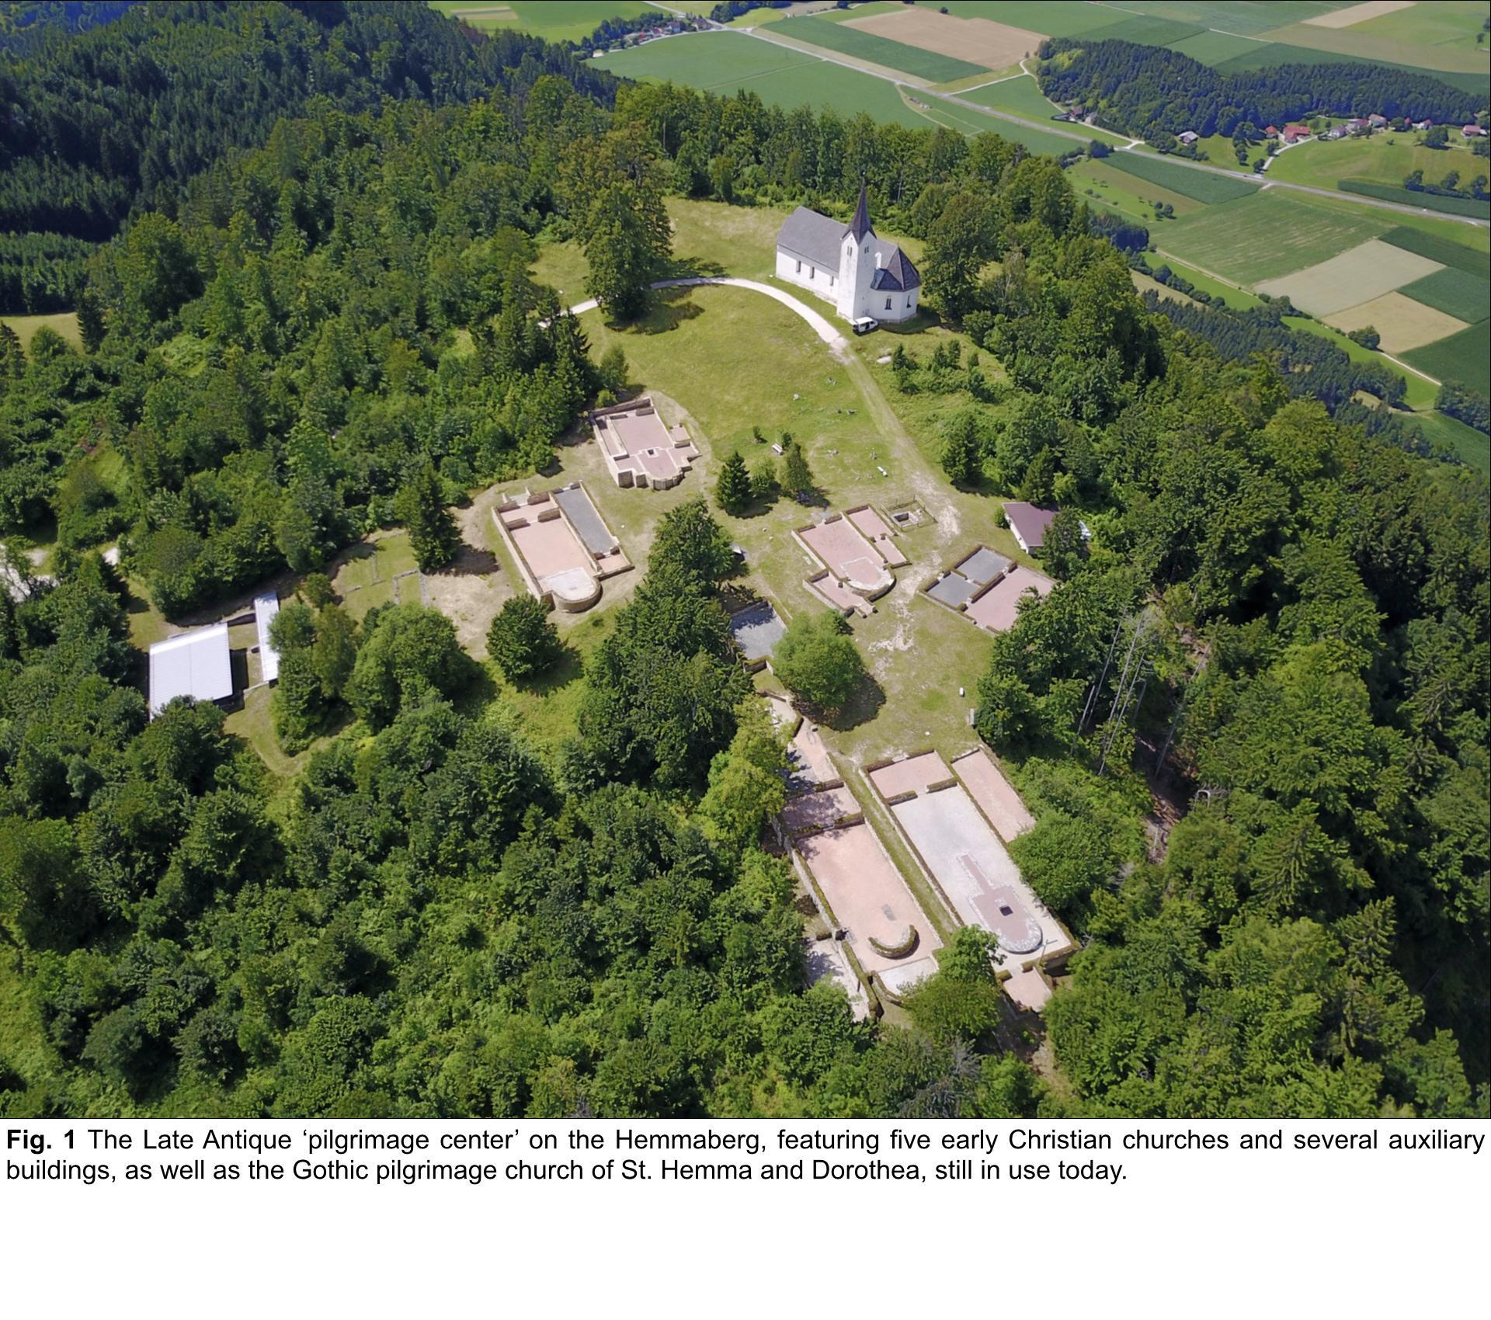

Materials and Methods

Research questions, objectives, challenges, expected results
With IUENNA, we present a new project to strengthen the application of digital methods in the field of archaeology in Austria by pursuing complex cultural-historical questions, shaping Digital Humanities (DH)-related methods in Classics, and securing cultural knowledge for the long-term. Our project is based on the archaeological micro-region of the Jauntal Valley (Carinthia/Austria). It involves the Landesmuseum für Kärnten/State Museum for Carinthia (kärnten.museum/LMK), the Österreichisches Archäologisches Institut/Austrian Archaeological Institute (ÖAI) at the Österreichische Akademie der Wissenschaften/Austrian Academy of Sciences (ÖAW), the Austrian Center for Digital Humanities and Cultural Heritage (ACDH-CH) at the ÖAW, the Bundesdenkmalamt/Federal Monuments Authority (BDA) and the archaeological company ARDIG. We follow a comprehensive open science approach, using the Late Antique ‚pilgrimage center‘ of the Hemmaberg with its decade-long excavations and related sites (Globasnitz/Iuenna, Jaunstein, and St. Stefan) as a case study.

IUENNA will provide, for the first time in Austria for Classics respectively Roman archaeology, a sustainable long-term archive of an elaborated excavation at one of the most critical Late Antique sites of the Southeast Alpine region and its vicinity and integrate all data types. We will present a model study on Globasnitz and its surroundings as a manifold Roman rural settlement region. All archaeological research data available will be digitized, structured in an all-new inclusive and hierarchically organized file folder system based on the guidelines of the BDA, and enhanced with metadata. IUENNA shall serve as an example for future projects for Austrian archaeology and beyond. Data will be made available online in full open access as far-reaching as possible using the repository ARCHE (A Resource Centre for the HumanitiEs) of the ACDH-CH/ÖAW (TROGNITZ & ĎURČO, 2018) and a web-mapping application (WMA).
The most important sites will be briefly highlighted: The archaeological structures at the Hemmaberg undoubtedly belong to some of the best-researched Late Antique hilltop settlements of the 4th-6th cent. AD, which makes the Hemmaberg a leading reference site for early Christianity in the Southeast Alpine region. The Hemmaberg is a world-renowned site, particularly its late antique settlement (‘pilgrimage center’), featuring at least five early Christian churches, several auxiliary buildings, and the Gothic pilgrimage church of St. Hemma and Dorothea, as well as the Rosalia Grotto, which are still in use today. (BINDER – LADSTÄTTER 2019; EITLER & SEIDEL 2022; GLASER 1982) (Fig.1)
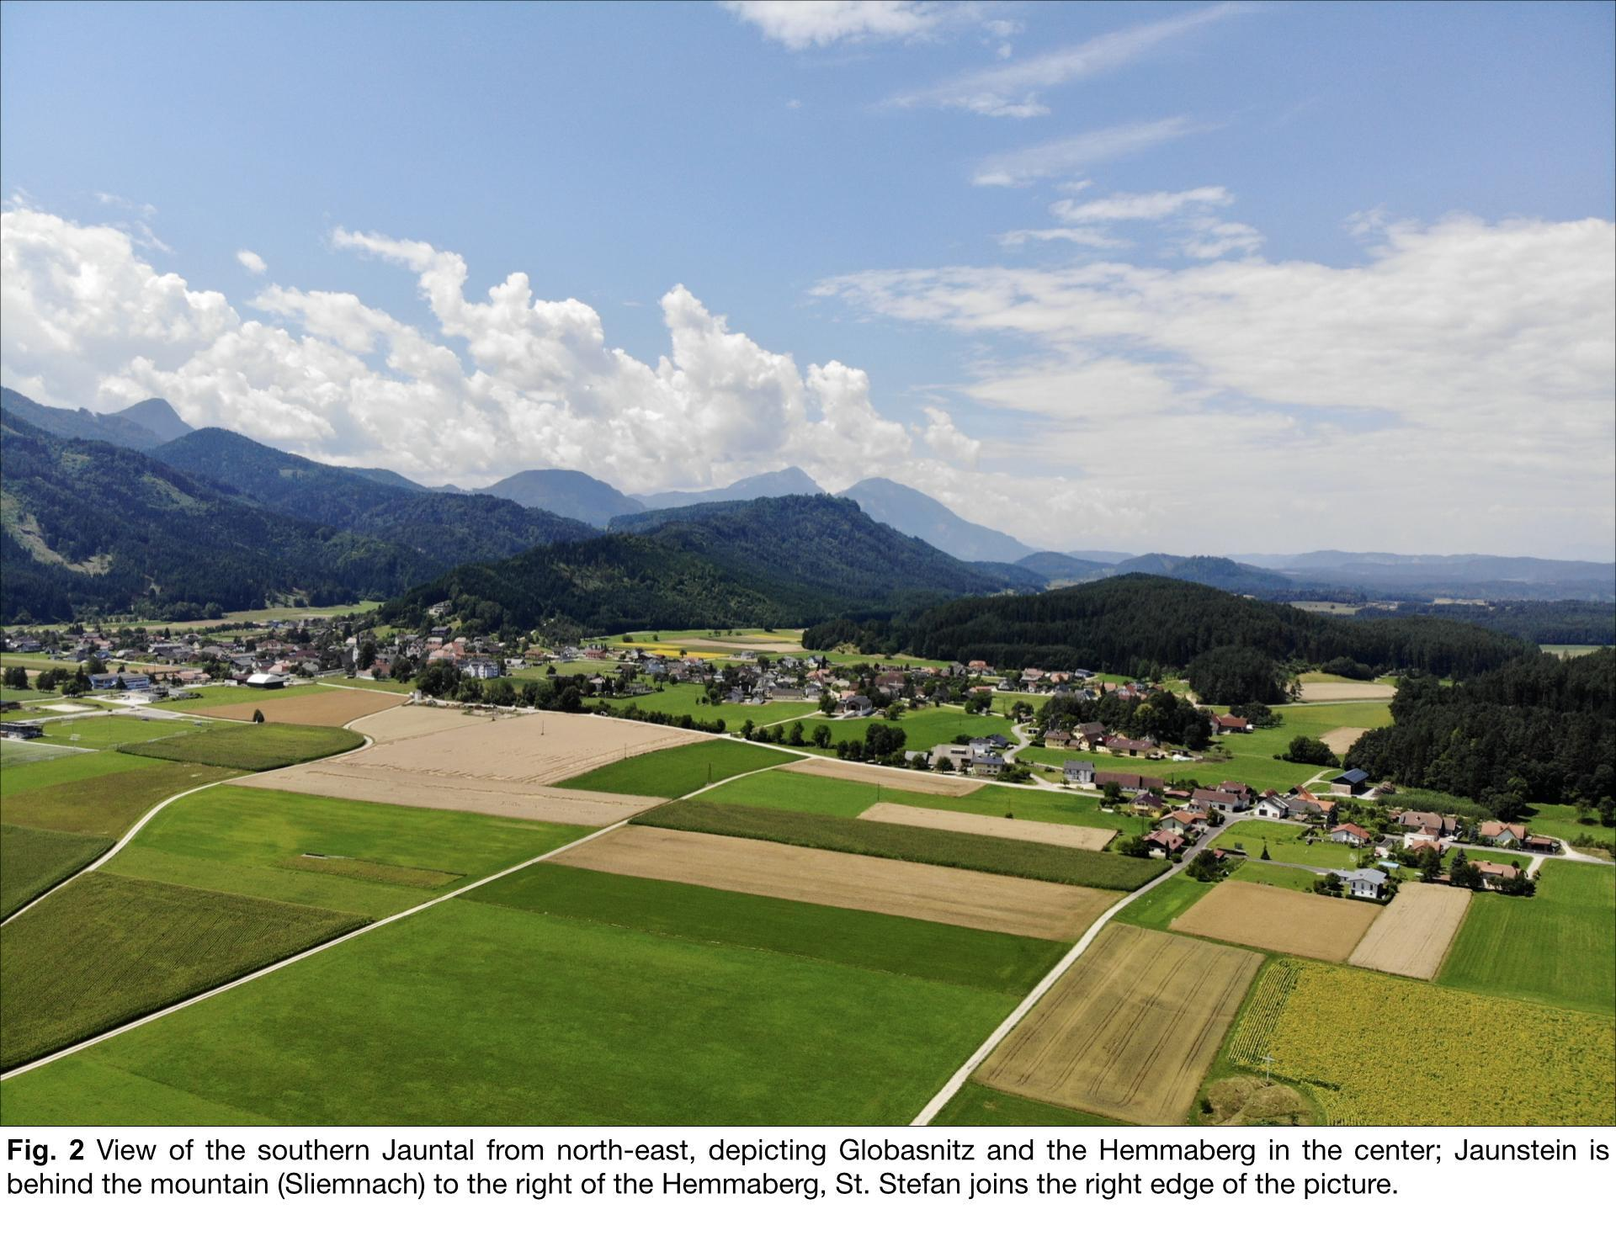
However, the Hemmaberg and its material culture should not be seen on its own since it is a significant part of a much more extensive settlement area with numerous archaeological sites from prehistoric times to the early Middle Ages, which can be described as the micro-region of the Jauntal, which features more than 2000 years of cultural history. (DORNIG 2014) (Fig. 2) Over 100 years of studies reflect a remarkable research history from that only the most crucial milestones should be pointed out: After the first investigations at the beginning of the 20th cent. by citizen scientists like the notary H. Winkler at the Hemmaberg, continuous activities took place primarily from the later 1970s onwards by the LMK under the direction of F. Glaser with a focus on Late Antiquity in the area of the Hemmaberg itself and, located at the foot of the mountain, in Globasnitz/Iuenna, a Roman ‘road station,’ including remains of the Roman link road Virunum – Celeia and a massive Late Antique burial ground. Other nearby sites are a recently discovered Late Antique (?) and an exceptionally big Roman ‘super-villa’ near St. Stefan. At Jaunstein, archaeological features exemplify the early Middle Ages, and investigations of the prehistoric (Hallstatt period) to early medieval settlement took place, for example, at Katharinakogel/Tscherberg by P. Gleirscher (LMK). Exploring the rich archaeological heritage of the Jauntal region, specific focus has been placed on its burials in the course of the history of research: The cemeteries crucial to the Jauntal region have been extensively excavated and researched, particularly those located on the Hemmaberg (spanning Late Antiquity to the Early Middle Ages), as well as in Globasnitz and Jaunstein. The available findings from the associated anthropological analyses are integral to the project and will be transitioned into long-term archival storage. (EBNER 2009; EICHERT & RICHARDS 2020; GLEIRSCHER 2000; POLLAK 2017; RICHARDS ET AL. 2023) (Fig.3)
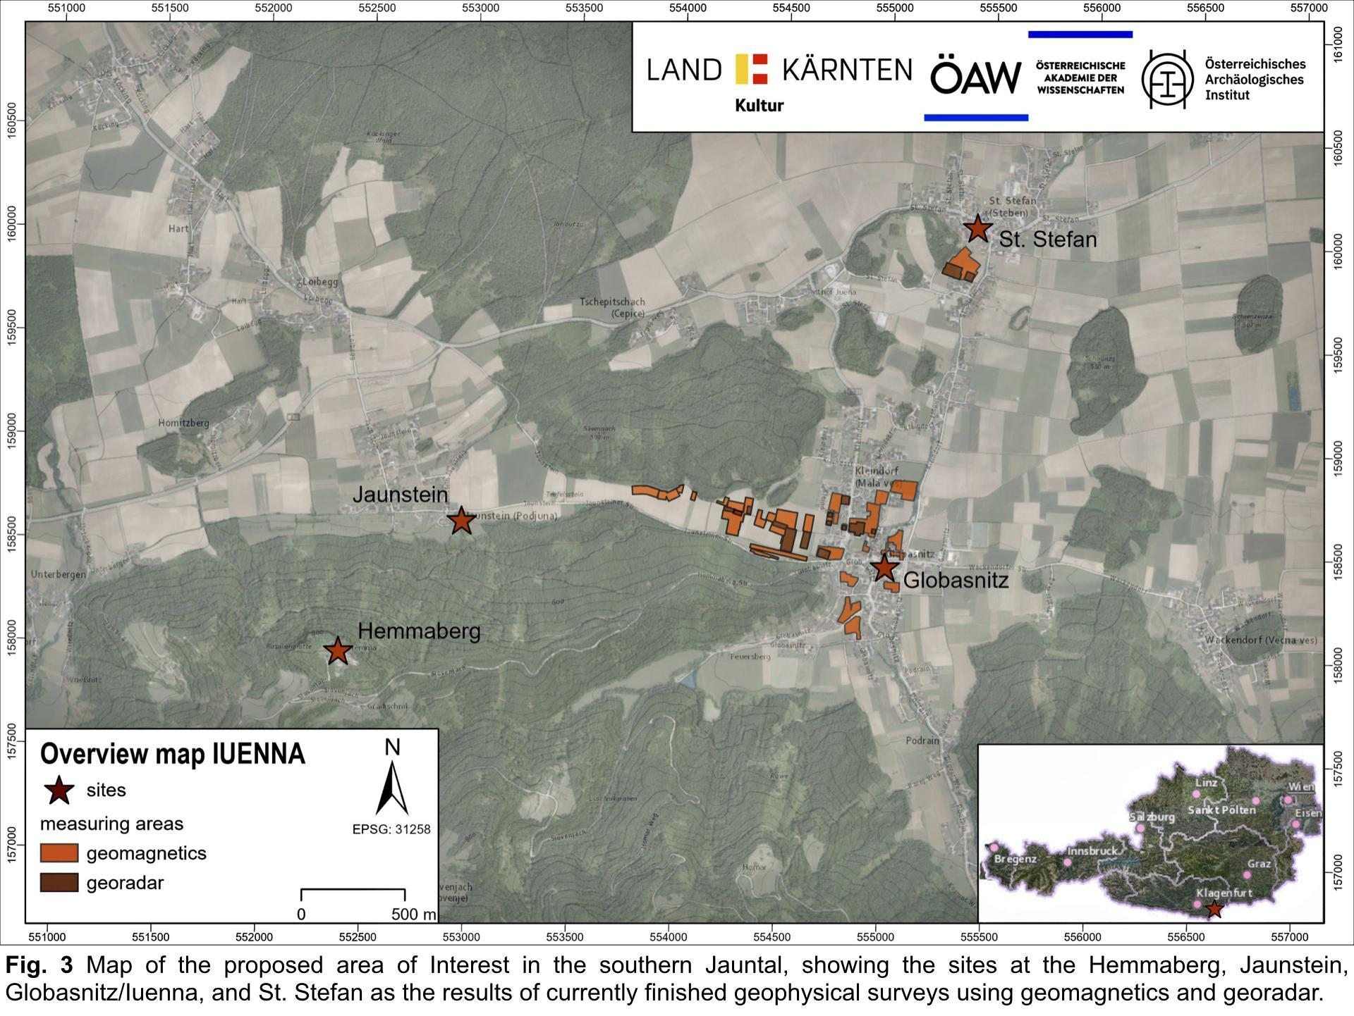
There is an urgent need for action about this archaeological data treasure in administrative, thematic, and methodological issues concerning the overall precarious situation of the data, which are currently stored in various locations, mainly completely unstructured and therefore at a tremendously high risk of loss. This situation results primarily because, after a phase of intensive field research during the last decades, a large and diverse set of documentation materials exists that should be promptly digitized, structured, and archived for the long term to keep it available. However, the Jauntal Valley is not a particular case: As shown by various enterprises with a strong focus on Digital Humanities (DH), particularly those employing GIS applications, archaeological projects – especially long-term excavations – often generate extensive and diverse sets of both analog and digital data. These can include hundreds, if not thousands, of analog documents and up to several terabytes of files (cf., for example, Eichert 2020; Filzwieser & Eichert 2020; Klehm 2023; Vargha 2022; Wallner et al. 2021). Acute action is needed to systematically transition these datasets from physical filing cabinets to a sustainable, networked virtual environment for long-term use (cf. for a similar approach STRUPLER 2021). Dealing with issues related to digital approaches, however, has a long history in archaeology, and the application of computational methods has a firm anchorage in that field, as can be seen in a wide range of current studies (e.g., ANICHINI ET AL., 2021; DI ANGELO 2021). ‘Digital archaeology’ investigates within DH the causes, effects, and characteristics of the phenomenon of digitization in archaeology (HAGMANN 2020). To a varying extent, the approaches of the so-called processual archaeology remained virulent in digital archaeology, which provides the discipline with vast experience in combining scientific and cultural-historical approaches to solve research questions related to cultural remains. Digital archaeology in the context of DH is, therefore, ideally suited to clarify such problems within archaeology. We, therefore, suggest three guiding questions to serve as a framework for the project:
- What steps must be taken to archive data from long-term archaeological projects, each containing diverse data from over 100 years of research?
- Which statements can be made on a thematic level about such an archaeological record?
- What lessons can be learned on a methodological level from such a project to provide a guideline for other existing and future projects throughout Austria to deal with similar data optimally?
To address these questions, we propose a pilot project for Austrian archaeology: All analog and digital archaeological data from the mentioned micro-region will be collected and structured in the first step. In a second step, it is planned to prepare the data for long-term archiving – this includes, in cooperation with the ACDH-CH, particularly the selection of the most important and meaningful data, data conversion, and adapting the data collection to the guidelines of the ÖAI and the repository ARCHE . The third step will be to transfer the processed data collection to the ACDH-CH for long-term archiving in ARCHE and to set up a WMA for interactive visualization. A final fourth step will be the cultural-historical evaluation of the data in terms of a model study for Globasnitz and its surroundings.
The main challenge for IUENNA lies in dealing with extensive data sets originating from different sources and research methods and digitizing and managing large quantities of finds in a reasonable time. Our whole raw stock of archaeological research data has thereby spatial, temporal, and qualitative/thematic components: The vast amount of data is available in both digital and, for the most part, analog form (approx. 8 meters of files/folders in various DIN formats and ca. 250 GB of digital data, including geophysics and 3D data from building scans). In the project, analog archival material like photos, technical drawings, and hand-written documents will be digitized, georeferenced, and mapped. Digital-born data like the record of recently excavated features (consisting of different data types and file formats, including 3D data) or geophysical data will also be included in our planned geodatabase; empirical values already exist from the Troesmis project, see GUGL - TROGNITZ 2020 for an overview on the general concept.
The expected result is a best practice model study for the long-term archiving and interpretation of exceptional long-running cultural-historical excavations in an utmost important archaeological micro-region of the southern Jauntal with its international archaeological significance, further strengthening archaeology under the umbrella of digital humanities. Hence, IUENNA will preserve archaeological data, which equals the knowledge of 2000 years of human history for the future.

Innovative aspects and relevance
Our project follows a thorough, open science approach: IUENNA will result in a sustainable and comprehensive long-term archive of an elaborated decade-long excavation and its surroundings on a methodological level, using one of the most critical sites as a case study. IUENNA integrates legacy and current data by comprehensively using a geographic information system (GIS) which suits perfect for managing, analyzing, and presenting (by [web-]maps) manifold spatio-temporal data types and file formats. On a thematic level, we will offer an outstanding model study on Globasnitz and its surroundings from the Roman period, serving as an exemplary case study for research on the local settlement pattern, including a detailed typo-chronological examination of the archaeological record – the model study is thereby based on the data processed in the course of IUENNA. With this aim in mind, we will design and finetune a sustainable working pipeline to manage diverse archaeological data to enable its long-term preservation, wide-ranging shareability, and the transferability of archaeological knowledge via open access. These measures will increase the efficiency of the archaeological workflow by introducing a practical guide for future projects.
We aim to showcase a best practice example for future Austrian archaeology projects by providing extensive documentation about data structuring, folder organization, and enrichment with structured metadata. The added value for the global research community will thus be freely accessible archaeological data for an archaeological micro-region, represented by a concise model study for Globasnitz, as well as practical guidelines for data and workflows related to long-term projects which enables other groups worldwide to build on top of our results methodologically and thematically. IUENNA’s new and open data management and storage approach can also be applied to other projects. IUENNA will fill a previously missing gap and enable new insights into human behavior and material culture for archaeology and the future by creating a newly structured, clearly arranged repository of born-digital and retro-digitized data. The digital added value for the national and international archaeological research community will be freely accessible and long-term archived multi-scale archaeological primary data in combination with associated interpretations and comprehensive visualizations, user-friendly dissemination through an easy-to-use WMA and ARCHE, as well as newly gained experience as a best practice example for handling digital research and metadata for future projects. The data archived in ARCHE will also be discoverable via the ARIADNE portal through an OAI Protocol for Metadata Harvesting (OAI-PMH) interface. These activities will help position the project internationally as an outstanding case study for open long-term archiving archaeological data in DH and Roman archaeology.

Methods and tools used
We pursue a strategy for free, open, and sustainable data dissemination and actively implement open science ideas, ensuring that our data are FAIR (HAGMANN 2020; NICHOLSON ET AL. 2023; WILKINSON ET AL. 2016). The project output, including all structured metadata, will be freely available online for the long-term and citeable via the repository ARCHE in full open access as far as possible, using CC BY 4.0 (Creative Commons Attribution 4.0 International) and a WMA. ARCHE is dedicated to provide long-term preservation, interoperability, and open access to a diverse range of digital humanities data. With features such as rigorous data curation, advanced search functionalities, and a user-friendly interface, ARCHE aims to centralize resources and enhance collaboration among researchers, educators, and policymakers – the platform thereby offers significant benefits like quality assurance and interdisciplinary collaboration (IANUS 2017; TROGNITZ & ĎURČO 2018; https://arche.acdh.oeaw.ac.at/). Our data will also be findable on the ARIADNE portal via ARCHE’s dissemination service strategies (https://ariadne-infrastructure.eu/).
The project involves a comprehensive approach for structuring and modifying all relevant data types and file formats, generally characterized as multifaceted and diverse and (yet to be retro-digitized) analog and digital-born data. Original (analog and digital) survey data were initially collected in the field and produced during post-processing. Further, qualitative and quantitative data (recorded as images, hand-drawn maps, tables, descriptive texts, etc.) give thematic information on the archaeological record. The expected amount of data will therefore consist of small (<100 KB) and big (> 1 GB) files and not exceed 4 TB in volume in total. To cope with these data appropriately, we follow recent digital humanities paradigms in open science: for data input, management, and processing, free and open-source software (FOSS) will be used as far-reaching as possible, and the whole data management and -storage workflow will be compliant with various open access initiatives and according to the FAIR principles. (BIBBY – DUCKE 2017)
We will organize and connect all available multifaceted archaeological data in a sophisticated, multilayered GIS coupled with a geodatabase. This measure enables us to keep and query all project-relevant information in one place, acknowledging the micro region’s complex role as an archaeological landscape in time and space and the data variety. Our raw stock of archaeological data has spatial components, so that we will use the GIS as the central tool for all archaeological data for cultural-historical studies, digital cartography, and comprehensive visualizations. (CONOLLY – LAKE 2006; GILLINGS ET AL. 2020) As mentioned above, the data will be organized in an enhanced file folder structure following the BDA specifications for the data organization of the guidelines for archaeological measures, which are binding for the data transfer to the BDA for all archaeological activities since 2012. (GUGL – TROGNITZ 2020) For optimal comprehensiveness, each physical object is treated as an individual database record, provided the necessary information is available – consequently, each archaeological entity is assigned a unique identifier and is accompanied by structured attributes detailing the material's archaeologically significant properties, such as feature type (e.g., wall) or vessel form type (e.g., dish). When applicable, finds are incrementally linked to their relevant contextual information, facilitating spatial and stratigraphic referencing. This linking may occur on multiple hierarchical levels, connecting the artifact to its corresponding archaeological feature (e.g., cellar), the feature to its associated find zone, and the find zone to its position within modern topography. The whole geodatabase can be easily archived in the repository. Consequently, we use a functional archaeological knowledge management design that integrates all context- and artifact-related data in one place that stands out compared to other projects. For 3D models, ARCHE provides the capability of archiving and viewing all models and assigning a stable link for sustainable (re-)use. 3D models and other datasets can be joined with the archaeological records, offering access to all qualitative, spatial, and temporal attributes. Version control is done via our strategy for data storage and by applying concise file naming conventions that include version numbers. As mentioned above, data are recorded using standardized digital forms to guarantee quick and simultaneously as error-free as possible. All data are checked for qualitative accuracy by various project members (dual control principle). A further check is carried out at least once more during the project; a final check is performed at the end of each work package (WP).
To ensure maximum verifiability, we will apply controlled vocabularies for chronology, finds, and features tailored to our topic, guaranteeing a standardized common understanding of our archaeological data. To accomplish this task, we will, if available, re-use terms and concepts already established in cultural heritage (e.g., Getty Research Institute’s AAT, PeriodO, FISH, or the controlled vocabulary currently developed at the ÖAI) as far-reaching as possible.
QGIS as FOSS is used to index and manage the data. For (retro-digitized) images and research literature, during the project, image management software (like Tropy or Adobe Bridge), a reference management program (Zotero), and other open-source software capable of handling archaeological data (Gimp; Inkscape; MeshLab; CloudCompare) will be used. Dissemination will be achieved following a strategy (cf. below), including an easy-to-use lightweight WMA using FOSS to disseminate geodata to provide a complete overview of our topic. All archaeological data get enhanced with structured metadata for all datasets an can be made available the project-, collection-, and file-level, following current best-practice guidelines (IANUS 2017). As mentioned above, long-term data archiving, dissemination, and permanent citeability will be accomplished using the ARCHE repository by providing a persistent identifier (PI) based on the Handle System. (TROGNITZ 2021)

Work plan, role of team members, interdisciplinary, and collaborative aspects
Stringent data management during the whole run of the proposed project is of utmost importance for the success of the planned undertaking. Our young digital archaeology/DH expert team is ideally suited to tackle this vital task. The following work plan provides an overview of the planned WPs handled during IUENNA and lists a general planned project timeline (Tab. 1; Dia. 1):
- At the project's outset, data must be acquired from respective project partners for processing. The data, both digital and analog, come in various formats and documents. Collection of this data requires coordination with responsible offices, most notably the LMK, the Archaeological Pilgrimage Museum Globasnitz, the ÖAI, and other steakholders. Once collected, the data are centralized within IUENNA for processing, as they are exclusively stored at partner depots. Proper transport logistics are essential, especially for voluminous analog data. Initial sorting and filing of the collected data must be performed before the end of the project's second quarter, factoring in a time buffer. Quality control protocols, as outlined in the Data Management Plan (DMP), will be applied.
- WP2 focuses on transferring diverse data inventories into a pre-planned folder structure, developed alongside organizational tasks. Analog data undergo retro-digitization and spatial datasets are georeferenced. Upon initial digitization or reorganization, metadata enrichment starts, while digitization and organizational efforts continue. WP2 aims for completion by the start of the project's second year, with quality control in alignment with the DMP.
- WP3 commences in the project's second year, leveraging data processed in WP2. This work package involves archaeological-thematic evaluation of the collected data, incorporating material culture studies and cultural interpretation. This aims to deepen scientific insights, building upon existing research while integrating new findings, particularly those near Iuenna. This will enable nuanced historical interpretations of rural settlement activities in the microregion.
- WP4 serves as the project's methodological core, focusing on long-term archiving of the processed data. Initiating in parallel with WP1, this work package aims to make archiving seamless and sustainable. Periodic reviews occur throughout the project, with the most intense phase of WP4 culminating in the final long-term archiving, including technical preparation and implementation of the WMA as a dissemination service.
- WP5 oversees the project in relation to planned science communication activities throughout the project's lifespan.
This structure ensures efficient data collection, processing, evaluation, and long-term archiving, all under the quality control frameworks stipulated in the DMP.

Tab. 1 Work plan
WP No. | Description | Timeframe*
1 | data preparation | Q1/Y1 to Q2/Y1
2 | data processing | Q2/Y1 to Q3/Y2
3 | archaeological evaluation and analysis | Q1/Y2 to Q4/Y2
4 | long-term data archiving | Q1/Y1 to Q2/Y1  Q4/Y1 to Q1/Y2  Q3/Y4 to Q4/Y4
5 | social media and public relations | Q1/1 to Q4/Y2
*The table provides an overview of the planned WP-related tasks of each project quarter (Q) within the respective project year (Y), excluding the projected travel expenses and costs for mobile storage devices
Dia. 1: Work plan – Gantt diagram
Work package | Responsibility | year 1 |  |  |  | year 2
 |  | Q1 | Q2 | Q3 | Q4 | Q1 | Q2 | Q3 | Q4
WP 1:  Data preparation | LMK  ÖAI
WP2:  Data processing | ARDIG  ÖAI/LMK
WP3:  Archaeological evaluation and analysis | LMK  ÖAI
WP4:  Long-term data archiving | ARCHE  LMK
WP5:  Social media and public relations | LMK

By selecting two young, promising, early-career researchers as PIs, the project will help promote their research and provide sustainable outputs. The team members complement each other just as ideally in their skills: D. Hagmann, as PI01, will take care of the archaeological part (i.e., the archaeological model study), data management and preparation for long-term archiving, project representation, social media, and coordinate the external services (WP1 to 5). F. Reiner, as PI02, will be systematically involved in the processing and interpreting of the geophysical data, generating cartographic visualizations, and contributing to the model study accordingly (WP2 to 3). N. Math will be involved in the retro-digitization of analog research data and data management tasks (WP1 to 3). The ACDH-CH will take care of long-term data archiving in ARCHE and are active in an advisory role; members of ARDIG will execute digitization and georeferencing tasks (WP4/WP2).

In its inter- and transdisciplinary orientation, IUENNA can be seen as an DH project, which combines approaches from archaeology, geoinformatics, geophysics, and computer science. Therefore, the research approach balances technical aspects with the interpretive framework concerning the historical-cultural elements of the material culture in Globasnitz, the Hemmaberg, and the surrounding areas. This integrated approach yields a comprehensive, long-term archival dataset for an archaeological microregion, completed with a model study that exemplifies the characteristics of rural settlement in the area.
The expertise of the team members will fruitfully contribute, on the one hand, to the model study and, on the other hand, to the archiving of the data during the whole project run.
Previous projects already showed the excellent ability of cooperation between the institutions involved in the project proposal; this concerns, in particular, on one side, the cooperation between the LMK and the ÖAI, for example, among many, the long-lasting and fruitful archaeological fieldwork projects in the surroundings of the municipality of Globasnitz (cf. BINDER – LADSTÄTTER 2019). On the other side, the cooperation between the ÖAI and the ACDH-CH shows the ability of successful cooperation in digital archaeology, as it became evident regarding the long-term archiving project on the legionary fortress of Troesmis (cf. GUGL - TROGNITZ 2020). ARDIG as a professional archaeological service provider has experience in cooperation with both the ÖAI and the LMK. All partners mentioned above, and institutions have finally extensive experience in successful cooperation with the BDA.

Expected impact
Using IUENNA as a case study for handling diverse archaeological datasets will add value to the global research community as well as to all project partners: The most important outcome will be structured and freely accessible archaeological data for an archaeological micro-region, represented by a concise model study, and practical guidelines for data and workflows related to long-term projects, which will enable other research groups not only in Carinthian archaeology but also in Austria and even worldwide to build on our results methodologically and thematically; for these reasons the proposed project is of interest to all groups working on digital classics.
For ACDH-CH and BDA, the added value lies in the development of an comprehensive archiving structure for archaeological field projects that are adapted or modified to the BDA guidelines (these are binding in Austria for archaeological measures), which can also be accompanied by the (further) development of tools and new regulations for data management. For the LMK, the added value lies in sustainably archiving one of Austria’s most crucial archaeological data collections; the workflows developed in the project can further be transferred to other sites. For the ÖAI, the added value lies in expanding expertise in managing extensive archaeological data collections; new empirical values can be gathered in assessing other data sets, providing a sound basis for future projects.

Sustainability
The project will be based on a close interdisciplinary collaboration between the ÖAI as Austria’s leading archaeological research institution, the LMK as one of Austria’s most prominent memorial institutions, the BDA as Austria’s federal monuments authority, and the ACDH-CH at the ÖAW as Austria’s top institution for DH. The conditions for this project are ideal: The ÖAI and its Digital Archaeology and Classics (DAC) unit have relevant, existing know-how due to the already completed archiving of archaeological data collections (c.f., e.g., the Troesmis-project; GUGL – TROGNITZ 2020). The unit is positioned at the intersection between archaeology and information science, while excellent contacts with the ACDH-CH and numerous close cooperation projects with the LMK and the BDA exist. The LMK has been the executing institution of most of the research activities in the Jauntal in the last decades and owns most of the archaeological data of the proposed project; it provides extensive know-how on most archaeological features.
Further, the BDA is responsible for Austria’s legal cultural heritage management regulations, providing extensive administrative know-how. Assigning DH-tasks to ARDIG as an archaeological service company additionally connects to one of Austria’s most important archaeological data providers, spanning an arch across all functional participants in today’s Austrian archaeological landscape in terms of modern research, ensuring the timely completion of the assigned tasks.

Dissemination strategy
We aim to publish in leading peer-reviewed journals like the Theoretical Roman Archaeology Journal (TRAJ), , or the renowned Jahreshefte des Österreichischen Archäologischen Institutes in Wien (ÖJh) and follow innovative approaches like open peer review (via PCI Archaeology). We plan further a publication about the dataset itself in the Journal of Open Archaeology Data (JOAD); besides, we will disseminate data via ARCHE to ARIADNE, which will further increase the outreach. A kick-off workshop is hosted in 2023 in the course of the round table “No Cradle of Filth – Zero Data Waste through the 5Rs in Austrian Digital Archaeology?” at the 28th Conference on Cultural Heritage and New Technologies (CHNT; https://chnt.at/), and other conference presentations are scheduled for 2023/2024 at the Theoretical Roman Archaeology Conference 2023 (title: “5 Minutes, 4d-data, 3d-reconstructions, 2 Case-studies, 1 Goal: Archiving for the Long-term. Applying Sustainable Digital Archaeology to the Material Culture of the Jauntal- and Traisental-valleys”; https://trac2023exeter.wordpress.com/) or the Austrian Day of Archaeology (“Österreichischer Archäologietag”) in 2024 (title: “IUENNA – openIng the soUthErn jauNtal as a micro-regioN for future Archaeology”). Furthermore, we enhance the project’s visibility by hostinga specific project web page for presenting and outlining the project (https://iuenna.hypotheses.org/), contributing to the ‘Digital Humanities Austria’ register (https://digital-humanities.at/en/dha/s-project/iuenna-opening-southern-jauntal-micro-region-future-archaeology), and using an identifying logo for the project. Additionally, we use (scientific) social network sites (Academia.edu, ResearchGate, and X [https://twitter.com/project_iuenna]) as well as a dedicated hashtag (#IUENNA). At least one blog post is planned for the research section of an Austrian newspaper. Furthermore, the project can actively contribute to university teaching. These measures will guarantee maximum public awareness by applying science-to-science and science-to-public communication.

Description of risks and proposed risk mitigation measures and contingency plan
Although the actual probability of occurrence can be assumed to be very low, specific threats may occur in the project that may cause the project objectives not to be met. As a result of the proposed contingency plan, such irregularities can be detected early, and appropriate countermeasures can be taken in time to eliminate any negative impact on the project’s progress. Likewise, fixed routines guarantee in advance that specific problem points will not occur in the first place. (Tab. 2)

Ethics aspects
There are no ethical barriers. For bioarchaeological data, which may be available from excavated cemeteries as (analog and digital) technical drawings, photographs, survey data, and 3D models, we apply the latest internationally renowned standards on ethics, such as the Code of Ethics by the British Association for Biological Anthropology and Osteoarchaeology. Sensitive data can also be subject to stricter access options in the repository, although full open access is always prioritized.

Tab. 2 Description of risks and proposed risk mitigation measures
Aspect | Threat | Risk factor | Probability | Counteraction/s
Loss of metadata | poor data management | not meeting project goals | very low | consistent and active data management
data access | no access | not meeting project goals | very low | comprehensive scheduling  systematic project coordination
software | severe technical problems | not meeting project goals | very low | involvement of partners for technical support  use of different software
dissemination | output not considered by recipients | not meeting project goals | very low | adaption of the dissemination strategy
lack of partner contributions | delay of project progress | not meeting project goals | very low | systematic project coordination  use of interactive management tools for project coordination  legal binding project agreements between the funding source, host institutions, and the project partners
management | poor management | not meeting project goals | very low | systematic project coordination  regular project meetings (jours fixes) for discussing actual needs  transparent communication

Discussion
This paper is composed based on the IUENNA research project proposal with the specific aim of formally presenting the project's foundational objectives to a broad audience in advance. This proactive strategy allows for “real-time” feedback that could identify areas for improvement not captured in the international, multi-stage review process associated with proposal submission. Such insights could constructively influence the IUENNA project, enabling timely adjustments to the research approach or objectives. This approach highlights the importance of open scholarly discourse and iterative development, particularly when innovative methodologies are involved. Unlike traditional papers that focus on scientific findings, works like this one can be seen as "unstructured para-descriptions," akin to "meta-descriptions" in HTML, which serve as concise summaries without adhering to a formal standard.
We are pleased to note that the project's objectives and planned work steps have thus far avoided substantial criticism. However, the public evaluation approach (i.e., peer-review process) we are pursuing has elicited some critique. This feedback has been invaluable in the project's early stages, but it is important to clarify that the absence of substantive criticism should not be considered an unequivocal endorsement of the project's ultimate success. Rather, it serves as an initial validation of its foundational principles.
Papers such as this one can be related to “project presentations” or even “registered reports” in other scientific disciplines, as emphasized by Chambers & Tzavella (2022). Such reports prioritize methodological rigor and mitigate issues like data dredging or selective reporting. In this context, it should be noted that we are operating on a theoretical meta-level, aiming to discuss the fundamental purpose and essence of the research idea more than focusing on the meticulous procedural details. However, it is not our intention to establish a new field or define a new direction within this framework. Rather, our focus remains on deepening the understanding of existing paradigms through critical discussion at a meta-theoretical level. In that sense, the inclusion of "paradata," detailed records of the research workflow as highlighted by Börjesson et al. (2022), adds another layer of scholarly output. It is crucial to mention that this approach is not novel and has been substantiated in a manner quite comparable by reputable journals, including those in the field of archaeology – cf., e.g., GUEST et al. (2023).
To ensures rigor and transparency, our engagement with the open-review framework through Peer Community In (PCI) Archaeology aligns with academic best practices. Papers like ours can serve as roadmaps for future research, providing a structured framework without necessarily presenting empirical findings. These methodologically oriented papers coexist with result-focused papers, enriching the academic discourse by allowing a more comprehensive approach to research questions. We have chosen to align with the PCI Archaeology initiative, as stated by Queffelec et al. (2023), due to their commitment to an open peer-review process and the use of preprints. This platform has validated our approach by enabling us to receive valuable, transparent feedback on our IUENNA project swiftly, hence incorporating it in the present paper. Critical reviews of experimental papers like ours thereby contribute to a larger dialogue about scholarly contributions in archaeology. They emphasize the importance of methodological clarity and workflow transparency, including risk assessments and ethical considerations. “Para-descriptions” like the present one thus enrich both the individual project and the broader academic landscape, questioning what constitutes a meaningful contribution to the scholarly community.

Paper life-cycle
- Version 1.0.0: The contents of this paper correspond to the successfully accepted proposal submitted as part of the Go!Digital 3.0 project application in an international, competitive, multi-stage review process. It incorporates feedback from the proposal reviewers and includes minor changes such as typo corrections and chapter rearrangements (budget and data management plan are not included). In addition, project-relevant information that became available after project approval (e.g., project number, URIs, and funding information) has been added.
- Version 2.0.0: The initial version of the paper was uploaded to the OSF Preprints platform, where it was assigned a DOI (https://doi.org/10.31219/osf.io/5vwg8). Subsequently, the paper underwent an open peer review process on the PCI Archaeology platform, managed by Ronald Visser as recommender. The present version incorporates feedback from four reviewers, which has significantly strengthened the paper, particularly its experimental approach on paradata recording. Version 2.0.0 further includes minor changes such as typo corrections and chapter rearrangements.

Acknowledgments
The authors thank the reviewers for their valuable input. Further, they thank Christian Gugl, Nina Richards, Martina Trognitz, and Ronald Visser for their extensive guidance to this text. The authors would also like to thank Heimo Dolenz, Sabine Ladstätter, Christian Wieser, Helmut Schwaiger, and Franz Glaser for their support.

Funding
This paper was funded by the Go!Digital 3.0 program of the Austrian Academy of Sciences (project number GD3.0_2021-24_IUENNA).

Open access statement
Except where otherwise noted, the content of this paper is licensed under a Creative Commons Attribution 4.0 International license. The ÖAI holds the copyright of all figures.

Image credits
Fig. 1: Image by ÖAI/ÖAW
Fig. 2: Image by ÖAI/ÖAW
Fig. 3: Map by ÖAI/ÖAW (basemap: ESRI)

Conflict of interest disclosure
The authors of this paper declare that they have no financial conflict of interest with the content of this article.

Bibliography
ANICHINI, F., DERSHOWITZ, N., DUBBINI, N., GATTIGLIA, G., ITKIN, B., & WOLF, L. (2021). The Automatic Recognition of Ceramics from Only One Photo: The ArchAIDE App. Journal of Archaeological Science: Reports, 36, 102788. https://doi.org/10.1016/j.jasrep.2020.102788
BIBBY, D., & DUCKE, B. (2017). Free and Open Source Software Development in Archaeology. Two Interrelated Case Studies: gvSIG CE and Survey2GIS. Internet Archaeology, 43. https://doi.org/10.11141/ia.43.3
BINDER, M., & LADSTÄTTER, S. (Eds.). (2019). Die Heilige vom Hemmaberg: Cold Case einer Reliquie (2nd ed.).
BÖRJESSON, L., SKÖLD, O., FRIBERG, Z., LÖWENBORG, D., PÁLSSON, G., & HUVILA, I. (2022). Re-purposing Excavation Database Content as Paradata: An Explorative Analysis of Paradata Identification Challenges and Opportunities. KULA: Knowledge Creation, Dissemination, and Preservation Studies, 6(3), 1–18. https://doi.org/10.18357/kula.221
CHAMBERS, C. D., & TZAVELLA, L. (2022). The Past, Present and Future of Registered Reports. Nature Human Behaviour, 6(1), Article 1. https://doi.org/10.1038/s41562-021-01193-7
CONOLLY, J., & LAKE, M. (2006). Geographical Information Systems in Archaeology. https://doi.org/10.1017/CBO9780511807459
DI ANGELO, L., DI STEFANO, P., GUARDIANI, E., & MORABITO, A. E. (2021). A 3D Informational Database for Automatic Archiving of Archaeological Pottery Finds. Sensors, 21(3), 978. https://doi.org/10.3390/s21030978
DORNIG, N. (2014). Eine archäologische Landschaft zur Römerzeit. Das Jauntal. In E. Trinkl (Ed.), Akten des 14. Österreichischen Archäologentages am Institut für Archäologie der Universität Graz vom 19. bis 21. April 2012, 83–92.
EBNER, D. (2009). Entwicklung der archäologischen Forschung und deren museale Präsentation ab dem 20. Jahrhundert in Kärnten [Masterthesis, University of Vienna]. https://doi.org/10.25365/thesis.4784
EICHERT, S. (2020). Herrschafts- und Sozialstrukturen im frühmittelalterlichen Ostalpenraum (Vol. 511). Verlag der Österreichischen Akademie der Wissenschaften. https://austriaca-at.uaccess.univie.ac.at?arp=0x003b6757
EICHERT, S., & RICHARDS, N. (2020). Ostalpenraum Revisited: Stand und Perspektiven der Forschung zum frühmittelalterlichen Ostalpenraum im 21. Jahrhundert. In R. Prien & J. Drauschke (Eds.), Quo vadis, Frühgeschichtliche Archäologie? Tagungsbeiträge der Arbeitsgemeinschaft Spätantike und Frühmittelalter: 9. Quo vadis, Frühgeschichtliche Archäologie? Standpunkte und Perspektiven (Berlin, 6.-8. Oktober 2014) (pp. 171–186). Verlag Dr. Kovač.
EITLER, J., & SEIDEL, Y. (2022). Das Gipfelplateau des Hemmabergs: Bruch – Wandel – Kontinuität. Ergebnisse des FWF-Projekts Cult Continuity at the Summit of Hemmaberg (P29452-G25). Verlag des Landesmuseums für Kärnten.
FILZWIESER, R., & EICHERT, S. (2020). Towards an Online Database for Archaeological Landscapes: Using the Web Based, Open Source Software OpenAtlas for the Acquisition, Analysis and Dissemination of Archaeological and Historical Data on a Landscape Basis. Heritage, 3(4), 1385–1401. https://doi.org/10.3390/heritage3040077
GLASER, F. (1982). Die römische Siedlung Iuenna und die frühchristlichen Kirchen am Hemmaberg.
GLEIRSCHER, P. (2000). Ausgrabungen am Katharinakogel bei St. Michael/Bleiburg. Rudolfinum- Jahrbuch des Landesmuseums für Kärnten, 2000, 25–32. https://www.zobodat.at/pdf/Rudolfinum_2000_0025-0032.pdf
GUEST, P., MA, H., MION, L., LAMB, A. L., & MADGWICK, R. (2023). Feeding the Roman Army in Britain. Antiquity, 1–5. https://doi.org/10.15184/aqy.2023.110
GUGL, C., & TROGNITZ, M. (2020). 2000 Jahre und länger. Archivierung digitaler Daten des Troesmis-Projekts. In L. Berger, L. Huber, F. Lang, & J. Weilhartner (Eds.), Akten des 17. Österreichischen Archäologentages am Fachbereich Altertumswissenschaften, Klassische und Frühägäische Archäologie der Universität Salzburg vom 26. bis 28. Februar 2018, 109–119.
HAGMANN, D. (2020). Digitale Archäologie in einer sozialen Dimension: Überlegungen zu sozialer Inklusion und Open Science in der digitalarchäologischen Praxis. In L. Berger, L. Huber, F. Lang, & J. Weilhartner (Eds.), Akten des 17. Österreichischen Archäologentages am Fachbereich Altertumswissenschaften, Klassische und Frühägäische Archäologie der Universität Salzburg vom 26. bis 28. Februar 2018, 121–130. https://doi.org/10.25365/phaidra.125
IANUS (Ed.). (2017). IT-Empfehlungen für den nachhaltigen Umgang mit digitalen Daten in den Altertumswissenschaften. https://doi.org/10.13149/000.y47clt-t
KLEHM, C. (2023). The Use and Challenges of Spatial Data in Archaeology. Advances in Archaeological Practice, 11(1), 104–110. https://doi.org/10.1017/aap.2022.38
NICHOLSON, C., KANSA, S., GUPTA, N., & FERNANDEZ, R. (2023). Will It Ever Be FAIR?: Making Archaeological Data Findable, Accessible, Interoperable, and Reusable. Advances in Archaeological Practice, 11(1), 63–75. https://doi.org/10.1017/aap.2022.40
POLLAK, M. (2017). Spätantike und Merowingerzeit in den beiden norischen Provinzen. Ein erster Blick auf den ostgotenzeitlichen Friedhof von Globasnitz. In Dörfler, Ines, P. Gleirscher, S. Ladstätter, & I. Pucker (Eds.), Ad amussim: Festschrift zum 65. Geburtstag von Franz Glaser.
RICHARDS, N., EICHERT, S., LADSTÄTTER, S., CHEUNG, C., RICHARDS, M. P., & SALESSE, K. (2023). When Big Data Initiatives Meet: Data Sharing Between Thanados and Isoarch for Early Medieval Cemeteries in Austria. Data in Brief, 109250. https://doi.org/10.1016/j.dib.2023.109250
STRUPLER, N. (2021). Re-discovering Archaeological Discoveries. Experiments with Reproducing Archaeological Survey Analysis. Internet Archaeology, 56. https://doi.org/10.11141/ia.56.6
TROGNITZ, M. (2021). Saving Us from the Digital Dark Age: The Austrian Perspective. Internet Archaeology, 58. https://doi.org/10.11141/ia.58.2
TROGNITZ, M., & ĎURČO, M. (2018). One Schema to Rule them All. The Inner Workings of the Digital Archive ARCHE. Mitteilungen Der Vereinigung Österreichischer Bibliothekarinnen Und Bibliothekare, 71(1), 217–231. https://doi.org/10.31263/voebm.v71i1.1979
VARGHA, M. (2022). Modelling Christianisation: A Geospatial Analysis of the Archaeological Data on the Rural Church Network of Hungary in the 11th-12th Centuries. Archaeopress Archaeology.
WILKINSON, M. D., DUMONTIER, M., AALBERSBERG, IJ. J., APPLETON, G., AXTON, M., BAAK, A., BLOMBERG, N., BOITEN, J.-W., DA SILVA SANTOS, L. B., BOURNE, P. E., BOUWMAN, J., BROOKES, A. J., CLARK, T., CROSAS, M., DILLO, I., DUMON, O., EDMUNDS, S., EVELO, C. T., FINKERS, R., … MONS, B. (2016). The FAIR Guiding Principles for Scientific Data Management and Stewardship. Scientific Data, 3(1), 160018. https://doi.org/10.1038/sdata.2016.18
WALLNER, M., LÖCKER, K., GUGL, C., TRAUSMUTH, T., VONKILCH, A., EINWÖGERER, C., JANSA, V., WILDING, J., POLLHAMMER, E., & NEUBAUER, W. (2021). The ‘Archpro Carnuntum’ Project – Integrated Archaeological Interpretation of Combined Prospection Data, Carnuntum (Austria). Építés - Építészettudomány, 49(1–2), 77–95. https://doi.org/10.1556/096.2021.00005

