Machine Learning for UAV and Ground-Captured Imagery: Toward Standard Practices

Authors:
Kayeleigh Sharp (Northern Arizona University, kayeleigh.sharp@nau.edu),
Brooklyn Christofis (San Diego State University),
Hossein Eslamiat (Southern Illinois University, Carbondale),
Upesh Nepal (Cooper machine Company Inc., Georgia, USA),
Carlos Osores Mendives (Pontifical Catholic University of Peru)

Abstract
Our collaborative work began in 2019 with the intent to overcome obstacles that had arisen from the inability to access curated artifact collections from remote locations. It was our specific aim to not only create digital twins of excavated objects that could not be exported out of their country of origin, but also to emphasize the contextual associations of objects residing in hidden museum collections using a range of digital techniques. As part of a growing field project in 2022, machine learning (ML) with YOLOv5, a family of compound-scaled object detection models trained on the COCO dataset was used to classify visual data and advance our understanding of in situ archaeological phenomena prior to destructive fieldwork. While not the sole contribution, the use of object-based machine learning improved quality and range of information obtained in non-destructive site surveys and improved data sharing capacity. Despite challenges encountered while training the algorithm and classifying objects, combining ML with drone data collection will continue as part of our long-term spatial data recording procedure. Despite both success and failures reported here, this work contributes to greater standardization of ML techniques in archaeological practice.

Keywords: machine learning, archaeology, UAV & ground-based imagery classification, YOLOv5, non-destructive site survey

Introduction
As part of our growing field project in 2022, we applied machine learning with YOLOv5 (DeepLearning 2020; Jocher 2020), a family of compound-scaled object detection models trained on the COCO dataset (see PyTorch 2023) to classify visual data and advance our understanding of in situ phenomena on the ground prior to conducting destructive archaeological fieldwork. Beyond what have become well-established digital field and laboratory methods in archaeology (e.g. high-resolution data capture, instant digital recording and transfer with tablets and other small devices) over the past few decades, the application of Machine Learning (ML) for Unmanned Aerial Vehicle (UAV) and ground-captured imagery was expected to greatly expand our ability to select areas for intensified investigation or excavation in expedient, non-destructive ways. Expanding on what we had learned while analyzing physical collections in previous field and laboratory analyses (see Sharp 2019), the development of a neural network that was aimed directly at survey presented several unforeseen challenges.
Although some initial difficulties while learning to train the algorithm and classify objects left much work to be done, ML on archaeological survey data captured with UAV will continue to be more tightly integrated into our standard data collection procedure in the field. With intensifying efforts to integrate ML into various disciplines and industries, however, we still find ourselves in relatively uncharted territory with a growing list of archaeological models to follow (but see Alexakis et al. 2012; Bonhage et al. 2021; Caspari and Crespo 2019; Lambers et al. 2019; Orengo et al. 2021; Sakai et al. 2023; Verschoof-Van der Vaart 2022; Verschoof-Van der Vaart et al. 2019).
Upon our return to the field in 2022 after a three-year hiatus, we discovered that some areas of our study area had become dangerous and inaccessible, necessitating the incorporation of remote sensing technology in our initial surveys. The application of ML object/structure detection was expected to facilitate not only precision recording of all areas of interest but also to help determine various environmental risk factors like El Niño/La Niña climate fluctuations. Additionally, we were hopeful that our non-destructive site monitoring data would assist with heritage preservation issues that would arise in the future (e.g., Caster et al. 2022).
This paper discusses our successes and failures and future directions of our work in northern Peru, with the primary aim to contribute to the dialogue at this transformational moment in digital archaeology. Looking toward the future and aiming to foreshadow challenges that our project and others will face, we urge for intensified efforts toward standardization of practice and integration of streamlined methods in this fast-expanding branch of computational archaeology.

Implementing YOLO for UAV and Ground-based Image Classification and Analysis

In 2022, we applied UAV-remote sensing and ML in our short fieldwork season to increase the amount of terrain our small team could study over the ten-day period. In anticipation of training a dataset for automated object detection and classification, we used digital cameras and “LiDAR” enabled smartphones with GPS to augment the range of data that our survey teams encountered on the ground (and which were expected to be encountered in the future). As we have witnessed in other cases, we anticipated the quality and coverage of data collected to improve dramatically using these cost-effective techniques and highly portable tools. Additionally, we aimed to test the feasibility of applying UAV in our proposed long-term research; one of several non-destructive survey techniques that we are hopeful will become standardized for surveys in our challenging topographical, environmental, or biodiverse terrain.

In this regard, the range of circumstances we confronted in regional surveys are both long-standing and recent. In northern coastal Peru, concerns that have become more prominent are the result of increased frequency of extreme climate events, as well as reduced site monitoring and protection capacity over the past five years. Given the challenging environment and sometimes perilous terrain, the ability of UAV to ensure the safety of field crews makes it an ideal choice.

Nepal and Eslamiat (2022) provided the context and justification for using UAV drones. UAVs have already been employed in numerous domains, including traffic monitoring, surveillance, inspection, surveys, etc. UAV use in contemporary fieldwork is transforming the way the world is viewed. ML algorithms increase both speed and accuracy of information capture. With the deployment of deep neural networks in recent years, UAVs have taken over aerial sensing research in the urban, environmental, and agricultural sectors (see Nepal and Eslamiat 2022).
ML algorithms use multiple layers to extract data features and recognize patterns. Their application has been used in a wide range of industries, from creating autonomous UAV trajectories (Li et al. 2019) to making significant strides in unified, real-time object detection (Redmon 2016). After training and verification, these methods provide real-time object detection which makes them appropriate for autonomous robotics and UAV applications in archaeology. The development of computer vision and machine learning methods has also been aided by the usage of graphics processing units (GPUs) for ML algorithms (Nepal and Eslamiat 2022). This allowed us to incorporate object detection methods appropriate for real-time application in our archaeological fieldwork.
In this study, we tested the utility of both UAVs (both DJI Mavic and DJI Phantom 4 Pro) and ground-based image capture (iPhone Pro MAX and various Android smartphones) in our archaeological fieldwork. When combined with increasingly established object detection capabilities of ML programing, we found these methods to be both economical and accessible, a clear advantage recognized in other academic and industry applications of the technique (see Nepal and Eslamiat 2022).
In the world of artificial intelligence (AI), ML plays a critical role in facilitating automated learning. Several ML algorithms have become more widely use over the past decade (e.g., Naïve Bayes, Decision Trees, Neural Networks, Fuzzy C-Means or Convolutional Neural Networks), YOLO is a single stage object detection system that is extremely fast because it looks at entire images rather than pixels and uses a single convolutional network (Davies 2022). Several ML algorithms like recurrent neural networks (RNN, see Mittal 2020), or the R-CNN (Regions with CNN features) model (see Girshick et al. 2014) now available use two-shot object detection which improves accuracy but is more computationally expensive (Kundu 2023) because of their structure (Baheti 2021). YOLO (You Only Look Once) is an object detection algorithm that uses deep learning techniques to predict classes and bounding boxes or an entire image in a single run of the algorithm. A single-shot detection method, like YOLO, achieves the ideal balance between performance and speed/resources, whereas two-shot detection models perform better. YOLO enables the detection across a neural network in forward propagation (see Deepchecks AI 2024), making it appropriate for real-time application (Figure 1). Because of its accelerated rate of detection and our team’s prior experience using it (Nepal and Eslamiat 2022), YOLO was the object detections system used in this study.

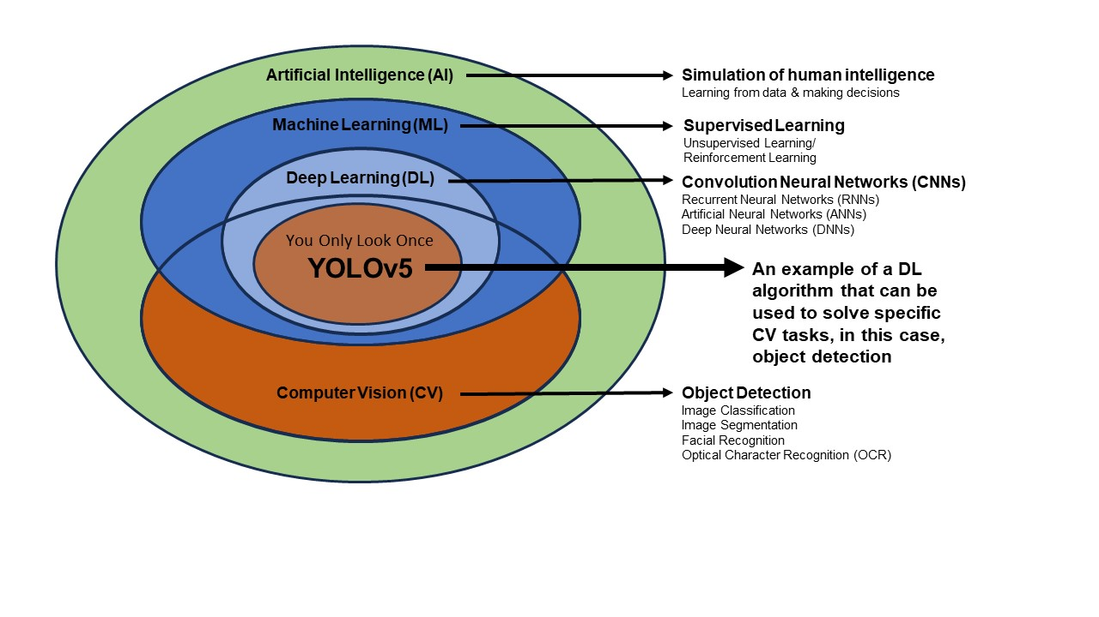
Figure 1: Diagram of the relationship between YOLO, ML and CV as subfields of AI

Data Set Successes and Challenges
The initial dataset selected for training the YOLOv5 algorithm consisted of aerial (100+ meters above surface) and near surface terrestrial imagery (ca. 1 meter) captured during 2022 fieldwork. While it was possible to distinguish various site components and concentrations of artifacts, construction materials and features including roads and walls in the UAV footage (Figure 2), we opted to use near surfaces imagery to explore the possibility of training the algorithm to identify smaller objects such as pottery in order to maximize the data collected during our short field season (Figure 3). For this reason, the images selected for training ranged from pictures of individual pottery fragments, pottery in a local workshop visited by the survey team in 2019, vessels fragments photographed in the lab during 2015 field season (Sharp 2019), and images downloaded from the internet that were representative of the range of vessel forms and decorative styles on pottery observed in the field.
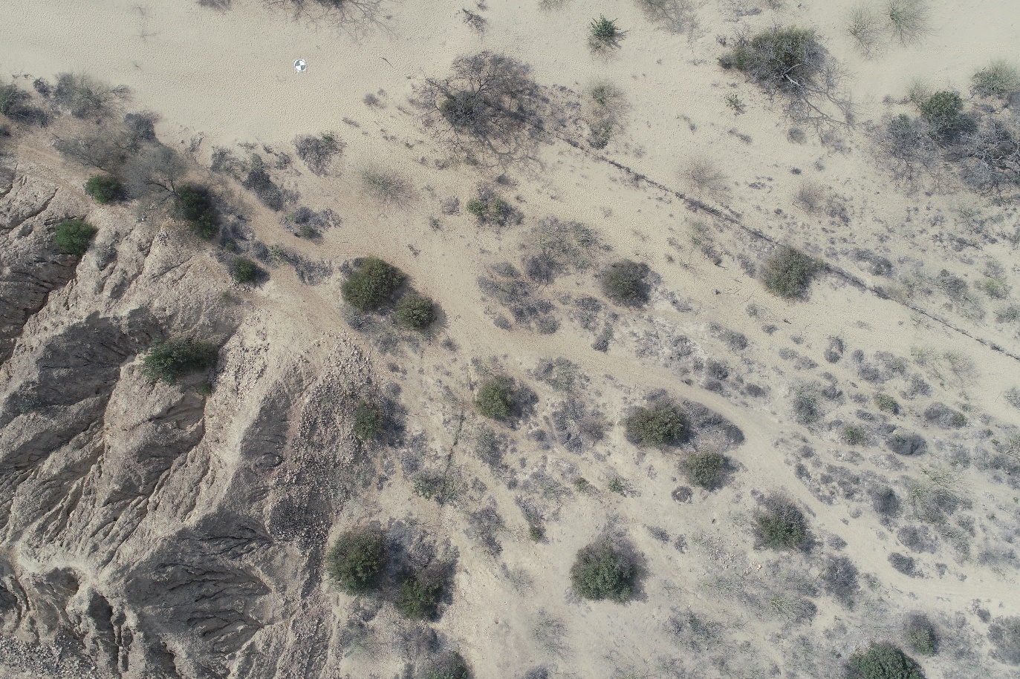
Figure 2: Aerial imagery initially proposed for training the algorithm.
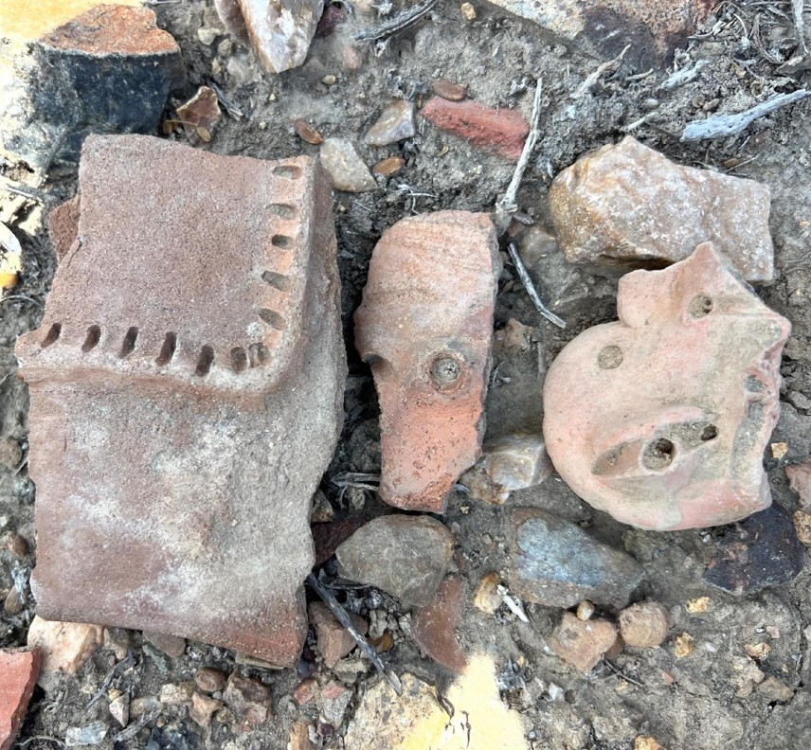
Figure 3: Example of field images of pottery and other materials in physical setting that comprise original training data which include pottery fragments in association with stones and twigs.
Downloading and installing programs to begin training revealed many compatibility issues while offline training of the algorithm with installed programs was bulky and required several steps. Considering the limitation of offline training on a Windows PC, we trained YOLOv5 for pottery sherd detection using the online Google Colab tool which allows Python commands to be implemented and stored in the cloud and easily shared (Zeman 2023).
Once we began working in the cloud, we were able to use several computing tools like the AI engine makesense.ai, to label our datasets categorically through bounding-boxes which made the method feasible when using consumer-grade PCs. The archaeologists on our team found this technique to be easy to learn and apply successfully, requiring only basic programming skills. Conveniently, the collaboration between GitHub repository and Ultralytics (Jocher 2020) supplied a Google Colab forum prefixed with a YOLOv5 training notebook. This provided the foundational base where our dataset (taken from 2022 fieldwork imagery) was input into Colab’s YOLOv5 training applications but the results were initially unsuccessful (Figures 4a and b).
After our YOLOv5 repository was established, a master folder containing training datasets (images) and their allocated labels was created – a compartment for each, titled “images” and “labels.” Inside these two folders, two more spaces were created to separate “train” and “validation” images and/or labeling. We then selected subsets from our original image data to create validation datasets used to fine-tune and evaluate the performance of our model during training. For this purpose, we chose collections that replicated the natural ‘noise’ of the landscape, where pottery sherds were scattered along rocks, found on dirt, and in association with sticks and leaves. With the master folder uniform, we began the process of bounded-box labeling for both the training and validation datasets. Makesense.ai allowed us to upload photos, set up personalized labels, and transfer our new labels into various components of our images.
During initial training proves, it was revealed that YOLOv5’s pre-existing classes were confusing object detection, requiring re-classification. For example, in the initial training session, the YOLOv5 misidentified pottery specimens as modern objects like toilets, hammers or books (Figure 5). Ergo, we edited the code on this file to match the classes/labels that we had created initially. Ensuring that our project-specific constraints were now recognized, we changed the number of classes to 4, and the names (labels) to “stone”, “sherd”, “stick”, and “leaf” which improved detection (Figures 6a and b) and produced meaningful results (Figure 7). With these adjustments in place, the data were re-imported back into Colab’s YOLOv5, where we could finally test detection capabilities in our workspace. After training at 150 epochs, we achieve a precision score of .28 and a recall score of .23, based on 56 images used in the training of the initial model. Although statistically marginal, several important observations were made. Our results of this pilot experiment are discussed in the following section.

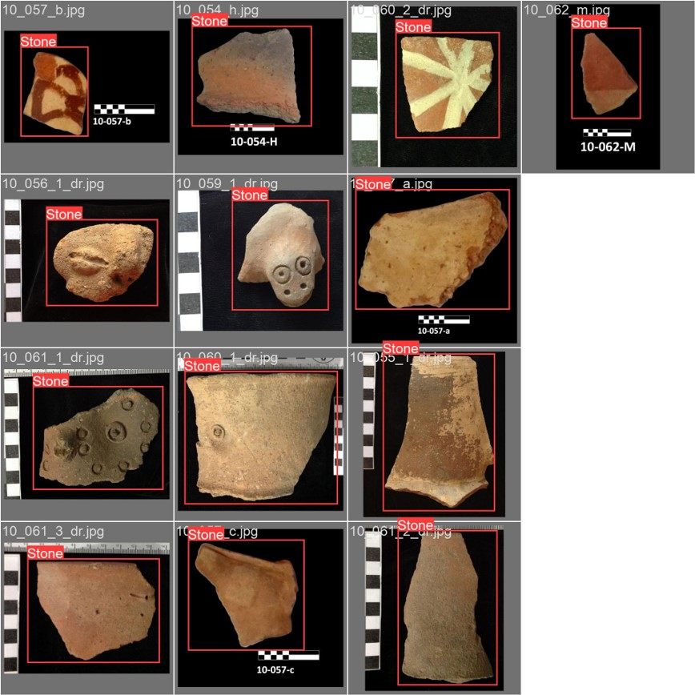 a.
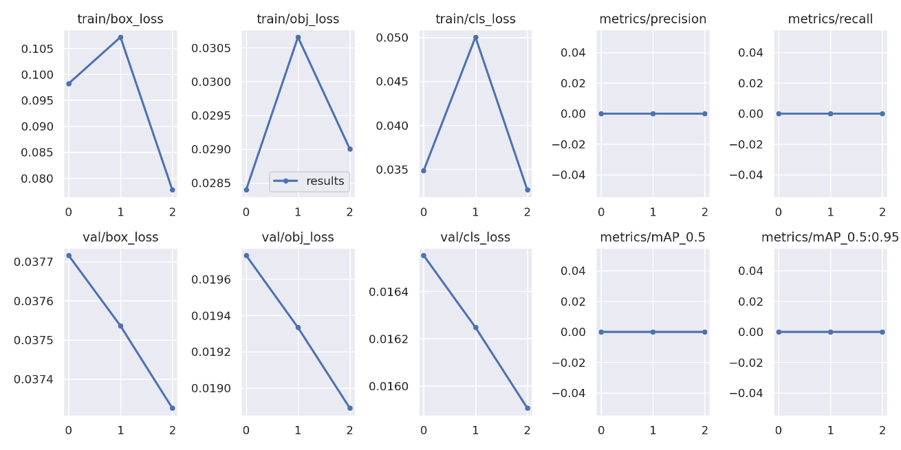b.
Figures 4 a and b: a. Unsuccessful training using low-resolutions images (640 px x 592 px) processed in the lab and b. results.
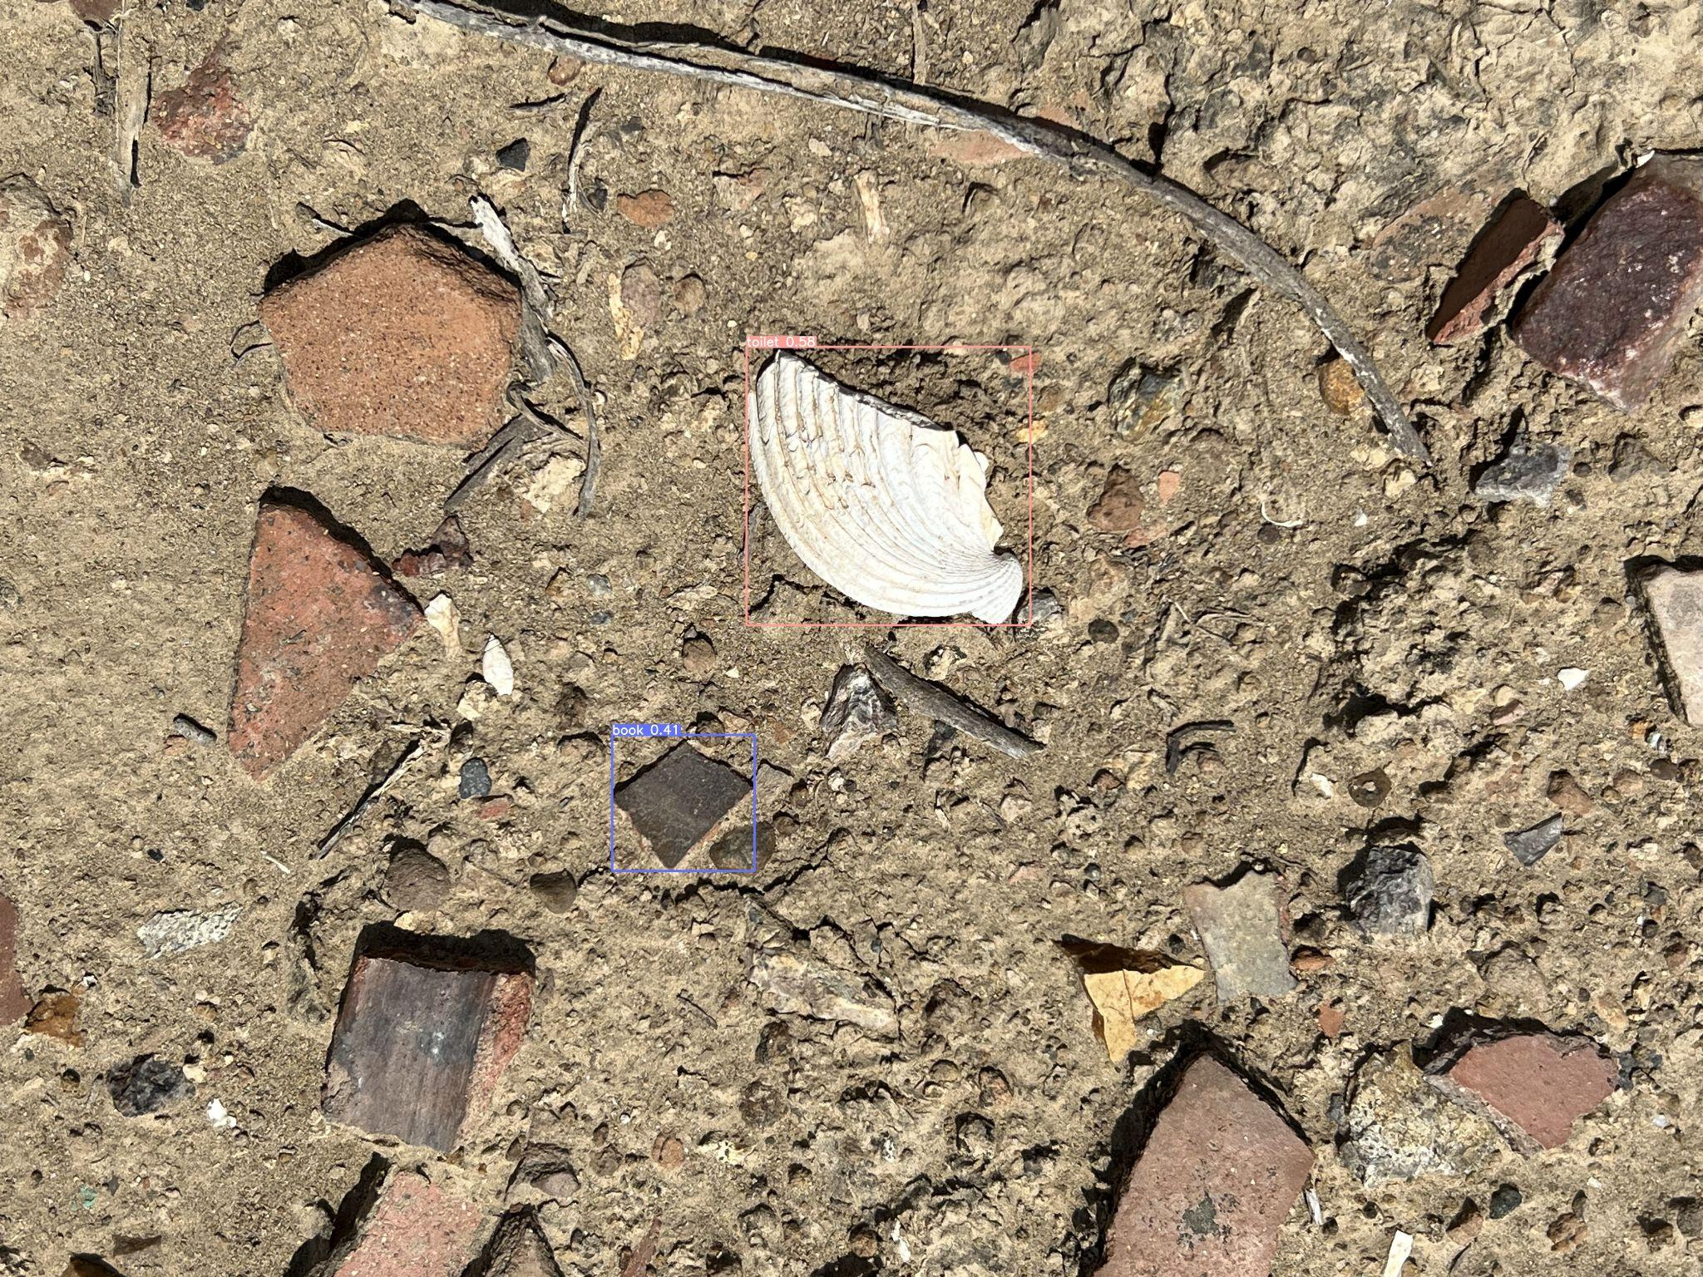
Figure 5: Image depicting a shell and pottery fragment misidentified as a toilet and book.
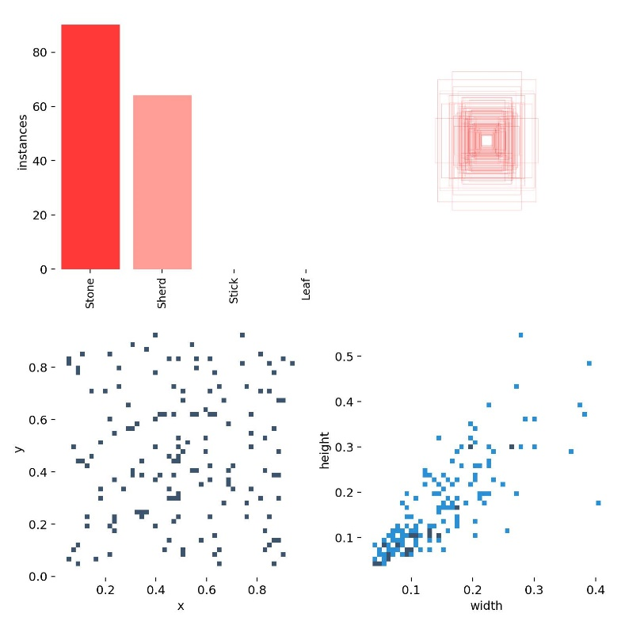 a.
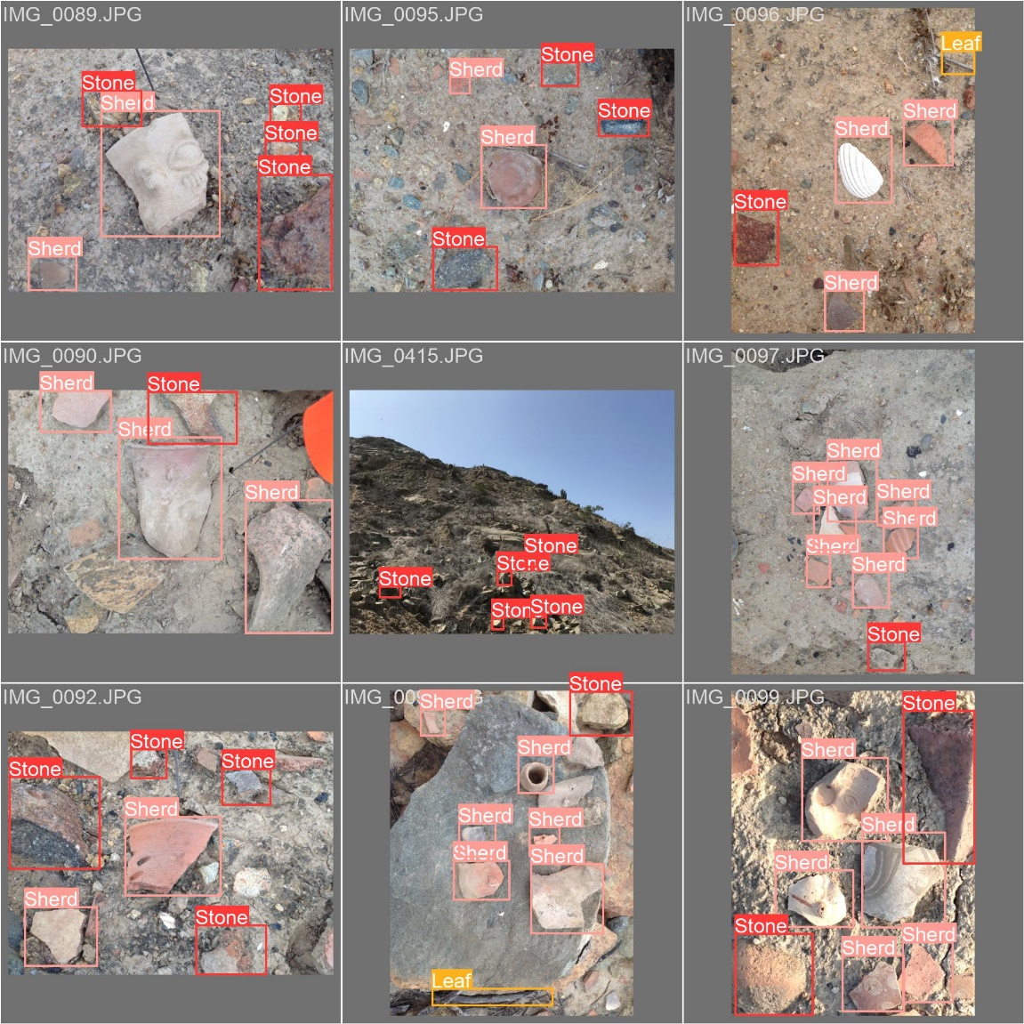 b.
Figures 6a and b: a. Improved object detection using smaller set of relevant classes, and b. successful identification of objects using a limited number of higher resolution images (4032 px x 3024 px).
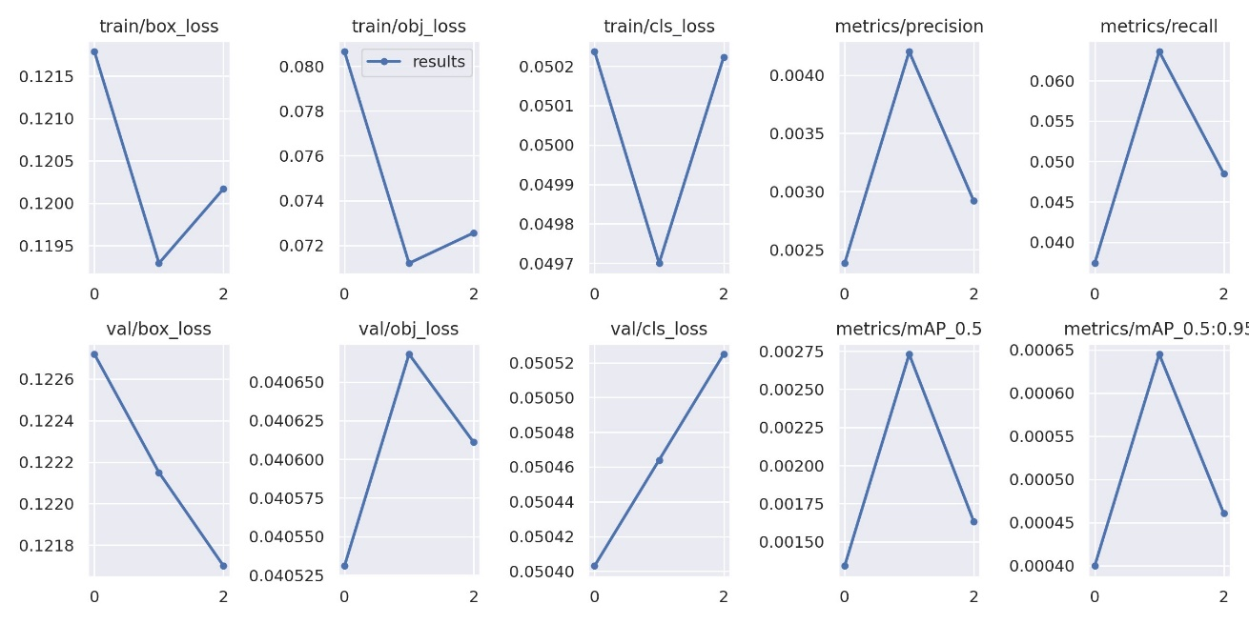
Figure 7: Object detection results after redefinition of classes.

Preliminary Findings
Although we consider our pilot test successful, we await the ability to expand research to improve ML results. Our first attempts at training the algorithm offline with installed software were not as easy as expected. For example, pre-defined classification of object categories was transferable to our archaeological objects, which necessitated re-definition and a significant amount of trial and error. We also discovered that using the lab imagery from previous years, which had been processed at a lower resolution and was free of ‘background noise’, did not work as well as (considerably more complex) field imagery.
In fact, while training the algorithm, Christofis discovered that the prepared diagnostic imagery and images of whole-vessel pottery specimens downloaded from the web worked exactly 0% of the time (see Figures 3 a and b). Although such images are certainly useful for typological identification of pottery and other artifacts, they were unsuitable for training the algorithm alongside field-captured imagery. That YOLOv5 was never able to identify any pottery sherd images taken in a lab setting once we used images captured in the field suggests the technique must be restricted to one group of images or another. We plan to test the idea that collections photos and other prepared diagnostics imagery can be used if trained separately from the objects photographed in the field in the future.

While we initially trained at 150 bounds, 60 was identified as the ideal constraint as we monitored YOLOv5’s performance throughout iterations. As visualized in the chart shown in figure 8, the model became relatively constant after 60 iterations at which point it began overfitting the data. After training at 150 epochs, we obtained a precision score of 0.28 and a recall score of 0.23 which supports the foundational proposition that YOLOv5 is able to correctly detect sherds against the complexities upon the natural landscape (as seen in our collation of stones, leaves, and sticks). Given that only 56 images were used for training the model used in this experiment, which normally requires that thousands of images be used (for example, see Nepal and Eslamiat 2022), we remain highly optimistic in this procedure. Although both of these outputs exhibit low precision and recall, we expect to significantly improve detection when new data are added.
To analyze initial results, we used mAP 0.5 or mean Average Precision metric, which measures the performance of a model when used in object detection tasks and for information retrieval on images (Ahmed 2023). A common way to monitor a model's performance during a training session is by plotting mAP as a function of the number of iterations. The graph below provides information on the YOLOv5 model’s performance during our training process. This gives us guidance on how well the model is fitting the training data. As illustrated below, during the initial stage of the training, mAP increases rapidly, and then slows down as the number of iterations increased. After 60 iterations, the model remained relatively constant, which means that the model began to overfit the data. Although we achieved a mAP value of only 0.19, interpretation of archaeological data remains quite complex.
The interpretation of a mAP value depends on the dataset and the specific task being evaluated, in addition, archaeological evidence can be exceptionally complex when small objects meet undergrowth and variable terrain quality. Thus, a score of 0.19 may be considered ‘good’ or ‘bad’ depending on the difficulty of the task assigned given different types of images and complexity of definable objects depicted in them (see an excellent overview in Verschoof-van der Varrt 2022:123-128). In other words, archaeological object detection may be more difficult than other utilities, and therefore, what is considered a ‘good’ mAP value for detecting scarce or small objects with irregular distributions at archaeological sites may be lower than detection rates in other applications. Results we obtained suggest that the YOLOv5 model can be improved either through improved data quality, algorithm optimization or by improving annotation process by using more images.

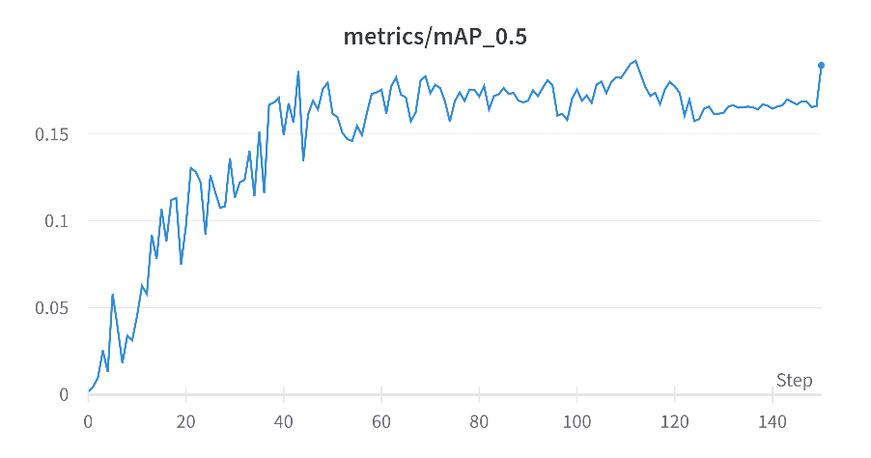
Figure 8: Graphical illustration of results after 150 iterations.
Discussion and Concluding Remarks
With the partly successful training of the algorithm, we hope to standardize YOLOv5’s object-based methodology and apply it in a multi-scalar way to our low altitude UAV, terrestrial LiDAR and geolocated pedestrian survey images in the future. How do the techniques applied in this pilot study fit into this picture? Certainly, several new platforms like Google Colab provided us with convenient tools when access to high-end computers was limited, purchasing new equipment was too costly, and software downloads and versioning presented critical problems. A critical question that emerged, was whether it would eventually be necessary to work independent of online tools like Google Colab when potential risks for data loss or product discontinuation, and when several options for off-line training exist but would require significant equipment upgrades. Such concerns, although significant, are relatively minor given the overall implications for advancement in this area of archaeological research.
The above challenges notwithstanding, the ability to conduct high-resolution analysis using semi-automated classification of objects on the ground without collecting them or using expensive GPS units presents several important advantages over traditional techniques. The ability to study a complex material culture assemblage which lies in an area fraught with environmental and occasional social concerns like looting and invasive settlement, for example, has opened a new world of possibility. Application of newly accessible machine learning techniques when combined with near-surface data with the tools available has allowed us to enter a new era of non-destructive computational archaeology along with our peers.
For our work in northern Peru, this affordable approach is transformational. We have already produced high-resolution spatial data through UAV survey and on-the-ground image capture with LiDAR/GPS enabled smart phones that is more than sufficient to make determinations about future work. Through the application of machine learning techniques, we are now able to study material culture records off-site in ways that are highly informative, contextually situated, easily accessible (i.e., limited post-processing), and of course, non-destructive. Among others, the ability to weed out non-essential data and focus on the essential, visually navigate and detect objects and features non-destructively are proving to be key advantages (see also Mittal 2020). While fundamentally successful at detecting pottery sherds on the ground, the ability to transfer attribute data back into our GIS for spatial analysis has already transformed our approach to regional and local survey, object recording, and artifact collection.
For archaeologists working in areas where site access may be limited (i.e., culturally insensitive or physically dangerous), a critical advantage of incorporating combined remote-sensing and object-based machine learning techniques is never having to touch an artifact or damage a site, while at the same time being able to analyze sites and materials stylistically, quantitatively, and locationally. Through high-resolution in situ recording, using images captured on the ground or remotely using UAVs, the preservation of fragile and at-risk archaeological sites is significantly improved. Furthermore, through the advancement of non-destructive techniques, we gain a high-resolution view of the landscape and surrounding environment while actively working towards conservation.
In this experiment, YOLOv5 has exhibited potential for consistent detection of archaeological phenomena, although statistically marginal. In this case, it was successful at detecting and classifying the presence of pottery sherds when used with images captured on the ground rather than the UAV imagery. Presently, images captured using our UAV camera were too vague to produce the necessary detail for distinguishing pottery from rocks. During the next step of this project, we plan to re-capture drone data at lower altitudes (approximately 15-20 meters) and use higher-resolution cameras to test our methodology.
We also believe that, given more time to enlarge the dataset and retrain the model, we support integration of tools like YOLOv5 in the study of non-destructive archaeological survey dada which can supplement and considerably improve the way that today’s digital archaeological fieldwork and surveying is conducted. UAV-captured surveying and diagnostic evaluation with machine learning tools saves time, money and resources, while allocating more space to actively research, excavate, and connect with communities. The immense amount of data collected by drones and AI-commanded algorithms, as well as its “no-touch” approach also leaves opportunities for a better (and more ethical) digital recording of both archaeological and contemporary phenomena; thus, assisting in the current revolution to advance a more decolonized archaeology and emphasize preservation.
Yet with our new-found ability to partially detect, analyze, interpret and share, we find ourselves ever at the cross-roads of experimentation, trial, and error. Although creative and thought provoking, we aim for standardized methodologies to lend credibility, longevity, and repeatability to our approach. With this paper and our shared insights, it is our aim to contribute to the dialogue on combining such approaches, helping to further integrate this advancing technique into our trans-disciplinary community of computational archaeology practitioners.
Acknowledgements

The authors wish to thank the field crew from the 2022 field season of Proyecto de Investigación Arqueológica Gallinazo del Norte (or PIAGN) for their help in recording the data used in this research. We are grateful for the loan of the DJI Mavic 2 drone used to capture data in 2022 PIAGN survey by Aerospace Controls Research Lab (ACRL) of Dr. Hossein Eslamiat, Southern Illinois University, Carbondale.
Funding
A portion of this project was funded through NSF Award # 1519048 Doctoral Dissertation Research Award: Social Interaction as Determined Through Spatial and Technological Analysis.
Conflict of interest disclosure
The authors declare that they comply with the PCI rule of having no financial conflicts of interest in relation to the content of the article.
References
Ahmed, Nisha Arya
Mean Average Precision (mAP): A Complete Guide. Kili Technology. https://kili-technology.com/data-labeling/machine-learning/mean-average-precision-map-a-complete-guide, accessed March 26, 2024.

Alexakis, D, Athos Agapiou, D Hadjimitsis, and Apostolos Sarris
2012 Remote sensing applications in archaeological research. Remote Sensing-Applications:435–462.

Baheti, Pragati
2021 Convolutional Neural Networks: Architectures, Types & Examples. https://www.v7labs.com/blog/convolutional-neural-networks-guide, https://www.v7labs.com/blog/convolutional-neural-networks-guide, accessed March 26, 2024.

Bonhage, Alexander, Mahmoud Eltaher, Thomas Raab, Michael Breuß, Alexandra Raab, and Anna Schneider
2021 A modified Mask region-based convolutional neural network approach for the automated detection of archaeological sites on high-resolution light detection and ranging-derived digital elevation models in the North German Lowland. Archaeological Prospection 28(2):177–186. DOI:https://doi.org/10.1002/arp.1806.

Caspari, Gino, and Pablo Crespo
2019 Convolutional neural networks for archaeological site detection–Finding “princely” tombs. Journal of Archaeological Science 110:104998. https://doi.org/10.1016/j.jas.2019.104998

Caster, Joshua, Joel B. Sankey, Helen Fairley, and Alan Kasprak
2022 Terrestrial lidar monitoring of the effects of Glen Canyon Dam operations on the geomorphic condition of archaeological sites in Grand Canyon National Park, 2010–2020. US Geological Survey. https://doi.org/10.3133/ofr20221097

Davies, David.
2022 “ YOLOv5 Object Detection on Windows (Step-By-Step Tutorial).” https://wandb.ai/onlineinference/YOLO/reports/YOLOv5-Object-Detection-on-Windows-Step-By-Step-Tutorial---VmlldzoxMDQwNzk4.

Deepchecks AI
2024 What is YOLO (object detection algorithm). Deepchecks. https://deepchecks.com/glossary/yolo-object-detection-algorithm/, accessed March 26, 2024.

DeepLearning.
2020 “YOLOv5 training with custom data.” YouTube.
https://www.youtube.com/watch?v=GRtgLlwxpc4&t=780s

Girshick, Ross, Jeff Donahue, Trevor Darrell, and Jitendra Malik
2014 Rich feature hierarchies for accurate object detection and semantic segmentation. arXiv.
https://doi.org/10.48550/arXiv.1311.2524

Jocher, Glenn
2020 YOLOv5 by Ultralytics. https://docs.ultralytics.com/yolov5/

Kundu, Rohit
2023 YOLO Algorithm for Object Detection Explained [+Examples]. https://www.v7labs.com/blog/yolo-object-detection, https://www.v7labs.com/blog/yolo-object-detection, accessed March 26, 2024.

Lambers, Karsten
2018 Airborne and spaceborne remote sensing and digital image analysis in archaeology. Digital Geoarchaeology: New Techniques for Interdisciplinary Human-Environmental Research:109–122. https://doi.org/10.1007/978-3-319-25316-9_7

Li, Yilan, Hossein Eslamiat, Ningshan Wang, Ziyi Zhao, Amit K Sanyal, and Qinru Qiu
2019 Autonomous waypoints planning and trajectory generation for multi-rotor UAVs. DESTION '19: Proceedings of the Workshop on Design Automation for CPS and IoT: 31–40. https://doi.org/10.1145/3313151.3313163
Mittal, Payal, Raman Singh, and Akashdeep Sharma
2020 Deep learning -based object detection in low-altitude UAV datasets: A survey. Image and Vision computing 104:104046. https://doi.org/10.1016/j.imavis.2020.104046

Nepal, Upesh, and Hossein Eslamiat
2022 Comparing YOLOv3, YOLOv4 and YOLOv5 for Autonomous Landing Spot Detection in Faulty UAVs. Sensors 22(2):464. DOI:10.3390/s22020464.

Orengo, Hector A., Arnau Garcia‐Molsosa, Iban Berganzo‐Besga, Juergen Landauer, Paloma Aliende, and Sergi Tres‐Martínez
2021 New developments in drone‐based automated surface survey: Towards a functional and effective survey system. Archaeological Prospection 28(4):519–526. https://doi.org/10.1002/arp.1822

PyTorch
2023 https://www.pytorch.org, accessed August 31, 2023.

Redmon, Joseph, Santosh Divvala, Ross Girshick, and Ali Farhadi
2016 You Only Look Once: Unified, Real-Time Object Detection. Proceedings of the IEEE Conference on Computer Vision and Pattern Recognition (CVPR), 2016, pp. 779-788

Sakai, Masato, Yiru Lai, Jorge Olano Canales, Masao Hayashi, and Kohhei Nomura
2023 Accelerating the discovery of new Nasca geoglyphs using machine learning . Journal of Archaeological Science 155:105777. DOI:https://doi.org/10.1016/j.jas.2023.105777.

Sharp, Kayeleigh
2019 Rethinking the Gallinazo: A Northern Perspective from the Mid-Zaña Valley, Peru. Southern Illinois University at Carbondale.

Verschoof-van der Vaart, W.B.
Learning to look at LiDAR | Scholarly Publications. https://scholarlypublications.universiteitleiden.nl/handle/1887/3256824, accessed March 26, 2024.

Verschoof-Van der Vaart, Wouter Baernd, and Karsten Lambers
2019 Learning to look at LiDAR: The use of R-CNN in the automated detection of archaeological objects in LiDAR data from the Netherlands. Journal of Computer Applications in Archaeology 2(1). DOI: 10.5334/jcaa.32

Zeman, Benjamin
2023 What is Google Colab? Android Police. https://www.androidpolice.com/google-colab-explainer/, accessed March 26, 2024.

Helpful support from Weights and Biases’ online YOLOv5 tutorial (Davies 2022)– a step-by-step guide on how to download and kickstart YOLO’s object detection features.
Following the exportation of our labels, our master training folder (now consisting of full datasets and labels) was ready to be uploaded for YOLOv5 training. Here, we transitioned to the next part of our research with the help of Google Colab. Google Colab’s YOLOv5 workspace is conveniently set up as a functioning tutorial – much of the code needed to run, validate, detect, and train through YOLOv5 has already been provided. After cloning YOLO, we activated the first line of code. This allowed us access to all applications in an individual Colab session. After cloning finalized, we uploaded and unzipped our training data into Colab.
In all lab-based datasets, YOLOv5 could not detect the differences between stone and sherd. These occurrences continued through approximately 50 images and three training runs, where all sherds were incorrectly detected as stones in our output. These results continued to come back just as inconclusive, even with aid provided by comparative training of lab-based datasets against stock images of stones. This means that, given the current capabilities of YOLOv5, the algorithm cannot be utilized for legacy assemblages if training multiple datasets (like survey imagery) subsequently and/or simultaneously.
0.19 means that model's performance in detecting and localizing objects in the images may not be ideal for non-archaeological applications, given that mAP score ranges from 0 to 1, where a score of 1 indicates perfect performance, and a score of 0 indicates that the model is not able to detect any objects correctly.
Such has been the case with other Google products like Google Poly or the hosting of Arts & Culture sites.

