TIPZOO: a Touchscreen Interface for Palaeolithic Zooarchaeology. Towards making data entry and analysis easier, faster, and more reliable

Author: Emmanuel DISCAMPS, CNRS UMR5608 TRACES, Université Toulouse Jean Jaurès, Toulouse 31058, FRANCE; ediscamps@gmail.com

Abstract: Zooarchaeological studies of fossil bone collections are often conducted using simple spreadsheet programs for data recording and analysis. After quickly summarizing the limitations of such an approach, we present a new software solution, TIPZOO, which uses a FileMaker touchscreen interface combined with R scripts and QGIS files. This tool was specifically designed for zooarchaeologists’ needs, and is freely available at http://tipzoo.cnrs.fr. In this article, the key features of TIPZOO are highlighted, and we present some of the tools developed in order to (1) simplify the use of recently published complex coding systems, (2) better control intra- and inter-analyst variation, and (3) allow faster and more reliable data entry, analysis and visualization in Palaeolithic zooarchaeology.

This paper was submitted to PCI Archaeology the 16th of April 2020.
- Introduction
Performing a zooarchaeological study of a faunal collection involves several steps, including anatomical and taxonomical identification, observation of bone surface modifications, and, as with most archaeological disciplines, data entry and analysis. For the last two steps, the vast majority of zooarchaeologists use spreadsheet software, such as Microsoft Excel, despite the inherent limitations of such programs. These software packages are, in fact, poor solutions for data recording and analysis as they are not adapted for the complexity of modern zooarchaeological analyses and integration within global archaeological datasets. The most significant problems that the use of such spreadsheet programs does not adequately address are outlined below:
- The multiplication and complexification of recorded variables and their coding. Even before computers were routinely used, zooarchaeologists created coding systems for efficient variable recording using abbreviations (e.g. “HUM” for a humerus, “SH” for a shaft fragment of a diaphysis). Early examples include Gifford and Crader's (1977)Gifford and Crader (1977) seminal system, and more recently systems have been proposed and used for cut marks (Soulier and Costamagno, 2017; Costamagno and Soulier, 2019) or anatomical landmarks (Morin et al., 2017, 2019). As zooarchaeologists refine their tools and analytical criteria, the coding systems become increasingly complex and hard to use. The number of variables to be recorded increases, as well as the number of abbreviated terms, or codes, the analyst has to remember. For example, the cut mark coding system developed by Soulier and Costamagno (ibid.) involves more than 400 codes, and the NDE landmark system proposed by Morin et al. (ibid.) relies on more than 100 variables. The simple memorization and/or training required to efficiently employ one of these systems is already difficult, with the difficulty obviously being amplified by the use of several systems, and this necessarily renders data entry and analysis in simple spreadsheet programs quite arduous. This is in part ultimately why these useful coding systems are still not commonly used by zooarchaeologists, despite their obvious and inherent qualities for reconstructing past butchering activities and skeletal-part representation. Advances in techniques of analysis entail a cumulation of complex coding systems, which ultimately impedes their broad use because datasets become increasingly unmanageable, especially for large faunal collections.

- Poor control during data entry: multiplication of errors and variable values. Despite being more efficient, complex systems for coding variables multiply the potential for human errors during data entry, as abbreviations can be confused with one another or simply be forgotten. The operational meaning behind certain variable states can also change or "drift" over time, which can happen when analyses are long or spread across multiple sessions, as is often the case for PhD students in training or for treating materials from ongoing excavations (e.g. unintentional shift in definition of taphonomic variable states such as "small spots” and “large spots” for manganese deposits, as analysts work on different collections with different degrees of preservation over multiple years). Furthermore, single variable states can be unintentionally multiplied (e.g. for a binary yes/no variable state, having multiple "yes" forms ["Y", "y", "Y?", "Y??","yes", etc.]) adding unnecessary variability. This addition of spurious variability forces analysts to spend considerable time cleaning spreadsheet data to remove typing errors, homogenize variable states, etc., but can also sometimes lead to the rerecording of data for fragments where aforementioned errors can create confusion regarding variable states when moving on to analysis.

- Implementation of real-time data verification. Even if theoretically possible, the implementation of scripts that verify the validity of entered data in a spreadsheet is rare (e.g. if a variable should have been recorded but was not, if a combination of two variable values is theoretically impossible, or if a duplicate value was entered in the fragment ID number). This lack of real-time verification is therefore another source for error.

- Database connection between zooarchaeological data with the field database. In many recent excavations, a field database is produced during excavation, recording the three-dimensional provenience for each artefact, artefact layer attributions, etc. Connecting a field database with zooarchaeological data, requiring the use of shared object keys, can seem complicated to the uninitiated. The result is that some analysts do not even attempt spatial analysis of their data as obtaining the coordinates for their sample is often seen as too cumbersome, even if spatialization of data can be particularly useful for taphonomic analyses.
In order to tackle these issues, we developed a new solution for data acquisition and analysis in Palaeolithic zooarchaeology, TIPZOO, which is freely available on the http://tipzoo.cnrs.fr website. In this paper we will highlight its key features and demonstrate its potential. A separate technical manual, also available for download at http://tipzoo.cnrs.fr, provides detailed information on the practical use of TIPZOO.
- TIPZOO general overview
This tool, called TIPZOO (Touchscreen Interface for Palaeolithic Zooarchaeology), is based on (Fig. 1):
- TIPZOO-FMP: its core element, a FileMaker solution connected to a relational database specifically designed for bone recording (identifications, taphonomic observations, minimum number of elements, refits, etc.), with a graphical and touchscreen interface adapted for tablets;
- TIPZOO-R: R scripts for analysis and statistical processing of the preformatted data exported by TIPZOO-FMP, linked with a collection of pre-entered zooarchaeological reference datasets (amount of bone occurrences per skeleton, bone mineral density values, food utility marrow indices, etc.);
- TIPZOO-QGIS: QGIS project and shapefiles designed for quick and easy representation of skeletal-part profiles on skeleton outlines, using preformatted data exported by TIPZOO-R (inspired by comparable efforts by Orton, 2010 using ESRI ArcGIS).
Many different types of information can be recorded or imported into TIPZOO: general site information, field data (XYZ coordinates, layers, etc.), basic information on a fragment (field ID number, size, etc.), refits between fragments, skeletal identification (element, portion, anatomical landmarks, etc.), variables for age estimation (tooth use wear, fusion stages, etc.), taxonomic identifications, taphonomic observations (including bone surface modifications), cut mark codes (according to their orientation and location), and Minimal Number of Element values. More information on what exactly can be recorded in TIPZOO is provided in the 26-page manual (http://tipzoo.cnrs.fr/).

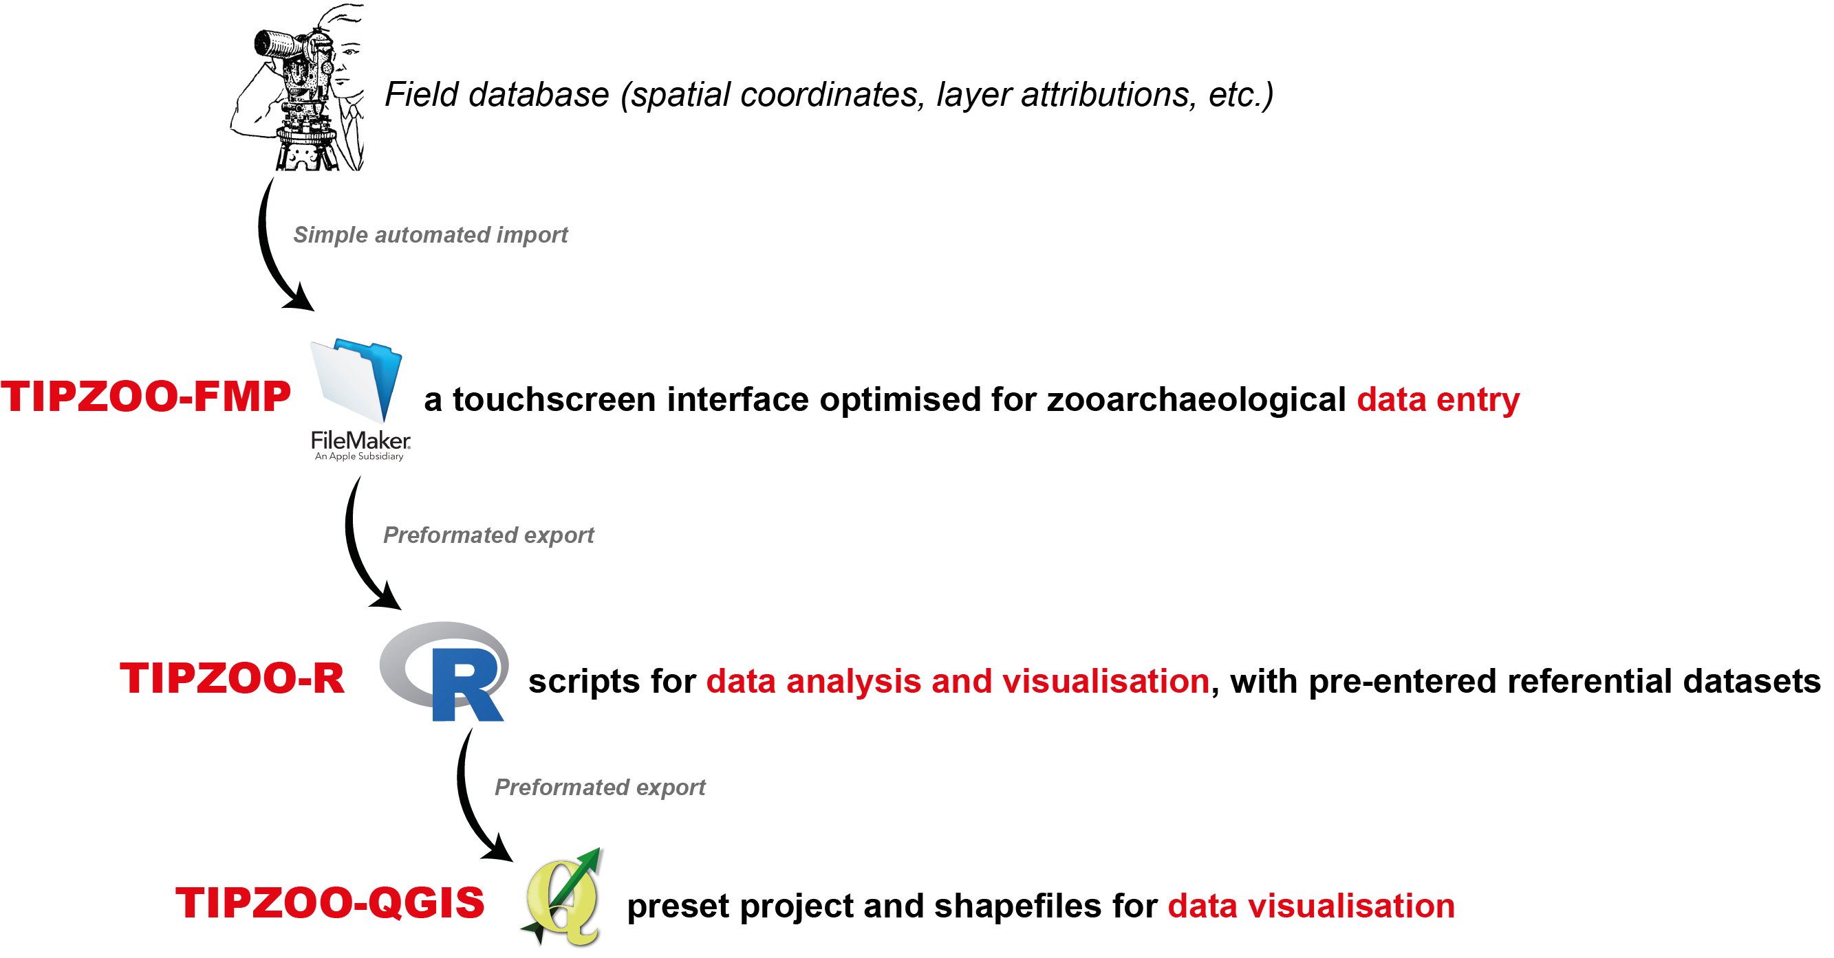
FIGURE 1: General workflow organization of the three components (in red) of TIPZOO.

- TIPZOO key features
TIPZOO-FMP, the first component, proposes a standardized and optimized system for data entry in order to increase the efficiency of Palaeolithic zooarchaeology data acquisition, both by speeding up data entry and by limiting coding errors. The following features contribute to this increased efficiency:
- Auto-filling and bulk entry. Some fields are automatically filled according to previously entered information, significantly speeding up data entry. One key feature in this respect is the “bulk recording” tool that allows the analyst to pre-enter identifications (skeletal element and/or species) for a set of fragments to be recorded, essentially cutting down the time needed for data entry for faunal collections that are sorted by element and/or species.
- Preset variable states. A given list of possible states is pre-entered for most variables, limiting coding errors.
- Simplified and more objective coding system for bone surface modifications. TIPZOO proposes a coding system for taphonomic alterations of bone surfaces that is based on a large literature review of different zooarchaeological classifications and recording methods (including Behrensmeyer, 1978; Binford, 1981; White, 1992; Lyman, 1994; Fisher, 1995; Fernandez-Jalvo and Andrews, 2016, as well as numerous PhD dissertations that detail their methodology, such as Castel, 1999; Costamagno, 1999; Morin, 2004; Coumont, 2006; Mallye, 2007; Rendu, 2007; Daujeard, 2008; Thompson, 2008; Magniez, 2010; Smith, 2010; Discamps, 2011; Campmas, 2012; Fourvel, 2012; Hodgkins, 2012; Soulier, 2013; Lacarrière, 2015). This coding system was conceived to be both simple and as objective as possible. Many authors use coding systems with variable states based on relative scales (e.g. “little”, “moderate” or “heavy alteration”), and these are often subject to important intra- and inter-analyst variability because relative scales are often observer-dependant. TIPZOO puts forward a set of variables and variable states that should be easier to use by different analysts (cf. manual), notably considering the use of what we have dubbed "variable reminders" (see below).
- Variable reminders. Variables and their possible states are identified in the layouts in full letters, rather than simply by their codes, and short descriptive texts are provided for each possible state in order to remind users of their definition. It is therefore no longer necessary to learn and remember long lists of different codes for different variables. These “variable reminders” limit coding errors, as well as any unwanted, and often time dependant, “drift” in the definition of variable states (see point 2 in the Introduction) by ensuring that the analyst is continually reminding themselves of the criteria to be used. For example, for bone surface modifications, a summarized description of each variable and of its possible states are provided directly in the interface, in addition to the more detailed information provided in the manual. Similarly, reminders regarding correspondences between species and size classes are also provided in the interface. A very important objective we had while developing TIPZOO was to provide a means to limit intra- and inter-analyst variability. Bone surface modification variables and their possible states were therefore redefined and are described in detail in the manual in order to make individual observations as objective as possible.
- Visual aids. Schematic drawings and images are integrated into the interface when they can help facilitate data entry (Fig. 2), refresh analysts' memories regarding specific definitions of variables, or even assist with anatomical identification (as in the case of carpal and tarsal bones).
- Dynamic display. Data entry is split into several different layouts, and interface elements that are not immediately and contextually relevant are hidden. For example, some fields are displayed dynamically according to skeletal element or portion, ultimately increasing the readability of the interface and overall recording speed. This also allows for tighter control of when a variable should be recorded and when recording is unnecessary or contextually irrelevant (for example, some bone surface modification variables are kept invisible for teeth and burned fragments).
- Touchscreen compatible. The interface is optimized for use with a touchscreen tablet, making it, in our experience, even faster and easier to use. However, the system can also be used with a mouse/keyboard.
- Simplified application of cut mark coding system. TIPZOO-FMP offers a touchscreen recording interface with graphical aids (Fig. 2b) to simplify the application of the cut mark coding system developed by Soulier and Costamagno (Soulier and Costamagno, 2017; Costamagno and Soulier, 2019). This rather complex coding system is easier to apply in this format, and does not require analysts to learn the codes themselves.
- Touchscreen recording of skeletal landmarks. Similarly, the TIPZOO touchscreen interface renders the recording of skeletal landmarks effortless (Fig. 2a and 2c). The coding system uses the landmarks proposed by Morin et al. (2017, 2019), supplemented by three additional landmarks (for mandibles, radio-ulnas and ribs) defined in other works (Castel, 1999; Morin, 2004) and four defined in the present work (for femurs and phalanges, as defined in the manual). When the analyst records a skeletal identification, a schematic drawing with the appropriate landmarks appears, and these can then be recorded using a simple touch/click. Combined with the automated data handling capacities of TIPZOO-R and TIPZOO-QGIS (cf. below), this renders the calculation of skeletal-part frequencies painless.
- Dual recording system for teeth. A recurrent issue with teeth is whether they should be recorded individually (one record per tooth, which would entail, for example, three records for one mandible fragment with three teeth), or at the scale of the fragment (one record for one mandible with three teeth). Both have their advantages and disadvantages. In TIPZOO-FMP, the “tooth creator” tool allows for a dual recording system. First, the fragment itself is recorded as a single object, and second, teeth are individually entered in a separate but linked table (Fig. 2c). This makes it easy to record individual information for each tooth (e.g. use-wear class, crown height) without altering the main fragment database (meaning there are no duplicate entries). Furthermore, TIPZOO-FMP offers the possibility to export a summary table of all teeth recorded (either isolated or included within a cranium/mandible fragment) for a given taxon, making MNI calculations and the computation of mortality profiles much easier.
- Recording assistant for Minimal Number of Elements. A specific layout in TIPZOO-FMP is designed to help record MNE values. It does this by providing a quick and easy way to list all the fragments that correspond to a given layer, element and species.
- Real-time verifications. Thanks to FileMaker scripting capabilities, many things occur “under the hood”. During data entry, real-time verifications (as listed in the manual) are performed at each step (identification of duplicates, of theoretically impossible combinations of variable values, of missing values, etc.).
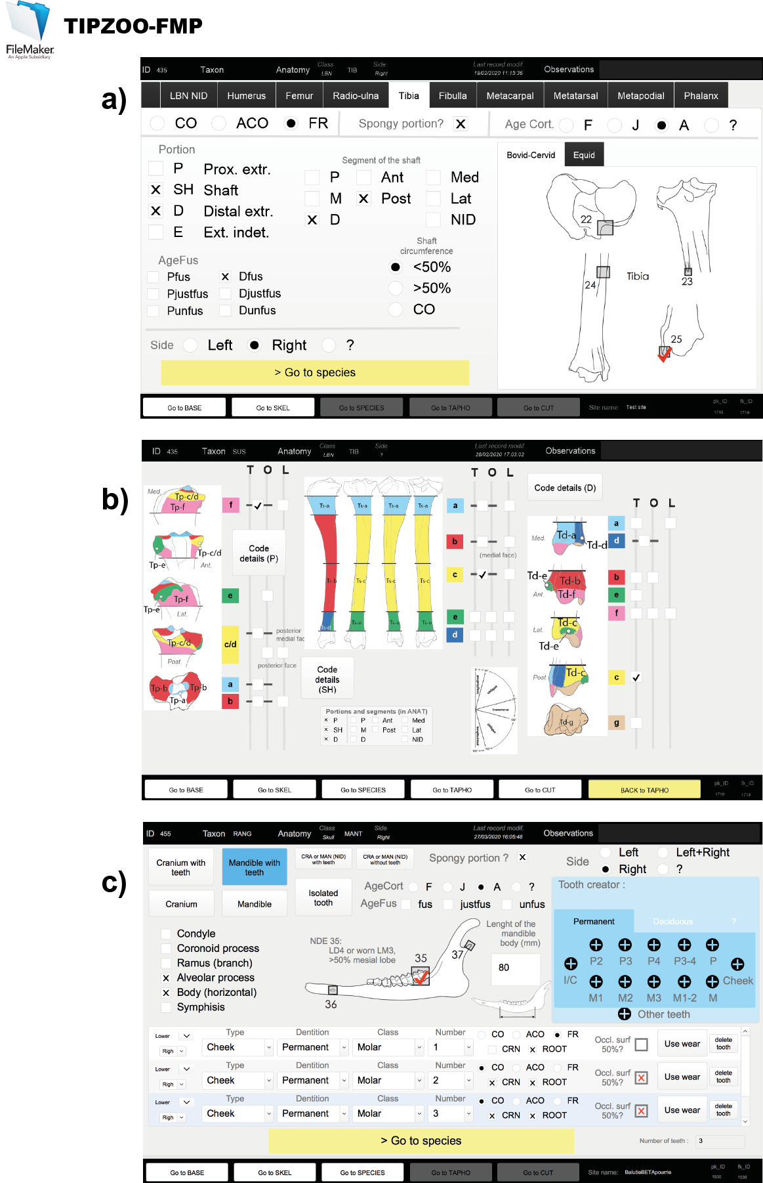
Figure 2: Examples of three layouts from the TIPZOO-FMP interface, for recording a) bone portions of a tibia fragment (note the touchscreen box system for landmarks on the right), b) cut mark codes (with its graphically aided recording system), and c) a mandible with three enclosed teeth (note the “tooth creator” in light blue on the right, and the dual recording system for the whole mandible fragment – top part – and the three enclosed teeth – bottom part).
Analyzing a faunal collection involves managing large quantities of material that are recorded in different ways in the field, often including, on one hand, plotted artefacts that are placed in individual bags with unique identification numbers (field IDs), and, on the other, sieve residues or bulk samples from which identifiable fragments are sometimes extracted. TIPZOO-FMP helps zooarchaeologists in the handling their collections by providing tools for:
- Numbering and keeping track of fragments and refits. When an analyst has to extract fragments from a bulk sample (e.g. a screen residue with a field ID of “square H12, spit 43”), TIPZOO-FMP offers a “subID” system for numbering artefacts with unique numbers: by clicking a button, the zooarchaeologist is provided with the last available subID number for the corresponding field ID (e.g. H12-43-1, H12-43-2, and so forth). This provides a quick and easy way to keep track of remains that have previously been numbered and avoids duplicating subID fields. A similar system is provided for refit groups (unique refit group numbers are automatically created) to easily keep track and record fragments that refit together.

- Live connection with the field database. TIPZOO-FMP offers a simple interface to import all relevant contextual information recorded in the field. This may include, for example, object coordinates, layer attributions, squares, object descriptions, or fabric measurements (orientation and plunge of objects twice as long as wide, see Lenoble and Bertran, 2004). When the zooarchaeologist enters a fragment in the database, using the individualized field ID, a portal shows all relevant information that was recorded in the field and verification scripts are run. The direct connection between field data and the faunal database allows for the real-time identification of problems in the former (e.g. TIPZOO-FMP will show an error message if a bone was plotted during excavation as a “lithic” in the field database), as well as the verification of some information (e.g. if a fabric measurement was taken in the field for a bone, the appearance of a new variable [elongated?] will remind the user to verify if the fragment is elongated enough to justify the valid use of this type of measurement, forcing the user to fill in this variable and therefore cleaning the fabric measurement database).

- Easy export of linked spatial and faunal data. Via the connection between the faunal database and the field database, which contains the general spatial information of objects plotted during excavation, TIPZOO-FMP offers a one-click solution for exporting automatically interlinked faunal and field data, greatly facilitating spatial analyses of zooarchaeological data.

Finally, TIPZOO is also intended to help with the analysis of data recorded, and therefore also has the following analytic features:
- Automated production of summary tables, basic graphs, and statistical tests. Buttons in the TIPZOO-FMP interface allow for the export of preformatted record data that can then be opened in an R-environment, TIPZOO-R (available on http://tipzoo.cnrs.fr). This R-environment includes scripts for the easy production of summary tables, graphs, and basic statistics. This is notably achieved via the inclusion of reference data tables, such as species' Latin and common names, number of portion occurrences per skeleton, bone mineral density values (e.g. Lam et al., 1999), body-part utility indices (e.g. Binford, 1978; Morin, 2007), or correspondences between cut mark codes and butchering activities (Soulier and Costamagno, 2017; Costamagno and Soulier, 2019), within the TIPZOO-R environment. The user therefore does not have to look up correspondences between the database codes and the corresponding information. TIPZOO-R automatically searches for this information in pre-entered reference datasets and automatically produces the summary tables (Fig. 3a), graphs, and statistical tests (Fig. 3b-d). Analytical scripts and reference datasets are continuously and gradually being integrated, thus TIPZOO-R is still far from complete, but should be considered a continuously evolving analytical tool. Zooarchaeological analysis is made faster by adding reference datasets to TIPZOO-R once and by subsequently scripting the necessary calculations for future use. TIPZOO-R scripts can also be used without relying on TIPZOO-FMP for data entry, for example with a spreadsheet software, but only if the formating rules of TIPZOO-FMP are followed (as described in the manual).

- Automated creation of body-part skeletal figures. Once datasets are processed in TIPZOO-R, they can be exported and opened in a pre-designed QGIS project, with integrated shapefiles (TIPZOO-QGIS), that allows for rapid schematic representations of body-part profiles using skeletal outline templates. Different species, and other types of data visualization, will gradually be developed and integrated into the system and made available on the TIPZOO website.

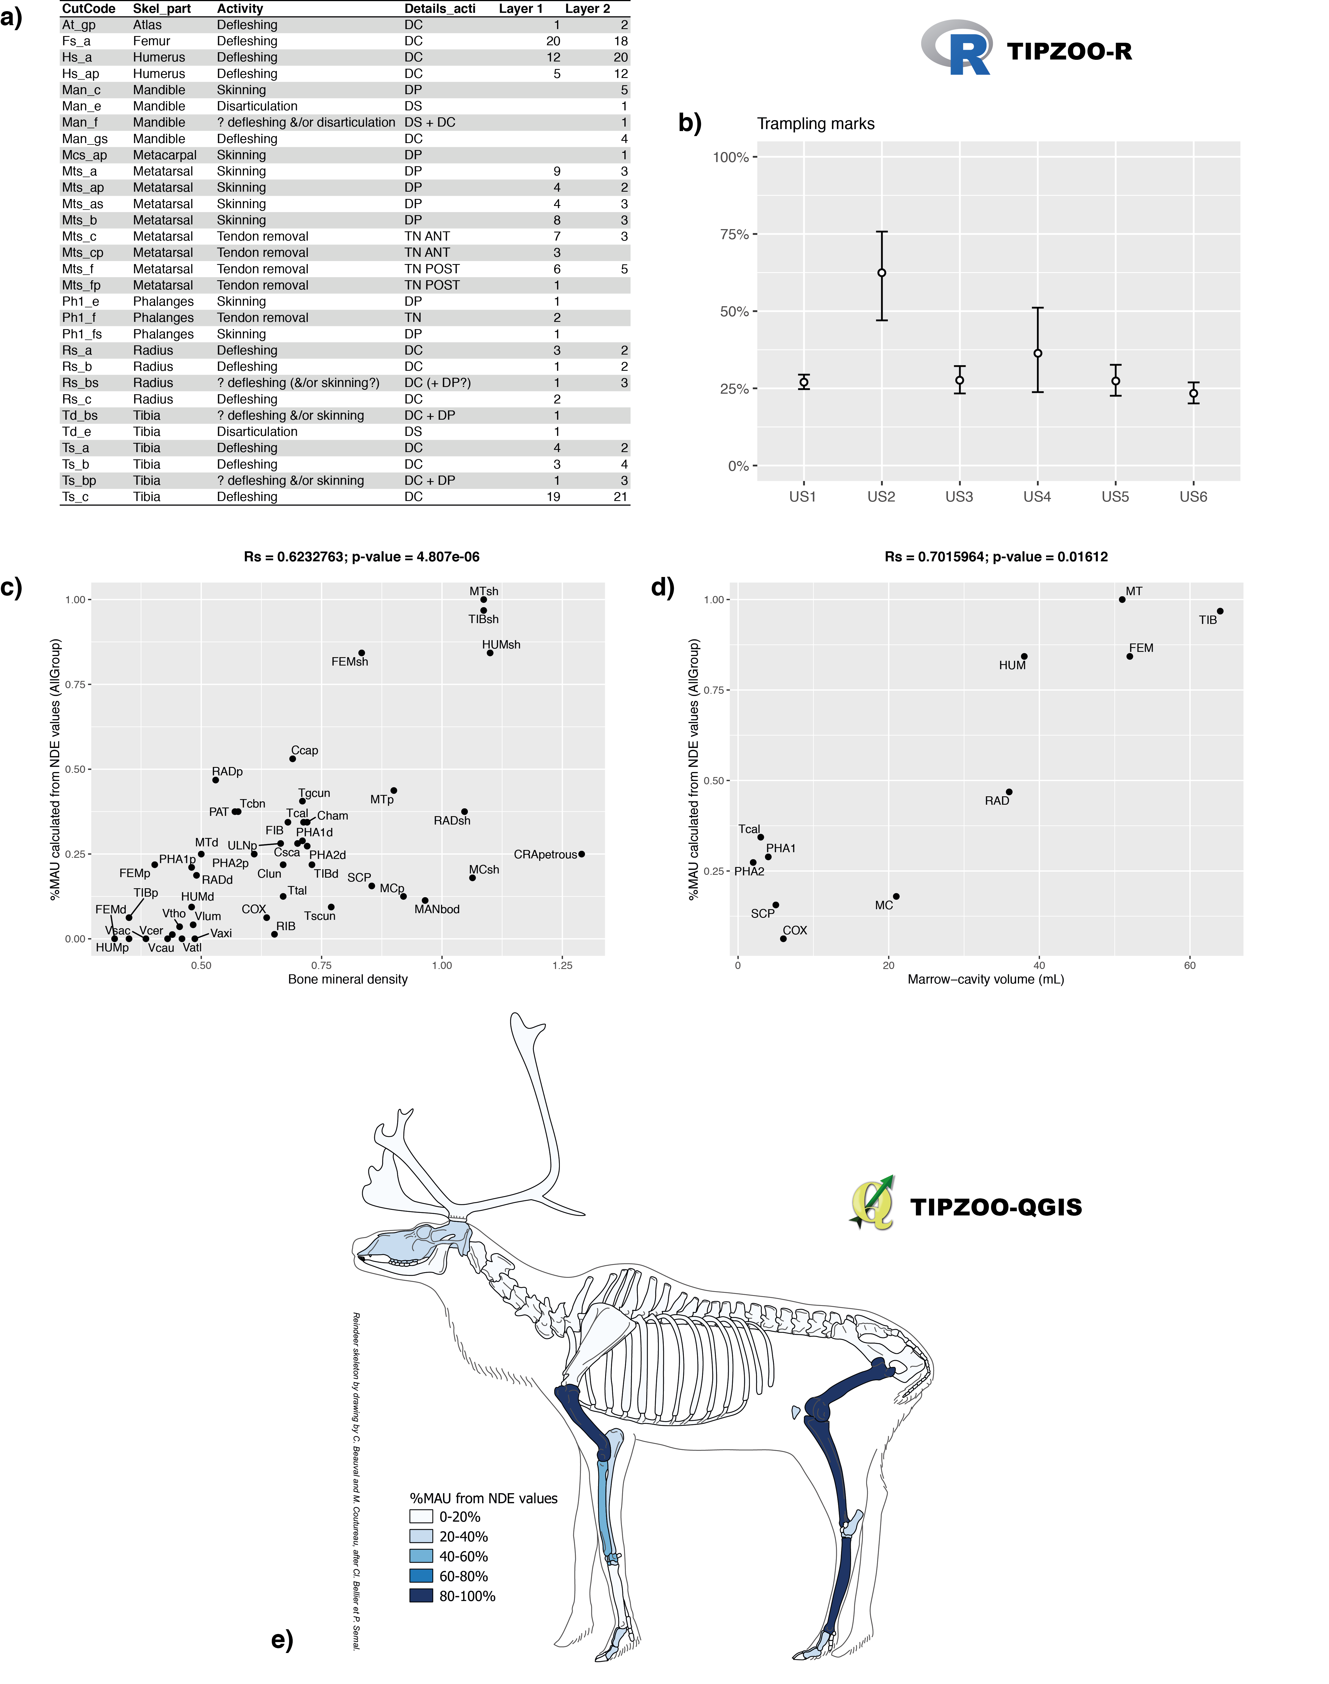
Figure 3: Examples of TIPZOO-R (a-d) and TIPZOO-QGIS (e) outputs. These tables and graphs are easily produced by running the different TIPZOO tools. a) Preformatted table listing the cut mark codes and activities identified in different layers; b) Percentage of bones with trampling marks across 6 different field layers with 95% confidence intervals; c) Analysis of density-mediated bone destruction, with biplot and Spearman correlation test; d) Utility-based analysis of bone differential transport using marrow-cavity volumes, with biplot and Spearman correlation test; e) Skeletal-part representation of reindeer bones in %MAU automatically calculated from NDE landmark data.
- Discussion
TIPZOO is a further step towards encouraging accurate and standardized recording practices among zooarchaeologists, building upon many previous efforts. It does this by attempting to reduce inter-analyst differences and by limiting undesired variability that can be introduced during data entry, using practical solutions such as bone and skeletal templates, relational databases with preset fields, landmark codes, etc. (e.g. Watson, 1979; Dobney and Rielly, 1988; Marean et al., 2001; Harland et al., 2003; Popkin, 2005; Thompson, 2005; Fischer, 2007; Smith, 2010; Abe et al., 2012; Garcia-Moreno et al., 2015; Morin et al., 2017, 2019). TIPZOO differs from previous attempts, however, by proposing a comprehensive solution that accompanies researchers through data entry, analysis, and visualization, as well as by using a touchscreen interface that was specifically designed to facilitate and accelerate data entry in Palaeolithic zooarchaeology. By heavily relying on visual aids and dynamic layouts, we hope to propose a system that is both simple to learn and to use, even without having read the online manual in detail. Data analysis has been streamlined and made more efficient by automating many of the steps taken during database verification, ultimately providing stronger control over the quality of datasets, and by providing tools for the production of summary tables and statistical analyses.
We have routinely used TIPZOO-FMP on a relatively inexpensive second-hand Windows tablet (Lenovo ThinkPad 10) for the analysis of several Middle Palaeolithic sites excavated in southwestern France (n = 6). In our experience, data entry and analysis are considerably faster with TIPZOO (even more so for the latter), but no quantitative estimation of time saved is yet available. Initial tests with other tablets have proven successful, and several Master's and PhD students from the University of Toulouse - Jean Jaurès are now using TIPZOO for their analyses. TIPZOO is a work in progress, developed over several years, and therefore may have some issues and bugs, but with user and community feedback and subsequent updates, the tool could easily be debugged and improved. New features will also be integrated, such as a better graphical interface for recording use-wear classes, additional reference datasets in TIPZOO-R and TIPZOO-QGIS (currently datasets are focused quite heavily on reindeer), modules that would allow the integration of inter-linked data sets (i.e. other data obtained on faunal remains such as stable isotopes, tooth microwear, cementum analysis, morphometrics, etc.), and help in the spatial analysis with QGIS (e.g. automated creation of cross-section plots, mapping of density patterns, processing of refit data, etc.).
- Conclusion
TIPZOO is intended to make data entry, analysis, and visualization in Palaeolithic zooarchaeology easier, faster, and more reliable. It provides tools to effectively implement recently published complex coding systems and better control for undesirable intra- and inter-analyst variability, contributing therefore to greater reproducibility and reliability in data collection, and allows analysts to save time by automating several of the steps involved in data entry and analysis. This should facilitate comparisons of distinct zooarchaeological studies, as well as free up time for zooarchaeologists so that they can concentrate on interpretations rather than data entry and initial analysis. Furthermore, the automatic export of interconnected faunal and spatial data should facilitate three-dimensional spatial analyses, an analytical practice that, despite its fundamental importance, is not sufficiently widespread (see Discamps et al., 2019 for an extended discussion of this topic). Finally, using TIPZOO could help standardizing data collection, which is a fundamental step towards encouraging the publication of acquired primary data as well as open-access data sharing (Atici et al., 2013; Steele, 2015; Lau and Kansa, 2018).

Acknowledgments:
My deepest thanks go to E. Bernard, E. Capdepon, Ch. Dancette and M.-C. Soulier, whose critical evaluation of some of TIPZOO-FMP features helped improve it. Part of the images used in TIPZOO-FMP were modified from original diagrams by others (see Pales and Lambert, 1981; Netter, 1989; Castel, 1999, p. 47; Morin, 2004, p. 125; Morin et al., 2017, 2019; Soulier and Costamagno, 2017; Costamagno and Soulier, 2019), and its touch keypad is a modified version of the scripts made available on the web by Stacy Chamblee (Chamblee, n.d.). The reindeer skeleton outline used in TIPZOO-QGIS was drawn by C. Beauval and M. Coutureau, modifying initial drawings by Cl. Bellier and P. Semal. Editing of the English for this article was conducted by L. Anderson. Funding by TRACES SMP3C team helped in the publication of this article.

Conflict of interest disclosure:
The author of this article declares that he has no financial conflict of interest with the content of this article.

References
Abe, Y., Marean, C.W., Nilssen, P.J., Assefa, Z., Stone, E.C., 2012. The Analysis of Cutmarks on Archaeofauna : A Review and Critique of Quantification Procedures, and a New Image-Analysis GIS Approach. Am. Antiq. 67, 643–663.
Atici, L., Kansa, S.W., Lev-Tov, J., Kansa, E.C., 2013. Other People’s Data: A Demonstration of the Imperative of Publishing Primary Data. J. Archaeol. Method Theory 20, 663–681.
Behrensmeyer, A.K., 1978. Taphonomic and ecologic information from bone weathering. Paleobiology 4, 150–162.
Binford, L.R., 1981. Bones: ancient men and modern myths, Studies in archaeology. Academic Press, Orlando.
Binford, L.R., 1978. Nunamiut: Ethnoarchaeology. New York: Academic Press.
Campmas, E., 2012. Caractérisation de l’occupation des sites de la région de Témara (Maroc) au Pléistocène supérieur et nouvelles données sur la subsistance des Hommes du Paléolithique moyen d’Afrique du Nord : Exemples des approches taphonomiques et archéozoologiques menées sur les faunes d’El Harhoura 2 et d’El Mnasra. PhD dissertation, Université Bordeaux 1.
Castel, J.-C., 1999. Comportements de subsistance au Solutréen et au Badegoulien d’apres les faunes de Combe Saunière (Dordogne) et du Cuzoul de Vers (Lot). PhD dissertation, Université Bordeaux 1.
Chamblee, S., n.d. TouchKeypad & TouchKeyboard.fmp12 [WWW Document]. FileMaker Scr. URL https://www.dropbox.com/s/jr5xup3db5d68w5/TouchKeypad%20%26%20TouchKeyboard.fmp12?dl=0
Costamagno, S., 1999. Stratégies de chasse et fonction des Sites au Magdalénien dans le Sud de la France. PhD dissertation, Université Bordeaux 1.
Costamagno, S., Soulier, M.-C., 2019. Analyse de l’emplacement des stries de boucherie : lier les stries aux activités et aux gestes du boucher, in: Thiébaut, C., Claud, É., Costamagno, S. (Eds.), L’acquisition et Le Traitement Des Matières Végétales et Animales Par Les Néandertaliens : Quelques Modalités et Quelles Stratégies ? Palethnologie.
Coumont, M.-P., 2006. Taphonomie Préhistorique : mammifères fossiles en contexte naturel, les avens-pièges, apport pour l’étude des archéofaunes. PhD dissertation, Université Aix-Marseille 1.
Daujeard, C., 2008. Exploitation du milieu animal par les Neanderthaliens dans le Sud-Est de la France. PhD dissertation, Université Lumière Lyon 2.
Discamps, E., 2011. Hommes et hyènes face aux recompositions des communautés d’Ongulés (MIS 5-3) : Éléments pour un cadre paléoécologique des sociétés du Paléolithique moyen et supérieur ancien d’Europe de l’Ouest. PhD dissertation, Université Bordeaux 1.
Discamps, E., Bachellerie, F., Baillet, M., Sitzia, L., 2019. The Use of Spatial Taphonomy for Interpreting Pleistocene Palimpsests: An Interdisciplinary Approach to the Châtelperronian and Carnivore Occupations at Cassenade (Dordogne, France). Paleoanthropology 2019, 362–388.
Dobney, K., Rielly, K., 1988. A method for recording archaeological animal bones: the use of diagnostic zones. Circaea 5, 79–96.
Fernandez-Jalvo, Y., Andrews, P., 2016. Atlas of taphonomic identifications: 1001+ images of fossil and recent mammal bone modification. Springer.
Fischer, A., 2007. Computerised bone templates as the basis of a practical procedure to record and analyse graphical zooarchaeological data. Revista Electrónica de Arqueología PUCP 2.
Fisher, J.W., 1995. Bone surface modifications in zooarchaeology. J. Archaeol. Method Theory 2, 7–68.
Fourvel, J.-B., 2012. Hyénidés modernes et fossiles d’Europe et d’Afrique: taphonomie comparée de leurs assemblages osseux. PhD dissertation, Université Toulouse 2.
Garcia-Moreno, A., Hutson, M.J., Villauenga, A., Turner, E., Gaudzinski-Windheuser, S., 2015. Counting Sheep Without Falling Asleep: Using GIS to Calculate the Minimum Number of Skeletal Elements (MNE) And Other Archaeozoological Measures In: CAA 2014: 21st Century Archaeology, Giligny F, Djindjian F, Costa L, Robert S, editors. Archeopress.
Gifford, D.P., Crader, D.C., 1977. A computer coding system for archaeological faunal remains. Am. Antiq. 225–238.
Harland, J.F., Barrett, J.H., Carrott, J., Dobney, K., Jaques, D., 2003. The York System: An integrated zooarchaeological database for research and teaching. Internet Archaeol. 13.
Hodgkins, J.M., 2012. Tracking Climate-driven Changes in Neandertal Subsistence Behaviors and Prey Mobility Patterns. PhD dissertation, Arizona State University.
Lacarrière, J., 2015. Les ressources cynégétiques au Gravettien en France. Acquisition et modalités d’exploitation des animaux durant la phase d’instabilité climatique précédant le dernier maximum glaciaire. PhD dissertation, Université Toulouse 2.
Lam, Y.M., Chen, X., Pearson, O.M., 1999. Intertaxonomic Variability in Patterns of Bone Density and the Differential Representation of Bovid, Cervid, and Equid Elements in the Archaeological Record. Am. Antiq. 64, 343–362.
Lau, H., Kansa, S.W., 2018. Zooarchaeology in the era of big data: Contending with interanalyst variation and best practices for contextualizing data for informed reuse. J. Archaeol. Sci. 95, 33–39.
Lenoble, A., Bertran, P., 2004. Fabric of Palaeolithic levels: methods and implications for site formation processes. J. Archaeol. Sci. 31, 457–469.
Lyman, R.L., 1994. Vertebrate taphonomy. Cambridge University Press.
Magniez, P., 2010. Étude paléontologique des Artiodactyles de la grotte Tournal (Bize-Minervois, Aude, France. Étude taphonomique, archéozoologique et paléoécologique des grands mammifères dans leur cadre biostratigraphique et paléoenvironnemental. PhD dissertation, Université de Perpignan.
Mallye, J.-B., 2007. Les restes de Blaireau en contexte archéologique : Taphonomie, archéozoologie et éléments de discussion des séquences préhistoriques. PhD dissertation, Université Bordeaux 1.
Marean, C.W., Abe, Y., Nilssen, P.J., Stone, E.C., 2001. Estimating the minimum number of skeletal elements (MNE) in zooarchaeology: a review and a new image-analysis GIS approach. Am. Antiq. 333–348.
Morin, E., 2007. Fat composition and Nunamiut decision-making : a new look at the marrow and bone grease indices. J. Archaeol. Sci. 34, 69–82.
Morin, E., 2004. Late Pleistocene population interaction in Western Europe and modern human origins: new insights based on the faunal remains from Saint-Césaire, Southwestern France. PhD dissertation, University of Michigan.
Morin, E., Beauval, C., Boileau, A., Ready, E., Laroulandie, V., 2019. The Number of Distinct Elements: Extending a landmark-based counting unit to other taxa. J. Archaeol. Sci. Rep. 24, 773–784.
Morin, E., Ready, E., Boileau, A., Beauval, C., Coumont, M.-P., 2017. Problems of Identification and Quantification in Archaeozoological Analysis, Part II: Presentation of an Alternative Counting Method. J. Archaeol. Method Theory 24, 886–937.
Netter, F.H., 1989. Atlas of Human Anatomy: Pelvis and Perineum. Ciba Medical Education Division.
Orton, D.C., 2010. A New Tool for Zooarchaeological Analysis: ArcGIS Skeletal Templates for Some Common Mammalian Species. Internet Archaeol. 28.
Pales, L., Lambert, C., 1981. Atlas ostéologique pour servir à l’identification des mammifères du Quaternaire. Éditions du CNRS, Paris.
Popkin, P., 2005. Caprine Butchery and Bone Modification Templates: A step towards standardisation. Internet Archaeol. 17.
Rendu, W., 2007. Planification des activités de subsistance au sein du territoire des derniers Moustériens. Cémentochronologie et approche archéozoologique de gisements du Paléolithique moyen (Pech-de-l’Azé I, La Quina, Mauran) et Paléolithique supérieur ancien (Isturitz). PhD dissertation, Université Bordeaux 1.
Smith, G.M., 2010. A contextual approach to the study of faunal assemblages from Lower and Middle Palaeolithic sites in the UK. PhD dissertation, University College London.
Soulier, M.-C., 2013. Entre alimentaire et technique: l’exploitation animale aux débuts du paléolithique supérieur: stratégies de subsistance et chaînes opératoires de traitement du gibier à Isturitz, La Quina aval, Roc-de-Combe et Les Abeilles. PhD dissertation, Université Toulouse 2.
Soulier, M.-C., Costamagno, S., 2017. Let the cutmarks speak! Experimental butchery to reconstruct carcass processing. J. Archaeol. Sci. Rep. 11, 782–802.
Steele, T.E., 2015. The contributions of animal bones from archaeological sites: the past and future of zooarchaeology. J. Archaeol. Sci. 56, 168–176.
Thompson, J.C., 2008. Zooarchaeological tests for modern human behavior at Blombos Cave and Pinnacle Point Cave 13B, southwestern Cape, South Africa. PhD dissertation, Arizona State University.
Thompson, J.C., 2005. The Impact of Post-Depositional Processes on Bone Surface Modification Frequencies : A Corrective Strategy and its Application to the Loiyangalani Site, Serengeti Plain, Tanzania. J. of Taphonomy 3, 67–90.
Watson, J.P.N., 1979. The estimation of the relative frequencies of mammalian species: Khirokitia 1972. J. Archaeol. Sci. 6, 127–137.
White, T.D., 1992. Prehistoric Cannibalism at Mancos 5MTUMR-2346. Princeton University Press.

