The Ashwell Project: creating an online geospatial community.
Alphaeus Lien-Talks, alfietalks@live.co.uk, University of York,
https://orcid.org/0000-0001-7384-208X, www.AlfieTalks.com

Abstract

Background:
As the world becomes increasingly digital, so too must the way in which archaeologists engage with the public. This was particularly important during the COVID-19 pandemic, and many outreach and engagement efforts began to move online. One such project was The Ashwell Project (TAP). Within TAP, it combined aspects of participatory GIS and crowdsourcing of datasets, with Progressive Web App functionality of geolocation and navigation to disseminate community-collected photographs and narratives. The project’s main area of study was how to disseminate anecdotal datasets within local heritage initiatives, and how to engage less technically competent users with inherently complex digital systems.

Subject:
The project aimed to function as a proof of concept, collating local narratives from the village of Ashwell, North Hertfordshire. The demographic of the village is a combination of an ageing population and commuter families. As such, it was vital to ensure the design considered the different needs of these groups. The project was created using the design thinking process of empathising with the users, ideation, definition, prototyping, and testing. The result was a free-to-access geospatial web application. The project was co-developed by Ashwell Museum and the University of York and aimed to capture previously excluded datasets in one digital resource, educating the public about local narratives, creating a digital community, and tackling the issue of isolation and community social health. The datasets within the project included anecdotal and intangible heritage alongside formal tangible heritage datasets, forming a ‘living digital record’. The application has since been taken down, yet several lessons can be learned from this project: the types of narratives individuals like to share, how to encourage older generations to use these applications, the potential of design thinking in encouraging wider participation with such technologies, and how progressive web applications can be utilised to increase the use of online heritage communities. From analysis of usage, the project was shown to be effective across a wide range of demographics, particularly those it targeted. It also revealed the diversity of narratives and stories individuals consider important, thus providing opportunities to increase the knowledge of locally significant heritage, working alongside Historic England’s Hidden Pieces initiative.

Discussion:
This paper notes interesting opportunities and lessons concerning the digital engagement of diverse communities. It considers how best to encourage the uptake of participatory GIS and crowdsourcing datasets, together with how users’ own devices can be utilised to increase engagement with tangible and intangible heritage. This paper argues that such approaches should be considered on a much wider scale, encouraging communities to engage with such platforms. The project revealed that the process of design thinking with its emphasis on empathy and iterative testing is imperative in designing successful heritage assets. Furthermore, it revealed how it is possible to engage the public with archaeology during a global pandemic.
Keywords: Participatory GIS, Progressive Web Apps, community engagement, Community social health

Introduction
As the world becomes increasingly digital, archaeologists must increasingly engage with the public using digital platforms (Morgan and Eve 2012). This is also the case for local heritage centres. Ashwell is a small village situated in the north of Hertfordshire and is a centre for tangible and intangible heritage, dating from prehistoric to modern-day (North Herts Council 2023). Ashwell’s tangible heritage ranges from monuments and religious sites to punishment and cultural structures and graffiti dating from the time of the Black Death, a series of natural springs used by people from prehistoric times and Romano-British structures including a temple site for a Roman goddess (Ashwell Museum n.d.; Greef 2015; Jackson and Burleigh 2018). The intangible heritage includes arguably one of the oldest cricket clubs in the country, local pottery makers, and modern-day recreational activities (The Ashwell Project n.d.). By combining the intangible with tangible heritage, it is possible to capture the diversity of heritage and its local significance to inform future heritage projects.

Aims and objectives.
The overall objective of the project, entitled “The Ashwell Project” (TAP) (figure 1), was to create a digital community encouraging participation in local heritage assets, increase pride and knowledge of local tangible and intangible heritage, and provide easy access to the breadth of Ashwell’s heritage from any digital device. This web-based application would create a living digital record containing photographs and written narratives from the community of Ashwell.
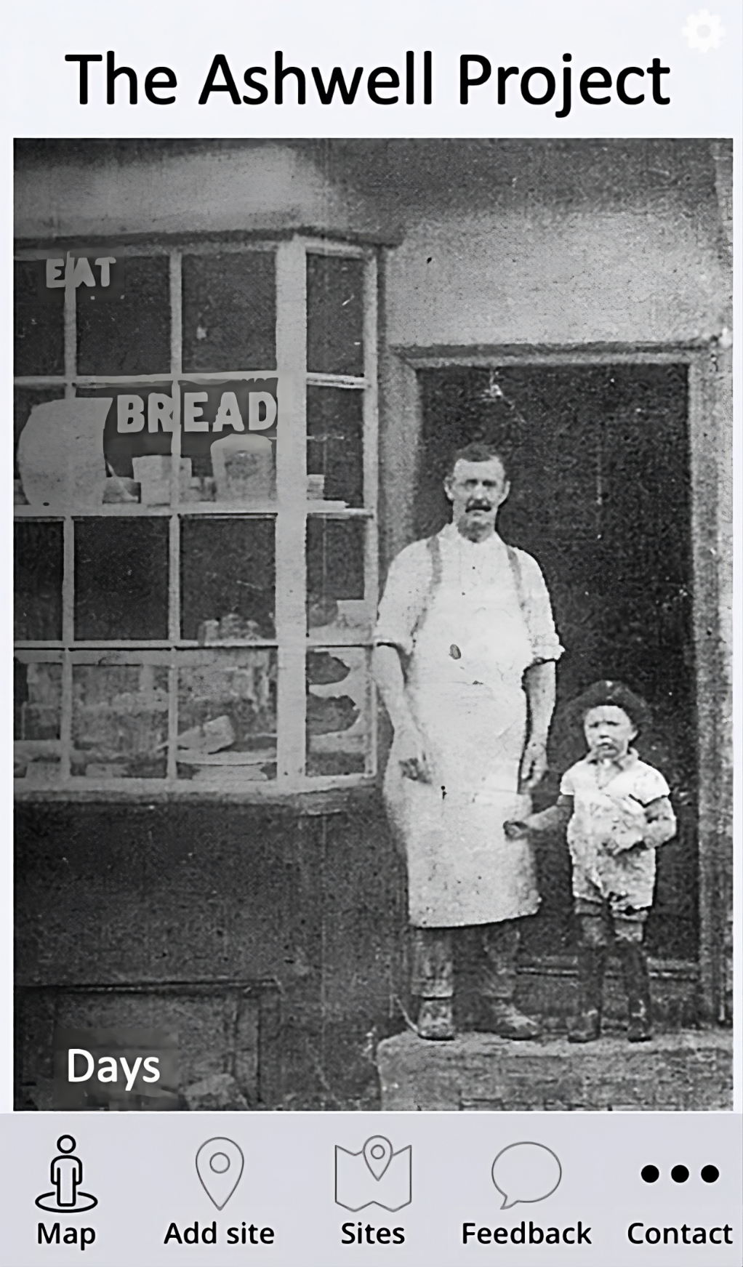
Figure 1 The home screen of The Ashwell Project (author’s own)
To create a ‘living digital record’ of Ashwell, several objectives were set:
- Analyse collection strategies to capture anecdotal stories.
- Analyse the types of intangible heritage captured using these techniques.
- Analyse the potential of Progressive Web Apps to digitally disseminate intangible and tangible heritage.
The conception followed a similar line of thinking to that used in “Hidden Newcastle” (Hidden Newcastle 2014), Layers of London (Cullum, Jarvis, and Unitt, 2020, 5) and Know Your Place West of England (Streich 2017, 3), with the additional research of creating a local online heritage platform during the COVID-19 pandemic. The principal idea was to provide a community space from which individuals could upload, comment, and share their own individual heritage abiding by social distancing and lockdown requirements. It was also hoped to reach a broad audience, providing a grassroots approach to education on the history of the village.
Within wider contexts, the combination of participatory GIS, crowdsourcing, and web application functionality enabled a novel understanding of how the use of these techniques can help unlock currently understated heritage assets, and produce an online community which shares pride in these elements.

Methods and materials
TAP aimed to investigate collection strategies that captured anecdotal stories, analyse the potential of Progressive Web Apps to digitally disseminate intangible and tangible heritage, and examine the types of intangible heritage captured using these techniques.

Data collection
Data collection methods encompassed a multi-pronged approach including in-person collection of paper forms conducted at community venues with paper forms to fill in, leveraging social media engagement with existing heritage groups, and enabling direct uploads through the app interface. Physical paper forms were handed out during group discussion in the local church providing opportunities for those who may be technophobic, while social media channels provided a convenient platform for gathering narratives from more digitally active participants (Richardson 2014). Direct app uploads offered another inclusive channel for contributions, ensuring participation from users across various community members (Koukopoulos and Koukopoulos 2018). The combination of the three different approaches enabled a more comprehensive collection of narratives, potentially increasing the variety of heritage subjects captured. Voluntary participation was ensured, with the right to withdraw at any stage. This methodology applies to the University of York’s Ethical Guidance and underwent ethical review.
All narratives underwent moderation by the researcher to ensure proper authentication, compliance with data regulations (e.g., GDPR), and to avoid misuse while protecting the community members’ anonymity. The moderation was carried out by manually checking that personal data was not disclosed, that the narratives did not contain any profanity and that they were appropriate for all ages.

GIS
Geographic Information Systems (GIS) enable the visual display of data for interpretation, analysis, and communication (Conolly 2006). However, traditional GIS has been criticised for its positivist nature and perceived authoritative expertise involved in representing geographical information (O’Sullivan 2006). Participatory GIS has emerged as a method to address such issues by democratising GIS through collaboration between diverse stakeholders such as academics (i.e., University of York), professionals (i.e., Ashwell Museum), and local community members to achieve more inclusive and socially just outcomes (Tripathi and Bhattarya 2004; Elwood 2006; Santos et al. 2021).
TAP adopted a participatory GIS approach due to its capacity to democratise geographic information representation and its alignment with the research objective of inclusively capturing diverse forms of intangible heritage. Through democratisation, it allows the community members themselves to identify heritage assets of particular importance (Santos et al. 2021; Goussios and Faraslis 2022). Democratisation has been used by Historic England through their Missing Pieces project to provide a platform from which individuals could suggest their own heritage assets (Historic England 2023).
Through the incorporation of the community voice, it was hypothesised that the community might identify sights of significance in Ashwell which were not included in the professionally collected heritage lists. Such stories could consist of lived experiences, cultural traditions, customs, memories, beliefs, and local knowledge connected to place.

Progressive Web Apps
Throughout the project, the capabilities of Progressive Web Apps (PWAs) were analysed for their potential to facilitate participatory approaches for digitally disseminating cultural heritage. PWA technology was selected for its ability to provide app-like experiences through a web browser, without needing app store installation or updates (Hume 2017). Key technical capabilities of PWAs include enabling features such as offline access, push notifications, navigation, and rapid loading times (Karki 2019). The implementation of service workers and progressive enhancement allows PWAs to maintain reliable performance even with unstable network connectivity. These capabilities allowed an exploration of the aims of the research as they had the potential to aid in capturing and disseminating heritage assets within the rural community of Ashwell. Furthermore, PWAs are built using standard web development languages like HTML, CSS, and JavaScript, facilitating responsiveness across diverse devices and screen sizes (ibid), meaning that the application had straightforward implementation and reduced complexity compared to native mobile applications. Nonetheless, making the platform available through a smartphone offered opportunities to immerse new audiences (e.g., young adults) within heritage (Tallon 2008; Slavec et al. 2021).

User Experience Design
To assist in TAP’s aims of effective capture and dissemination of heritage, the user Experience Design was carefully considered. To achieve this end, phenomenological and design thinking approaches were utilised.
Phenomenology, based on the theory that humans perceive spatial data in similar ways, informed the app’s design (van Dyke 2014). Through the incorporation of phenomenology, it was hypothesised that the app would be able to encourage interaction, further disseminating the heritage contained within. The phenomenological approach is clearest in its user design, as well as its incorporation of different walking tours of Ashwell’s timeline and changing use of land, on different themes (Fig. 2). Users were guided to traverse key landmarks while spatial storytelling conveyed how inhabitants experienced and interacted with the landscape within living memory.
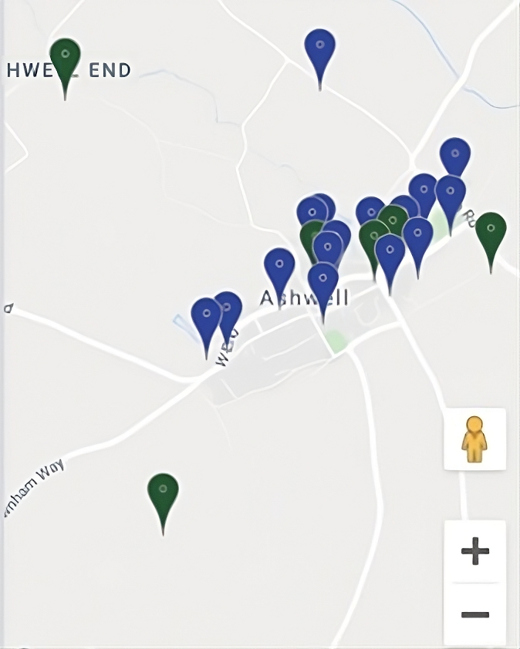
Figure 2 Map of sites (authors own with data from Google Maps)
Design thinking guided the app's co-development process to aid the dissemination and capturing of the community’s heritage (Brown 2008; Lo Presti and Carli 2023). Public opinions were continually incorporated in the design thinking stages: empathising, defining, ideating, prototyping, testing, implementation, and evaluation. Initial engagement to empathise with end-users helped accurately define the problem statement and objectives for TAP. Solutions were then ideated to tackle these objectives and prototyping incorporated public feedback to improve these solutions. Iterative small-scale testing with users provided input to refine the app’s user experience design. Implementation included final adjustments based on user perspectives before public launch. Ongoing evaluation through monitored use and direct surveys enabled continuous app improvements incorporating the community’s input (e.g., Fig 3). Overall, through the integration of public opinions within the design thinking process aimed to ensure a user-centric app aligned with target users' needs, expectations and diverse heritage experiences in Ashwell. It is hypothesised that the methodology facilitated accessible and engaging digital heritage preservation.
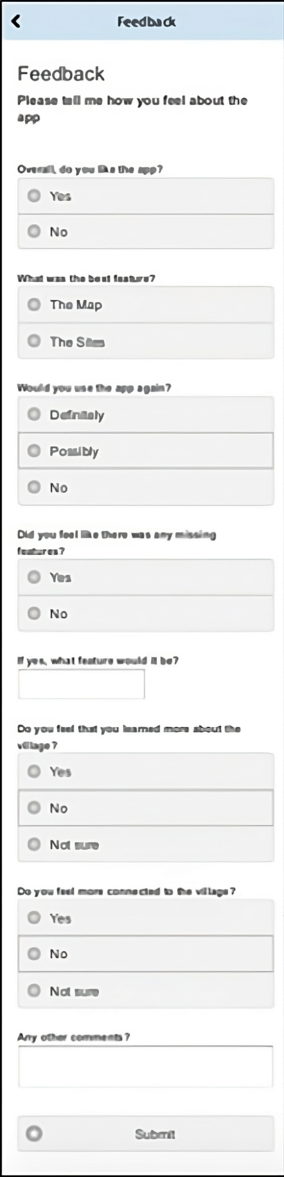
Figure 3 feedback feature in the app (Authors own).

Results
Stories were provided both through in-person events and online platforms (social media and through the PWA). In total, there were 51 places recorded as being culturally significant with 33 associated stories collected in the in-person events, and 29 places recorded with 23 stories using online communication channels. There were zero stories uploaded to the platform itself. The stories provided covered a range of different topics and were of various lengths (average character length of 210.76 for social media and 42.24 for stories collected via paper forms). The stories covered topics of places of living, retail and community facilities, nature, or religion/rest.

Discussion
Although limited narratives were provided, the results suggest interesting lessons that should be considered when carrying out the project on a larger scale.

Data collection
Data collection was conducted through three main strategies: in-person paper forms, via social media, and through the app itself. This multifaceted approach aligns with Aim One, which aims to analyse diverse collection techniques for gathering impactful intangible histories. Most of the results were gathered through in-person events, suggesting that this is the most effective way to capture data from as many individuals as possible. Nonetheless, the narratives captured using social media had a longer average character length than the paper forms, indicating that online participation captured more detailed narratives. Therefore, future projects should consider the required data format, whether it prioritises the quantity or quality of the data.

Narratives collected
The stories submitted convey Ashwell's rich intangible heritage across an array of different intangible heritage categories (Fig. 4 and 5). Analysing these collection strategies and identifying heritage types connects directly back to aims one and three.
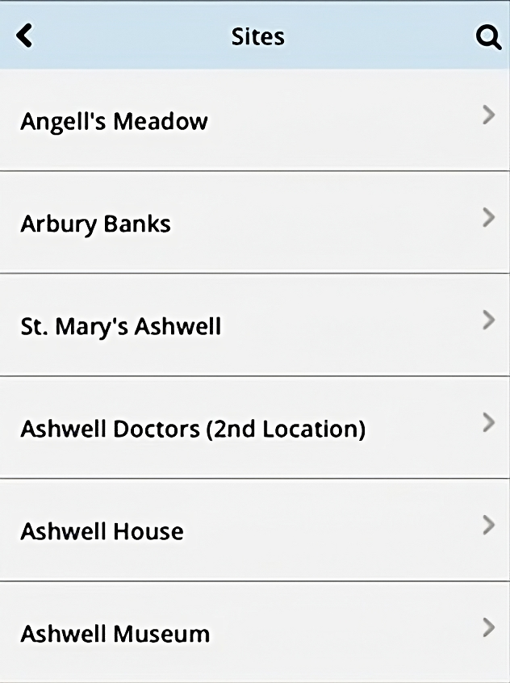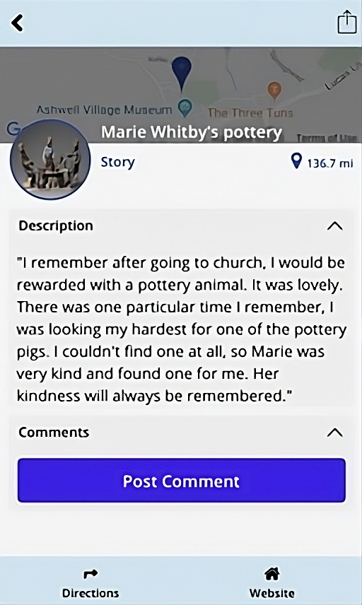
Figure 4, left, Part of the list of locally important sites and Figure 5, right, showing a story associated with this place (author’s own).
Natural landmarks constituted the majority of the results (19) and contained entities such as The Springs (14), woods (two), viewpoints over the village (two), or working in the allotment (one). These landscapes led to narratives of 80 characters in length, suggesting that they have a particular narrative associated with them. In turn, the character length demonstrated the significance of natural landscapes for intangible heritage. These trends can be taken further when ignoring The Springs (up to 121 characters). As the number of listings suggests, The Springs is a well-known landmark in the village, and as such, respondents might feel it should be part of the list rather than having a particular narrative associated with the area. In turn, having the listing included multiple times without an associated narrative illustrates the differences between community heritage and personal heritage, and as such methods to capture both should be encouraged in future projects.
Public facilities are the second most populous (15), including sports facilities - Smallgains, cricket pitch, and the Recreation ground (Rec), built – Ashwell School and The Village Hall, and cultivated - The Cottage Garden. On average, the character length was 71, suggesting associated narratives. These narratives included: bright murals and close companionships formed at Ashwell Primary School, and bustling events at The Village Hall. These spaces demonstrate how shared experiences in common environments profoundly shape the culture and character of this tight-knit community. Although some of these spaces are listed (Historic England n.d.), places such as Smallgains, Village Hall, and Recreation Ground are not, showing the necessity of encouraging local voices to acknowledge significant sites.
Family homes and historical sites were both listed 12 times, offering a glimpse into the different types of heritage captured within TAP. Historic landmarks like Arbury Banks (seven), temple sites (two), and The Lockup, Gardiners Lane Wall, and The Museum (one each) connect modern-day Ashwell to its past and its more traditional heritage value. Nonetheless, as the average character length is 105, it shows that there can be intangible heritage associated with traditional tangible heritage sites, demonstrating the importance of considering how the local population may consider sites when carrying out heritage research.
Even more personal places like family homes and landholdings (Dixies Farm and Ashwell House) add even greater levels of personal history within the intangible heritage. These spaces symbolise intimate intangible heritage of lineage and personal growth, suggesting that individual intangible heritage closely interweaves with ideas of family and hearth. Nonetheless, intriguingly the average character length is only 55, suggesting although considered significant through the number of listings that included personal homes, the respondents did not include a specific narrative. Reasons as to why this might be the case include being too numerous or personal to share through an app. As such, in future projects, it is important to consider how best to balance personal datasets of addresses with inclusivity of what individuals consider their own identity in intangible heritage.
Retail and Places of worship/rest had ten listings each showing how built heritage can play further roles in the community heritage. Places of worship/rest consisted of St Mary's Church (seven) and The Congregational Church, Village Graveyard, and War Memorial (one each). Part of the reason why there might be numerous listings for St Mary's Church is that the paper form was distributed in the church, and as a result, might skew the proportions. It is important to consider the place of data collection within future initiatives to ensure that data is not biased in the future, nonetheless, the character length here (98) suggests that spirituality plays a role in Ashwell’s heritage. In terms of retail, a large variety of places were included – Days of Ashwell (Bakers) and Hairdressers (56 High Street) (two), and The Rose & Crown, Ashwell Garage, Marie Poter's Pottery, Crumps (butchers), Chemist and Post Office (one each). This grouping is the most diverse; however, it suggests that there is a commonality of shopping and retail being significant to the cultural identity. On average, the character length was 228, suggesting that the retail spaces have the most detailed intangible heritage. An example is The Rose & Crown pub representing adulthood and independence, with residents fondly recalling milestone 18th birthday celebrations there. The results are skewed by having the two longest narratives (974 and 855 characters), and five listings do not have an associated narrative, nonetheless, the frequency of inclusion reveals that retail has a significant impact on cultural heritage.
A further category, farms (Dixies and Blue Gates), shows Ashwell’s connection to its wider rural landscape. The inclusion of these shows how the wider context of a community also impacts the intangible identity of communities. In the case of the Dixies Farm listing, it is associated with a long narrative further supporting the idea that the wider context of communities contains heritage significance for Ashwell’s residents.
Overall, the captured narratives show the potential of mixed methodologies to capture diverse tangible and intangible heritage. These sites were often associated with narratives, suggesting that the technical capabilities deployed in the Ashwell Project can be used to capture detailed heritage information. By digitally archiving these intangible heritage treasures, not only can cultural resonance be sustained for the future, but insights for bolstering community bonds today can be gathered as well. Given these promising results, expanding efforts to capture local narratives could profoundly benefit other communities too.

Potential of PWAs
Evaluating the intended audience and usage of TAP connects directly to aim two's goal of analysing the potential of Progressive Web Apps for disseminating heritage. Envisioned users like touring families, socially isolated individuals, and student groups guided TAP’s design and feature considerations. This methodology not only spotlights TAP's successes in engaging diverse demographics during initial testing but also introduces opportunities to strengthen accessibility and utility for future iterative projects. Analysing these use cases and potential thus aligns with aim two by elucidating best practices for digitally sharing cultural heritage via Progressive Web Apps to enrich communities. The insights gained can shape inclusive development strategies to overcome barriers to participation like geography, ability, age, or social marginalisation.
Narrative is a vital way to learn about the world, providing personal stories and bringing alive experiences for users of all ages by appealing to their imagination. By incorporating community narratives relevant to places, TAP was able to educate a family group about the local heritage in a manner accessible to both children and adults. Their engagement was enhanced through the combination of narrative and visuals as well as navigational abilities, as was successful in Mulholland and Collins (2002). In conversations with users, it was clear how the app had provided an opportunity to meet COVID-19 restrictions on travel and time outside, whilst also allowing novel and interesting content for COVID household “bubbles”. As such, the results suggest that PWAs had the potential to disseminate heritage multi-generationally.
Unfortunately, isolation is a common problem in ageing populations, and although strategies, such as social prescribing initiatives, are in place to minimise this, it is still a worrying trend (Beacker et al. 2014). The methodology used within TAP may have been favourably biased towards digitally active and socially connected individuals, potentially overlooking marginalised voices (e.g., isolated older populations) within the community. Nonetheless, it has been argued by Social Connectedness (2018) that by using digital technology, there is a possibility for greater connectivity between the individual and the community. A recent project by Capital Regional District in Victoria, Canada, combined maps to mitigate senior social isolation (Social Connectedness 2018). This was an approach used within TAP. This was derived from the idea that “narrative is … central to collaboration and the building of community identity” (Mulholland and Collins 2002, 1), and the results show the diversity of different narratives that have been captured through the project. The results of this were shown anecdotally by the local church community, by them stating it was a lovely opportunity to discuss their memories with each other. Furthermore, notifications were added when a new story was uploaded or if a museum event was taking place, allowing the user to be included in the wider community. As an addition, the use of navigation was beneficial as it enabled users to spend time outdoors in a more phenomenological manner. The use of navigation originated from the need for exercise, particularly in the older ages (Larson et al. 2006; Larson and Wang 2004). The use of the application showed how the Progressive Web App was able to not only disseminate the intangible and tangible heritage contained within but also tackle some of society's wider challenges today.
TAP's blended data delivery demonstrated the educational potential of Progressive Web Apps, connecting to aims one and two. As Phillip et al. (2013) assert, pairing facts with geographical and narrative context transforms information into resonant knowledge. By mapping Ashwell’s heritage sites and overlaying the populous’ poignant recollections, this digitisation empowered various learning modalities (e.g., if a museum group wished to run a village heritage tour focused on intangible heritage based on architecture). Though COVID hindered in-person activities, modelling future functionality spotlights promising versatility for place-based education. Expanding these inclusive tools could profoundly benefit teachers and students exploring community heritage across disciplines.
One aspect that the PWA failed on was the capturing of heritage narratives. Reasons as to why this may have been the case include limited run time, over-promotion on social media diverting upload through this channel or hesitance to upload narratives this way. Due to the variety of potential shortcomings, it is difficult to assess whether it was inherent challenges associated with PWAs themselves. As such, further research should be carried out to assess whether this is the case. Nonetheless, as zero stories were uploaded to the PWA, TAP’s PWA was not successful in this one aim.

Conclusion
In conclusion, this paper presented The Ashwell Project, a novel participatory GIS and crowdsourcing initiative leveraging Progressive Web App technology to capture and disseminate the rich tangible and intangible heritage of the rural English village of Ashwell. Through an interdisciplinary methodology incorporating design thinking and phenomenology alongside technical implementation, the research aimed to democratise heritage representation, boost community cohesion, and improve accessibility to local culture.
Results demonstrated the viability of varied narrative collection techniques like paper forms and social media alongside direct app uploads to gather impactful community stories grounded in place. Captured intangible heritage spanned diverse emotionally resonant landmarks like natural springs, schools, homes, and pubs. Progressive Web App capabilities proved engaging for audiences ranging from socially isolated seniors to touring families, affirming the potential for flexible, inclusive dissemination.
While app uploads were limited, overall, the positive reception and breadth of stories collected affirm the merit in expanding such participatory digital heritage efforts. This could profoundly enrich marginalised voices, intergenerational knowledge transfer, place-based education, and community identity. The research also highlights how empathy-driven design thinking can tackle barriers to digital participation.
In summary, The Ashwell Project pioneered an innovative methodology synthesising participatory GIS, crowdsourcing, and Progressive Web Apps to advance inclusive, community-anchored heritage engagement. As digital mediation increases amidst the pandemic and beyond, these strategies hold valuable lessons for sustaining living culture. This research helps chart a path for grassroots digital tools promoting agency and social connection through our shared narratives across space and time.

Acknowledgements:
We would like to express our sincere gratitude to Ashwell Museum and the University of York for their collaboration and support throughout The Ashwell Project. Their contributions were invaluable in making this project a reality. Furthermore, thanks go to the Ashwell community for their insights and stories.

Funding:
The research presented in this paper did not receive any specific funding. However, the author would like to disclose that attendance at the Computer Applications in Archaeology 2022 conference was made possible through the support of the Arts and Humanities Research Council’s Collaborative Doctoral Partnership Scheme. The author is grateful for this funding opportunity, which facilitated their participation in the conference and provided valuable insights and collaborations for this research. It is important to note that the funding source played no role in the design, execution, analysis, interpretation, or presentation of the research findings in this paper. The research and its conclusions remain independent and solely reflect the author’s efforts and expertise in the field of bioarchaeology and data reusability.

Conflict of Interest Statement:
The author of this paper declares no conflict of interest related to the content presented in this research. The study, data analysis, and conclusions have been conducted independently and without any financial, personal, or professional affiliations that could potentially influence the objectivity or integrity of the information provided. There are no associations or financial arrangements with any organisations or individuals that could be perceived as having a vested interest in the outcomes or findings of this article.
In the event of any potential conflicts of interest arising in the future, the author will promptly disclose them and take appropriate actions to ensure transparency and maintain the highest level of integrity in the research process. The author is committed to upholding ethical practices in scientific inquiry and reporting to maintain the credibility and credibility of the research findings.

Data, scripts, code, and supplementary information availability
Data associated with this paper is accessible from here: https://doi.org/10.5281/zenodo.8307859

References
Alibhai, K. (2017). Social Isolation and Technology: How Technology Can be Used to Reduce Social Isolation Among Older Adults in British-Columbia (Social Connectedness Fellowship Program). Samuel Centre for Social Connectedness.
Beacker, R., Sellen, K., Crosskey, S., Boscart, V., & Neves, B. B. (2014). Technology to Reduce Social Isolation and Loneliness. In Proceedings of the 16th International ACM SIGACCESS Conference on Computers & Accessibility (pp. 27-34). Technologies for Aging Gracefully Lab (TAGlab).
Conolly, J. (2006). GIS in Archaeology. Cambridge University Press.
Du, J. T., Peters, S., Haines, J., Trevorrow, A. E., Jia, R. M., & Ziaian, T. (2022). A Framework for Co‐designing and Developing Participatory Storymaps with Aboriginal Communities. Proceedings of the Association for Information Science and Technology, 59(1), 420-425.
Elwood, S. (2006). Critical issues in participatory GIS: Deconstructions, reconstructions, and new research directions. Transactions in GIS, 10(5), 693-708.
Eve, S. (2017). The Embodied GIS. Using Mixed Reality to explore multi-sensory archaeological landscapes. Internet Archaeology, 2(44), 124.
Frieman, C., & Gillings, M. (2007). 'Seeing is perceiving?' World Archaeology, 39(1), 4.
Gaffney, V. L. (1996). GIS Approaches to Regional Analysis: A Case Study of the Island of Hvar, Ljubljana. Oxbow Books.
Goussios, D., & Faraslis, I. (2022). Integrated Remote Sensing and 3D GIS Methodology to Strengthen Public Participation and Identify Cultural Resources. Land, 11(10), 1657.
Greef, A. (2015). A Late Neolithic Henge at Ashwell: Post-excavation Assessment and Updated Project Design OAE Report Number 1780.
Hamilakis, Y. (2011). Archaeologies of the Senses. In T. Insoll (Ed.), The Oxford Handbook of the Archaeology of Ritual and Religion (pp. 208-225). Oxford University Press.
Hidden Newcastle. (2014). Hidden Newcastle: Strange. Extraordinary. Forgotten. [Online]. Available at: http://www.hiddennewcastle.org [Accessed 20 December 2020].
Historic England (2023). Missing Pieces Project: Add Your Pieces to the Big Picture. Available at: https://historicengland.org.uk/listing/missing-pieces/
Historic England (n.d.). "Search the List." Available at: https://historicengland.org.uk/listing/the-list/.
Hume, D. (2017). Progressive web apps. Simon and Schuster.
Jackson, R., and Burleigh, G. (2018). Dea Senuna: Treasure, Cult and Ritual at Ashwell, Hertfordshire, The British Museum
Jeater, M. (2012). Smartphones and site interpretation: the Museum of London’s Street Museum Applications. In C. Bonacchi (Ed.), Archaeology and Digital Communication: Towards Strategies of Public Engagement (pp. 66-82). Archetype Publications.
Karki, A. (2019). Progressive Web Applications (PWAs): powerful websites, functional as native mobile apps. Undergraduate thesis, Turku University of Applied Sciences.
Kenderdine, S. (2015). Embodiment, Entanglement, and Immersion in Digital Cultural Heritage. In S. Schreibman, R. Siemens, & J. Unsworth (Eds.), A New Companion to Digital Humanities (pp. 22-41). John Wiley & Sons.
Koukopoulos, Z., & Koukopoulos, D. (2018). Evaluating the usability and the personal and social acceptance of a participatory digital platform for cultural heritage. Heritage, 2(1), 1-26.
Larson, E. B., & Wang, L. (2004). Exercise, aging, and Alzheimer disease. Alzheimer Disease and Associated Disorders, 18(2), 54-56.
Larson, E. B., Wang, L., Bowen, J. D., McCormick, W. C., Teri, L., Crane, P., & Kukull, W. (2006). Exercise is associated with reduced risk for incident dementia among persons 65 years of age and older. Annals of Internal Medicine, 144(2), 73-81.
Lo Presti, O., & Carli, M. R. (2023). Promoting Underground Cultural Heritage through Sustainable Practices: A Design Thinking and Audience Development Approach. Sustainability, 15(11), 9125.
Morgan, C., & Eve, S. (2012). DIY and digital archaeology: what are you doing to participate? World Archaeology, 44(4), 521-537.
Mulholland, P., & Collins, T. (2002). Using digital narratives to support the collaborative learning and exploration of cultural heritage. In Proceedings of the 13th International Workshop on Database and Expert Systems Applications (pp. 527-531). IEEE.
North Herts Council (2023). Ashwell Conservation Area Character Appraisal and Management Plan. Available at: https://democracy.north-herts.gov.uk/documents/s22416/Ashwell%20-%20Appendix%20B%20-%20Final%20Version%20CAAMP%2027062023%20Cabinet%20Draft%20Agenda.pdf
O'Sullivan, D. (2006). Geographical information science: Critical GIS. Progress in Human Geography, 30(6), 783-791.
Pavlovskaya, M. (2006). Theorizing with GIS: a tool for critical geographies? Environment and Planning A, 38(11), 2003-2020.
Philip, T. M., Schuler-Brown, S., & Way, W. (2013). A Framework for Learning About Big Data with Mobile Technologies for Democratic Participation: Possibilities, Limitations, and Unanticipated Obstacles. Technology, Knowledge and Learning, 18(3), 103-120.
Richardson, L. (2013). A Digital Public Archaeology? Papers from the Institute of Archaeology, 23(10), 1-12.
Richardson, L.J. (2014). Public Archaeology in a Digital Age. Doctoral thesis , UCL (University College London).
Said, J., & Schleppenbach, D. (2004). Accessible user interface and navigation system and method. US Patent.
Santos, B., Gonçalves, J., Martins, A.M., Pérez-Cano, M.T., Mosquera-Adell, E., Dimelli, D., Lagarias, A. and Almeida, P.G. (2021). GIS in architectural teaching and research: planning and Heritage. Education Sciences, 11(6).
Shih, P. C., Han, K., & Carroll, J. M. (2015). Engaging community members with digitally curated social media content at an arts festival. In Proceedings of the 2015 Digital Heritage International Congress (pp. 321-324). IEEE.
Slavec, A., Sajinčič, N., & Starman, V. (2021). Use of smartphone cameras and other applications while traveling to sustain outdoor cultural heritage. Sustainability, 13(13), 7312.
Tallon, L. (2008). Introduction: Mobile, Digital and Personal. In L. Tallon & K. Walker (Eds.), Digital Technologies and the Museum Experience: Handheld Guides and Other Media (pp. xiii-xxv). AltaMira Press.
The Ashwell Project (n.d.). The Ashwell Project. University of York and Ashwell Museum.
Thomas, J. (2008). On the ocularcentrism of archaeology. In V. Jorge & J. Thomas (Eds.), Archaeology And The Politics of Vision In A Post-Modern Context (pp. 1-12). Cambridge Scholars Publishing.
Walker, D. (2014). Antisocial Media in Archaeology? Archaeological Dialogues, 21(2), 217-235.
Wheatley, D., & Gillings, M. (2002). Spatial technology and Archaeology: The Archaeological Application of GIS. Taylor and Francis.

