Surface texture analysis in Toothfrax and MountainsMap® SSFA module: Different software packages, different results?

Ivan CALANDRA ª*, Konstantin BOB ^{b}, Gildas MERCERON ^{c}, François BLATEYRON ^{d}, Andreas HILDEBRANDT ^{b}, Ellen SCHULZ-KORNAS ^{e-f}, Antoine SOURON ^{g}, Daniela E. WINKLER ^{f,h,i}

ª Römisch-germanisches Zentralmuseum, MONREPOS, Neuwied, Germany, ivan.calandra@rgzm.de
^{b} Scientific Computing and Bioinformatics, Institute of Computer Science, Johannes Gutenberg University, Mainz, Germany
^{c} PALEVOPRIM, UMR CNRS 7262, University of Poitiers, Poitiers, France
^{d} Digital Surf, Besançon, France
^{e} Department of Cariology, Endodontology and Periodontology, University of Leipzig, Leipzig, Germany
^{f} Leibniz Institute for the Analysis of Biodiversity Change, Center for Taxonomy and Morphology, Section Mammalogy and Paleoanthropology, Zoological Museum, Hamburg, Germany
^{g} CNRS, MCC, PACEA, UMR 5199, University of Bordeaux, Pessac, France
^{h}Department of Natural Environmental Studies, Graduate School of Frontier Sciences, The University of Tokyo, Chiba, Japan
^{i} Institute of Geosciences, Applied and Analytical Paleontology, Johannes Gutenberg University, Mainz, Germany

* Corresponding author

ORCID:
François BLATEYRON 0000-0001-7048-4045
Konstantin BOB 0000-0002-1929-9829
Ivan CALANDRA 0000-0003-3816-6359
Andreas HILDEBRANDT 0000-0003-2180-6516
Gildas MERCERON 0000-0001-5777-7126
Ellen SCHULZ-KORNAS 0000-0003-1657-8256
Antoine SOURON 0000-0001-7384-4974
Daniela E. WINKLER 0000-0001-7501-2506

Abstract
The scale-sensitive fractal analysis (SSFA) of dental microwear textures is traditionally performed using the software Toothfrax. SSFA has been recently integrated to the software MountainsMap® as an optional module. Meanwhile, Toothfrax support has ended. Before switching to the new module, the outputs between the two software packages must be compared for consistency.
We have performed such a test using Bayesian modelling on three datasets including dental surfaces of sheep (Merceron et al., 2016) and guinea pig (Winkler et al., 2019a) from controlled feeding experiments, as well as surfaces of quartzite and flint flakes used in an actualistic archeological experiment on cleaning procedures (Pedergnana et al., 2020a).
We found that the two software packages calculate significantly different values for the SSFA parameters epLsar, Asfc, HAsfc9 and R², even when the same settings are used. Nevertheless, the treatments (different diets or cleaning procedures) are discriminated similarly within each dataset.
While the new software module is as good as the original software to differentiate treatments, our results imply that the outputs from the two software packages are not directly comparable and, as such, cannot be merged. Surface texture analysts should therefore consider re-analyzing published surfaces before integrating them in their studies.

Keywords
Bayesian models, dental microwear texture analysis, scale-sensitive fractal analysis, software comparison, tooth wear, use-wear analysis
1. Introduction
The scale-sensitive fractal analysis (SSFA) is a method originally developed for the quantification of wear in industrial and engineering applications (e.g. Brown et al., 1993; Brown, 2000). A surface is rougher at finer scales than at larger ones, and SSFA investigates such changes across scales that are relevant for functional assessments. Since its first applications on primate teeth for dietary reconstructions (Ungar et al., 2003; Scott et al., 2005), SSFA has become an essential tool for biologists, paleontologists, zooarchaeologists and anthropologists as part of the dental microwear texture analysis (DMTA) (Ungar, 2015; DeSantis, 2016; Calandra & Merceron, 2016; Green & Croft, 2018; Schulz-Kornas et al., 2020a). DMTA quantifies the micro-topography on tooth surfaces resulting from abrasion, attrition and erosion due to the contact with food items and other abrasive particles such as dust or grit during comminution (Hara et al., 2016, 2021; Ranjitkar et al., 2017; Krueger et al., 2021). This method is therefore commonly applied to infer diets of extant and fossil vertebrates (Ungar & Evans, 2016; Ungar & Zhou, 2017) and to reconstruct paleo-environments (e.g. Ungar et al., 2012, 2020; Merceron, Novello & Scott, 2016; Berlioz et al., 2018; Blondel et al., 2018). SSFA has also been applied by archeologists to quantify the wear produced on stone and bone tools by different uses (Stemp et al., 2009; Lesnik, 2011; Stemp & Chung, 2011; Key et al., 2015; Watson & Gleason, 2016; Stemp, Lerner & Kristant, 2018; Pedergnana et al., 2020b,a), although its application is less generalized than in biology/paleontology (Calandra et al., 2019a).
Originally, the SSFA for DMTA has been performed with a custom-made software called Toothfrax, in combination with Sfrax, developed by SurFract Corp (Worcester, MA) (see details in Scott et al., 2006). It computes five parameters: area-scale fractal complexity (Asfc, referred to as "complexity"), scale of maximum complexity (Smc), length-scale anisotropy of relief (epLsar, "anisotropy"), heterogeneity of area-scale fractal complexity (HAsfc, "heterogeneity"), and textural fill volume (Tfv). Only Tfv is calculated in the software Sfrax; the other four parameters are computed with the software Toothfrax. Some recent studies have focused only on complexity and anisotropy because these parameters seem to be the most discriminant ones to reconstruct diets (e.g. Kubo et al., 2017; Schmidt et al., 2019; Arman et al., 2019; Winkler et al., 2019b; Ackermans et al., 2020; Ungar et al., 2020). However, analyses of incisor microtextures have found that Tfv is an important parameter related to anterior tooth loading and tooth use (Krueger & Ungar, 2010; Krueger, 2015; Delezene, Teaford & Ungar, 2016; Krueger et al., 2017, 2019; see also Caporale & Ungar, 2016 on rodents).
Many manufacturers of 3D profilometers and confocal microscopes use the MountainsMap® software solution by Digital Surf (Besançon, France) as a software platform for their instruments. They also adjust the modularized MountainsMap® software for their requirements, resulting for example in ConfoMap by Carl Zeiss Microscopy (Jena, Germany), LeicaMap by Leica Microsystems (Wetzlar, Germany), SensoMAP by Sensofar (Barcelona, Spain) and µsoft analysis by Nanofocus (Oberhausen, Germany). This makes MountainsMap® software solution the most used software package to prepare and process the raw 3D surface data before conducting any further quantitative analysis.
The MountainsMap® software allows the calculation of other parameters according to 3D surface texture analysis using standardized ISO parameters and further analyses (STA or 3DST according to Schulz, Calandra & Kaiser, 2010; Calandra et al., 2012). This analysis has been applied to teeth of various vertebrates (e.g. Purnell, Seehausen & Galis, 2012; Purnell et al., 2013, 2017; Gill et al., 2014; Winkler et al., 2016, 2019a,b; Calandra et al., 2016; Kubo et al., 2017; Yamada et al., 2018; Schulz‐Kornas et al., 2019; Stuhlträger et al., 2019; Aiba, Miura & Kubo, 2019; Bestwick, Unwin & Purnell, 2019; Bethune et al., 2019), but also to lithic (e.g. Werner, 2018; Caux et al., 2018; Galland et al., 2019; Macdonald, Xie & Gallo, 2019; Ibáñez, Lazuen & González-Urquijo, 2019; Pedergnana et al., 2020b,a; see also Rosso, d’Errico & Queffelec, 2017 for an application on ochre) and bone (e.g. Martisius et al., 2018, 2020; Turcotte et al., 2020) surfaces.
Digital Surf implemented the SSFA as new optional module for their MountainsMap® software, first released in 2018 in the MountainsMap® software version 7.4.8676. It is now possible in the MountainsMap® software to calculate different types of DMTA, e.g. SSFA and 3DST, in a single, optimized software with templates for automation.
Three differences between the original Toothfrax software and MountainsMap’s SSFA module are noteworthy, though. First, in the SSFA module, the Smc parameter has been renamed to Smfc (scale of maximum fractal complexity) to differentiate it from the ISO 25178 Smc parameter (inverse areal material ratio of the scale-limited surface); we follow this terminology here. Second, the Tfv parameter is not available in the SSFA module, even in the latest release of MountainsMap (v. 9.2.10170), although it will probably be released with a future update. Third, starting with MountainsMap version 8, a new anisotropy parameter called NewEpLsar is available, alongside the original one. This new parameter is meant to correct a mistake in the code of Toothfrax (see section 4.3 below).
The majority of the published data were calculated with the software packages Sfrax and Toothfrax, and this remains true for many recent studies (e.g. Berlioz et al., 2017, 2018; Percher et al., 2018; Ungar & Berger, 2018; Smith & DeSantis, 2018, 2020; Merceron, Colyn & Geraads, 2018; Hofman-Kamińska et al., 2018; Tanis, DeSantis & Terry, 2018; Schmidt et al., 2019; Sewell et al., 2019; Arman et al., 2019; DeSantis et al., 2019, 2020; Stynder et al., 2019; Catz, Bignon-Lau & Merceron, 2020; Ungar et al., 2020; Robinet et al., 2020; Merceron et al., 2021). Others have already moved to MountainsMap’s SSFA module (e.g. Böhm et al., 2019; Winkler et al., 2019b, 2020b,a; Ackermans et al., 2020; Prassack et al., 2020; Schulz-Kornas et al., 2020b; Ungar et al., 2021). Sfrax and Toothfrax are not supported anymore; hence, the move to the new SSFA module is inevitable. This raises the question of whether the new module produces results that are identical to the ones from the original software, given identical contexts and configurations. In other words, can the output from the new SSFA module be directly compared to the published output of the Toothfrax software? Should this not be the case, are the results at least close enough, so that the functional interpretations (e.g. animal diet or tool use) remain? And how does the new anisotropy parameter (NewEpLsar) perform and compare to the original one?
Four years after the first release of MountainsMap’s SSFA module, we believe it is now time to take a step back and address these questions. In this paper, we compare the outputs from the two software packages on three published datasets of experimental sheep teeth (Merceron et al., 2016), guinea pig teeth (Winkler et al., 2019a) and lithic flakes (Pedergnana et al., 2020a). These datasets cover a range of biological and archeological applications on different materials (enamel, flint and quartzite) and at different sizes (guinea pig and sheep teeth, and lithic flakes). Additionally, the data were acquired using three types of confocal microscopes (programmable array scanning, disc-scanning, and laser-scanning confocal microscopes; Artigas, 2011), with objectives having different magnifications and numerical apertures (100×/NA=0.90, 100×/NA=0.80 and 50×/NA=0.95), and at different pixel sizes (from 0.0852 to 0.16 µm). Therefore, the conclusions should be relevant to many applications in various scientific as well as industrial user communities beyond the ones shown here as examples.

2. Material and Methods
2.1. Material
This section gives brief summaries for the three published datasets analyzed here (Table 1). We refer the reader to the original publications for details. Raw data for the present analysis can be freely accessed on Zenodo (https://doi.org/10.5281/zenodo.7219855; see also section 2.2.3 below).

 |  | Sheep | Guinea pigs | Lithics
Dataset | Reference | Merceron et al. (2016) | Winkler et al. (2019a) | Pedergnana et al. (2020a)
 | N | 40 ewes (Ovis aries) | 18 guinea pigs (Cavia porcellus) | 8 flakes (flint and quartzite)
 | Treatments | Clover | Dry grass | Control
 |  | Clover + dust | Dry lucerne | RubDirt
 |  | Grass | Dry bamboo | BrushNoDirt
 |  | Grass + dust | - | BrushDirt
Acquisition settings | Measuring equipment | Leica DCM8 | Nanofocus μsurf Custom | Zeiss LSM800 MAT
 | Objective | Leica 100×/0.90 | Nikon long-distance 100×/0.80 | Zeiss 50×/0.95
 | Light source | White LED (550 nm) | Blue LED (470 nm) | Violet laser (405 nm)
 | Step size | 0.20 µm | 0.06 µm | 0.25 µm
 | FOV | 333 × 251 µm | 160 × 160 μm | 255.56 × 255.56 μm
 | Frame size | 2584 × 1945 pixels | 984 × 984 pixels | 3000 × 3000 pixels
 | Measured on | Molds | Molds | Originals
Pre-processing | Software | Leica Map 7.0.6863 | MountainsMap 7.4.8676 | MountainsMap 8.2.9767
 | Extracted FOV | 200 × 200 µm | 60 × 60 μm | 50 × 50 μm
 | Extracted frame size | 1550 × 1550 pixels | 369 × 369 pixels | 588 × 588 pixels
 | Mirroring | Z | Z | -
 | Peak removal | batch algorithm for IMAGEJ based on mathematical morphological tools | - | -
 | Surfaces saved as | SUR files | NMS files | SUR files
 | N scans | 40 | 70 | 32
Table 1. Overview of the three published datasets re-analyzed. FOV = field of view, N = sample size.

2.1.1. Sheep dataset
This dataset has been collected and analyzed by Merceron et al. (2016). It contains data on a feeding experiment on 40 ewes (Ovis aries) fed four different diets for about 11 weeks: clover, grass, clover + dust, and grass + dust (10 ewes per diet).
The disto-labial enamel band of the protoconid of one of the lower second molars was molded using a polyvinylsiloxane elastomer. The molds were then scanned with a Leica DCM8 confocal profilometer (Leica Microsystems; see Table 1 for details on acquisition settings). Among other pre-processing steps (Table 1), abnormal peaks were automatically erased with a batch algorithm computed on IMAGEJ software based on mathematical morphological tools (this procedure can now be applied in MountainsMap 8 and its derivatives directly).

2.1.2. Guinea pig dataset
This dataset has been collected and analyzed by Winkler et al. (2019a). It contains data on a feeding experiment on 18 guinea pigs (Cavia porcellus) fed three different diets for three weeks: dry grass, dry lucerne and dry bamboo (6 individuals per diet). The original dataset includes three extra fresh diets that were not included in the present analysis.
The mesial enamel band on the right upper fourth premolars was molded. The molds were scanned using a μsurf Custom confocal disc-scanning microscope (NanoFocus AG; see Table 1 for details on acquisition settings).
For each specimen, four non-overlapping scans were taken. For individuals 2CC5G1 and 2CC5G2 (dry grass group), only three scans could be acquired, as the enamel bands were too thin or showed damage. See Table 1 for details on pre-processing.

2.1.3. Lithic dataset
This dataset has been collected and analyzed by Pedergnana et al. (2020a). It contains data on an actualistic brushing experiment on eight flakes. Flakes were knapped from two raw materials, flint or quartzite (four flakes each), and were subjected to four treatments: application of sediment and cleaning through rubbing with fingers (RubDirt), application of sediment and cleaning through brushing (BrushDirt), only brushing (BrushNoDirt), and control (no sediment and no brushing/rubbing), with one flake of each raw material per treatment.
The samples were scanned at two spots before and after treatment using a coordinate system to relocate the spots (Calandra et al., 2019c), resulting in 32 scans. An LSM800 MAT laser-scanning confocal microscope (Carl Zeiss Microscopy GmbH) was used for the scanning (see Table 1 for details on acquisition settings).
One spot of one sample ("Area 1" of sample FLT3-8) was not correctly acquired before the experiment but this was noticed only after the experiment had been performed; this area was therefore excluded from the subsequent analyses (see section 6.3.2 Exclude FLT3-8_Area1 ("before" wrongly acquired) in the R script "R_analysis/scripts/SSFA_1_Import" on Zenodo https://doi.org/10.5281/zenodo.7219855). Note that this did not exclude the sample, as the second spot was included. In sum, 32 scans were processed (Table 1) but only 30 scans were included in the statistical analysis (see section 2.2.3).
Unlike Pedergnana et al. (2020a), we restricted the analysis to a smaller, manually chosen area of the surface (Table 1) to limit the number of non-measured points to be filled later (see section 2.2.1).

2.2. Methods
The analysis presented below was performed with Carl Zeiss’ ConfoMap as a derivative of Digital Surf’s MountainsMap® software. Since the results are not specific to ConfoMap but are valid for any derivative of MountainsMap® featuring the SSFA module, we refer below to "MountainsMap" for simplicity and generality. Note however that the raw 3D surface data and the surface analysis (https://doi.org/10.5281/zenodo.6645445), as well as the statistical analyses (https://doi.org/10.5281/zenodo.7219855 and https://doi.org/10.5281/zenodo.7219884), explicitly mention ConfoMap.

2.2.1. Processing of 3D surfaces
All surfaces have been processed in MountainsMap version 8.2.9767 through a template performing the following steps. Most settings were chosen following Arman et al. (2016)'s workflow.
(1) Remove form with a polynomial of degree 2. The degree 2 was chosen following Schulz et al. (2013) and based on the visual inspection of some of the surfaces. Francisco et al. (2018) found that a degree 8 gave the best results. However, here we follow Schulz et al. (2013)'s and Arman et al. (2016)'s workflows by applying a degree 2, and recommend more testing for future studies.
(2) Level with a least-squares plane by subtraction. According to MountainsMap's reference guide, the least-squares plane "method is recommended for surfaces with random surface texture", which is the case here. Subtraction is recommended for surfaces with low slopes and ensures that the leveling keeps the XY spacing of the points (= digital lateral resolution) constant.
(3) Remove outliers (maximum slope 80°, measurement noise removed). The maximum slope of 80° was chosen in relation to the numerical apertures of the objectives (see below). The setting for the strength of the method is not used when removing outliers based on the maximum slope. The option to remove measurement noise was selected because no other filter was applied for this purpose.
(4) Threshold 0.1-99.9%. Most outliers are likely to be removed by the previous operator, but some points with extreme heights that are likely to be measurement artifacts might remain.
(5) Fill-in non-measured points (smooth shape from neighbors). It seems that MountainsMap and Toothfrax handle non-measured points differently, so we chose to avoid this confounding factor.
Because the surfaces for the Sheep dataset had already been cleaned of aberrant peaks before (see section 2.1.1), steps 3-4 were not applied on these surfaces.
The result surfaces (studiables after step 5) were saved manually in the uncompressed SUR format (for version 7.2 or older). This is crucial as the new compressed format (default when exporting the resulting studiables through templates) is not interpreted correctly by Toothfrax: Asfc value are extremely inflated (> 1000).

Note that in this analysis, as in some recent studies (e.g. Arman et al., 2016; Winkler et al., 2019b, 2021; Ackermans et al., 2020; Pedergnana et al., 2020b,a), the SSFA was run on scale-limited surfaces because form and measurement noise were filtered out prior to analysis. While this differs from the original applications of SSFA (Ungar et al., 2003; Scott et al., 2005, 2006), measurement noise can only blur the signal (Arman et al., 2016) and form is not related to the wear processes of interest here (Forbes, 2013; Evans et al., 2014; International Organization for Standardization, 2021).
Removing points with a high slope (> 80°) and filling these non-measured points (NMP) with a smooth shape from neighbors can artificially reduce the degree of fractality of the surfaces. Based on the numerical apertures of the objective used to measure the surfaces (Table 1), slopes > 72° (for NA = 0.95) on flat surfaces cannot be measured by the instruments; the maximum measurable slopes are even lower for smaller NAs (53° for NA = 0.80 and 64° for NA = 0.90). Even accounting for scattering on rough surfaces, slopes > 80° are very likely to result in aberrant points; keeping these aberrant points would artificially increase the fractality.
Some surfaces had very high ratios of NMP (≥ 20%). While these surfaces were processed, they were excluded from the statistical analysis (see section 2.2.3). For surfaces with less than 20% NMP, it should be noted that the NMP are isolated rather than concentrated (see results on Zenodo). Additionally, we ran the statistical analyses on two sets of surfaces: surfaces with NMP ratio < 5% and surfaces with NMP ratio < 20% (see section 2.2.3).
Altogether, we argue that this processing ensures data quality by removing aberrant points and does not substantially alter the degree of fractality of the surfaces.

The results of the processing for each surface can be freely accessed in both MNT (containing the acquired surface, the workflow and the results) and PDF (exported from the MNT) formats on Zenodo (https://doi.org/10.5281/zenodo.6645445).

2.2.2. SSFA
The SSFA was performed in two software packages: MountainsMap version 8.2.9767 with the SSFA module, and the original Toothfrax software. The latter followed the steps detailed in Scott et al. (2006), except for the maximum scale of the area-scale computation, which was reduced from 7200 to 1200 µm². This setting was modified to avoid erroneous calculations of Asfc when Smfc is very high (> 1200 µm²; see also section 4.1 below). We did try with a maximum scale of 7200 µm² but Smfc was never higher than 300 µm². This means that limiting the maximum scale to 1200 µm² does not change the results in this case. Since the Tfv parameter is not available yet in MountainsMap, Sfrax was not used.
The same settings were used in MountainsMap; all other settings were set to the default values. Since the SSFA module is relatively new, we provide a more detailed workflow here. First, a length-scale SSFA was conducted on rows; two parameters were calculated: epLsar and NewEpLsar, both calculated at 5° intervals and at the 1.8 µm scale of observation by default. Second, an area-scale SSFA was conducted on four corners; five parameters were calculated: R², Asfc, Smfc, HAsfc9 (3×3 subregions) and HAsfc81 (9×9 subregions). Note that due to the small size of the analyzed surfaces for the guinea pig and lithic datasets (Table 1), HAsfc81 was considered only for the sheep dataset and was excluded from the Bayesian analysis (see section 2.2.3). Other HAsfc parameters with splittings from 2×2 to 11×11 are also available but were not used. Both analyses were performed with the full data, i.e. the option "draft analysis" was deactivated.
R² is the coefficient of determination for the curve of relative area versus scale. It can be seen as a quality indicator (the higher the value, the better), but it is usually not used in dietary or functional interpretations.
The results of the SSFA in MountainsMap for each surface can be freely accessed in both MNT and PDF formats on Zenodo (https://doi.org/10.5281/zenodo.6645445).

2.2.3. Statistical analysis
All raw data, derived data, plots, scripts and reports were incorporated into a research compendium following Marwick et al. (2018), which is freely available on GitHub (https://github.com/tracer-monrepos/SSFAcomparisonPaper) and Zenodo (https://doi.org/10.5281/zenodo.7219855).

Descriptive statistics
The CSV output files from Toothfrax and MountainsMap were first imported, formatted and merged. Descriptive statistics were then calculated and boxplots were plotted; two surfaces from the lithic dataset (section 2.1.3), as well as all surfaces with ≥ 20% NMP (section 2.2.1), were excluded for these steps.
All statistical analyses were performed in the open-source software R version 4.1.2 (R Core Team, 2021) through RStudio version 2021.9.1.372 (RStudio Team, 2021) for Microsoft Windows 10.
The following packages were used: doBy version 4.6.11 (Højsgaard & Halekoh, 2021), ggh4x version 0.2.1.9000 (van den Brand, 2021), ggplot2 version 3.3.5 (Wickham, 2016), openxlsx version 4.2.4 (Schauberger & Walker, 2021), R.utils version 2.11.0 (Soler, 2022), rprojroot version 2.0.2 (Müller, 2020) and tidyverse version 1.3.1 (Wickham et al., 2019). The scripts were written as R markdown (*.Rmd) files and rendered to HTML and GitHub (i.e. Markdown, *.md) documents using the packages knitr version 1.36 (Xie, 2014, 2015, 2021) and rmarkdown version 2.11 (Xie, Allaire & Grolemund, 2018; Xie, Dervieux & Riederer, 2020; Allaire et al., 2021).
The research compendium was created in R using the packages rrtools version 0.1.5 (Marwick, 2019) and usethis version 2.1.3 (Wickham, Bryan & Barrett, 2021). The R computing environment (packages and their versions) was incorporated into the research compendium using the package renv version 0.14 (Ushey, 2021).

Bayesian statistics
Overview. In order to test the influence of the different software packages on the surface parameters Asfc, epLsar, HAsfc9, Smfc, R² and NewEpLsar, a Bayesian multi-factor ANOVA was applied on each surface parameter. As mentioned in section 2.2.2, HAsfc81 is relevant only for the sheep dataset and was therefore excluded from the Bayesian analysis. This method uses models to relate the dependent variables (measurement outcomes, i.e. surface parameters) to the independent variables (factors, i.e. treatments, software, samples; see below) which are assumed to influence the former. It can ultimately be used to compute whether the effects of factors differ significantly. Similar Bayesian statistics have been successfully applied as multilevel and multivariate Bayesian models to explain surface parameter variation measuring micro-topography of bone surfaces (Martisius et al., 2018, 2020).
Compared to the traditional null hypothesis testing procedure, there are several advantages to this approach (Kruschke, 2013). First, this method does not rely on assumptions other than the ones stated below and is therefore more transparent. In particular, the data do not have to be normally distributed. Second, a Bayesian approach allows leveraging prior knowledge and more importantly, the uncertainty of the results can also be estimated by using the full posterior distribution. Finally, the availability of steadily increasing computational power and appropriate software libraries means that the greater complexity of the computation should not present a serious drawback anymore relative to the gain in insight.

Software, i.e. MountainsMap or Toothfrax, is considered here as the first factor, x₁. Treatment (diet and cleaning procedures, e.g. clover, dry bamboo, BrushNoDirt) is the second factor x₂, and sample is the third factor x₃.
Three models were built. Different factor combinations were defined for the respective models. The first model examined the differences due to software, considering the effects of treatment and sample, for each of the surface parameters except NewEpLsar. In other words, it looks at the differences due to software for each individual surface within each treatment. It allows us to test whether the two software packages produce statistically identical values. In this model, all three factors (x₁, x₂ and x₃) were considered but not their interactions, as the sample factor (x₃) already explains most of the data and our goal was to test whether the software packages differ conditionally on all treatments and samples. We refer to this model as the "Three-factor model".
The second model was used to inspect the differences in treatment due to software. In this case, individual surfaces were not considered anymore. The goal was to compare the discrimination power between treatments of each software package, for each of the surface parameters except NewEpLsar. Thus, the factors software and treatment (x₁ and x₂, respectively) and their interaction were used. We call this model "Two-factor model".
The last model was applied to test whether the NewEpLsar parameter (only calculated in MountainsMap) discriminates treatments in the same way as the standard epLsar (from both software packages) does. A model using only the treatment factor (x₂) was used. This is the "NewEpLsar model".
All models were run twice: a first time on surfaces with less than 5% NMP ("strong filter"), and a second time on surfaces with less than 20% NMP ("weak filter"; see section 2.2.1).

Details. Before performing the Bayesian multi-factor ANOVA, the values of each surface parameter were transformed into standard scores (z-scores), i.e. the sample mean was subtracted and the result was divided by the sample standard deviation. There are two reasons for this. First, from a theoretical point of view, this enables the use of a single model for every parameter, which in turn improves comparability. Second, from a computational point of view, having all values involved in a narrow numerical range stabilizes the algorithm against numerical errors. Note that while the description of the model below is expressed in standard scores, the estimated model parameters were scaled back to the original numerical ranges for the plots, easing the comparison.
In all models, for every single measured surface parameter, the predicted value μ is related to the factors by a linearized model, which is given by
$μ= β_{0}+β_{1} x_{1}+β_{2} x_{2}+β_{3} x_{3}+x_{1}M_{12} x_{2}+x_{1}M_{13} x_{3}+x_{2}M_{23} x_{3}$ (1)
where all possible terms up to the second order are included. The terms of the equation (1) can be understood as follows: β₀ is a real number that indicates the overall order of magnitude of the measured values. β₁ is a vector of length 2 that contains the effect strengths of choosing the respective software, while x₁ is a vector that indicates the level of factor 1, i.e. x₁ is [0, 1] when choosing the first level of factor (Toothfrax) and [1, 0] when choosing the second level (MountainsMap). The same applies to β₂ and x₂, but here with 11 different levels for each treatment (4 diets for the sheep dataset, 3 diets for the guinea pig data and 4 cleaning procedures for the lithic dataset), and to β₃ and x₃ with 140 levels (40 analyzed surfaces for the sheep dataset, 70 for the guinea pig data and 30 for the lithic dataset). M₁₂, M₁₃ and M₂₃ are matrices that indicate the effect strength of the particular combination of two factors. Joint modeling of all three datasets in a single large model improves the estimates of quantities that occur in all datasets (e.g. the effect of the software factor), because there are more samples to calculate the posterior with. However, the effects of the treatments were analyzed within each dataset.
The predicted value µ is related to the observed value y by
$y \sim t(μ, σ, ν)$ (2)
where t denotes a Student's t distribution with mean µ, standard deviation σ, and ν degrees of freedom.
Priors were chosen so that they cover the whole range of the data. This way, the posterior is mostly influenced by data and not by prior. This was achieved in three steps: (1) by using hierarchical priors, i.e. prior distributions with hyperprior distributions for their parameters (see "s_{x}" and "sd_{x.y}" in the diagrams of the Bayesian models in Supplementary Material); (2) by choosing maximum entropy distributions that are by construction as vague as possible under the given constraints and (3) by suitable parameter choice. For parameter choice we used a version of the empirical Bayes method by using maximum standard deviations from the data as a basis for setting the prior widths. We combined it with educated guesses and found the final parameters iteratively by repeated visual inspection (see below) and adjustment afterwards.
The posterior distribution is then accessed by sampling using a special variant of Markov Chain Monte Carlo, the Hamiltonian Monte Carlo algorithm (Hoffman & Gelman, 2014) in the implementation by Salvatier et al. (2016). When performing the sampling, the results have to be checked for consistency based on the trace plots and on the energy plots of Hamiltonian Monte Carlo (see notebooks in the folder "Python_analysis/code/" on Zenodo). All models were also visually inspected by providing prior-predictive (see "prior_predictive" plots in the folder "Python_analysis/plots/" on Zenodo) and posterior-predictive (see "prior_posterior_predictive" plots in the folder "Python_analysis/plots/" on Zenodo) plots. These show the distribution of hypothetical data based on the prior and posterior respectively, thus being easy interpretable. The visual inspection helps in assessing whether the prior indeed covers the whole data range, how well the posterior fits the data, and how large the uncertainty in the parameter estimation is.
By selecting the appropriate terms of the general model shown above and providing prior distributions for all remaining model parameters, the model gets adapted to the question at hand. Kruschke (2015, section 15.4.1) provides further insight into model selection for typical analysis questions and was used as guidance. We built three different models: the Three-factor, the Two-factor and the NewEpLsar models (see above). A detailed, graphical description of the models is given in the Supplementary Material ("Bayesian-models_PCIarchaeo.pdf", also available on Zenodo https://doi.org/10.5281/zenodo.7219877).
In order to compare the levels of the factors, we computed contrasts, i.e. the probability distribution of the difference in posterior between any two levels of a factor. The contrasts are then plotted (see "contrast" and "treatment_pairs" plots in the folder "Python_analysis/plots/" on Zenodo): the x-axis shows the possible values for the difference and the curve gives the probability (technically: probability density) that each of these values is the "true" value. If 95% of the values are away from 0, i.e. if the 95% high probability density interval (HDI) does not include 0, then the two levels are significantly different. In the three-factor model, the contrast between the two levels of the software factor (β₁ in equation (1)) was computed, excluding the effects of treatment and sample. In the two-factor model, the contrasts between levels of treatments (β₂ in equation (1)) belonging to the same datasets were computed, for each software individually, taking the interaction terms (M₁₂ in equation (1)) into account as well. Lastly, for the NewEpLsar model, the contrasts between levels of treatments (β₂ in equation (1)) belonging to the same datasets were computed.
For the analysis in the Python programming language version 3.8.5 (Van Rossum & Drake, 2010), the following free and open-source software packages were used: ArviZ version 0.9.0 (Kumar et al., 2019), pandas version 1.1.2 (Reback et al., 2020), matplotlib version 3.3.1 (Hunter, 2007), NumPy version 1.19.2 (Harris et al., 2020), seaborn version 0.11.0 (Waskom, 2021), and PyMC3 version 3.9.3 (Salvatier, Wiecki & Fonnesbeck, 2016). A Docker image of the analysis is available on Zenodo (https://doi.org/10.5281/zenodo.7219884).

3. Results
The complete research compendium (including both R and Python analyses) is freely available on GitHub (https://github.com/tracer-monrepos/SSFAcomparisonPaper); for long-term accessibility, a release (version 3.1) has been uploaded to Zenodo (https://doi.org/10.5281/zenodo.7219855).

The goal of the present study is not to formally compare the discrimination power among treatments between the Bayesian analysis presented here and the analyses presented in the original publications. Nevertheless, a qualitative comparison is presented in Supplementary Material ("Comparison-analyses_PCIarchaeo.pdf", also available on Zenodo https://doi.org/10.5281/zenodo.7219884).

The three-factor model shows that, when accounting for variations due to treatments (diet for animals and cleaning procedures for lithics) and samples (individual 3D surfaces), Asfc, epLsar, HAsfc9 and R² are significantly different when calculated with the two software packages (i.e. 95% HDIs do not include 0; Figs 1-4).
HAsfc81 was not statistically analyzed because it is only relevant for the sheep datasets, for which larger surfaces were analyzed (see sections 2.2.2 and 2.2.3). Nevertheless, it seems to follow the same trend as HAsfc9 (Fig. 1).
Smfc could not be analyzed due to a few extremely high values. Graphically, it seems that in general MountainsMap produces values that are higher than Toothfrax. This pattern becomes apparent when some of these extreme values in the sheep and lithic datasets are excluded (see "R_analysis/plots/SSFA_plots-Smfc.pdf" on Zenodo).
When analyzing all surfaces with less than 20% NMP, the results vary only slightly: Asfc, epLsar, HAsfc9 and R² are again significantly different when calculated with the two software packages (compare files of the "filter_strong" and "filter_weak" runs for the three-factor model in the folder "Python_analysis/" on Zenodo). HAsfc81 (sheep dataset) and Smfc follow the trends mentioned above.

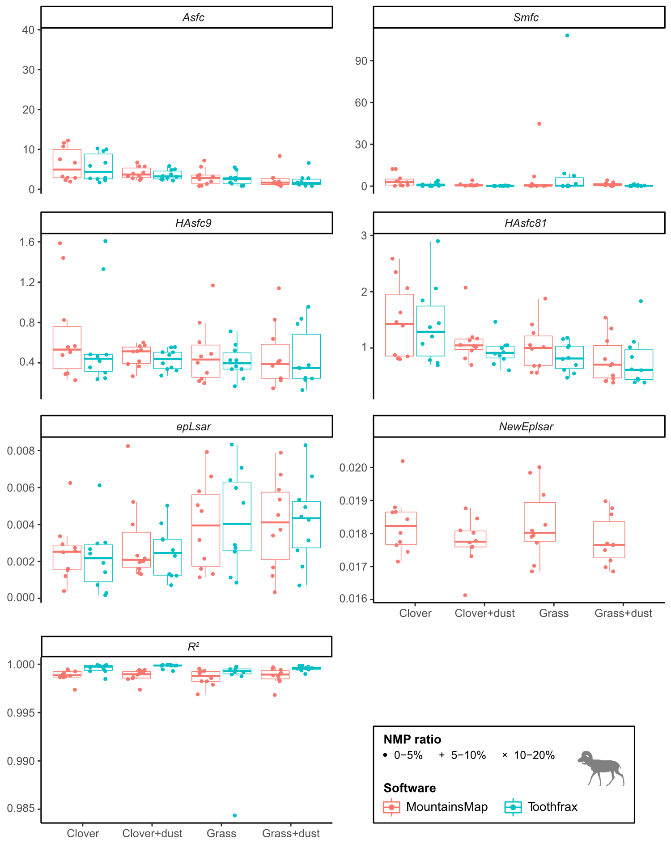
Fig. 1. Boxplots of the Scale-Sensitive Fractal Analysis (SSFA) parameters for the sheep dataset. The boxes represent the interquartile range (IQR), i.e., between the 25th and 75th percentile, with the median shown as a thick horizontal line. The bars extend up to 1.5 IQR on each side of the box. The points are spread horizontally within each group to avoid overlap for readability. NMP = non-measured points. See text for details on surface parameters and treatments. Sheep silhouette from PhyloPic (phylopic.org, Scott Hartman, Public Domain Dedication 1.0 license).
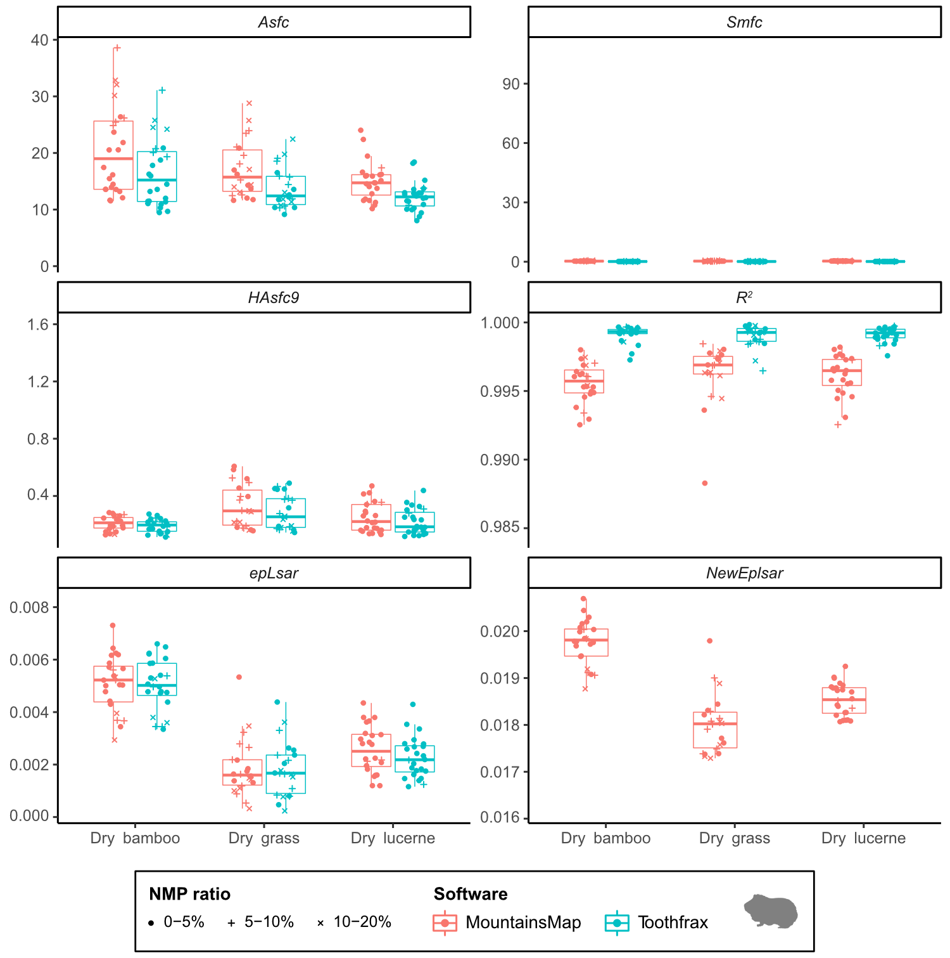
Fig. 2. Boxplots of the SSFA parameters for the guinea pig dataset. See Fig. 1 for details on boxplots and abbreviations. See text for details on surface parameters and treatments. Guinea pig silhouette from Wikimedia Commons (Flappiefh, CC BY 3.0 license).

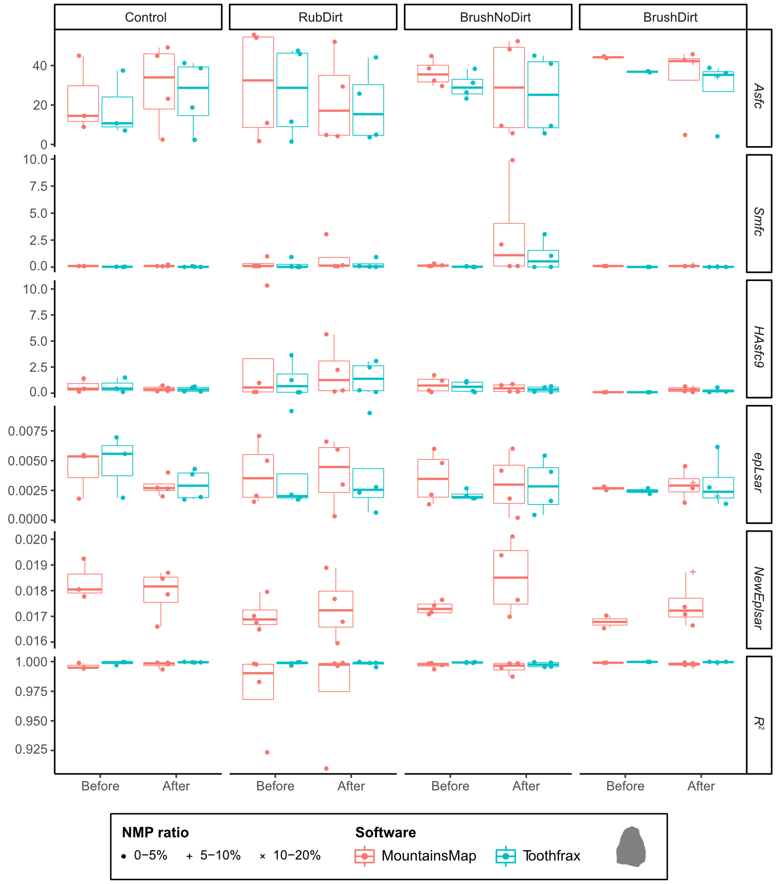
Fig. 3. Boxplots of the SSFA parameters for the lithic dataset. Surfaces with more than 20% NMP were excluded (three surfaces per software package; see "R_analysis/summary_stats/ SSFA_summary-stats.xlsx " on Zenodo). See Fig. 1 for details on boxplots and abbreviations. See text for details on surface parameters and treatments. Silhouette: courtesy from J. Marreiros.

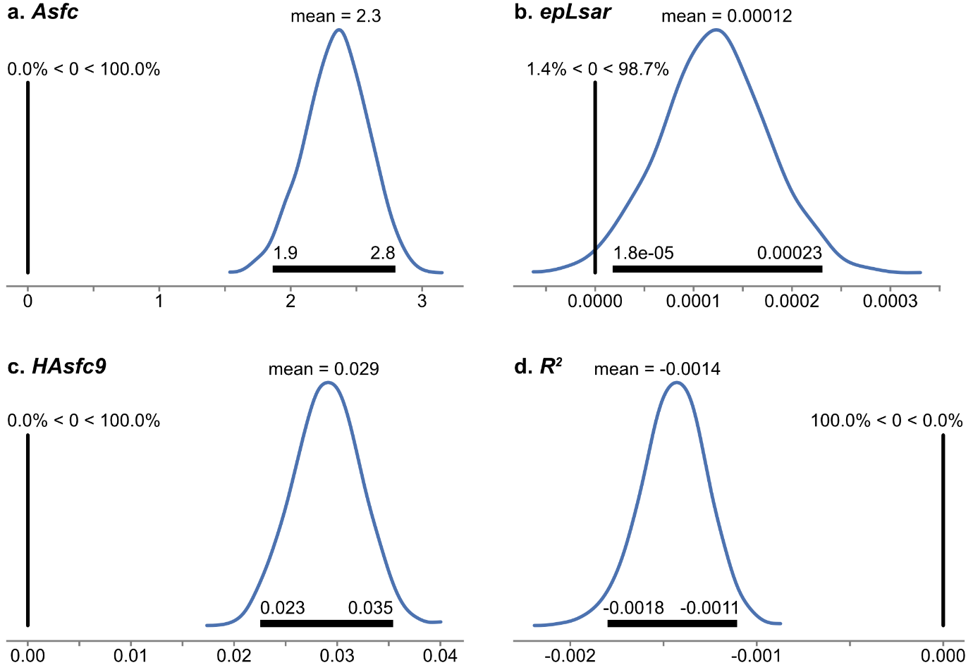

Fig. 4. Contrast plots of MountainsMap vs. Toothfrax from the three-factor model for the Scale-Sensitive Fractal Analysis (SSFA) parameters Asfc (a), epLsar (b), HAsfc9 (c) and R² (d) on the surfaces with < 5% non-measured points (NMP). The y-axis shows the probability density and the x-axis represents the difference in parameter between the two software packages. The black horizontal bar in each plot covers the 95% high density interval (HDI), with the associated values for its boundaries (2.5 and 97.5%). The black vertical line marks the 0-effect strength; the values above it indicate the estimated probabilities of the contrast being smaller or greater than 0. See text for details on surface parameters.

Yet, as shown by the two-factor model (i.e. when samples are not accounted for), these differences did not obscure most of the differences in treatment within each dataset (Fig. 5; see also treatment pair plots in the folder "Python_analysis/plots/statistical_model_two_factors_filter_strong/" on Zenodo). Nine of the 60 pairwise comparisons (15 contrasts for each of the four surface parameters) yielded different results between the two software packages, five of which on R² (Table 2). Additionally, there is no pattern in these different contrasts. In other words, none of the software is better at discriminating the treatments than the other, whether considering any single surface parameter or dataset, or taking all parameters into account. In summary, even though the two software packages produce significantly different results at the level of individual surfaces, roughly the same significant differences in treatment were found independently of the software used.
When analyzing all surfaces with less than 20% NMP, even less differences appear between the discriminations of the two software packages (compare files of the "filter_strong" and "filter_weak" runs for the two-factor model in the folder "Python_analysis/ " on Zenodo). This could result from the noise introduced by the lower quality data (NMP ≥ 5%) blurring the signal.

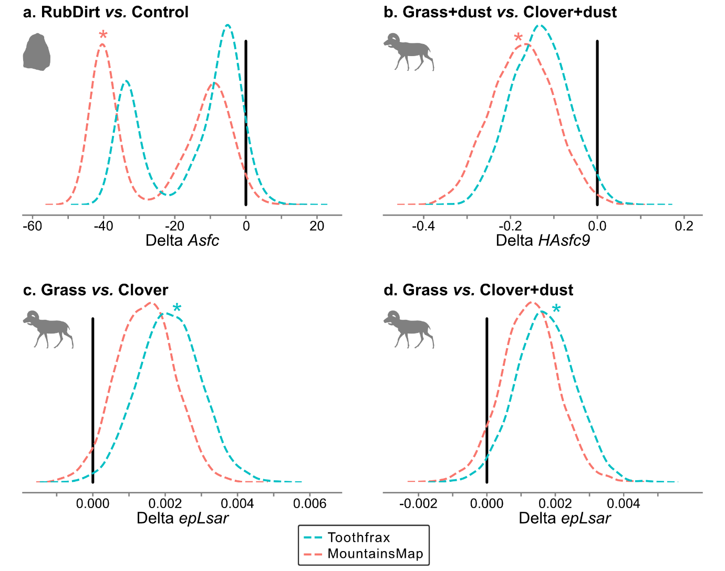
Fig. 5. Contrast plots of treatment pairs for which both software packages disagree on the surfaces with < 5% NMP: Asfc (a), HAsfc9 (b) and epLsar (c-d). Stars mark significant differences for the given treatment pair and software. See Table 2 for 95% HDIs and results on R², Fig. 4 for details on how to read the plots and for abbreviations, Figs 1&3 for details on silhouettes, and text for details on surface parameters and treatments.

 | Treatment |  | MountainsMap |  |  | Toothfrax
Parameter | i | j | Signif. | 2.5% HDI | 97.5% HDI | Signif. | 2.5% HDI | 97.5% HDI
Asfc | RubDirt | Control | True | -44.051 | -2.428 | False | -37.081 | 0.973
HAsfc9 | Grass+dust | Clover+dust | True | -0.3111 | -0.0322 | False | -0.2534 | 0.0001
epLsar | Grass | Clover | False | -0.00020 | 0.00289 | True | 0.00043 | 0.00376
epLsar | Grass | Clover+dust | False | -0.00034 | 0.00288 | True | 0.00006 | 0.00339
R² | Dry grass | Dry bamboo | True | 0.00154 | 0.00283 | False | -0.00034 | 0.00045
R² | Dry lucerne | Dry bamboo | True | 0.00055 | 0.00186 | False | -0.00037 | 0.00018
R² | Dry lucerne | Dry grass | True | -0.00154 | -0.00044 | False | -0.00061 | 0.00020
R² | RubDirt | BrushDirt | True | -0.00156 | -0.00007 | False | -0.00112 | 0.00003
R² | Grass | Clover+dust | False | -0.00070 | 0.00053 | True | -0.00083 | -0.00014

Table 2. Differences in significance for the two software packages. Only treatment pairs and parameters for which the software packages disagree are shown. For all comparisons, see frames [44], [69], [95] and [128] in the notebook "Statistical_Model_TwoFactor_filter_strong" (folder "Python_analysis/code/" on Zenodo). "True" indicates that the given treatment pair is significantly different for the given parameter and software, i.e. its 95% high probability density interval (HDI) does not include 0. See text for details on surface parameters and treatments. Signif. = significance.

Even though the values for NewEpLsar (calculated in MountainsMap only) are much higher than the values for epLsar (from both software packages; Figs 1-3), they mostly discriminate the treatments in the same way as the epLsar values do (Fig. 6; see also treatment pair plots in the folder "Python_analysis/plots/statistical_model_neweplsar_filter_strong/" on Zenodo). There are six differences out of 15 contrasts, though (Table 3). Interestingly, in those six cases, NewEpLsar always gives results different from Toothfrax's epLsar, although it does not always agree with MountainsMap's epLsar (i.e. NewEpLsar sometimes discriminates differently from epLsar in general).
When analyzing all surfaces with less than 20% NMP, one more difference appears between the discriminations NewEpLsar compared to epLsar (compare files of the "filter_strong" and "filter_weak" runs for the NewEpLsar model in the folder "Python_analysis/ " on Zenodo). This could result from the noise introduced by the lower quality data (NMP ≥ 5%) "faking" a signal.

Treatment |  | MountainsMap NewEpLsar |  |  | MountainsMap epLsar |  |  | Toothfrax epLsar
i | j | Signif. | 2.5% HDI | 97.5% HDI | Signif. | 2.5% HDI | 97.5% HDI | Signif. | 2.5% HDI | 97.5% HDI
Control | BrushDirt | True | 0.00036 | 0.00185 | False | -0.00056 | 0.00130 | False | -0.00059 | 0.00139
RubDirt | Control | True | -0.00178 | -0.00025 | False | -0.00070 | 0.00133 | False | -0.00144 | 0.00047
Grass | Clover | False | -0.00075 | 0.00059 | False | -0.00011 | 0.00154 | True | 0.00023 | 0.00201
Grass | Clover+dust | False | -0.00030 | 0.00099 | False | -0.00018 | 0.00154 | True | 0.00003 | 0.00181
Grass+dust | Clover | False | -0.00112 | 0.00015 | True | 0.00013 | 0.00175 | True | 0.00031 | 0.00194
Grass+dust | Clover+dust | False | -0.00067 | 0.00052 | True | 0.00001 | 0.00167 | True | 0.00012 | 0.00172

Table 3. Differences in significance for NewEpLsar against epLsar from the two software packages. Only treatment pairs and parameters for which NewEpLsar disagrees with epLsar from at least one software package are shown. For all comparisons, see frame [55] in the notebook "Statistical_Model_NewEplsar_filter_strong" (folder "Python_analysis/code/" on Zenodo). See Table 2 for details on how to read the table and for abbreviations, and text for details on surface parameters and treatments.

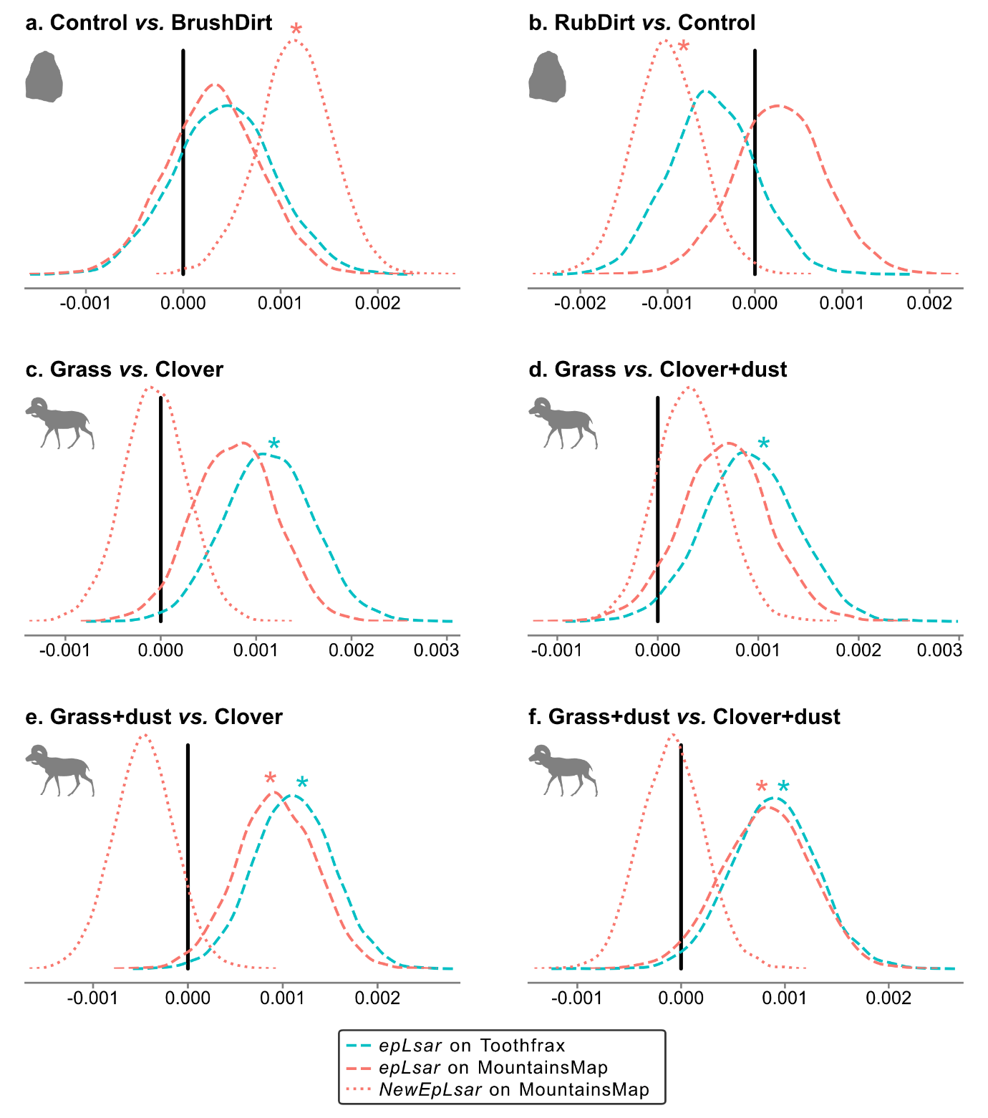
Fig. 6. Contrasts of treatment pairs for which NewEpLsar disagrees with epLsar from at least one software package on the surfaces with < 5% NMP. See Table 3 for 95% HDIs, Fig. 4 for details on how to read the plots and for abbreviations, Figs 1&3 for details on silhouette, and text for details on surface parameters and treatments.

4. Discussion
We compared Toothfrax and MountainsMap’s SSFA module by analyzing the same surfaces with both software packages using the same settings; Bayesian multi-factor ANOVAs were then used to assess the significance of the divergences. The surfaces are derived from three datasets of experimental samples (guinea pig and sheep teeth, and flint and quartzite flakes) and the values range over several orders of magnitude (epLsar from 0.00017 to 0.00917, Asfc from 0.79 to 68.22 and HAsfc9 from 0.07 to 10.32; Figs 1-3; see also table "/R_analysis/summary_stats/SSFA_summary_stats.xlsx" on Zenodo https://doi.org/10.5281/zenodo.7219855). We therefore assume that it is very likely that the findings will apply to other types of surfaces as well.

4.1. Comparing Toothfrax and MountainsMap outputs
The results of the three-factor model show that the two software packages do produce divergent results. The effect on Asfc is very large (Fig. 4a), but the effects on the other parameters are small (Fig. 4b-d). Nevertheless, Asfc, epLsar and HAsfc9 are all significantly higher when calculated with MountainsMap (Figs 1-3).
Different calculations of HAsfc and epLsar in the two software packages could explain the differences on these parameters.
HAsfc is normally defined as median absolute deviation (MAD) divided by the median of values (Scott et al., 2006):
HAsfcHAsfcdefinition= MADx=median(xi-x)x (3)
with x_{i} being the individual Asfc values for each subregion, and $\tilde{x}$ being the median of the Asfc values of all subregions. However, in Toothfrax, HAsfc is calculated using the mean instead of the median:
HAsfcHAsfcToothfrax=1x1N-1|xi-x|=mean(xi-x)x (4)
HAsfc has been implemented in Mountains Map in the same way as in Toothfrax (eq. (4)), but the true MAD calculation (eq. (3)) is also implemented in MountainsMap under the name MadHAsfc.
The spacing of the extracted profiles is different between the implementations of epLsar in Toothfrax and MountainsMap. While it should be fixed at 1.8 µm by default, it seems that profiles extracted at different angles can have different spacing in Toothfrax; the spacing is constant in MountainsMap.
R² is consistently higher when using Toothfrax, although the mean difference in posterior is very small yet significant (-0.0014; see Figs. 1-3 and 4d). Since this parameter describes the quality of the correlation in the area-scale analysis, it would imply that the change of relative area across scales is more regular in Toothfrax. It could mean that the results of the area-scale analysis (Asfc and HAsfc parameters) are more robust when using Toothfrax. The difference could also be a result of the higher number of points per surface used in MountainsMap’s SSFA module, especially at the smallest scales. Toothfrax’s point spread settings can be used in MountainsMap’s SSFA too, but this is not the default (the default settings were used here). Another potential source of difference is that Toothfrax calculates by default a regression of order 2, while MountainsMap uses a regression of order 1.
Although not tested in the Bayesian models due to some very extreme values, it seems that Smfc is higher when computed with MountainsMap than with Toothfrax (Figs 1-3; see also "SSFA_plots-Smfc.pdf" in the folder "/R_analysis/plots/" on Zenodo https://doi.org/10.5281/zenodo.7219855). Unlike Toothfrax, MountainsMap has rules to avoid calculating Smfc over an inappropriate range of scales (i.e. smallest or largest scales). This could explain the different results. We conclude that the complexity (Asfc) and heterogeneity (HAsfc) parameters are calculated at different scales with the two software packages using the default settings. We propose that this difference in Smfc could actually be the source of the differences in Asfc and HAsfc (together with differences in the pavement algorithms, see below). It is therefore possible that the differences in complexity and heterogeneity would disappear if they were calculated at the same scale in both software packages, i.e. if both software packages would calculate Smfc the same way. In MountainsMap, it is possible to manually adjust the range of scales over which the regression is calculated; it could therefore be tested whether the two software packages produce the same Asfc and HAsfc values when Smfc values are identical.
Another potential source of the differences between the two software packages concerns the pavement algorithm in the area-scale method (used for all parameters but epLsar and NewEpLsar). In this method, triangles of a given area are used to cover (i.e. pave) the topography. A general description of this pavement is given in different standards (ASME B46.1 and ISO 25178-2); however, this description is conceptual and leaves some freedom for the implementation. Depending on the choices of the developers, the results of the area-scale analysis may be slightly different. In MountainsMap and Toothfrax, the pavement starts in one corner and paves the surface in successive bands by placing a south-west-oriented triangle and then a north-east-oriented triangle, these triangles sharing one side. At the end of each band, there is a zone that cannot be covered by triangles because there is not enough space left. Depending on which corner the pavement starts, the non-paved zone is different. This is why we applied the four-corner method to average the contributions of the four starting points. Furthermore, triangles are placed step by step: a new triangle is added based on the two shared vertices of the preceding triangle and on a third new vertex. At small scales, triangles become more and more distorted, resulting in very elongated triangles at the end of the band. Toothfrax and MountainsMap use different algorithms to deal with these elongated triangles, and they use differing precisions (rounding, floating point…) and error thresholds, resulting in small deviations that propagate.

4.2. Similarities and differences within each dataset
When surfaces are not considered individually anymore but instead grouped within treatments (diets for animals, e.g. clover or dry bamboo, and cleaning procedures for lithics, e.g. BrushNoDirt) in the two-factor model, the values calculated by both software packages usually discriminate the same treatments within each dataset. There are exceptions to this (Fig. 5, Table 2). Nevertheless, these differences concern only nine out of 60 contrasts (15 treatments pairs for four parameters), that is, 15%; when excluding R² (not used in functional interpretations), only four out of 60 contrasts (6.67%) are different. It could be that epLsar is more discrimant when calculated with Toothfrax, and Asfc and HAsfc with MountainsMap (Table 2), but this is very speculative with only the four differences.
The effect detected on Asfc in the three-factor model is very large (mean difference in posterior = 2.3, Fig. 4a), yet both software packages discriminate the treatments in the exact same way for all but one contrast (Fig. 5a and Table 2). The effects on epLsar and HAsfc9 are much smaller (mean difference in posterior = 0.00012 and 0.029 respectively; Fig. 4b-c), but they still do influence some of the treatment discriminations (Fig. 5b-d). This means that these differences are large enough to influence the functional interpretations of the results in some cases.

4.3. Comparing epLsar and NewEpLsar
The new epLsar parameter (NewEpLsar) offered in MountainsMap’s SSFA module is calculated differently from the original epLsar parameter. Both parameters are calculated through a length-scale analysis, done on all extracted profiles of rotated versions of the surface, by default every 5° at the 1.8 μm-scale (i.e. the spacing of the points along these profiles) (Scott et al., 2006). The relative-length relL is the length of the profile at a given scale divided by the projected length (Brown, 2013). At each angle α, relL(α) is calculated with α = iΔα, with Δα = 5° by default and i being the index of the rotated version of the surface. Then a polar mean vector is calculated with its norm equal to relL(i) and its angle α. From this, cartesian coordinates are calculated for each angle:
$r_{x}\left(i\right)=relL\left(i\right)\cos{(i∆α)}$ (5)
$r_{y}\left(i\right)=relL\left(i\right)\sin{(i∆α)}$ (6)
The sum of all vectors is calculated as:
$S_{relL}= \sum_{i=0}^{N-1}{{relL}_{i}}$ (7)
with N being the number of angles (N = π /Δα).

Then the mean cartesian coordinates are calculated as the normalized means:
$\overline{r_{x}}= \frac{1}{N}\frac{1}{S_{relL}}\sum_{i=0}^{N-1}{r_{x}(i)}$ (8)
$\overline{r_{y}}= \frac{1}{N}\frac{1}{S_{relL}}\sum_{i=0}^{N-1}{r_{y}(i)}$ (9)

Finally:
$epLsar= \sqrt{{\overline{r_{x}}}^{2}+ {\overline{r_{y}}}^{2}}$ (10)
In Toothfrax, the calculation apparently uses cos(2iΔα) instead of cos(iΔα) (see equation (5)). The parameter epLsar is calculated the same way in MountainsMap to make it comparable to the Toothfrax implementation, but the parameter NewEplsar uses the correct angle iΔα.
This difference in calculation likely explains why NewEpLsar is approximately one order of magnitude higher than the values of the epLsar parameters from both software packages (Figs 1-3). Therefore, NewEpLsar data are not comparable to published epLsar data. Nevertheless, in most cases, it discriminates the treatments as epLsar does (Fig. 6 and Table 3; compare also the plots "Python_analysis/plots/statistical_model_two_factors_filter_strong/treatment_pairs_epLsar.pdf" and "Python_analysis/plots/statistical_model_neweplsar_filter_strong/treatment_pairs_NewEplsar.pdf" on Zenodo https://doi.org/10.5281/zenodo.7219855). It should be noted that the two treatments pairs of the lithic dataset (BrushDirt and RubDirt vs. Control) are well discriminated by NewEpLsar, but the diets of the sheep datasets that could be differentiated using epLsar (grass vs. clover/clover+dust and grass+dust vs. clover/clover+dust) cannot be separated with NewEpLsar (Table 3). It therefore seems that, due to its new algorithm, this new parameter can be either more or less powerful to discriminate the treatments as compared to the original epLsar parameter, depending on the surfaces.

4.4. Implications
These results imply that the analyses from both software packages are in general equally powerful to discriminate treatments. Although the results from both software packages look similar (Figs 1-3), our analysis demonstrates that the values from the two software packages cannot be directly compared. Neither of the software packages seems to allow more discrimination among the treatments within any dataset than the other (Tables 2-3): in some cases, Toothfrax better discriminates the treatments, while in others, MountainsMap is better on this aspect. Without calibration against a profile or surface with known (nominal) values for the parameters (“Ground truth” approach, e.g. Todhunter et al., 2017, 2019, 2020), it is not possible to determine which software package is closer to the "true" values. Unfortunately, such a calibration is currently impossible for these parameters.
Most of these differences are likely due to the corrections and/or further developments of the algorithms in MountainsMap. Such adjustments were and are necessary, but they also introduced differences between the two software packages. Some settings can be adjusted in MountainsMap to make the results closer (but probably still not identical) to those from Toothfrax, although that does not make these results "better". There is therefore a compromise between accuracy/performance of the calculation and fidelity to Toothfrax.
While the output produced by the new MountainsMap’s SSFA module can be qualitatively compared to the output produced by Toothfrax, our results imply that the outputs cannot be directly combined into a single quantitative analysis. This could prove problematic for the future of dental microwear texture analysis (DMTA) if studies using MountainsMap’s SSFA module cannot use the extensive published data analyzed with Toothfrax. We therefore recommend re-analyzing raw surface data with MountainsMap (or any of its derivatives) before comparing with published Toothfrax data (see also discussion by Arman et al., 2016). Even though it is potentially computer-time-intensive, it requires little effort from analysts and seems to be currently the best option. Future updates of MountainsMap’s SSFA module might tackle (some of) the discrepancies in the computation of the parameters. Nevertheless, the source of some of these discrepancies is due to corrections and developments in the algorithms and, as such, will unlikely be reverted to the original versions. Additionally, a new body of literature using the current MountainsMap’s SSFA module is already being produced (see references in the introduction), and re-analysis of data will still be inevitable. It is therefore of utmost importance that original raw surfaces will be accessible for comparative studies and re-analysis in the future (see also Arman et al., 2016).
Even though MountainsMap can replace Toothfrax (with the caveats mentioned above), the parameter Tfv is still not available in MountainsMap. So, for the time being, the original Sfrax software cannot be replaced to compute Tfv. Once MountainsMap's SSFA module incorporates Tfv, a comparison like the one presented here will be necessary to check the similarities between the original Sfrax and the future MountainsMap calculations, and potentially, the re-analysis of published data will be also required for this parameter.

5. Conclusions
The results of our Bayesian modeling showed that Toothfrax and MountainsMap’s SSFA module produce significantly different values for all SSFA parameters investigated (epLsar, Asfc, HAsfc9 and R²); Smfc also seems to be different but it could not be statistically tested. This is to be expected from the differences in computation between the two software packages. Even though the discrimination power among the treatments (different diets for experimental animals and different cleaning procedures for lithics) are similar between the two software packages, the present results have important implications. Indeed, the majority of published data about dental microwear texture analysis (DMTA) has been produced by Toothfrax. If the data produced by MountainsMap are not directly comparable, analysts using MountainsMap (or any of its derivatives) cannot simply combine the data from both software packages, but instead need to re-analyze the existing raw surface data with MountainsMap if they intend to include published Toothfrax data into their analyses. This requires some (computer-)time investment. This issue comes on top of an existing lack of standardization in acquisition and processing (e.g. Arman et al., 2016; Calandra et al., 2019b). More problematic though is the fact that very few of the published studies have made the raw surfaces available to the research community. Therefore, we urge all analysts to share their raw surfaces with every published article, either as uncompressed SUR files, or even better for reproducibility as MNT files including the processing steps, as we did here (on Zenodo https://doi.org/10.5281/zenodo.6645445). Ideally, in the future, researchers will even upload the raw surface data directly with each publication. For already published raw data, as well as for future raw data, it might be helpful to first create a central repository to host all these surfaces, their associated data, metadata and paradata, considering a spectrum of open source public copyright licenses in industry and academia (e.g. Creative Commons).
Funding
IC has been supported within the Römisch-Germanisches Zentralmuseum – Leibniz Research Institute for Archeology by German Federal and Rhineland Palatinate funding (Sondertatbestand "Spurenlabor"). This research is publication no. 11 of the TraCEr laboratory. DEW has been funded by the European Research Foundation (ERC Project Vertebrate Herbivory, Co-Grant 681450 to Thomas Tütken) and the Japan Society for the Promotion of Science (JSPS) under a grant-395 in-aid, no. 20F20325.
The funding source had no involvement in study design; in the collection, analysis and interpretation of data; in the writing of the report; nor in the decision to submit the article for publication.

Conflict of interest

François Blateyron is working at, and is co-owner of Digital Surf, the editor of the MountainsMap software, used in comparisons described in this paper. However, he was not involved in data acquisition and analysis.

Author contributions
François Blateyron: writing - review & editing
Konstantin Bob: methodology, formal analysis, resources, data curation, writing - original draft, writing - review & editing
Ivan Calandra: conceptualization, methodology, formal analysis, resources, data curation, writing - original draft, writing - review & editing
Andreas Hildebrandt: writing - review & editing
Gildas Merceron: conceptualization, methodology, resources, data curation, writing - review & editing
Ellen Schulz-Kornas: conceptualization, writing - review & editing
Antoine Souron: writing - review & editing
Daniela E. Winkler: conceptualization, methodology, resources, data curation, writing - review & editing

References
Ackermans NL, Winkler DE, Martin LF, Kaiser TM, Clauss M, Hatt J-M. 2020. Dust and grit matter: abrasives of different size lead to opposing dental microwear textures in experimentally fed sheep (Ovis aries). Journal of Experimental Biology 223:jeb220442. DOI: 10.1242/jeb.220442.
Aiba K, Miura S, Kubo MO. 2019. Dental Microwear Texture Analysis in Two Ruminants, Japanese Serow (Capricornis crispus) and Sika Deer (Cervus nippon), from Central Japan. Mammal Study 44:183–192. DOI: 10.3106/ms2018-0081.
Allaire JJ, Xie Y, McPherson J, Luraschi J, Ushey K, Atkins A, Wickham H, Cheng J, Chang W, Iannone R. 2021.rmarkdown: Dynamic Documents for R. R package version 2.11. Available at https://rmarkdown.rstudio.com
Arman SD, Prowse TAA, Couzens AMC, Ungar PS, Prideaux GJ. 2019. Incorporating intraspecific variation into dental microwear texture analysis. Journal of The Royal Society Interface 16:20180957. DOI: 10.1098/rsif.2018.0957.
Arman SD, Ungar PS, Brown CA, DeSantis LRG, Schmidt C, Prideaux GJ. 2016. Minimizing inter-microscope variability in dental microwear texture analysis. Surface Topography: Metrology and Properties 4:024007. DOI: 10.1088/2051-672X/4/2/024007.
Artigas R. 2011. Imaging Confocal Microscopy. In: Leach R ed. Optical Measurement of Surface Topography. Berlin, Heidelberg: Springer Berlin Heidelberg, 237–286. DOI: 10.1007/978-3-642-12012-1_11.
Berlioz E, Azorit C, Blondel C, Ruiz MST, Merceron G. 2017. Deer in an arid habitat: dental microwear textures track feeding adaptability. Hystrix, the Italian Journal of Mammalogy 28:222–230. DOI: 10.4404/hystrix-28.2-12048.
Berlioz É, Kostopoulos DS, Blondel C, Merceron G. 2018. Feeding ecology of Eucladoceros ctenoides as a proxy to track regional environmental variations in Europe during the early Pleistocene. Comptes Rendus Palevol 17:320–332. DOI: 10.1016/j.crpv.2017.07.002.
Bestwick J, Unwin DM, Purnell MA. 2019. Dietary differences in archosaur and lepidosaur reptiles revealed by dental microwear textural analysis. Scientific Reports 9:11691. DOI: 10.1038/s41598-019-48154-9.
Bethune E, Kaiser TM, Schulz-Kornas E, Winkler DE. 2019. Multiproxy dietary trait reconstruction in Pleistocene Hippopotamidae from the Mediterranean islands. Palaeogeography, Palaeoclimatology, Palaeoecology 533:109210. DOI: 10.1016/j.palaeo.2019.05.032.
Blondel C, Rowan J, Merceron G, Bibi F, Negash E, Barr WA, Boisserie J-R. 2018. Feeding ecology of Tragelaphini (Bovidae) from the Shungura Formation, Omo Valley, Ethiopia: Contribution of dental wear analyses. Palaeogeography, Palaeoclimatology, Palaeoecology 496:103–120. DOI: 10.1016/j.palaeo.2018.01.027.
Böhm K, Winkler DE, Kaiser TM, Tütken T. 2019. Post-mortem alteration of diet-related enamel surface textures through artificial biostratinomy: A tumbling experiment using mammal teeth. Palaeogeography, Palaeoclimatology, Palaeoecology 518:215–231. DOI: 10.1016/j.palaeo.2019.01.008.
van den Brand T. 2021.ggh4x: Hacks for “ggplot2”. R package version 0.2.1.9000. Available at https://github.com/teunbrand/ggh4x
Brown CA. 2000. Issues in Modeling Machined Surface Textures. Machining Science and Technology 4:539–546. DOI: 10.1080/10940340008945721.
Brown CA. 2013. Areal Fractal Methods. In: Leach R ed. Characterisation of Areal Surface Texture. Berlin, Heidelberg: Springer, 129–153. DOI: 10.1007/978-3-642-36458-7_6.
Brown CA, Charles PD, Johnsen WA, Chesters S. 1993. Fractal analysis of topographic data by the patchwork method. Wear 161:61–67. DOI: 10.1016/0043-1648(93)90453-S.
Calandra I, Labonne G, Schulz-Kornas E, Kaiser TM, Montuire S. 2016. Tooth wear as a means to quantify intra-specific variations in diet and chewing movements. Scientific Reports 6:34037. DOI: 10.1038/srep34037.
Calandra I, Merceron G. 2016. Dental microwear texture analysis in mammalian ecology. Mammal Review 46:215–228. DOI: 10.1111/mam.12063.
Calandra I, Pedergnana A, Gneisinger W, Marreiros J. 2019a. Why should traceology learn from dental microwear, and vice-versa? Journal of Archaeological Science 110:105012. DOI: 10.1016/j.jas.2019.105012.
Calandra I, Schulz E, Pinnow M, Krohn S, Kaiser TM. 2012. Teasing apart the contributions of hard dietary items on 3D dental microtextures in primates. Journal of Human Evolution 63:85–98. DOI: 10.1016/j.jhevol.2012.05.001.
Calandra I, Schunk L, Bob K, Gneisinger W, Pedergnana A, Paixao E, Hildebrandt A, Marreiros J. 2019b. The effect of numerical aperture on quantitative use-wear studies and its implication on reproducibility. Scientific Reports 9:6313. DOI: 10.1038/s41598-019-42713-w.
Calandra I, Schunk L, Rodriguez A, Gneisinger W, Pedergnana A, Paixao E, Pereira T, Iovita R, Marreiros J. 2019c. Back to the edge: relative coordinate system for use-wear analysis. Archaeological and Anthropological Sciences 11:5937–5948. DOI: 10.1007/s12520-019-00801-y.
Caporale SS, Ungar PS. 2016. Rodent incisor microwear as a proxy for ecological reconstruction. Palaeogeography, Palaeoclimatology, Palaeoecology 446:225–233. DOI: 10.1016/j.palaeo.2016.01.013.
Catz N, Bignon-Lau O, Merceron G. 2020. Reindeer feeding ecology and hunting strategies by Magdalenians from Pincevent (Paris Basin, France): New insights from dental microwear textural analyses. International Journal of Osteoarchaeology 30:519–528. DOI: 10.1002/oa.2879.
Caux S, Galland A, Queffelec A, Bordes J-G. 2018. Aspects and characterization of chert alteration in an archaeological context: A qualitative to quantitative pilot study. Journal of Archaeological Science: Reports 20:210–219. DOI: 10.1016/j.jasrep.2018.04.027.
Delezene LK, Teaford MF, Ungar PS. 2016. Canine and incisor microwear in pitheciids and Ateles reflects documented patterns of tooth use. American Journal of Physical Anthropology 161:6–25. DOI: 10.1002/ajpa.23002.
DeSantis LRG. 2016. Dental microwear textures: reconstructing diets of fossil mammals. Surface Topography: Metrology and Properties 4:023002. DOI: 10.1088/2051-672X/4/2/023002.
DeSantis LRG, Crites JM, Feranec RS, Fox-Dobbs K, Farrell AB, Harris JM, Takeuchi GT, Cerling TE. 2019. Causes and Consequences of Pleistocene Megafaunal Extinctions as Revealed from Rancho La Brea Mammals. Current Biology 29:2488-2495.e2. DOI: 10.1016/j.cub.2019.06.059.
DeSantis LRG, Sharp AC, Schubert BW, Colbert MW, Wallace SC, Grine FE. 2020. Clarifying relationships between cranial form and function in tapirs, with implications for the dietary ecology of early hominins. Scientific Reports 10:8809. DOI: 10.1038/s41598-020-65586-w.
Evans AA, Macdonald DA, Giusca CL, Leach RK. 2014. New method development in prehistoric stone tool research: Evaluating use duration and data analysis protocols. Micron 65:69–75. DOI: 10.1016/j.micron.2014.04.006.
Forbes AB. 2013. Areal Form Removal. In: Leach R ed. Characterisation of Areal Surface Texture. Berlin, Heidelberg: Springer, 107–128. DOI: 10.1007/978-3-642-36458-7_5.
Francisco A, Blondel C, Brunetière N, Ramdarshan A, Merceron G. 2018. Enamel surface topography analysis for diet discrimination. A methodology to enhance and select discriminative parameters. Surface Topography: Metrology and Properties 6:015002. DOI: 10.1088/2051-672X/aa9dd3.
Galland A, Queffelec A, Caux S, Bordes J-G. 2019. Quantifying lithic surface alterations using confocal microscopy and its relevance for exploring the Châtelperronian at La Roche-à-Pierrot (Saint-Césaire, France). Journal of Archaeological Science 104:45–55. DOI: 10.1016/j.jas.2019.01.009.
Gill PG, Purnell MA, Crumpton N, Brown KR, Gostling NJ, Stampanoni M, Rayfield EJ. 2014. Dietary specializations and diversity in feeding ecology of the earliest stem mammals. Nature 512:303–305. DOI: 10.1038/nature13622.
Green JL, Croft DA. 2018. Using Dental Mesowear and Microwear for Dietary Inference: A Review of Current Techniques and Applications. In: Croft DA, Su DF, Simpson SW eds. Methods in Paleoecology: Reconstructing Cenozoic Terrestrial Environments and Ecological Communities. Vertebrate Paleobiology and Paleoanthropology. Cham: Springer International Publishing, 53–73. DOI: 10.1007/978-3-319-94265-0_5.
Hara AT, Elkington-Stauss D, Ungar PS, Lippert F, Eckert GJ, Zero DT. 2021. Three-Dimensional Surface Texture Characterization of In Situ Simulated Erosive Tooth Wear. Journal of Dental Research 100:1236–1242. DOI: 10.1177/00220345211005678.
Hara AT, Livengood SV, Lippert F, Eckert GJ, Ungar PS. 2016. Dental Surface Texture Characterization Based on Erosive Tooth Wear Processes. Journal of Dental Research 95:537–542. DOI: 10.1177/0022034516629941.
Harris CR, Millman KJ, van der Walt SJ, Gommers R, Virtanen P, Cournapeau D, Wieser E, Taylor J, Berg S, Smith NJ, Kern R, Picus M, Hoyer S, van Kerkwijk MH, Brett M, Haldane A, del Río JF, Wiebe M, Peterson P, Gérard-Marchant P, Sheppard K, Reddy T, Weckesser W, Abbasi H, Gohlke C, Oliphant TE. 2020. Array programming with NumPy. Nature 585:357–362. DOI: 10.1038/s41586-020-2649-2.
Hoffman MD, Gelman A. 2014. The No-U-Turn Sampler: Adaptively Setting Path Lengths in Hamiltonian Monte Carlo. Journal of Machine Learning Research 15:1593–1623.
Hofman-Kamińska E, Merceron G, Bocherens H, Makowiecki D, Piličiauskienė G, Ramdarshan A, Berlioz E, Kowalczyk R. 2018. Foraging habitats and niche partitioning of European large herbivores during the Holocene – Insights from 3D dental microwear texture analysis. Palaeogeography, Palaeoclimatology, Palaeoecology 506:183–195. DOI: 10.1016/j.palaeo.2018.05.050.
Højsgaard S, Halekoh U. 2021.doBy: Groupwise Statistics, LSmeans, Linear Contrasts, Utilities. R package version 4.6.1. Available at https://CRAN.R-project.org/package=doBy
Hunter JD. 2007. Matplotlib: A 2D Graphics Environment. Computing in Science & Engineering 9:90–95. DOI: 10.1109/MCSE.2007.55.
Ibáñez JJ, Lazuen T, González-Urquijo J. 2019. Identifying Experimental Tool Use Through Confocal Microscopy. Journal of Archaeological Method and Theory 26:1176–1215. DOI: 10.1007/s10816-018-9408-9.
International Organization for Standardization. 2021. ISO 25178-2 – Geometrical product specifications (GPS) – Surface texture: Areal – Part 2: Terms, definitions and surface texture parameters.
Key AJM, Stemp WJ, Morozov M, Proffitt T, de la Torre I. 2015. Is Loading a Significantly Influential Factor in the Development of Lithic Microwear? An Experimental Test Using LSCM on Basalt from Olduvai Gorge. Journal of Archaeological Method and Theory 22:1193–1214. DOI: 10.1007/s10816-014-9224-9.
Krueger KL. 2015. Reconstructing diet and behavior in bioarchaeological groups using incisor microwear texture analysis. Journal of Archaeological Science: Reports 1:29–37. DOI: 10.1016/j.jasrep.2014.10.002.
Krueger KL, Chwa E, Peterson AS, Willman JC, Fok A, van Heel B, Heo Y, Weston M, DeLong R. 2021. Technical note: Artificial Resynthesis Technology for the experimental formation of dental microwear textures. American Journal of Physical Anthropology 176:703–712. DOI: 10.1002/ajpa.24395.
Krueger KL, Ungar PS. 2010. Incisor microwear textures of five bioarcheological groups. International Journal of Osteoarchaeology 20:549–560. DOI: 10.1002/oa.1093.
Krueger KL, Ungar PS, Guatelli-Steinberg D, Hublin J-J, Pérez-Pérez A, Trinkaus E, Willman JC. 2017. Anterior dental microwear textures show habitat-driven variability in Neandertal behavior. Journal of Human Evolution 105:13–23. DOI: 10.1016/j.jhevol.2017.01.004.
Krueger KL, Willman JC, Matthews GJ, Hublin J-J, Pérez-Pérez A. 2019. Anterior tooth-use behaviors among early modern humans and Neandertals. PLOS ONE 14:e0224573. DOI: 10.1371/journal.pone.0224573.
Kruschke JK. 2013. Bayesian estimation supersedes the t test. Journal of Experimental Psychology: General 142:573–603. DOI: 10.1037/a0029146.
Kruschke JK. 2015. Doing Bayesian data analysis: a tutorial with R, JAGS, and Stan. Boston: Academic Press.
Kubo MO, Yamada E, Kubo T, Kohno N. 2017. Dental microwear texture analysis of extant sika deer with considerations on inter-microscope variability and surface preparation protocols. Biosurface and Biotribology 3:155–165. DOI: 10.1016/j.bsbt.2017.11.006.
Kumar R, Carroll C, Hartikainen A, Martin O. 2019. ArviZ a unified library for exploratory analysis of Bayesian models in Python. Journal of Open Source Software 4:1143. DOI: 10.21105/joss.01143.
Lesnik JJ. 2011. Bone tool texture analysis and the role of termites in the diet of South African hominids. PaleoAnthropology 2011:268–281.
Macdonald DA, Xie L, Gallo T. 2019. Here’s the dirt: First applications of confocal microscopy for quantifying microwear on experimental ground stone earth working tools. Journal of Archaeological Science: Reports 26:101861. DOI: 10.1016/j.jasrep.2019.05.026.
Martisius NL, McPherron SP, Schulz-Kornas E, Soressi M, Steele TE. 2020. A method for the taphonomic assessment of bone tools using 3D surface texture analysis of bone microtopography. Archaeological and Anthropological Sciences 12:251. DOI: 10.1007/s12520-020-01195-y.
Martisius NL, Sidéra I, Grote MN, Steele TE, McPherron SP, Schulz-Kornas E. 2018. Time wears on: Assessing how bone wears using 3D surface texture analysis. PLOS ONE 13:e0206078. DOI: 10.1371/journal.pone.0206078.
Marwick B. 2019.rrtools: Creates a Reproducible Research Compendium. R package version 0.1.5. Available at https://github.com/benmarwick/rrtools
Marwick B, Boettiger C, Mullen L. 2018. Packaging Data Analytical Work Reproducibly Using R (and Friends). The American Statistician 72:80–88. DOI: 10.1080/00031305.2017.1375986.
Merceron G, Berlioz E, Vonhof H, Green D, Garel M, Tütken T. 2021. Tooth tales told by dental diet proxies: An alpine community of sympatric ruminants as a model to decipher the ecology of fossil fauna. Palaeogeography, Palaeoclimatology, Palaeoecology 562:110077. DOI: 10.1016/j.palaeo.2020.110077.
Merceron G, Colyn M, Geraads D. 2018. Browsing and non-browsing extant and extinct giraffids: Evidence from dental microwear textural analysis. Palaeogeography, Palaeoclimatology, Palaeoecology 505:128–139. DOI: 10.1016/j.palaeo.2018.05.036.
Merceron G, Novello A, Scott RS. 2016. Palaeontology of the Upper Miocene vertebrate localities of Nikiti (Chalkidiki Peninsula, Macedonia, Greece) – paleoenvironments inferred from phytoliths and dental microwear texture analyses of meso-herbivores. Geobios 49:135–146. DOI: 10.1016/j.geobios.2016.01.004.
Merceron G, Ramdarshan A, Blondel C, Boisserie J-R, Brunetiere N, Francisco A, Gautier D, Milhet X, Novello A, Pret D. 2016. Untangling the environmental from the dietary: dust does not matter. Proceedings of the Royal Society B: Biological Sciences 283:20161032. DOI: 10.1098/rspb.2016.1032.
Müller K. 2020.rprojroot: Finding Files in Project Subdirectories. R package version 2.0.2. Available at https://CRAN.R-project.org/package=R.utils (accessed November 19, 2020).
Pedergnana A, Calandra I, Bob K, Gneisinger W, Paixão E, Schunk L, Hildebrandt A, Marreiros J. 2020a. Evaluating the microscopic effect of brushing stone tools as a cleaning procedure. Quaternary International 569–570:263–276. DOI: 10.1016/j.quaint.2020.06.031.
Pedergnana A, Calandra I, Evans AA, Bob K, Hildebrandt A, Ollé A. 2020b. Polish is quantitatively different on quartzite flakes used on different worked materials. PLOS ONE 15:e0243295. DOI: 10.1371/journal.pone.0243295.
Percher AM, Merceron G, Akoue GN, Galbany J, Romero A, Charpentier MJ. 2018. Dental microwear textural analysis as an analytical tool to depict individual traits and reconstruct the diet of a primate. American Journal of Physical Anthropology 165:123–138. DOI: 10.1002/ajpa.23337.
Prassack KA, DuBois J, Lázničková-Galetová M, Germonpré M, Ungar PS. 2020. Dental microwear as a behavioral proxy for distinguishing between canids at the Upper Paleolithic (Gravettian) site of Předmostí, Czech Republic. Journal of Archaeological Science 115:105092. DOI: 10.1016/j.jas.2020.105092.
Purnell MA, Crumpton N, Gill PG, Jones G, Rayfield EJ. 2013. Within-guild dietary discrimination from 3-D textural analysis of tooth microwear in insectivorous mammals. Journal of Zoology 291:249–257. DOI: 10.1111/jzo.12068.
Purnell MA, Goodall RH, Thomson S, Matthews CJD. 2017. Tooth microwear texture in odontocete whales: variation with tooth characteristics and implications for dietary analysis. Biosurface and Biotribology 3:184–195. DOI: 10.1016/j.bsbt.2017.11.004.
Purnell M, Seehausen O, Galis F. 2012. Quantitative three-dimensional microtextural analyses of tooth wear as a tool for dietary discrimination in fishes. Journal of The Royal Society Interface 9:2225–2233. DOI: 10.1098/rsif.2012.0140.
R Core Team. 2021.R: A language and environment for statistical computing. R Foundation for Statistical Computing, Vienna, Austria. Version 4.1.2. Available at https://www.R-project.org/
Ranjitkar S, Turan A, Mann C, Gully GA, Marsman M, Edwards S, Kaidonis JA, Hall C, Lekkas D, Wetselaar P, Brook AH, Lobbezoo F, Townsend GC. 2017. Surface-Sensitive Microwear Texture Analysis of Attrition and Erosion. Journal of Dental Research 96:300–307. DOI: 10.1177/0022034516680585.
Reback J, McKinney W, Jbrockmendel, Bossche JVD, Augspurger T, Cloud P, Gfyoung, Sinhrks, Hawkins S, Klein A, Roeschke M, Tratner J, She C, Terji Petersen, Ayd W, MomIsBestFriend, Garcia M, Schendel J, Hayden A, Jancauskas V, Saxton D, McMaster A, Battiston P, Skipper Seabold, Chris-B1, H-Vetinari, Hoyer S, Kaiqi Dong, Overmeire W, Winkel M. 2020. pandas-dev/pandas: Pandas 1.1.2. DOI: 10.5281/ZENODO.4019559.
Robinet C, Merceron G, Candela AM, Marivaux L. 2020. Dental microwear texture analysis and diet in caviomorphs (Rodentia) from the Serra do Mar Atlantic forest (Brazil). Journal of Mammalogy 101:386–402. DOI: 10.1093/jmammal/gyz194.
Rosso DE, d’Errico F, Queffelec A. 2017. Patterns of change and continuity in ochre use during the late Middle Stone Age of the Horn of Africa: The Porc-Epic Cave record. PLOS ONE 12:e0177298. DOI: 10.1371/journal.pone.0177298.
RStudio Team. 2021.RStudio: Integrated Development for R. RStudio, Inc., Boston, MA. Version 1.4.1103. Available at http://www.rstudio.com/ (accessed January 26, 2020).
Salvatier J, Wiecki TV, Fonnesbeck C. 2016. Probabilistic programming in Python using PyMC3. PeerJ Computer Science 2:e55. DOI: 10.7717/peerj-cs.55.
Schauberger P, Walker A. 2021.openxlsx: Read, Write and Edit xlsx Files. R package version 4.2.4. Available at https://CRAN.R-project.org/package=openxlsx
Schmidt CW, Remy A, Sessen RV, Willman J, Krueger K, Scott R, Mahoney P, Beach J, McKinley J, D’Anastasio R, Chiu L, Buzon M, Gregory JRD, Sheridan S, Eng J, Watson J, Klaus H, Da‐Gloria P, Wilson J, Stone A, Sereno P, Droke J, Perash R, Stojanowski C, Herrmann N. 2019. Dental microwear texture analysis of Homo sapiens sapiens: Foragers, farmers, and pastoralists. American Journal of Physical Anthropology 169:207–226. DOI: 10.1002/ajpa.23815.
Schulz E, Calandra I, Kaiser TM. 2010. Applying tribology to teeth of hoofed mammals. Scanning 32:162–182. DOI: 10.1002/sca.20181.
Schulz E, Calandra I, Kaiser TM. 2013. Feeding ecology and chewing mechanics in hoofed mammals: 3D tribology of enamel wear. Wear 300:169–179. DOI: 10.1016/j.wear.2013.01.115.
Schulz-Kornas E, Kaiser TM, Calandra I, Winkler DE. 2020a. A brief history of quantitative wear analyses with an appeal for a holistic view on dental wear processes. In: Martin T, von Koenigswald W eds. Mammalian Teeth - Form and Function. Munich, Germany: Verlag Dr. Friedrich Pfeil, 44–53.
Schulz‐Kornas E, Stuhlträger J, Clauss M, Wittig RM, Kupczik K. 2019. Dust affects chewing efficiency and tooth wear in forest dwelling Western chimpanzees (Pan troglodytes verus). American Journal of Physical Anthropology 169:66–77. DOI: 10.1002/ajpa.23808.
Schulz-Kornas E, Winkler DE, Clauss M, Carlsson J, Ackermans NL, Martin LF, Hummel J, Müller DWH, Hatt J-M, Kaiser TM. 2020b. Everything matters: Molar microwear texture in goats (Capra aegagrus hircus) fed diets of different abrasiveness. Palaeogeography, Palaeoclimatology, Palaeoecology 552:109783. DOI: 10.1016/j.palaeo.2020.109783.
Scott RS, Ungar PS, Bergstrom TS, Brown CA, Childs BE, Teaford MF, Walker A. 2006. Dental microwear texture analysis: technical considerations. Journal of Human Evolution 51:339–349. DOI: 10.1016/j.jhevol.2006.04.006.
Scott RS, Ungar PS, Bergstrom TS, Brown CA, Grine FE, Teaford MF, Walker A. 2005. Dental microwear texture analysis shows within-species diet variability in fossil hominins. Nature 436:693–695. DOI: 10.1038/nature03822.
Sewell L, Merceron G, Hopley PJ, Zipfel B, Reynolds SC. 2019. Using springbok (Antidorcas) dietary proxies to reconstruct inferred palaeovegetational changes over 2 million years in Southern Africa. Journal of Archaeological Science: Reports 23:1014–1028. DOI: 10.1016/j.jasrep.2018.02.009.
Smith GJ, DeSantis LRG. 2018. Dietary ecology of Pleistocene mammoths and mastodons as inferred from dental microwear textures. Palaeogeography, Palaeoclimatology, Palaeoecology 492:10–25. DOI: 10.1016/j.palaeo.2017.11.024.
Smith GJ, DeSantis LRG. 2020. Extinction of North American Cuvieronius (Mammalia: Proboscidea: Gomphotheriidae) driven by dietary resource competition with sympatric mammoths and mastodons. Paleobiology 46:41–57. DOI: 10.1017/pab.2020.7.
Soler S. 2022.cc-licenses: Creative Commons Licenses for GitHub Projects. Available at https://github.com/santisoler/cc-licenses (accessed September 27, 2022).
Stemp WJ, Childs BE, Vionnet S, Brown CA. 2009. Quantification and Discrimination of Lithic Use-Wear: Surface Profile Measurements and Length-Scale Fractal Analysis. Archaeometry 51:366–382. DOI: 10.1111/j.1475-4754.2008.00404.x.
Stemp WJ, Chung S. 2011. Discrimination of surface wear on obsidian tools using LSCM and RelA: pilot study results (area-scale analysis of obsidian tool surfaces). Scanning 33:279–293. DOI: 10.1002/sca.20250.
Stemp WJ, Lerner HJ, Kristant EH. 2018. Testing Area-Scale Fractal Complexity (Asfc) and Laser Scanning Confocal Microscopy (LSCM) to Document and Discriminate Microwear on Experimental Quartzite Scrapers. Archaeometry 60:660–677. DOI: 10.1111/arcm.12335.
Stuhlträger J, Schulz-Kornas E, Wittig RM, Kupczik K. 2019. Ontogenetic Dietary Shifts and Microscopic Tooth Wear in Western Chimpanzees. Frontiers in Ecology and Evolution 7:298. DOI: 10.3389/fevo.2019.00298.
Stynder DD, DeSantis LRG, Donohue SL, Schubert BW, Ungar PS. 2019. A Dental Microwear Texture Analysis of the Early Pliocene African Ursid Agriotherium africanum (Mammalia, Carnivora, Ursidae). Journal of Mammalian Evolution 26:505–515. DOI: 10.1007/s10914-018-9436-y.
Tanis BP, DeSantis LRG, Terry RC. 2018. Dental microwear textures across cheek teeth in canids: Implications for dietary studies of extant and extinct canids. Palaeogeography, Palaeoclimatology, Palaeoecology 508:129–138. DOI: 10.1016/j.palaeo.2018.07.028.
Todhunter LD, Leach RK, Lawes SDA, Blateyron F. 2017. An analysis of type F2 software measurement standards for profile surface texture parameters. Measurement Science and Technology 28:065017. DOI: 10.1088/1361-6501/aa6924.
Todhunter L, Leach R, Lawes S, Harris P, Blateyron F. 2019. Mathematical approach to the validation of functional surface texture parameter software. Surface Topography: Metrology and Properties 7:015020. DOI: 10.1088/2051-672X/ab07ca.
Todhunter L, Leach R, Lawes S, Harris P, Blateyron F. 2020. Mathematical approach to the validation of field surface texture parameter software. Surface Topography: Metrology and Properties 8:015010. DOI: 10.1088/2051-672X/ab7367.
Turcotte CM, Green DJ, Kupczik K, McFarlin S, Schulz‐Kornas E. 2020. Elevated activity levels do not influence extrinsic fiber attachment morphology on the surface of muscle-attachment sites. Journal of Anatomy 236:827–839. DOI: 10.1111/joa.13137.
Ungar PS. 2015. Mammalian dental function and wear: A review. Biosurface and Biotribology 1:25–41. DOI: 10.1016/j.bsbt.2014.12.001.
Ungar PS, Abella EF, Burgman JHE, Lazagabaster IA, Scott JR, Delezene LK, Manthi FK, Plavcan JM, Ward CV. 2020. Dental microwear and Pliocene paleocommunity ecology of bovids, primates, rodents, and suids at Kanapoi. Journal of Human Evolution 140:102315. DOI: 10.1016/j.jhevol.2017.03.005.
Ungar PS, Berger LR. 2018. Brief communication: Dental microwear and diet of Homo naledi. American Journal of Physical Anthropology 166:228–235. DOI: 10.1002/ajpa.23418.
Ungar PS, Brown CA, Bergstrom TS, Walker A. 2003. Quantification of dental microwear by tandem scanning confocal microscopy and scale-sensitive fractal analyses. Scanning 25:185–193. DOI: 10.1002/sca.4950250405.
Ungar PS, Evans AA. 2016. Exposing the past: surface topography and texture of paleontological and archeological remains. Surface Topography: Metrology and Properties 4:040302. DOI: 10.1088/2051-672X/4/4/040302.
Ungar PS, Saylor L, Sokolov AA, Sokolova NA, Gilg O, Montuire S, Royer A. 2021. Incisor microwear of Arctic rodents as a proxy for microhabitat preference. Mammalian Biology 101:1033–1052. DOI: 10.1007/s42991-021-00138-x.
Ungar PS, Scott JR, Curran SC, Dunsworth HM, Harcourt-Smith WEH, Lehmann T, Manthi FK, McNulty KP. 2012. Early Neogene environments in East Africa: Evidence from dental microwear of tragulids. Palaeogeography, Palaeoclimatology, Palaeoecology 342–343:84–96. DOI: 10.1016/j.palaeo.2012.05.005.
Ungar PS, Zhou Z. 2017. Dental biotribology: Wearing away the boundary between biology and engineering. Biosurface and Biotribology 3:115–118. DOI: 10.1016/j.bsbt.2017.11.002.
Ushey K. 2021.renv: Project Environments. R package version 0.14. Available at https://CRAN.R-project.org/package=renv
Van Rossum G, Drake FL. 2010. The Python language reference. Hampton, NH: Python Software Foundation.
Waskom ML. 2021. seaborn: statistical data visualization. Journal of Open Source Software 6:3021. DOI: 10.21105/joss.03021.
Watson AS, Gleason MA. 2016. A comparative assessment of texture analysis techniques applied to bone tool use-wear. Surface Topography: Metrology and Properties 4:024002. DOI: 10.1088/2051-672X/4/2/024002.
Werner JJ. 2018. An experimental investigation of the effects of post-depositional damage on current quantitative use-wear methods. Journal of Archaeological Science: Reports 17:597–604. DOI: 10.1016/j.jasrep.2017.12.008.
Wickham H. 2016. ggplot2: Elegant Graphics for Data Analysis. New York, USA: Springer.
Wickham H, Averick M, Bryan J, Chang W, McGowan LD, François R, Grolemund G, Hayes A, Henry L, Hester J, Kuhn M, Pedersen TL, Miller E, Bache SM, Müller K, Ooms J, Robinson D, Seidel DP, Spinu V, Takahashi K, Vaughan D, Wilke C, Woo K, Yutani H. 2019. Welcome to the Tidyverse. Journal of Open Source Software 4:1686. DOI: 10.21105/joss.01686.
Wickham H, Bryan J, Barrett M. 2021.usethis: Automate Package and Project Setup. R package version 2.1.3. Available at https://CRAN.R-project.org/package=usethis (accessed January 26, 2021).
Winkler DE, Andrianasolo TH, Andriamandimbiarisoa L, Ganzhorn JU, Rakotondranary SJ, Kaiser TM, Schulz‐Kornas E. 2016. Tooth wear patterns in black rats (Rattus rattus) of Madagascar differ more in relation to human impact than to differences in natural habitats. Ecology and Evolution 6:2205–2215. DOI: 10.1002/ece3.2048.
Winkler DE, Clauss M, Rölle M, Schulz-Kornas E, Codron D, Kaiser TM, Tütken T. 2021. Dental microwear texture gradients in guinea pigs reveal that material properties of the diet affect chewing behaviour. Journal of Experimental Biology 224:jeb242446. DOI: 10/gqp2c5.
Winkler DE, Schulz-Kornas E, Kaiser TM, Codron D, Leichliter J, Hummel J, Martin LF, Clauss M, Tütken T. 2020a. The turnover of dental microwear texture: Testing the “last supper” effect in small mammals in a controlled feeding experiment. Palaeogeography, Palaeoclimatology, Palaeoecology 557:109930. DOI: 10.1016/j.palaeo.2020.109930.
Winkler DE, Schulz-Kornas E, Kaiser TM, Cuyper AD, Clauss M, Tütken T. 2019a. Forage silica and water content control dental surface texture in guinea pigs and provide implications for dietary reconstruction. Proceedings of the National Academy of Sciences 116:1325–1330. DOI: 10.1073/pnas.1814081116.
Winkler DE, Schulz-Kornas E, Kaiser TM, Tütken T. 2019b. Dental microwear texture reflects dietary tendencies in extant Lepidosauria despite their limited use of oral food processing. Proceedings of the Royal Society B: Biological Sciences 286:20190544. DOI: 10.1098/rspb.2019.0544.
Winkler DE, Tütken T, Schulz-Kornas E, Kaiser TM, Müller J, Leichliter J, Weber K, Hatt J-M, Clauss M. 2020b. Shape, size, and quantity of ingested external abrasives influence dental microwear texture formation in guinea pigs. Proceedings of the National Academy of Sciences 117:22264–22273. DOI: 10.1073/pnas.2008149117.
Xie Y. 2014. knitr: A Comprehensive Tool for Reproducible Research in R. In: Stodden V, Leisch F, Peng RD eds. Implementing Reproducible Computational Research. Boca Raton, Florida: Chapman and Hall/CRC,.
Xie Y. 2015. Dynamic Documents with R and knitr. Boca Raton, Florida: Chapman and Hall/CRC.
Xie Y. 2021.knitr: A General-Purpose Package for Dynamic Report Generation in R. R package version 1.36. Available at https://yihui.name/knitr/
Xie Y, Allaire JJ, Grolemund R. 2018. R Markdown: The Definitive Guide. Chapman and Hall/CRC.
Xie Y, Dervieux C, Riederer E. 2020. R Markdown Cookbook. Chapman and Hall/CRC.
Yamada E, Kubo MO, Kubo T, Kohno N. 2018. Three-dimensional tooth surface texture analysis on stall-fed and wild boars (Sus scrofa). PLOS ONE 13:e0204719. DOI: 10.1371/journal.pone.0204719.

Supplementary Material

Bayesian-models_PCIarchaeo.pdf
Diagrams of the Bayesian models used (three-factor model, two-factor model and NewEpLsar model), similar to Kruschke’s (2015) diagrams.
Γ = Gamma distribution, Gumbel = Gumbel distribution, HN = half-normal distribution, N = normal distribution, sd_{x.y} = standard deviations when varying on factor only and s_{x} = maxima of the sd_{x.y}, t = Student’s t distribution. The symbol "~" should be read as "is distributed as". Grey boxes enclose random variables, while white boxes are for fixed variables.
Also available on Zenodo https://doi.org/10.5281/zenodo.7219877

Comparison-analyses_PCIarchaeo.pdf
Comparison of the results from the present Bayesian analysis with those from the analyses in the original publications.
Also available on Zenodo https://doi.org/10.5281/zenodo.7219877

Other supplementary materials available in open-access on Zenodo
- MountainsMap (ConfoMap) processing results as MNT and PDF files: https://doi.org/10.5281/zenodo.6645445
- Raw data, scripts, raw results and reports of the statistical analyses: https://doi.org/10.5281/zenodo.7219855
- The Docker image of the Python analysis: https://doi.org/10.5281/zenodo.7219884

