Ran-thok and Ling-chhom: indigenous grinding stones of Shertukpen tribes of Arunachal Pradesh, India

Norbu Jamchu Thongdok ¹, Gibji Nimasow ², Oyi Dai Nimasow ³
1. Research Scholar, Department of Geography, Rajiv Gandhi University, Rono Hills – Doimukh (Itanagar) – 791112. Email: jamchuthongdok26@gmail.com
2. Associate Professor, Department of Geography, Rajiv Gandhi University, Rono Hills – Doimukh (Itanagar) – 791112. Email: gibji.nimasow@rgu.ac.in
3. Assistant Professor, Department of Botany, Rajiv Gandhi University, Rono Hills – Doimukh (Itanagar) – 791112. Email: oyidai.nimasow@rgu.ac.in

Abstract:
The Shertukpens are an Indigenous tribal group inhabiting the western and southern parts of Arunachal Pradesh, Northeast India. They are accomplished carvers of carving wood and stone. The paper aims to document the rich cultural heritage of grinding stone implements, Ran-thok (grinding stone) and Ling-chhom (nutting stone) used by the Shertukpens for grinding and nutting of cereal grains, fruits, rhizomes, and other food products. The study employed an interview-based survey followed by focused group discussion and observations during June and July 2019. A simple chaine operatoire was applied to understand the entire process of manufacturing grinding stones. The results reveal that the grinding implements are examples of endangered material culture, the use of which may produce better quality flour from both nutritional and gustatory perspectives.
Keywords: India; Arunachal Pradesh; Shertukpen tribe; Indigenous culture; Grinding stone

1. Introduction and background
The study of traditional knowledge systems for sustainable development is of immense importance to understand the hidden practices of tribal communities that are not exposed much to the rest of the world (Tsering et al. 2015). The knowledge-holding community needs to ensure that its knowledge systems and practices are supported and recorded and that they are not locked out of the research agenda of the major institutions (Singh & Sureja 2006). The study is the first attempt to document the cultural heritage of grinding stones practiced by the Shertukpen tribes of Northeast India from an ethnographic and anthropological view of point. The term ‘grinding stone’ in this paper refers to the stone tools that are used to grind and pound a variety of materials, most often cereals. Terminologies used in the study included traditional mills (rotary quern and nutting stone) and mechanical mills. The terms Chakki (rotary quern / millstone in Hindi), Ran-thok (a type of Chakki used by the Shertukpens) and Ling-chhom (nutting stone) have been used to represent the traditional mills.
Stone tools that played a crucial role in the daily life of hunter-gatherers, settled agriculturists, and pastoralists for centuries are used by few people in the world today. These tools are the fundamental component of food-production necessary to human survival during the past years (Ebeling & Rowan 2004). The stone tools from Upper Paleolithic were used to process plant foods, and they constitute the earliest evidence for this activity (De Beaune 1993; Piperno et al. 2004). Such tool kits commonly include either saddle stones or rotary querns turned by hand (Revedin et al. 2010). Saddle querns are the most ancient and widely used type of quern-stone which was superseded around the 5th to 4th century B.C. by the more efficient rotary querns (McLaren & Hunter 2008). Rotary querns were common type of mills in Europe and Mediterranean basin during the middle iron age that was supposedly introduced from Spain (Curwen, 1937; Moritz, 1958: 109). The earliest published example of a rotary quern in the Middle East is from 1st Century A.D. Masada, Israel (Ebeling 2019). In Central Asia including India, the introduction of rotary querns has been determined by the Soviet scholars as 3rd and 4th Century A.D. (Stančo 2018). Rotary querns, which is based on the principle of a fixed lower stone and a rotating runner stone has changed very little in thousands of years (Catterall 1999; Rajasthan Agricultural Competitiveness Project 2019). On the other hand, stone tools used for nut cracking are also known as pitted stone cobbles, anvil or nutting stones, pitted stone hammers and cupstones (M’guire 1891; Odell 1998; Adams 2002; Goren-Inbar et al. 2002; Roda Gilabert et al. 2012). Such stone tools have been presumed to be used prehistorically for crushing nuts such as hickory, etc. as foodstuffs (Walters et al. 2015). Nutting stones are typically small flat stone made of limestone, sandstone, or other sedimentary types of rock that could be carried by hand and the bottom stones have flat surfaces or feature one or more ground or pecked cups of various sizes, shapes, and depth (Davis 1995: 334). These stone tools have distinct local traditions laden with social as well as functional importance (Shoemaker et al. 2017). The surfaces of such objects may be intentionally modified during the manufacturing process, altered exclusively by use, or by a combination of these forces (Peterson 2008). Ethnographic studies documented the multiple functions of ground stone implements that are either related to or unrelated to food processing. For instance, mineral pigments, hides, small mammals, legumes, hydrophytic tubers, ferns, as well as a variety of substances for consumption such as coffee, sugar, chili, salt, and herbs (Adams 1988; Davis 1995; Dubreuil 2004; Fullagar et al. 2008; Hayden 1987; Jones 1986; Perry 2004; Yohe et al. 1991).

In India, Chakki are used to grind grains and spices. Chapati (in Hindi) or unleavened bread is the staple food of the majority of the population in the Indian sub‐continent. It is popularly known as Atta (in Hindi) or wheat flour which is obtained by grinding wheat in Chakki (Haridas Rao et al. 1986). Chakki are attrition mills consisting of two circular stones mounted on a vertical axis which consists of a stationary stone cylinder upon which a smaller stone cylinder rotates (Barbosa‐Canovas et al. 2006). The smaller ones, for household use, are operated by two people and the larger ones for community or commercial purposes use livestock to rotate the upper cylinder (Yallappa et al. 2019).
Arunachal Pradesh is a diverse state of India in terms of ethnicity. The state is inhabited by about 26 major tribes and more than 100 sub-tribes. In addition to the Shertukpen other major tribes are the Adi, Aka, Apatani, Bugun, Digaru Mishmi, Galo, Hill Miri (Now Nyishi), Idu Mishmi, Khamba, Khampti, Memba, Miju Mishmi, Mishing, Monpa, Nocte, Nyishi, Puroik, Tagin, Tangsa, Singpho, Sajolang, Sartang, Wancho, Yobin, and Zakhring which makes the state panoramic and distinct from the other states. The Shertukpen tribe consists of small communities residing towards the far western corner of the state in the West Kameng district (Figure 1). Agriculture is the mainstay of life for the Shertukpens who practice both shifting and permanent cultivation. They are also keen traders. And while they have adopted Buddhism of the Mahayana sect, their religion is an interesting blend of Buddhism and Indigenous magico-religious beliefs. They are also good at wood carving and stone sculpting. The availability of raw materials such as stone and wood in the surroundings has encouraged the Shertukpen artisans to become skilled experts in making stone tools. Shertukpen livelihoods are heavily dependent on agriculture, and thus they have a long tradition of making stone tools to grind cereals like wheat, maize, millet, etc. which became invaluable to meet their food requirements. Here we attempt to document the significance of grinding stones to their livelihood, and also discuss the feasibility of improvements using modern technologies and the necessity of its preservation.

2. Study area
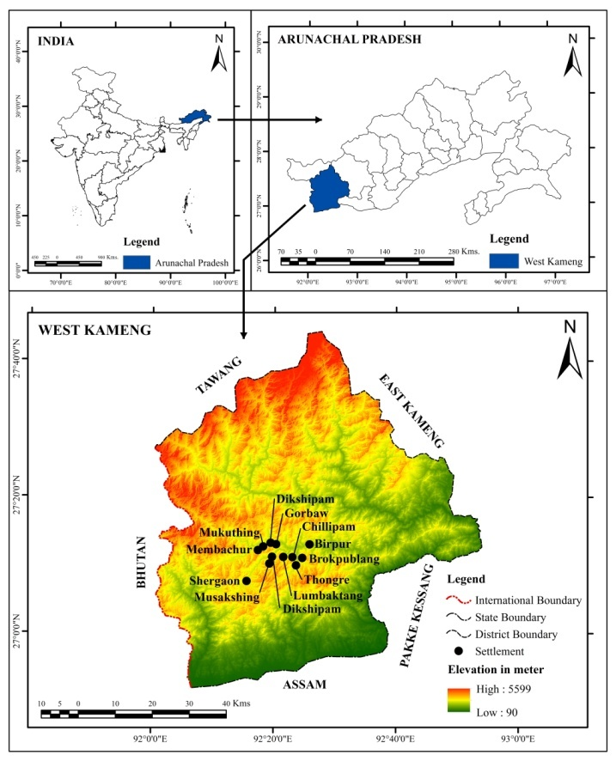
The study area is West Kameng district of Arunachal Pradesh, Northeast India (Figure 1.) The district shares an international border with Tibet and Bhutan. The topography of the district is mostly mountainous with tangled peaks and valleys. Bichom, Dirang Chu and Tenga are the main rivers flowing through the district. The forest types of West Kameng range from tropical semi-evergreen to alpine, and they are a storehouse of more than 500 species of plants of medicinal and pharmacological significance. On average, the area receives 1743 mm of annual rainfall and has a mean monthly maximum and minimum temperature of 21.44˚ C and -1.24˚ C. West Kameng district has a total population of 87,013 (Census of India 2011). The inhabitants of the district are comprised mainly of Aka (Hrusso), Bugun (Khowa, Monpa), Sajalong (Miji), Sartang and Shertukpen ethnic groups. The Shertukpens largely depend on agriculture and animal products for their livelihood. The district is divided into 260 villages, 5 administrative blocks, and 13 administrative circles. The administrative circles of the district are Balemu, Bhalukpong, Bomdila, Dirang, Jamiri, Kalaktang, Kamengbari-Doimara, Nafra, Rupa, Shergaon, Singchung, Thembang, and Thrizino.

Figure 1. Location map of the study area (Source: Bapu & Nimasow, 2021)

3. Methods
The study is based on primary data collected through personal interviews and field observations that occurred during June and July 2019. A total sample of 120 households - 10 each from 12 Shertukpen inhabited villages - was randomly selected to carry out the survey. The names of the surveyed villages are Birpur, Brokpublang, Chillipam, Dikshipam, Gorbaw, Jigaon, Lumbaktang, Membachur, Mukuthing, Musakshing, Shergaon, and Thongre. The elderly people and artisans (above 60 years of age), both men and women, were interviewed to understand the history and usage of grinding stones. Information on the significance of this practice and the materials used for grinding was also obtained through Focus Group Discussion with the villagers. Participant observation was another important tool for understanding the antique traditional grinding stones. Besides, the three surviving craftsperson have been interviewed to understand the entire process of manufacturing grinding stones. A simple chaine operatoire (operational chain) was used by paying attention to the selection of raw materials, energy spent and techniques applied for shaping and converting a stone into usable products – Ran-thok and Ling-chhom. Chaîne opératoire is a means to break down each technological process into its elements (links in the chain). The interrelationships between the links of the chain focus on the technology itself, the socio-cultural, the political, and the ideological aspects that are expressed through human courses of action and speech (Leroi-Gourhan 1993).

4. Results
Manufacturing Ran-thok (rotary quern) and Ling-chhom (nutting stone)
The grinding stones are manufactured by specific professionals known as Zyopo (Figure 2) in the Shertukpen dialect. These tools are made for their own use and also sold to other members of the village on requisition. The interview with the surviving manufacturers reveals that the manufacturing process of grinding stones is an arduous and time consuming task. The time taken in manufacturing these tools depends on the consistency and the number of men involved in the work. For example: when we asked about how long it took to make a Ran-thok, the answer during the interview ranged between one month if two to four men are involved and two months if the manufacturer work single-handedly every day. On the other hand, the manufacturing of Ling-chhom is easier and less time consuming i.e. about 10 to 15 days of daily work. The manufacturing process involves collection of raw materials, processing and finishing. The Zyopos informed during the interview that there are no differences between the villages in terms of the raw materials used in making stone tools. They collect ling-say (gneiss rock) from the surroundings as the preferential material for making the grinding stones. Such suitable stones are generally available in the area but sometimes they also excavate or break it from the rocks. Besides, the wooden mortar and pestle are made from Pinus roxburghhi (pine tree) or Castanopsis spp. (oak tree), depending on the availability in the vicinity. Majority of the time is spent in the processing of the materials as they use indigenous tools like hammer, hoe, chisel, etc. for shaping, polishing and finishing the grinding stones. These tools are made of iron with wooden and plastic handles. Name of some of the common tools in their dialect are Chapzee Achandu (Figure 3a), Chanzee (Figure 3b), Nzongbee (Figure 3c), and Thung (Figure 3d). The mean size of finished product slightly varies in different villages due to wear and tear during manufacturing process. The details of stone tools, average mean size and raw materials used are shown in Table 1.
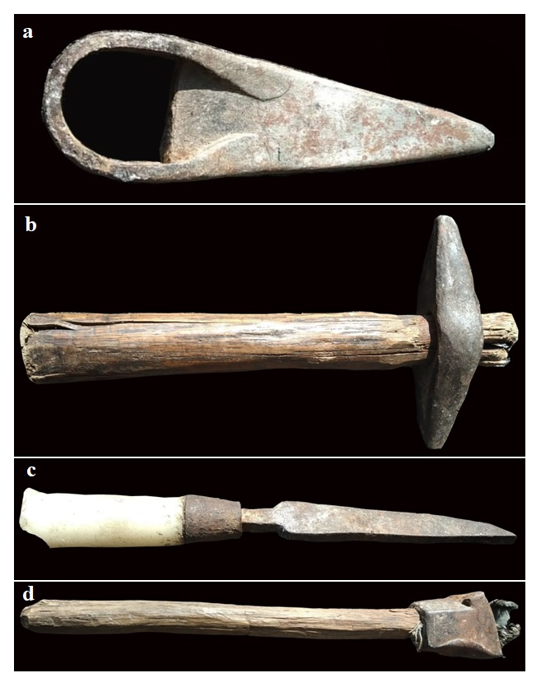

Figure 2. Rinchin Dorjee Megeji (Zyopo) at work Figure 3(a). Chapzee Achandu (b). Chanzee
(c). Nzongbee (d). Thung
(Photo by K. D. Thongdok)
Table 1. Types of grinding tools, average size and raw materials used
Villages | Types of grinding tools | Average Size (in cm) |  | Raw materials used
 |  | Rotary quern | Nutting stone
Birpur | 1. Ran-thok (Rotary quern)  2. Ling-chhom (nutting stone) | Lower stone Diameter = 40 Thickness = 10  Upper stone  Diameter = 40 Thickness = 15  Wooden plank Length = 115  Breadth = 75 | Length = 60  Width = 30  Height = 45  Pestle = 150 | 1. Gneiss stone  2. Pinus roxburghii  3. Castanopsis spp.

Brokpublang
Chillipam
Dikshipam
Gorbaw
Jigaon
Lumbaktang
Membachur
Mukuthing
Musakshing
Shergaon
Thongre

Parts and function of Ran-thok and Ling-chhom
The traditional Ran-thok (grinding stone) comes in pairs (Figures 2a). The base consists of wooden planks (made of Castanopsis spp.), 115cm x 75cm, which form a bent structure known as bleng (Figure 2b). The bleng stabilizes the stones while also collecting the flour that comes out of grinding. The rounded base or lower stone, diameter 40cm, thickness 10cm, and known as the uukhu, is stationary (Figure 2d). Above the lower stone is the getheng (upper stone), diameter 40cm, thickness 15cm. The getheng does the actual grinding (Figure 2c). The upper stone spins above the stationary lower stone creating the grinding action of the stones. It is generally slightly concave, while the lower stone is slightly convex. This helps to channel the flour that comes out of grinding to the outer edges of the stones where it can aggregate for collection. A wooden handle known as the enyi is fixed on a corner of the runner stone for turning it. A short lever on the centre of the lower stone connects with a small hole at the centre of the runner stone as a support for holding both the stones. A small hole is made on the upper stone where the grains are poured to be slowly ground. Ran-thok is mostly operated by the women either single or double in sitting gesture (Figure 3).

Figure 2(a). Ran-thok (b). Bleng (wooden plank) (c). Getheng (Upper stone) (d). Uukhu (lower stone) (e&f). Ling-chhom (nutting stone). Photos by N. J. Thongdok

There are two types of nutting tools used by the Shertukpens – one made of gneiss, and known as Ling-chhom and another, made of wood, known as Hing-chhom (Figures 2e, 2f). The nutting stone is oval in shape with a length, width, and height dimensions of 60cm, 30cm, and 45cm, respectively. The the wooden tool is 20cm in diameter and 60cm in height. Interactions with the villagers revealed that these tools were largely used for breaking corn grains into coarse-ground cornmeal and cracking nuts. The grains are put into the hole and pounded by a wooden pestle (made of Pinus roxburghii) known as chang-khey – which is about 150cm. Some nutting stones and pestles can be quite large. Generally, women either single or double in standing gesture pounds corn grains or crack nuts (walnut) in the Ling-chhom (Figure 4).

Figure 3. Shertukpen woman grinding millet using Ran-thok (Photo by N. J. Thongdok).

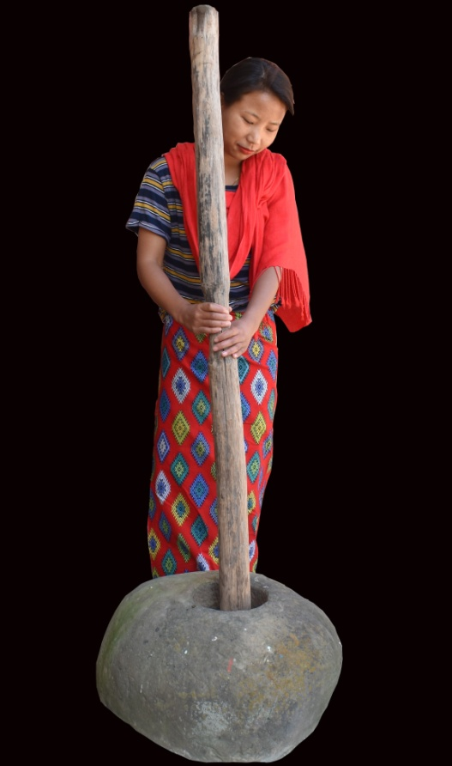

Figure 4. Shertukpen girl pounding corn grains in a nutting stone (Photo by N. J. Thongdok).

According to villagers, the use of these tools is not specific to them, as the neighboring tribes also used similar tools. During the survey, the grinding stones especially Ran-thok was observed in majority of the households. The grinding and pounding activities are mostly performed by the women (Figure 3 & 4). However, it is not specific to them only as men occasionally help them. They further reported that usage and importance of these grinding stones in recent years has declined due to convenient access to commercially produced flour and mechanical mills. Traditionally, wheat, millet, corn, and barley were important crops for food but nowadays rice and other readily available food items are preferred more by the younger generations. Consequently, changing food habits have limited the use of these tools to the remote and inaccessible villages only. The villagers, particularly in rural areas, reported that they still largely depend on the grinding stones for processing food items as it is linked to their age-old tradition. They also reported that grinding and pounding activities provide opportunities for social interactions such as merrymaking, and performing folk songs with fellow friends. So, the interviewed villagers expressed interest to continue grinding and pounding practices into the future for both meeting food requirements and to develop interpersonal relationships in traditional ways.

5. Discussion

The Shertukpens pay attention while sculpting and selecting the type of stones for easy and quick grinding of cereals as the right profile and accurate gap between the stones is important for better quality of flour that comes out of grinding. However, the traditional grinding stones are increasingly lacking in proper sculpting and maintenance of the gap between the stones as the tools are very old and handed over from one generation to another generation.The accurate gap between the stones is an important consideration because too big a gap or unbalanced stones result in coarse or poorly ground flour. Through this study, it is learned that the manufacturing of grinding stones is a complex process that requires skills, knowledge and hard work. Nixon-Darcus & Meresa (2020) also reported similar findings in northeastern Tigrai. The study found that grinding traditions have been impacted by changing livelihoods and new grinding technologies. However, the villagers in rural areas have retained the use of some grinding-stone tools despite these not always being the most efficient options. This is consistent with similar findings on grinding stone studies in Africa (Shoemaker et al. 2017). The stone used for a quern needs to be resistant to wear and durable. Generally, manual querns are made from different rock types; preferably of igneous origin. The reported use of gneiss in rotary querns by the Shertukpens is in conformity with the Celtic rotary querns of the Czech Republic (Waldhauser 1981). These stone tools are environment-friendly in compare to the mechanical mills because it is manufactured from the natural resources that are easily available in the area and operates through manual labour that produces less noise.
These traditional mills have been reported to develop flour of the highest quality. Stone milling has been found to have very little effect on macro-element losses and no effect on micro-element losses thereby producing flours with high nutritional value (Albergamo et al. 2018). Traditional Chakki-milled flour is preferred over mechanical-milled by the consumers of the Indian sub‐continent for its taste and texture due to the burning effect and carotenoid content which noticeably improve the flavour. However, despite the taste people tend to consume more flour from mechanical mills as it is cheaper and easily available. Stone grinding breaks the starch sufficiently to release extra sweetness while burning it slightly gives a subtle smokey flavour (McKee 2012). It also has nutritional superiority in terms of higher dietary fiber, Vitamin E content and dietary minerals (Rajasthan Agricultural Competitiveness Project 2019). Thus, the flour produced by traditional grinding stones has a nutritional and gustatory advantage over the mechanical mills. However, the considerable heat generated due to friction in stone milling was found to damage the starch, protein, and unsaturated fatty acids which have impacted shelf-life and product quality (Prabhasankar & Rao 2001).

The grinding stone tool assemblages are useful in reconstructing the past human, plant, and other substance interactions and interpreting the objects as materializing aspects of social life (Shoemaker et al. 2017). The study found that grinding traditions have been impacted by changing livelihoods and new grinding technologies. However, the villagers in rural areas have retained the use of some grinding-stone tools despite these not always being the most efficient options. This is consistent with similar findings on grinding stone studies in Africa (Shoemaker et al. 2017). Grinding practices in many societies, including the Shertukpens, are linked with the socialization process which is crucial for sustaining interpersonal relations (Hamon & Le Gall 2013). Ethnographic studies in Ghana (Goody 1982) and Ethiopia (Nixon-Darcus & D’Andrea 2017) stated that woman working together can result in beneficial social interactions such as singing, chatting about community and family, getting more other work done, and enjoying each other’s company. Nixon-Darcus (2014) emphasized that the move to mechanical mills has largely relaxed the strenuous and difficult work of grinding in Northern Ethiopia but it may have significant implications on the community engagements and cooperation that was previously facilitated through grinding practices. Therefore, local mechanical mills can be set up with reasonable prices and working procedures to create cooperation opportunities and socialization process.

6. Conclusions
The indigenous grinding stones reported in this study are considered to be laborious and time-consuming (Hayden 1987; Searcy 2011) but the manufacturing and operating monetary costs are zero, in terms of cash outlay. They are also environment-friendly tools made from the natural resources that produce less noise. The Shertukpens, in rural areas are still dependent on the grinding stones for food processing. It is linked to their age-old tradition and also provides opportunities for social interactions. However, with the advent of globalization, traditional practices have been diluted by the external actors of modern milling technologies, and mass production of affordable, mechanical mills (Bapu et al. 2020). The introduction of mechanical mills (Nixon-Darcus & Meresa 2020) and affordable access to readymade flours in the markets have largely decreased the utilization of grinding stones in recent years. So, there is a need for efforts that encourage villagers to continue such sound and healthy practices with little modifications to ensure high-quality flour. The possibilities of modifying indigenous grinding stones with modern power tools could be disseminated to the Shertukpens for sustaining such endangered material culture.

Glossary
Shertukpen English
bleng curved wooden plank
chang-khey wooden pestle
enyi wooden handle
getheng upper stone
hing-chhom wooden nutting stone
ling-chhom nutting stone
ling-say gneiss rock
ran-thok grinding stone
Shertukpen Indigenous tribal group, Arunachal Pradesh, India
uukhu lower stone
zyopo grindstone makers

Hindi English
atta wheat flour
chakki mill stone
chapati unleavened bread

Acknowledgements
The authors are thankful to all the villagers for cooperation and sharing information about grinding stones during the field survey. We are also thankful to the Department of Geography, Rajiv Gandhi University, Rono Hills, Doimukh for infrastructural support in accomplishing the work.

Data accessibility statement
All data used in the manuscript are accessible and included in the text. The data is unrestricted and the authors are ready to comply with journal’s policy regarding data availability and research reproducibility.

List of supplementary files
Nil

Conflict of interest

The authors of this article declare that they have no financial conflict of interest with the content of this article.

References
Adams, J.L. 1988, Use-Wear Analyses on Manos and Hide-Processing Stones. Journal of Field Archaeology, 15(3): 307–315. https://doi.org/10.1179/009346988791974394
Albergamo, A., Bua, G.D., Rotondo, A., Bartolomeo, G., Annuario, G., Costa, R. & Dugo, G. 2018, Transfer of major and trace elements along the “farm-to-fork” chain of different whole grain products. Journal of Food Composition and Analysis, 66: 212–220. https://doi.org/10.1016/j.jfca.2017.12.026
Bapu, T.D. & Nimasow, G. 2021, An assessment of the population status of the threatened medicinal plant Illicium griffithii Hook.f. & Thomson in West Kameng District of Arunachal Pradesh, India. Journal of Threatened Taxa, 13(1): 17504–17512. https://doi.org/10.11609/jott.6082.13.1.17504-17512
Bapu, T.D., Nimasow, G. & Nimasow, O.D. 2020, Role of indigenous belief systems in conservation of animals among the Monpa and Shertukpen tribes of Arunachal Pradesh (India). Shodh Sanchar Bulletin, 10(38): 155–162.
Barbosa‐Canovas, G.V., Ortega‐Rivas, E., Juliano, P. & Yan, H. 2005, Food Powders: Physical Properties, Processing, and Functionality. Springer-Verlag, US. 372 p.
Catterall, P. 1999, Flour milling. In: Technology of Breadmaking (Cauvain, S.P. & Young, L.S., Eds.), Springer, Boston: p. 296-329. https://doi.org/10.1007/978-1-4757-6687-5_12
Census of India, 2011, Primary Census Abstracts. Registrar General of India, Ministry of Home Affairs, Government of India, Retrieved: 10 December 2020. URL: https://www.censusindia.gov.in/2011census/PCA/pca_highlights/pe_data.html
Curwen, C.E. 1937, Querns. Antiquity, 11: 133–151.
Davis, D.J. 1995, Prehistoric Artifacts of Texas Indians. Pecos Publishing Co., Ft. Sumner, New Mexico. 449 p.
De Beaune, S. 1993, Non-flint stone tools of the early Upper Paleolithic. In: Before Lascaux: The complex record of the Early Upper Paleolithic (Knecht, H., Pike Tay, A. & White, R. Eds.), CRC Press Inc., Boca Raton: p. 163–191.
Dubreuil, L. 2004, Long-term trends in Natufian subsistence: a use-wear analysis of ground stone tools. Journal of Archaeological Science, 31: 1613–29. https://doi.org/10.1016/j.jas.2004.04.003
Ebeing, R. 2019, Rotary querns and the presentation of the past. In: Stone Tools in the Ancient Near East and Egypt (Squitieri A. & Eitam, D., Eds.), Archaeopress Publishing Ltd., Oxford: p. 81–92.
Ebeling, J.R. & Rowan, Y.M. 2004, The Archaeology of the daily grind: Ground stone tools and food production in the Southern Levant. Near Eastern Archaeology, 67(2): 108–117. https://doi.org/10.2307/4132366
Fullagar, R., Field, J. & Kealhofer, L. 2008, Grinding stones and seeds of change: starch and phytoliths as evidence of plant food processing. In: New Approaches to Old Stones: Recent Studies of Ground Stone Artifacts (Rowan, Y.M. & Ebeling, J.R., Eds.), Equinox Publishing, London: p. 159–172.
Goody, J. 1982, Cooking, cuisine, and class: A study in comparative sociology. Cambridge University Press, Cambridge. 253 p.
Hamon, C. & Le Gall, V. 2013, Millet and sauce: The uses and functions of querns among the Minyanka (Mali). Journal of Anthropological Archaeology, 32: 109–121. https://doi.org/10.1016/j.jaa.2012.12.002
Haridas Rao, P., Leelavathi, K. & Shurpalekar, S.R. 1989, Effect of damaged starch on chapati making quality of whole wheat flour. Cereal Chemistry, 66: 329–333.
Hayden, B. 1987, Past to present uses of stone tools in the Maya Highlands. In: Lithic Studies Among the Contemporary Highland Maya (Hayden, B., Eds.), University of Arizona Press, Tucson: p. 160–234
Jones, C.E.R. 1986, Archaeochemistry: fact or fancy? In: The Prehistory of Wadi Kubbaniya (Close, A.E., Eds.), Southern Methodist University Press, Dallas: p. 260–266.
Leroi-Gourhan, A. 1993, Gesture and Speech. (Translated by Bostock Berger, A.). MIT Press, Massachusetts. 431 p.
Mckee, D. 2012, Lifting the screen on Indian milling. World Grain, 30: 40–45.
McLaren, D. & Hunter, F. 2008, New aspects of rotary querns in Scotland. Proceedings of the Society of Antiquaries of Scotland, 138: 105–128.
Moritz, L.A. 1958, Grain-Mills and flour in classical antiquity. Clarendon Press, Oxford. 230 p.
Nixon-Darcus, L. & D’Andrea, A.C. 2017, Necessary for Life: Studies of Ancient and Modern Grinding Stones in Highland Ethiopia. African Archaeological Review, 34(2): 193–223. https://doi.org/10.1007/s10437-017-9252-4
Nixon-Darcus, L. & Meresa, Y. 2020, Men at work: Grinding stone production by the experts and others in northern Ethiopia. Journal of Lithic Studies, 7(3): 1–24. https://doi.org/10.2218/jls.3091
Nixon-Darcus, L. 2014, The cultural context of food grinding equipment in Northern Ethiopia: an ethnoarchaeological approach. Master of Arts thesis at the Archaeology Department, Simon Fraser University, Burnaby, 343 p.
Perry, L. 2004, Starch analyses reveal the relationship between tool type and function: an example from the Orinoco valley of Venezuela. Journal of Archaeological Science, 31: 1069–1091. https://doi.org/10.1016/j.jas.2004.01.002
Peterson, J. 2008, New insights from old stones: a survey of ground stone studies. In: New Approaches to Old Stones: Recent Studies of Ground Stone Artifacts (Rowan, Y.M. & Ebeling, J.R., Eds.), Equinox Press, London: p. 361–370.
Piperno, D.R., Wiess, E., Holst, I. & Nade, D. 2004, Processing of Wild Cereal Grains in the Upper Palaeolithic revealed by starch grain analysis. Nature, 430: 670–673. https://doi.org/10.1038/nature02734
Prabhasankar, P. & Rao, P.H. 2001, Effect of different milling methods on chemical composition of whole wheat flour. European Journal of Food Research and Technology, 213: 465–469. https://doi.org/10.1007/s002170100407
Rajasthan Agricultural Competitiveness Project, 2019, Detailed project report on Aata Chakki and Roller Flour Mill, Prepared by Grant Thornton India LLP, New Delhi. Retrieved: 25 December 2020. URL: http://www.agriculture.rajasthan.gov.in/content/dam/agriculture/Rajasthan%20Agricultural%20Competitiveness%20Project/ABPFTechDPR/RACP_ABPF_Tech%20DPR_Wheat%20flour%20Mill.pdf
Revedin, A., Aranguren, B., Becattini, R., Longo, L., Marconi, E., Lippi, M.M., Skakun, N., Sinitsyn, A., Spiridonova, E. & Svoboda, J. 2010, Thirty thousand-year-old evidence of plant food processing. Proceedings of the National Academy of Sciences of the United States of America, 107(44): 18815–18819. https://doi.org/10.1073/pnas.1006993107
Searcy, M.T. 2011, The Life-Giving Stone: Ethnoarchaeology of Maya Metates. University of Arizona Press, Tucson. 168 p.
Shoemaker, A.C., Davies, M.I. & Moore, H.L. 2017, Back to the Grindstone? The Archaeological potential of Grinding-Stone studies in Africa with reference to contemporary grinding practices in Marakwet, Northwest Kenya. African Archaeological Review, 34: 415–435. https://doi.org/10.1007/s10437-017-9264-0
Singh, R.K. & Sureja, A.K. 2006, Community knowledge and sustainable natural resources management: Learning from Monpa tribe of Arunachal Pradesh. The Journal for Transdisciplinary Research in South Africa, 2(1): 73–102.
Stančo, L. 2018, Getting rotary: introduction of rotary quern stones in Ancient Bactria. In: The problems of history, archaeology and ethnology of Central Asia (Sagdullaev A.S., Eds.), Tashkent: p. 118–128.
Tsering, G., Nimasow, G. & Nimasow, O.D. 2015, Chuskor: an indigenous watermill for sustainable resource utilization by the Monpa tribes of Arunachal Pradesh, India. Current Science, 109(2): 247–250.
Waldhauser, J. 1981, Keltské rotačnímlyny v Čechách. Pamatky Archeologické, 72: 153–221.
Walters, M., Bozarth, S. & Guderjan, T.H. 2015, An examination of six “Nutting stones” from East Texas for plant phytoliths. Index of Texas Archaeology: Open Access Gray Literature from the Lone Star State, 54: 93–100. https://doi.org/10.21112/.ita.2015.1.37
Yallappa, D., Mathad, P.F., Nidoni, U.K., Gururaj, T., Roopabai, R.S., Ambrish, S.G. & Kenchappa, C. 2019, Performance evaluation of pedal operated flour mill with multi-applications. Journal of Pharmacognosy and Phytochemical, 8(2): 1250–1254.
Yohe, R.M., Newman, M.E. & Schneider, J.S. 1991, Immunological identification of small-mammal proteins on aboriginal milling equipment. American Antiquity, 56: 659–666. https://doi.org/10.2307/281543

