AT THE EDGE OF A CITY: THE DIGITAL STORYLINE OF THE BRONTOCHION MONASTERY OF MYSTRAS
Vayia V. Panagiotidis*, Vasiliki Valantou, Anastasios Kazolias and Nikolaos Zacharias¹

¹ Laboratory of Archaeometry,
Department of History, Archaeology and Cultural Resources Management,
University of the Peloponnese, Old Camp, 24133 Kalamata, Greece

*Corresponding author
Correspondence: vayiap@gmail.com

Abstract
The Byzantine city of Mystras is situated at the foot of Mt. Taygetos, six kilometres west of the city of Sparta in the Peloponnese Greece. Mystras was established in 1249AD when the Frank Commander William II of Villehardouin built a castle fortress on top of Myzithra Hill. The Acropolis fortress provided safety to the population of Medieval Sparta which eventually transferred to the hill settlement. Mystras grew and evolved through a number of phases, population changes and rulers (Sinos 2009).
This study focuses on the digital depiction of the storyline of the Monastery of Brontochion of Mystras, located at the southwest edge of the city. The Monastery initially included the church of Hagioi Theodoroi founded by Pachomios, the enterprising abbot of Mystras, and built sometime before 1296. Twenty years later a second instalment to the Monastery was added by Pachomios. The Church of Panagia Hodegetria (“Aphentiko”) was built as a prestigious temple to commemorate “the Renaissance” of the Palaiologos dynasty.
. The digital recreation of the Monastery of Brontochion is part of the overall study of the Medieval City, implemented using modern spatial technologies, an unmanned aerial system (UAS) for documenting the area, a high accuracy GPS GNSS reciever, control points for georeferencing the drone images and a high resolution DSLR camera for documenting the buildings. Photogrammetry is applied to create the orthophoto of the study area, which works as the basemap for the subsequent analysis via GIS, as well as for the generation of the 3D models of the buildings of the Monastery. The final product is a visualization of the archaeological site and its evolution from the foundation of the Monastery to the present.

Keywords: UAV Photogrammetry, Mystras, GIS, Cultural Heritage Management, Digital Applications
Introduction
Documentation of archaeological sites with the incorporation of geodatabases are used for the presentation and monitoring of sites as a widely spread practice, though laborious and time consuming. Such applications of internationally acknowledged significance include the archaeological excavations of Ancient Corinth also in the Peloponnese (American School of Archaeological Studies at Athens, 2021), the documentation of antiquities at a national level in Iraq and Jordan (Kalaf et al., 2018; Getty Conservation Institute; Howland et al., 2014), the technological applications in Catalhouyuk, Tur-key (Forte et al., 2020), the documentation and digital reconstruction of the Delphi sanctuary (Liritzis et al., 2016; Hatzopoulos et al., 2017), the documentation of Roman sites in Croatia (Popovic et al., 2021), as well as for monitoring vulnerability and at-risk archaeo-logical sites (Moreno et al., 2019; Sideris et al., 2017).
This project is part of the larger ongoing research project “Digital Mystras”, that involves the creation of a temporal and spatial presentation of the evolution of the Medieval city of Mystras located in the south east Peloponnese utilized by the Laboratory of Archaeometry of the University of the Peloponnese. The unique topographical and architectural features of Mystras present substantial challenges to traditional documentation methods. For this reason Structure-from-Motion (SfM) technology, employing an Unmanned Aerial Vehicle (UAV) and GPS GNSS receiver in order to document and develop a reliable and highly accurate digital model of the site was applied. In the context of this broader research project, the focus of this paper centers on the process and results of the documentation of the Brontochion Monastery, including the creation of an orthomosaic of the SW region of Mystras which in turn is used for the development of the geodatabase of the Monastery complex. Through a detailed examination of this methodological approach, the research sheds light on the potential of digital tools in enhancing understanding and preservation efforts of cultural heritage sites especially those situated in hard to access regions or challenging morphological terrain. In the case of Mystras both are relevant. By addressing this question, we seek to contribute valuable insights to both scholarly discourse and practical conservation efforts in the spectrum of heritage preservation and digital documentation.
The archaeological site of Mystras is situated in western Laconia, 6km southwest of Sparta, and 55km from Kalamata. Included in UNESCO’s list of World Cultural Heritage sites since 1989, the medieval city is considered the best preserved Byzantine state of Greece covering more than 540 acres (54.43 hectares) over the east side of Myzithras hill (Ministry of Culture and Sports; UNESCO). Myzithras hill constitutes a coarse environment extending over sharp slopes in some >45% as well as extensive dense vegetation, high and low. Mystras was founded in 1249AD when the Frankish Prince of Achaia, William Villardhouin II, erected the castle fortress of Mystras on the hill top, a key position to control the valley of Evrotas.
The Monastery of Brontochion was established with the first catholicon built in the north west area of Mystras, Hagioi Theodoroi. The church of Hagioi Theodoroi as mentioned by an inscription within the church, was founded by abbots Daniel and Pachomios sometime between 1290 and 1295. The catholicon’s octagon domed architectural type, 11,0 x 11,0m, (external dimensions), is unique for the city of Mystras (Figure 2). Its design was based on a Middle-Byzantine type, exemplified later in Peloponnese with the 12thc. catholicon of Hagia Sophia of Monemvasia and the church of Soter at Christianon. Erection of the church began by abbot Daniel and was continued and completed by abbot Pachomios, the enterprising abbot of Mystras (Acheimastou-Potamianou, 2003). Twenty years later a new catholicon was added to the Monastery by Pachomios. The Church of Panagia Hodegetria or Our Lady Hodegetria (the Leader of the Way) (“Aphentiko”) was built as a prestigious temple to commemorate “the Renaissance” of the Palaeologan dynasty (Arvanitopoulos, 2004).
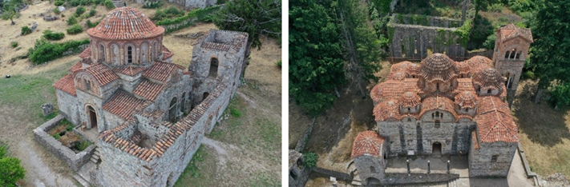
Figure 1 - Church of Hagioi Theodore (left), Church of Hodegetria or Our Lady Hodegetria (right).
The narthex of Hagioi Theodoroi located on the west side of the catholicon as well as the its two-storey tower styled funerary chapels are later additions to the church. The north-east chapel contains representations of an emperor, while the south-east chapel has portraits of two noblemen wearing conical hats (Sinos, 2009). Following the foundation of the church of Hodegetria, Hagioi Theodoroi was a ceremonial chapel and cemetery.
The catholicon of Panagia Hodegetria, follows the mixed architectural type which can be described as a as a three-ailed basilica type on the ground floor and a cross-in- square five domed church above. This architectural type will be later known as the “mixed type of Mystras” and the catholicon of Hodegetria the first to be built in the city. Hodegetria also incorporates a two storey narthex with a dome and chapels at its ends, a peristyle on the west, north and south sides and a bell tower at the south end of the west portico.
The church was built in two different phases. The first testifies the initial intent of building a cross-in- square five domed church. Soon after the appointment of the first commissioner of Mystras Hodegetria was redesigned to include a second level with galleries. To the west the narthex was added with side extensions from which at the north and south sides of the church the north and south galleries were placed respectively. Built during the Late Byzantine I period, Hodegetria is turned into a mosque following the surrender of the city to the Ottoman Turks in 1460.
The Monastery of Brontochion also worked as a scriptorium where manuscripts were copied as well as a medical center for the higher ranking families similarly to the Metropolis for the common residents (Sinos, 2009). It is possible that following the foundation of Hodegetria and its functional buildings that Hagioi Theodoroi became functionally the exomonastic area with practical functions connected to the city such as medical services, elderly care, storage facilities, stables etc. leaving Hodegetria and its structures to esomonastic functions.
Methods
In order to facilitate the challenging endeavor of creating a detailed digital repre-sentation of the current situation of the city advanced surveying technologies were used. The methodological approach to the site survey included the use of an unmanned aerial system (UAS), the DJI Mavic 2 Pro UAV in collaboration with the Top Con GR5 GNSS receiver. The differential correction technique employed to enhance the quality of GNSS receiver location data is real-time kinematic (RTK). The corrections of positioning gathered by U.R.A.N.U.S. represent a Full GNSS network of fixed reference stations providing high-quality GPS, GLONASS, GALILEO, and BEIDOU corrections to rover receivers utilized in surveying, construction, GIS, and agricultural applications.. The overall study of the archaeological site can be distinguished into different approaches. Initially, the survey of the city which was realized by photogrammetry combining photographs taken with an UAS and the assistance of a GPS station for georeferencing the model used in the production of an orthophoto of the archaeological site which in turn acts as the basemap for the development of the geodatabase of the application. The geodatabase functions as a digital depiction of the storyline of the Medieval city (Panagiotidis & Zacharias, 2022). A third approach to the study is that of creating 3D models of a number of monuments, buildings, churches etc. For this study the Monastery of Brontochion, located at the southwest edge of the city was documented additionally to the survey in order to create a high definition 3D model of the buildings that constitute the Monastery in their present state.
For the purposes of the survey of the archaeological site the city was separated into five regions in order to deal with issues that occur with extreme elevational fluctuations as well as dense vegetation and inaccessibility. The study area was photographed using an UAS and GPS GNSS receiver. Ground Control Points (GCPs) where set over the study area and their coordinates measured using GPS, for further georef-erencing of the model. All data was collected in the Greek coordinate system EGSA ’87. Images for the photographic overview of the study area were captured with at a relative altitude of 80m from each takeoff point. Each area was photographed separately and data was combined during processing. Abrupt and significant elevation differences prohibited longer flights over extended areas with the specific UAS. In order to approach the survey challenges multiple flights were implemented over smaller areas with smaller altitude variations. Multiple flights however have the disadvantage of coloring differentiations due to different lighting conditions (natural light and weather conditions) per flight. GCP placement in challenging areas such as Mystras in many cases can be a significantly time consuming process in order to properly place them in inaccessible terrain. Flight plans during the survey follow single grid formation as designed using a navigation application which allows the pilot to configure all parameters before flight. The route, formation of the flight, relative altitude of the UAV, flight speed, camera tilt as well as photo capture overlap are determined in advance. For best results an overlap of at least 75% was maintained (Gutiérrez, et al., 2016). Respectively, in order to create 3D models of the Monastery buildings additional flights where implemented, in this case at a much lower altitude and following manual photo capture. The 3D models were signified using markers to create a measurable model. Images were captured in both cases with an overlap of 75-85%.
The surveying process for the entire archaeological site with the UAS resulted in over 1000 photographs with 5472 X 3648 pixels analysis with 62 GPCs set during the process. Specifically, for the generation of the basemap of the Monastery area a total of 350 photos were used and 5 GCPs for georeferencing. The flights for capturing the study area provide ground sample distances (GSD) of 2,03cm/px. GSD is calculated using geometry, flight and UAV parameters. In this case, the Pix4D GSD calculator was used (Pix4d.com). The calculated GSD could be optimized by changing survey parameters such as lower altitude flights or using a higher resolution camera. Similarly, for the generation of the 3D model of the church of Hagioi Theodoroi, Hodegetria and their surrounding buildings 540 photographs were used along with 20 markers. The photographs were processed using the photogrammetric software Agisoft Metashape v 1.8.4.
Table 1 Number of photographs, GCPs and Dense cloud points and GSD for each case study
Site | Photographs | GSD | GCPs/ Markers
Monastery of Brontochion Basemap | 350 | 2.03 cm/px | 5
Hodegetria Model | 250 | - | 10
Hagioi Theodoroi Model | 290 | - | 10

The processing procedure for orthophoto generation, in brief, includes image (camera) alignment, referencing system conversion, importing target coordinates (GCPs), generating the dense point cloud, classification, mesh creation, generating the DEM and orthomosaic. The software aligns photos by identifying camera positions and orientations, generating a rough three-dimensional model as a sparse point cloud. Ground control points (GCPs) are then added and adjusted in each image to ensure accurate positioning, followed by optimization to create a dense point cloud and ultimately generate a detailed three-dimensional model of the area (Figure 2a- 2d). The result of the 3D model from photographs taken at 90°(nadir) contains a number of blurs and discontinuities, for that reason the 3D model was created using a combination of images with 90° and 45°angles. From the optimized dense cloud, the digital elevation model (DEM) of the study area is produced, from which in turn the high resolution orthophoto (200MB) is generated. The generated orthophoto is used as the georeferenced basemap for the development of the geodatabase of the study area.
The overall GCP error, calculated after the camera optimization methodology and the GNSS correction through the RTK procedure, is 1.6 cm. This error can be reduced by employing the post-process kinematic (PPK) correction technique, which involves surveying the targets and recording their position for a specific amount of time. The position is then corrected in the office. In that case study the accuracy gained is accepted for the as a means of precise documentation of the mentioned sites.
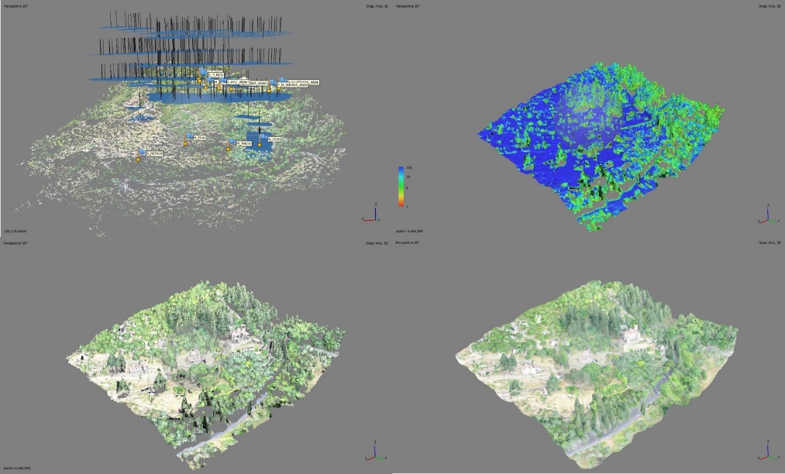
Figure 2 3D perspective of archaeological site (mild processing), alignment and sparse point cloud (a), dense point cloud (b), dense cloud confidence (c), 3D model (d)
Similarly, for the creation of the 3D models the procedure includes camera alignment and sparse cloud generation (Figure 4a), marker detection and scale bar definition (Figure 4b), generating the dense cloud (Figure 4c), creating the mesh, tiled model (Figure 4d) and finally extracting the 3D object with texture (Figure 8). Markers were set on the structures themselves and measured from center to center in order to define scale bar distances and ultimately generate a 3D model to scale with the physical object.
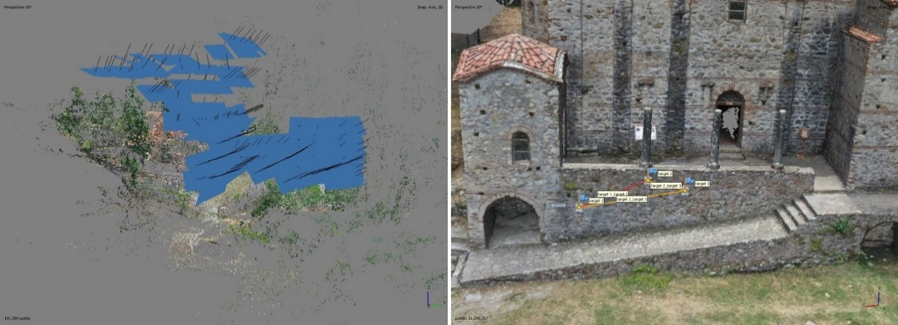
Figure 3 Processing for the creation of the 3D model of the Church of Hodegetria and surrounding buildings, align photos (left), setting marker distances (right)
Following dense cloud generation points were classified and cleared by classification as described above for the orthophoto. Points with classification under 4 were removed (Figure 4). Screenshots of the north and east sides of the model are presented in Figure 5.
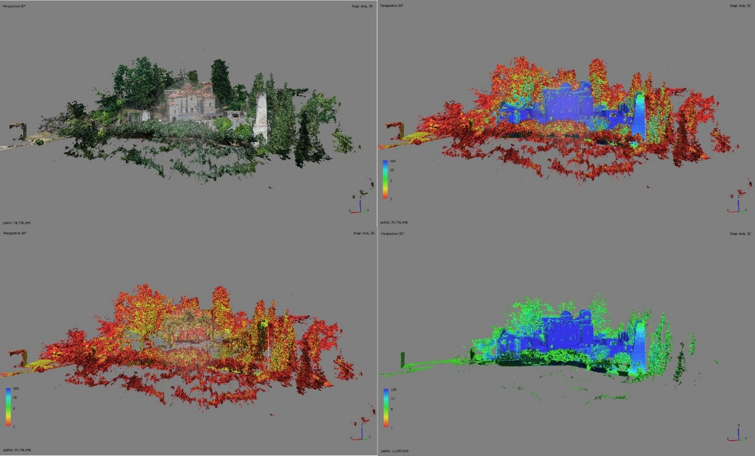
Figure 4 3D model point classification
Images were captured using a UAS manually at different altitudes from the ground with close proximity to the structures. Photogrammetric processing was realized using Agisoft Metashape software.

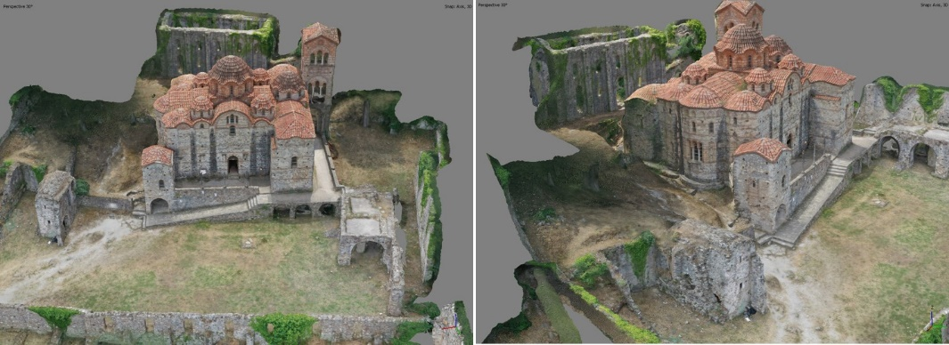
Figure 5 Views from 3D model of Hodegetria
Results
As mentioned above the work presented in this paper is part of the overall project of creating a georeferenced geodatabase for the Medieval City of Mystras including representative data regarding the structural development of the city in correspondence to the political changes it overwent. In order to organize the data, the spatial depiction of the archaeological information was divided chronologically into five time periods based on the administrative state of the city.
These chronological phases are:
Period of Latin occupancy 1249 – 1262 (Figure 6a)
- Late – Byzantine I 1262 – 1348 (seat of the Byzantine General) (Figure 6b)
- Late – Byzantine II 1348 – 1384 (Reign of Kantakouzenos) (Figure 6c)
- Late – Byzantine III 1384 – 1460 (Reign of Palaeologos) (Figure 6d)
- Post - Byzantine 1460 – 1821.
Multiple layers of information concerning Mystras were developed in the GIS environment. The published doctoral dissertation of Dr. St. Arvanitopoulos titled: "The City of Mystras: Aspects of the organization and operation of a late Byzantine urban ensemble" and the published work of the Committee for the Restoration of Mystras "The Monuments of Mystras” under the scientific supervision of Prof. Stefanos Sinos, were used extensively for the descriptions and identification of the buildings of the city (Arvanitopoulos, 2004; Sinos, 2009). The geodatabase includes records of all the buildings of the city, ecclesiastical, administrative, secular as well as fortification structures, the road network, latrines, cisterns and water basins (Panagiotidis & Zacharias, 2022).
In the cases of structural segments such as the Monasterial units, four in total, documentation is more detailed and provides for more information for the database, such as construction phases for buildings, building types and changes in usage as well as individual examination of the additions made or alterations made. For this project focus is on the further study of the Monastery of Brontochion with a more detailed description for the geodatabase as well as the generation of a reliable and representative 3D model. The geodatabase attributes table (Table 1) for the Monastery of Brontochion includes 16 records, the two Monastery churches, eleven buildings and three towers from the fortification.
Table 1 Brontochion Monastery Layer Attribute Table
Code | Structural Remains | Dating | Period | Description
Ν3.1 | Hagioi Theodoroi | 1296 | LBI | Church of Hagioi Theodoroi built between 1290 and 1295 after the foundation of the Metropolis by Abbots Daniel and Pachomios..
Ν3.2 | Catholicon Hodegetria | 1310 | LBI | Church dedicated to the Our Lady Hodegetria (the Leader of the Way) founded by Abbot Pachomios.
N3.3 | Senior Refectory | 1296-1310 | LBI | Monasterial refectory prior to N3.5.
N3.4 | Cells | 1310-1348 | LBI | Monastery cells.
N3.5 | Refectory | 1262-1348 | LBI | The monumental structure that housed the refectory the largest preserved building with such functionality in Mystras.
N3.6 | Auxiliary Building | 1262-1348 | LBI | Structure related to defense
N3.7 | Cells | 1262-1348 | LBI | Monastery cells.
N3.8 | Cells | 1262-1348 | LBI | Monastery cells.
N3.9 | Structures | 1262-1348 | LBI | Unidentified usage
N3.10 | Cells | 1262-1348 | LBI | Initial cells structure.
N3.11 | Structures | 1262-1348 | LBI | Unidentified usage
N3.12 | Food Preparation Areas | 1262-1348 | LBI | North of the refectory were the cooking areas, kitchens with the large hearth. Complementary structures to the refectory (N3.5) for food preparation and cooking.
N3.13 | Refectory complex | 1262-1348 | LBI | Refectory complex including structures related to food preparation and dining.
K2 | Tower K2 | 1460-1821 | PB | Post Byzantine tower.
K3 | Tower K3 | 1262-1348 | LBI | Five storey tower
K4 | Tower K4 | 1460-1821 | PB | Small tower for the protection of the Monastery.

The data provided here as well as that that regards the city overall is contained in the geodatabase of the archaeological site available as a web application developed on the ArcGIS Online platform as a Map Series page titled “The Castle City of Mystras”. Similarly to the database the application uses the chronological structure described above while providing additional selection using thematic visualizations. Each section presents the archaeological site from a different perspective. Relevant to the work provided here the layer “Ecclesiastical” includes a representation of all churches and chapels of Mystras. Each item includes the name of the church or chapel, the time period of its initial construction, the architectural type, its founder and a short description (Figure 6), the Monastery of Brontochion is depicted in pink (Pangiotidis & Zacharias, 2022).
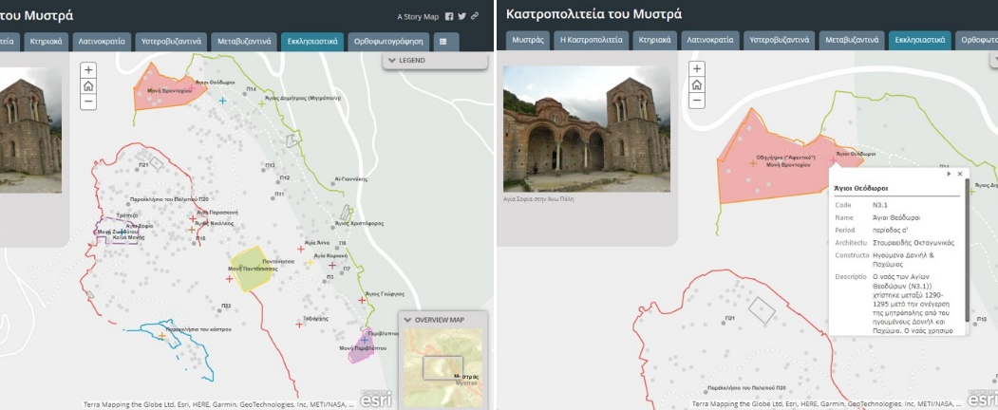
Figure 6 Ecclesiastical tab of ArcGIS online application "The Castle City of Mystras"
The geodatabase developed in this study works as a dynamic tool for the study of the urban development of the city over the course of 600 years with correlations between buildings and building complexes, infrastructure and infrastructure usage in relation to the political/historical status. The users easily witness the rapid transformation of a fortress outpost into a prominent city. The format of the georeferenced basemap provides the means to further identification of new structures and encourages enrichment with new data arising from archaeological and historical studies. The information gathered on such interactive platforms expand the scope of existing published research while enhancing dissemination to a larger audience. Through the applications presented in this project a more thorough insight on the use of space is available for research and educational purposes.
The digitization of the phases, structural and temporal presented overlapping G. Millet’s historical topographical plan offers a unique perspective in relation to the archaeological study and the remains of the city of Mystras that exist today (Figure 7). Millet’s plan of the city was scanned and imported to ArcGIS Pro. The digitized map is referenced by recognizing elements of the current landscape as reference points and scale matching. Each collection of data is created in separate layers in the ArcGIS environment, thus composing a database of historical information (Anagnostakis et al., 2014).

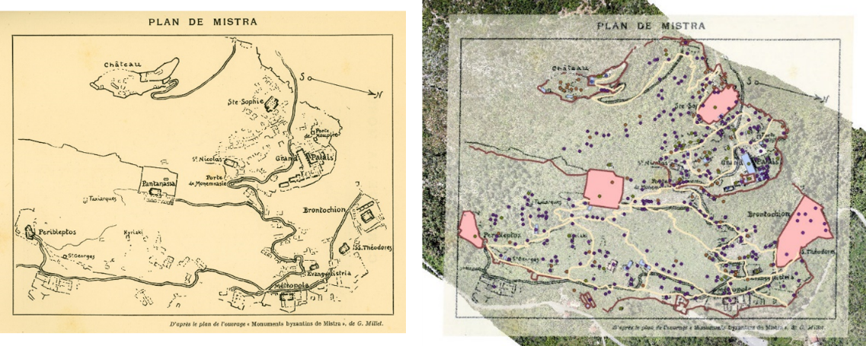
Figure 7 (a) Plan of Mystras [Monuments Byzantine de Mistra, de G. Millet] (b) Basemap overlayed with Millet's plan and the generated geodatabase
Through the spatial visualization of Mystras, unknown to the public areas and aspects of the urban fabric area revealed. Specifically, the Brontochion complex of buildings are evident in the topographical plan and offer a unique insight in comparison with the basemap created. The main buildings credited to the Monastery are the churches of Hagioi Theodoroi (N3.1) and Panagia Hodegetria (N3.2) along with buildings of additional uses such as the first refectory (N3.3), the larger refectory (N3.5), the Cells (N3.4, N3.7, N3.8 & N3.10) and auxiliary buildings (N3.6 & N3.9) (Figure 8).

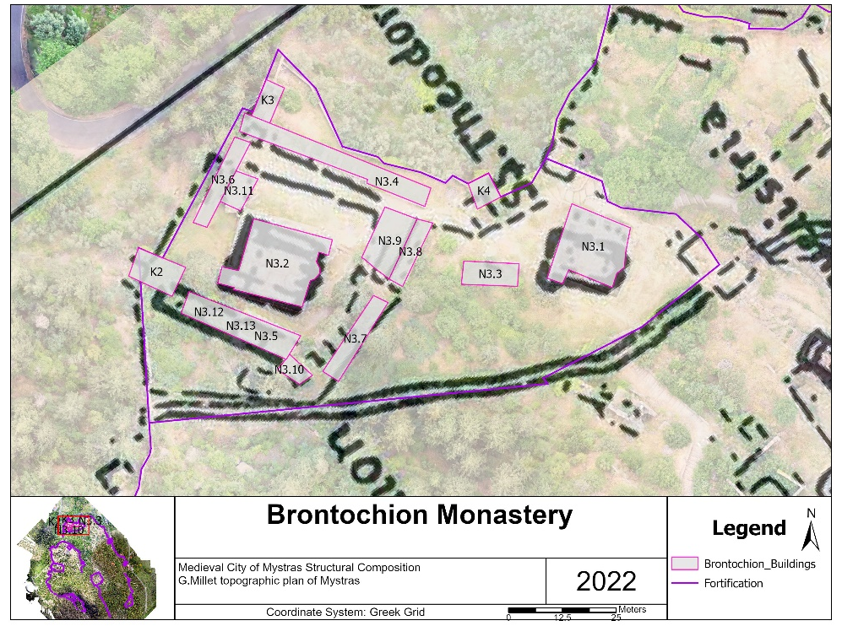
Figure 8 Structural composition of Monastery of Brontochion overlaying G. Millet’s topographic Plan
Although the majority of the structures were erected during the Late Byzantine I period, 1262 – 1348, the Monastery maintains a timeline of three different phases, the initial phase when Hagioi Theodoroi was built, the second phase when the church of Hodegetria was erected initially as a basilica and the third phase when Hodegetria is redesigned into the mixed type of Mystras and the surrounding complex is built. Additionally, towers K3 and K4 have been dated as post-Byzantine, built during the Ottoman period of Mystras (Figure 9).
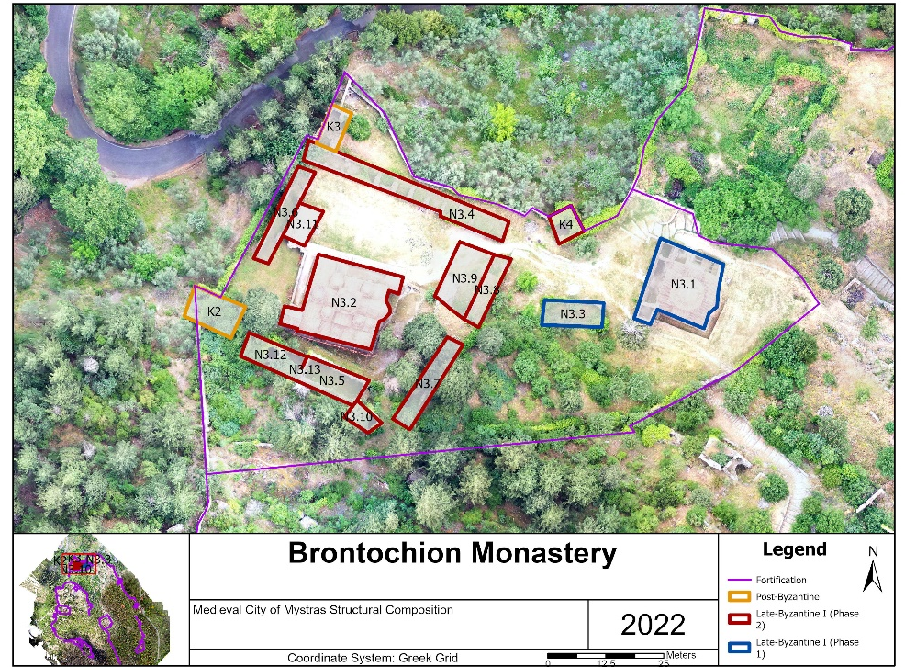
Figure 9 Timeline of Brontochion Monastery
Discussion
The work presented in this study is part of an ongoing research effort for the mapping and high-resolution depiction of the archaeological site of Mystras including a detailed geodatabase of all the structures of the city. Through the overall presentation of the medieval city via GIS and the developed geodatabase users have the opportunity to study the site depending on their research interests through a centralized application containing a significant segment of the published research data regarding Mystras. The database layers can be used in a variety of additional applications from AR and VR applications, to 3D visualization projects, educational games, and digital smart guides. The final database including orthophotos and 3D models can be used in further study of the site by researchers and students. All data and visualization tools are available to the Ephorate of Antiquities of Lakonia. Future aims include the continuation of the development of the geodatabase in English and enhanced information. Additionally, the archaeological site will be scanned using LIDAR technology in order to obtain a better view of the site surface which is covered by the extensive vegetation over Myzithra hill. LIDAR technology will provide valuable insights into the topography and features of the archaeological site, aiding in the identification of hidden structures and landscape features. Furthermore, the integration of LIDAR data with the existing geodatabase will enhance the accuracy and detail of the spatial representation, facilitating more comprehensive analyses and interpretations of the site's cultural significance.

Acknowledgements
Acknowledgments to the “Exceptional Laboratory Practices in Cultural Heritage: Upgrading Infrastructure and Extending Research Perspectives of the Laboratory of Archaeometry”, a co-financed by Greece and the European Union project under the auspices of the program “Competitiveness, Entrepreneurship and Innovation” NSRF 2014-2020 under which this research is implemented.
Conflict of interest disclosure
The authors declare that they comply with the PCI rule of having no financial conflicts of interest in relation to the content of the article
References
Anagnostaki K., Petmezas S., Sarris Ap. (2014). Reading history on a map: the Venetian land registry of Vostitsa, Proceedings of the 3rd Symposium on Arch_RNT-Archaeological Research and New Technologies (ed. N. Zacharias), University of the Peloponnese, Publications Humanities Series, 31-38, Kalamata
Arvanitopoulos St., (2004). The City of Mystras: Aspects of the Organization and Opera-tion of a Late Byzantine Urban Complex Based on Sources and Public Buildings. National and Kapodistrian University of Athens, unpublished PhD Thesis (in Greek)
Chatzidakis M., (1992), Mystras the Medieval City and the Castle, a full guide of the Palaces, Churches and the Castle, Athinon publishing, Athens
Chase, K. (2003), Firearms: A Global History to 1700, Cambridge University Press
Georgiades N., (2002), Mystras, TAP, Athens
Gutiérrez G., Erny G., Friedman A., Godsey M. and Gradoz M., (2016), Archaeological Topography with Small Unmanned Aerial Vehicles, Special Edition Drones in Archaeology, vol. 16 no. 2, The SAA Archaeological Record
Kalonaros, P., (1940). The Chronicle of the Morea, D. Dimitrakou Publishing House, Ath-ens (in Greek)
Forte M., Danelon N. and Marciniak A., (2020) Drones At Çatalhöyük: A New Survey for Landscape Interpretation, Archaeology of Anatolia, Vol.3, Cambridge University Press
Meouche R El, Hijazi L., Oncet PA., Abumemeh M., Rezouge M, (2016), UAV Photo-grammetry Implementation to Enhance Land Surveying, Comparisons and Possibilities, Vol XlII-2/W2, 11th 3D Geoinfo Conference, 20-21 October 2016, Athens Greece, doi:10.5194/isprs-archives-XLII-2-W2-107-2016
Millet, Ecole: Gabriel Millet, L'Ecole Grecque dans Γ architecture Byzantine, Paris 1916
Panagiotidis V., (2022), Survey, Virtual and Augmented Reality, Internet Applications for Culture, in Cultural Heritage and New Technologies, (Αποτυπώσεις Χώρων, Εικονική και Επαυξημένη Πραγματικότητα, Εφαρμογές Διαδικτύου για τον Πολιτισμό, στο Πολιτιστική Κληρονομιά και Νέες Τεχνολογίες), (Editing: Ν. Zacharias), Papazisis Publications, 2022, (in Greek)
Panagiotidis V., Malaperdas G., Palamara E., Valantou V & Zacharias N. (2019). Information Technology, Smart Devices and Augmented Reality Applications for Cultural Heritage Enhancement: The Kalamata 1821 Project, 1st International Transdisciplinary Multispectral Modelling and Cooperation for the Preservation of Cultural Heritage, Athens. Springer Nature Switzerland AG. https://doi.org/10.1007/978-3-030-12957-6_15
Panagiotidis V. V. & Zacharias N., 2022, “Digital Mystras: An approach towards under-standing the use of an archaeological space”, 2nd International Conference on Global Issues of Environment & Culture, Scientific Culture Vol. 8 No. 3, pp 85 99
Runciman St. (1980), Mistra, Thames & Hudson, Athens (in Greek)
Sinos, St. (2009). The Monuments of Mystras, The work of the Committee for the Restora-tion of Mystras Monuments. Athens: Credit Management Fund for the Execution of Archaeological Works Committee for the Restoration of Mystras Monuments, 11-22, 80-89 (in Greek)
Sinos, St. (2021). The Late Byzantine Palace of Mystras and its Restoration, Kapon Editions, Athens Archaeological Site of Mystras, Available at: https://whc.unesco.org/en/list/511/
The Castle City of Mystras, (2005). History & Character of the Byzantine City [online). Available at: https://www.culture.gr/mystras-edu/history/index.html# [July 20, 2019].

